Medical Operations Intelligence Dashboard & Automation System
System Architecture
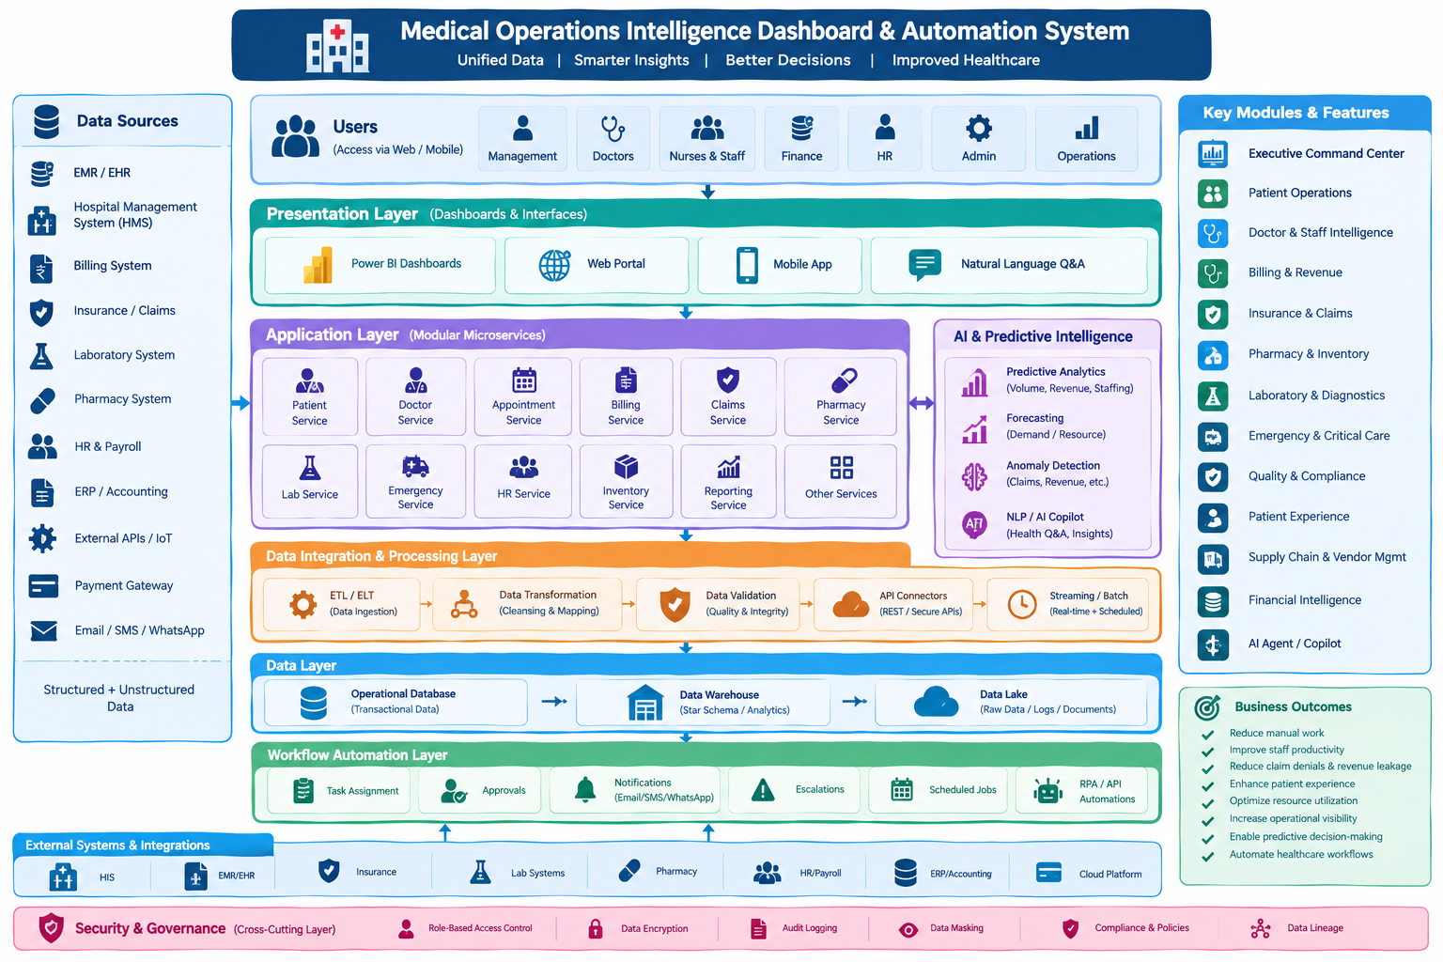
Architecture Description
The proposed system is a modular medical operations intelligence platform. It connects healthcare data sources to dashboards, application services, AI and predictive analytics, data processing, workflow automation, and secure integrations.
1. Data Sources
- EMR / EHR
- Hospital Management System (HMS)
- Billing System
- Insurance / Claims
- Laboratory System
- Pharmacy System
- HR & Payroll
- ERP / Accounting
- External APIs / IoT
- Payment Gateway
- Email / SMS / WhatsApp
2. Users / Stakeholders
- Hospital Management
- Doctors
- Nurses & Staff
- Finance
- HR
- Administration
- Operations
3. Presentation Layer
- Power BI Dashboards
- Web Application / Portal
- Mobile Application
- Natural Language Q&A / AI interface
4. Application Layer – Modular Services
- Patient Service
- Doctor Service
- Appointment Service
- Billing Service
- Claims Service
- Pharmacy Service
- Laboratory Service
- Emergency Service
- HR Service
- Inventory Service
- Finance Service
- Reporting Service
- Other supporting services
5. AI & Predictive Intelligence
- Predictive analytics
- Demand and resource forecasting
- Appointment no-show prediction
- Claim-denial prediction
- Anomaly detection
- Natural-language AI Copilot
- AI-generated insights and recommendations
6. Data Integration & Processing Layer
- ETL / ELT
- Data transformation and mapping
- Data validation and quality checks
- Secure API connectors
- Real-time streaming and scheduled batch processing
7. Data Layer
- Operational Database – transactional healthcare data
- Data Warehouse – structured analytical and reporting data
- Data Lake – raw, historical, log, and document data
8. Workflow Automation Layer
- Automated task assignment
- Approvals
- Email / SMS / WhatsApp notifications
- Escalation workflows
- Scheduled jobs and reports
- RPA / API automation
9. External Systems & Integrations
- Hospital Information Systems (HIS)
- EMR / EHR
- Insurance platforms
- Laboratory systems
- Pharmacy systems
- HR / Payroll
- ERP / Accounting
- Cloud platforms
10. Security & Governance
- Role-Based Access Control (RBAC)
- Data encryption
- Audit logging
- Data masking
- Data lineage
- Compliance and governance policies
11. Key Business Modules
- Executive Command Center
- Patient Operations
- Doctor & Staff Intelligence
- Billing & Revenue Intelligence
- Insurance & Claims
- Pharmacy & Inventory
- Laboratory & Diagnostics
- Emergency & Critical Care
- Quality & Compliance
- Patient Experience
- Supply Chain & Vendor Management
- Financial Intelligence
- AI Agent / Copilot
13. Business Outcomes
- Reduce manual administrative work
- Improve staff productivity and resource utilization
- Reduce claim denials and revenue leakage
- Improve patient experience
- Reduce operational delays
- Increase operational visibility
- Enable predictive decision-making
- Automate repetitive healthcare workflows
12. Overall Data Flow
Data Sources → Data Integration & Processing → Data Layer → Application Services / Analytics → AI & Predictive Intelligence → Dashboards and AI Copilot → Workflow Automation → Business Outcomes.

