SUBJECT : PROBLEM SOLVING AND TESTING USING JAVA STUDENT NAME : SK NAZEEM
COURSE CODE : 10211CS227 VTU NUMBER : VTU28507

Task 1 (Easy): Salary Transformation System Problem Description
A company stores employee salaries in a list. Increase each salary by 10% and print the updated salaries using functional transformation techniques.

Input Format
- First line contains integer N.
- Second line contains N space-separated integers.
Output Format Print updated salaries. Constraints
- 1 ≤ N ≤ 10^5

Sample Input
5
1000 2000 3000 4000 5000

Sample Output
1100 2200 3300 4400 5500

PROGRAM :
import java.util.*;
import java.util.stream.*;

public class Main {

public static void main(String[] args) { Scanner sc = new Scanner(System.in);

// Read number of employees int n = sc.nextInt();

// Read salaries and increase each by 10% List<Integer> updatedSalaries = IntStream.range(0, n)
.map(i -> sc.nextInt())
.map(salary -> salary + (salary * 10 / 100))
.boxed()
.collect(Collectors.toList());

// Print updated salaries
updatedSalaries.forEach(salary -> System.out.print(salary + " "));

sc.close();
}
}

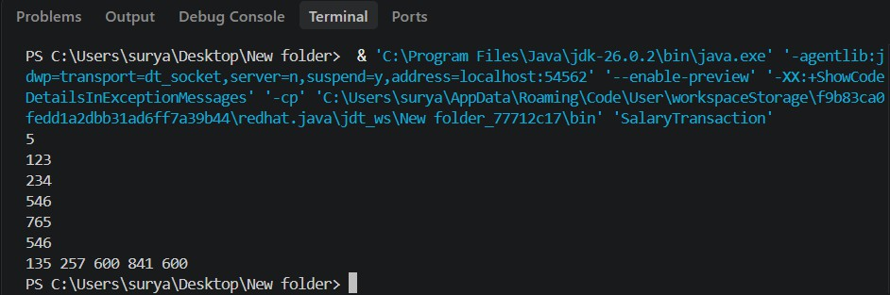
OUTPUT :

