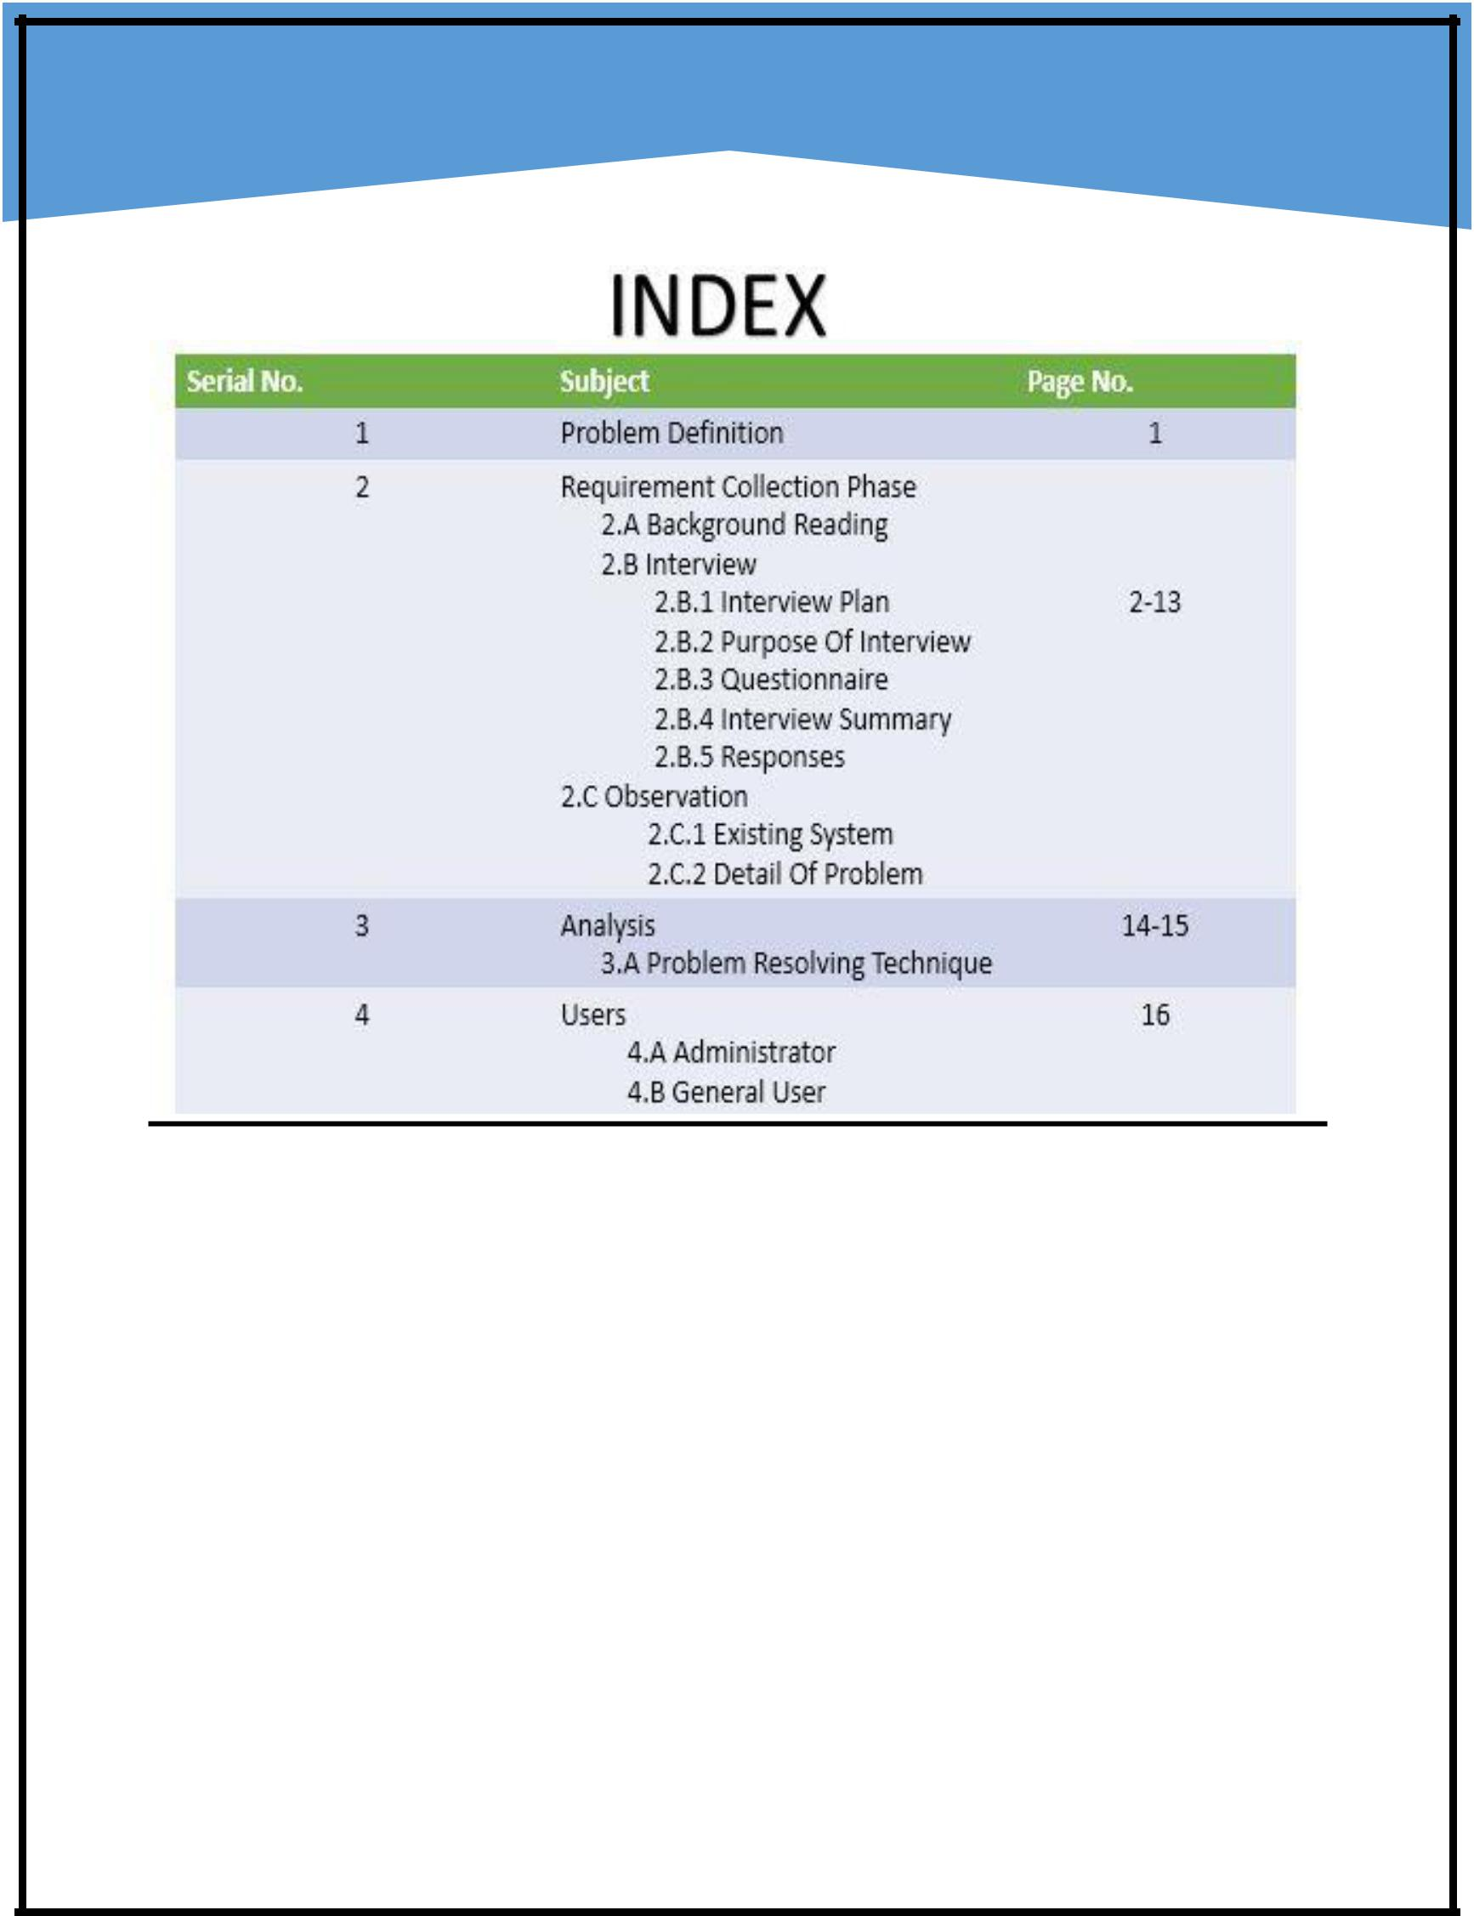

**By: Shailesh Mishra(2016120107)**

**By: Binayak Gouri Shankar (201612069)**

**Shailesh Mishra (2016120107)**

**Real Estate Automation**

**Database Management System**

**Software Requirement Specification (SRS)**

**Document**

**1.Problem Definition:**

The basic problem in the current system is all about the manual functionalities. Our goal is to develop a system that will be automated and will require less efforts and will efficient in context of economy, user friendly and comprehensive.

**2. Requirement Collection Phase:**

**2.A Background Reading:**

As per the requirement of this project where we have to implement a software on “**Real Estate Database Management**

**System”** , we gone through what actually a “Real Estate” is !, itis basically related to buy, sell and rent of the property from an agent to a buyer or tenant. It was identified as a problem when

Page | 1

people used to view “classifieds” in daily newspapers and magazines, although the real time data and results were not available. This led to the innovation of this system, now all reputed real estate firms use such kind of system which is user friendly and the implemented business logic fulfils the mutual requirements.

Earlier, there was a mediator which actually acted as a link between the customer and the agent, which used to create chaos as there was no real time data available, which was the most prominent drawback of that traditional style of Real Estate property dealings.

**Customer enquires about the related property**

**Agent**  **Customer**

**Making data available to customer as per his requirement**

The above diagram shows that how both, customer and the agent were mutually dependent on each other, however the system was completely manual, which is to be automated for both the sides.

After a formal study of an existing system which is quite traditional, we pointed out few features:

Page | 2

* Concerned person of the firm keeps all records of the related property manually i.e. each time to register the property there is no automated and filtered concept of data storing is implemented yet.
* At Present, the staff carries out all the work manually. All the data and records are stored manually in the files.
* At the end of the day all the sales and purchase records entries are made manually in file system, which results into intolerable mistakes.
* Big and large registers are maintained for every transaction. All the details have to be maintained minutely and have to be taken care of manual errors.
* Customer and agents validations are done manually.
* Generation of bills, reports, and invoice is done manually, which results into lots of paper wastage.
* No real time data available for the land and property.
* Searching becomes hectic as data are unarranged.

**2.B Interview:**

**2.B.1 Interview Plan:**

System: Real Estate Management System

Project Reference: DA/MSIT/2016/09

Page | 3

Participants: Binayak Gouri Shankar (Student)

Shailesh Mishra (Student)

Mr. Rohan Halani(Real Estate Agent)

**Date:** 22thAugust 2016

**Time:** 05:30 PM

**Duration:** 1 Hour

**Place:** Infocity

**2.B.2 Purpose of Interview:**

Preliminary meeting to identify problems and requirements regarding the currently manual real estate automation system.

**Agenda:**

1. Problems with manual system and any other concerns
2. Current security and retrieval function along with real time data availability.
3. Problems faced by agents regarding collecting the data from various sources.
4. Follow up actions.

Page | 4

**Documents to be brought to the interview:**

Proposed automated system block diagram. Outline of current system implemented in general.

**2.B.3 Questionnaire:**

1. What your customer actually look for while buying a property?
   1. Price
   2. Place
   3. Furnished
   4. Nothing as such
2. Do you provide real time data/information to your clients or customers?
   1. Sometimes
   2. Always
   3. Never
3. Are you comfortable in maintaining all the records manually or in file system?
   1. Yes, Its fine

Page | 5

* 1. No, we are looking for automation

1. Do you store your investment records manually?
   1. Yes
   2. No
2. Do you have automated query system?
   1. Yes
   2. No
3. How much time you usually take to provide sorted data to your customer/client?
   1. 1 hour to 5 hours
   2. 6 hours to 12 hours
   3. Probably next day
4. Are your employees happy with the manual system?
   1. No
   2. Yes
   3. Can’t Say
5. Do you have consistent data of your employees and clients?
   1. Don’t know
   2. Yes
   3. No
6. What problem you basically face while working with your current system?

Page | 6

**10.** How can you provide better service to yourclients? Mention your plans.

******************************************

**2.B.4 Interview Summary:**

System: Real Estate Management System

Project Reference: DA/MSIT/2016/09

Participants: Binayak Gouri Shankar (Student)

Shailesh Mishra (Student)

Mr. Rohan Halani (Real Estate Agent)

**Date:** 22ndAugust 2016

**Time:** 05:30 PM

**Duration:** 1 Hour

**Place:** Infocity

Page | 7

**2.B.5 Responses:**

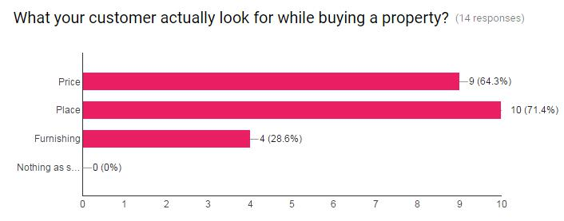

**1.**

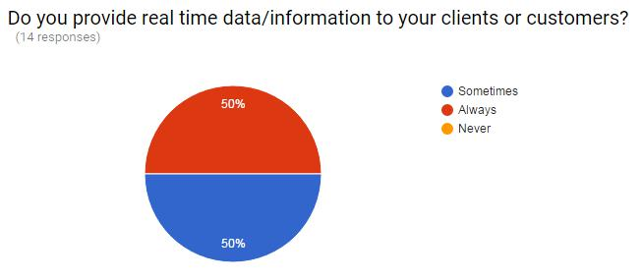

**2.**

**3.**

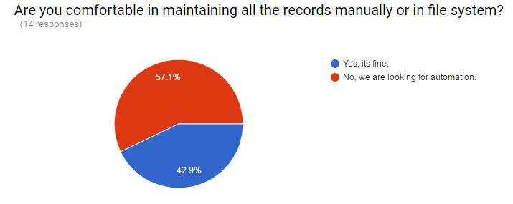

Page | 8

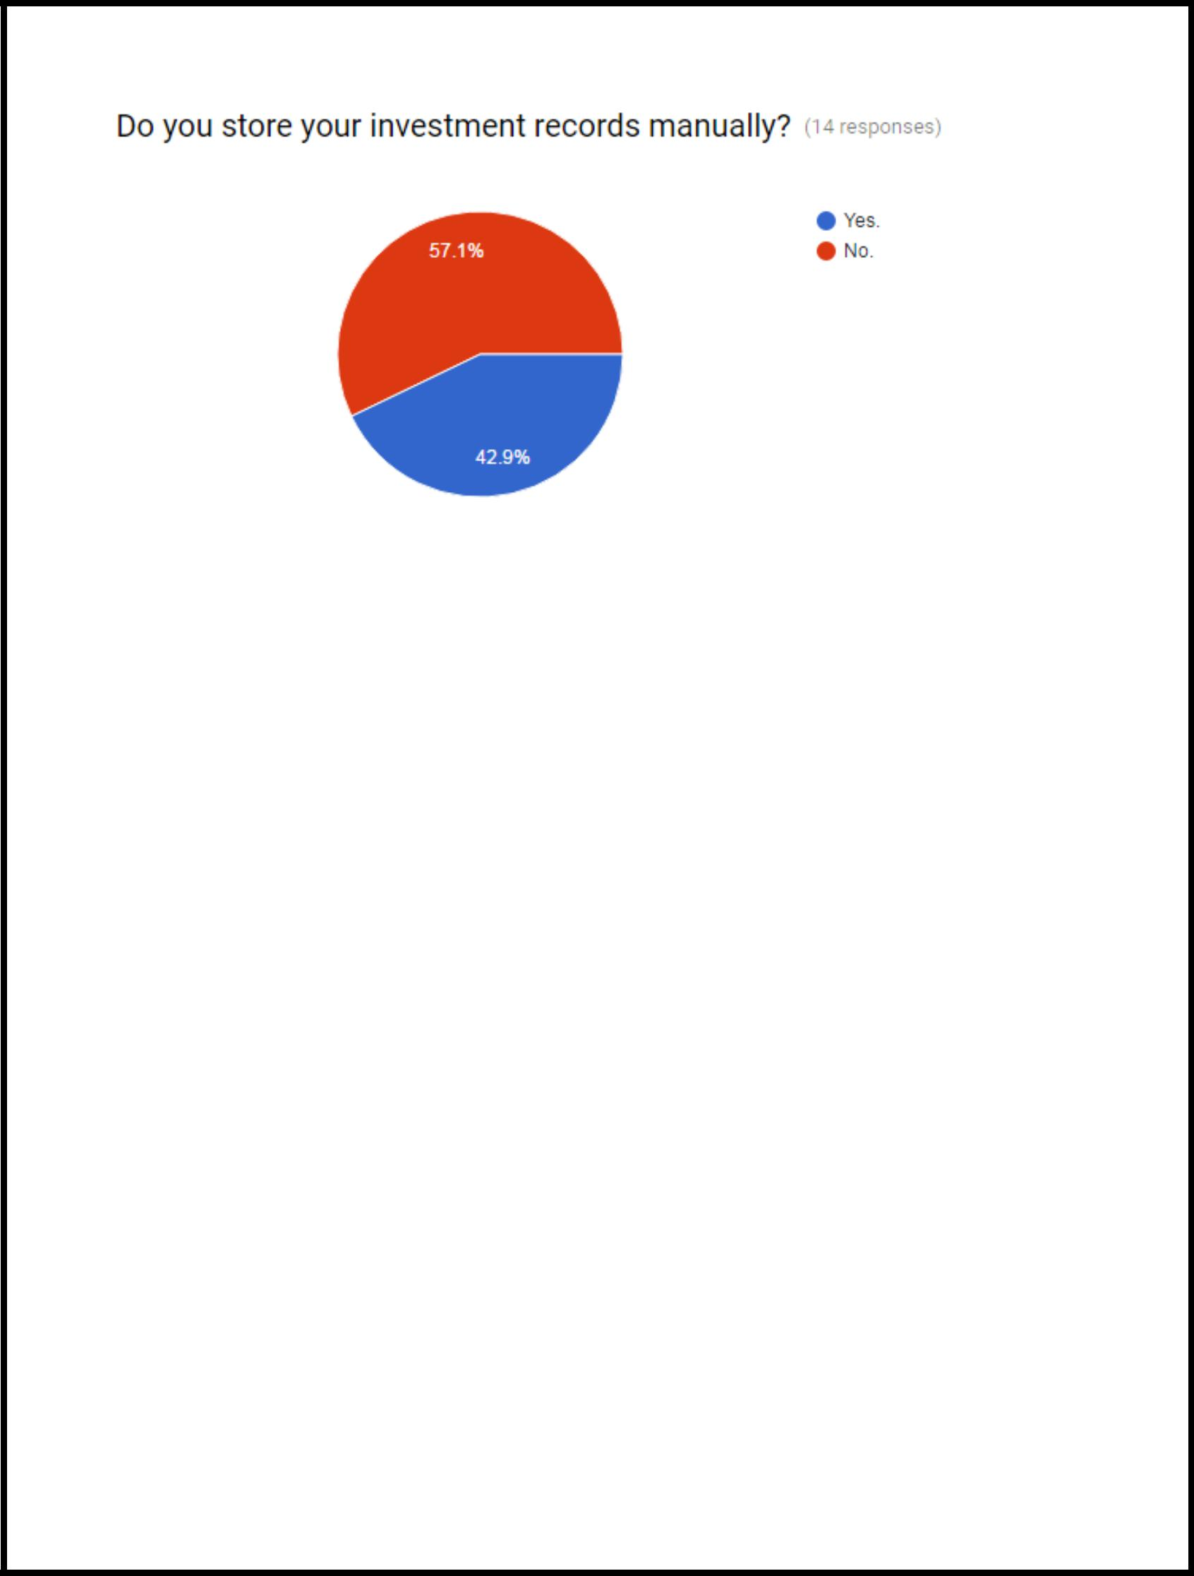**4.**

**5.**

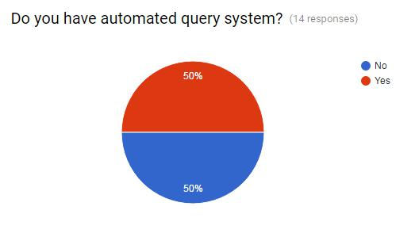

**6.**

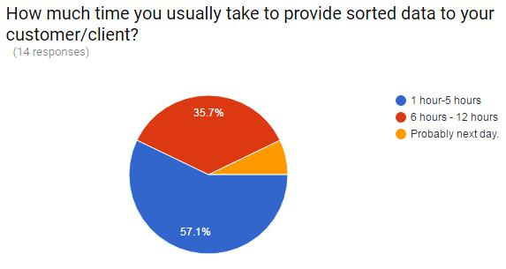

Page | 9

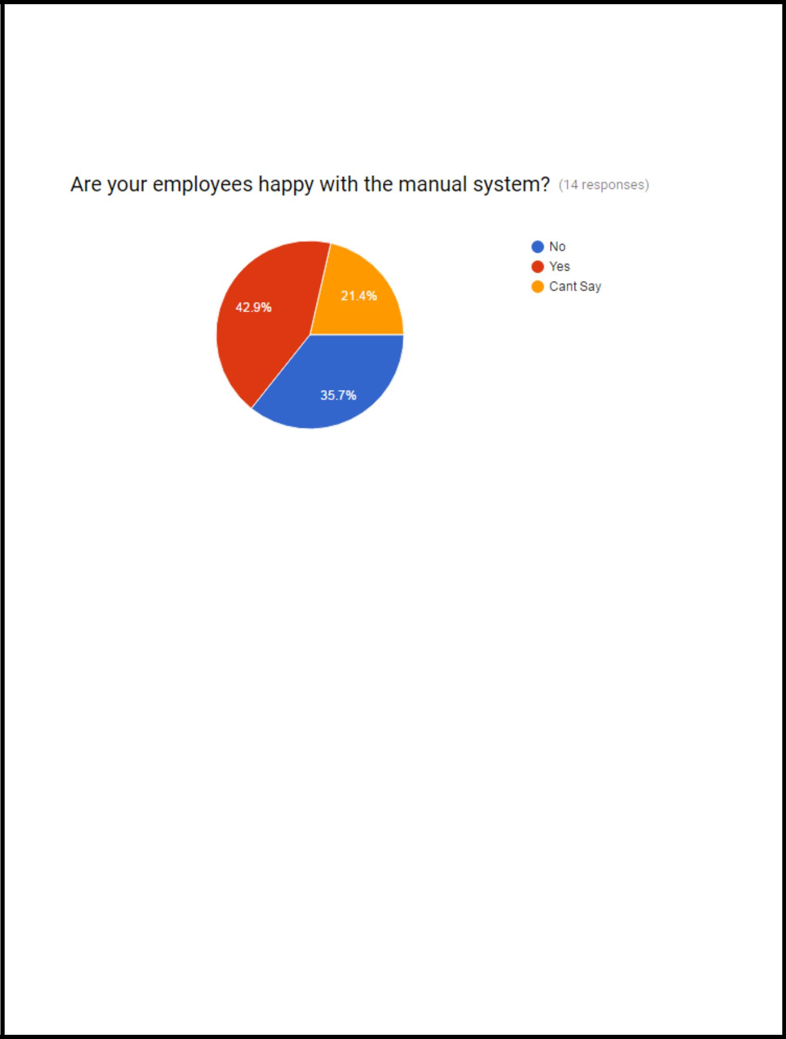

**7.**

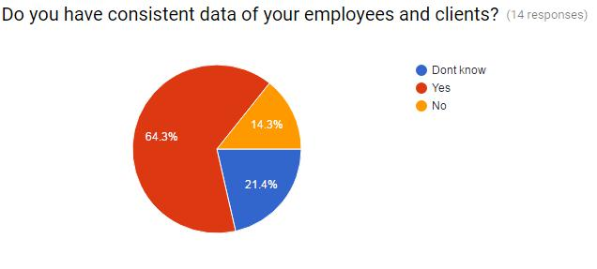

**8.**

**Cont…**

Page | 10

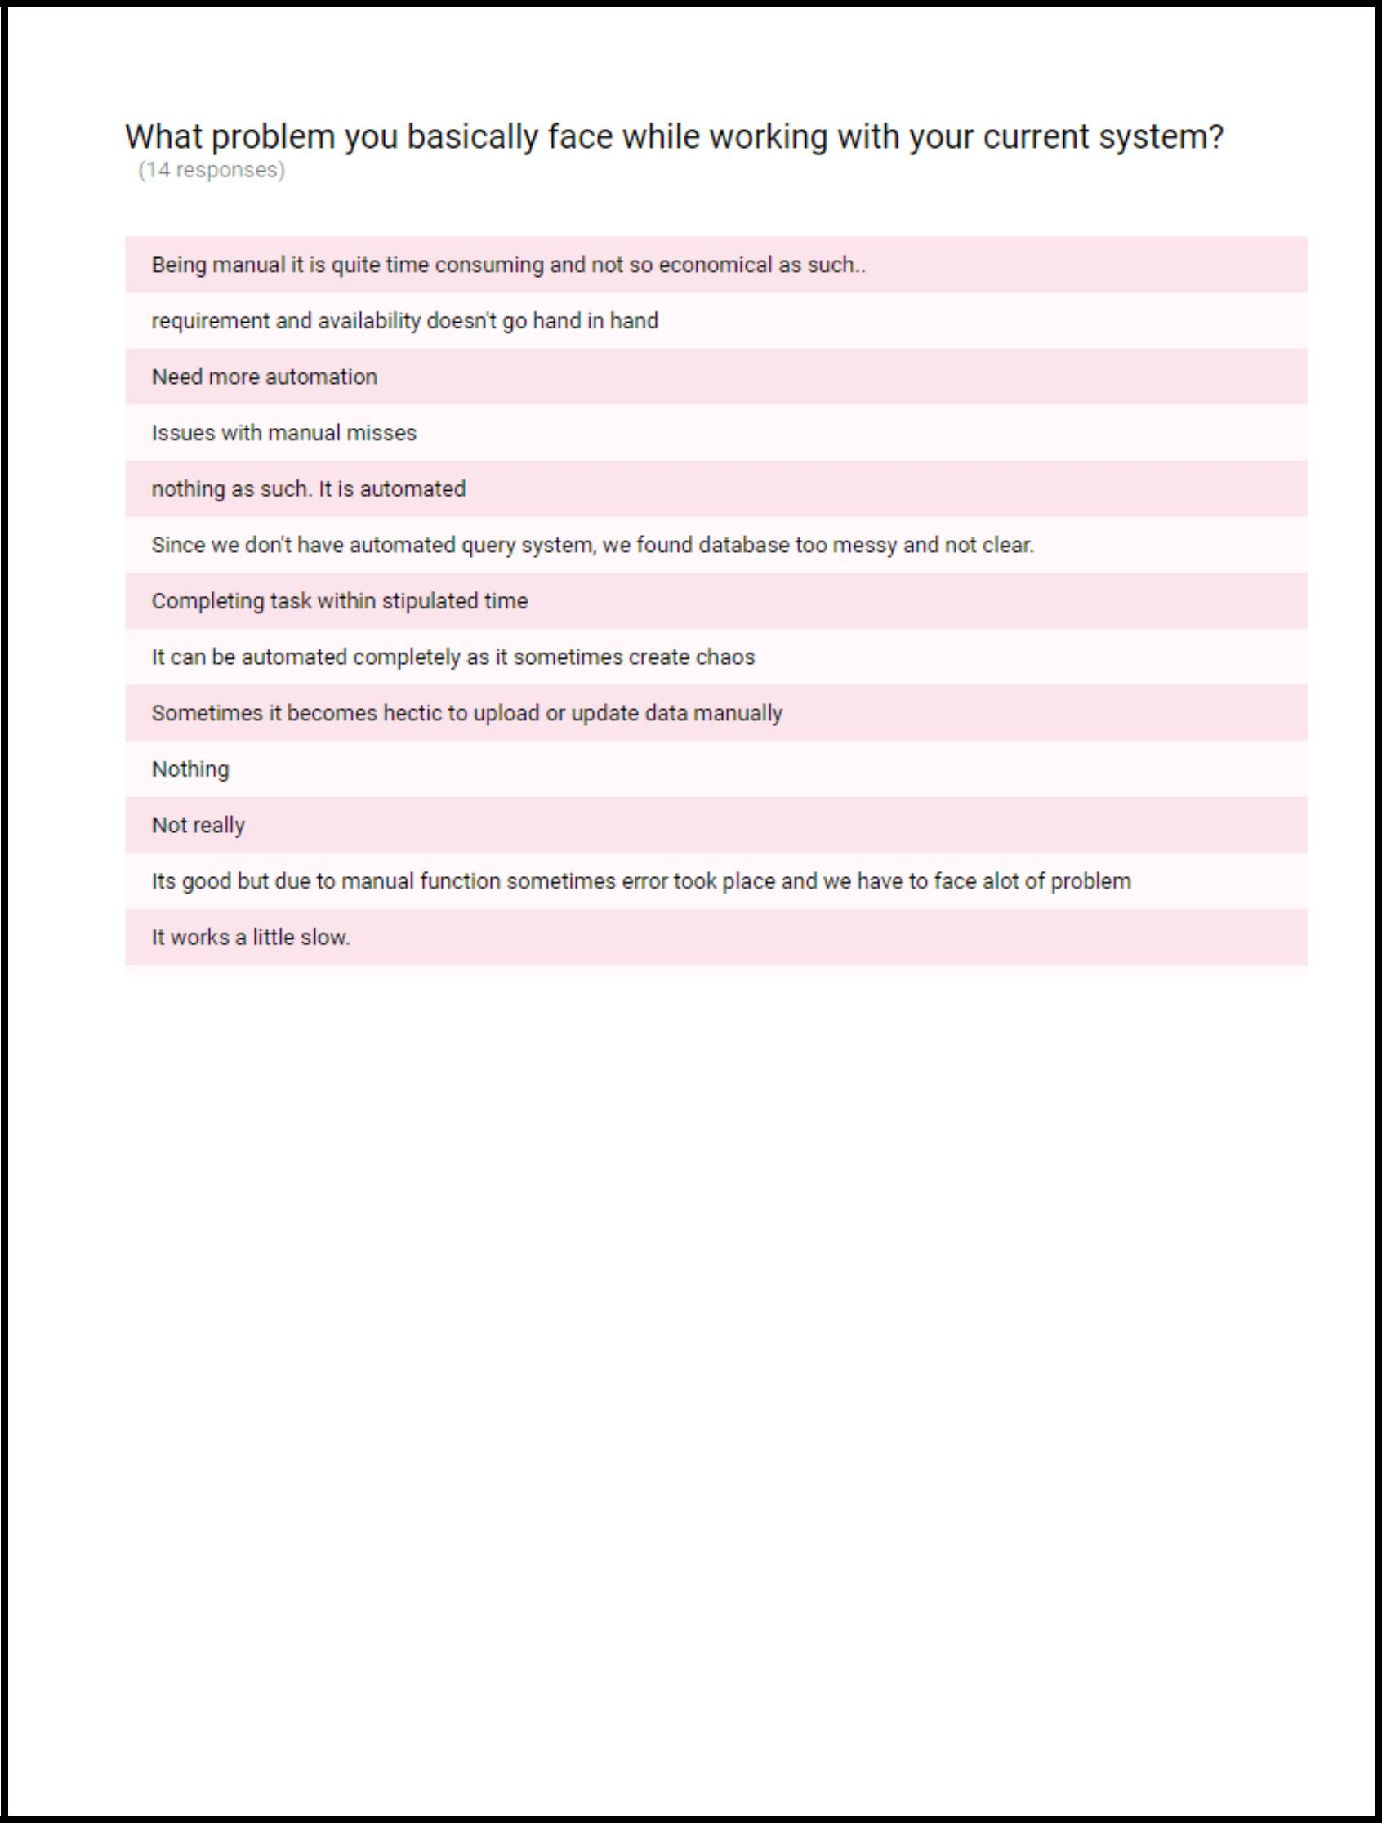**9.**

Page | 11

**10. -**

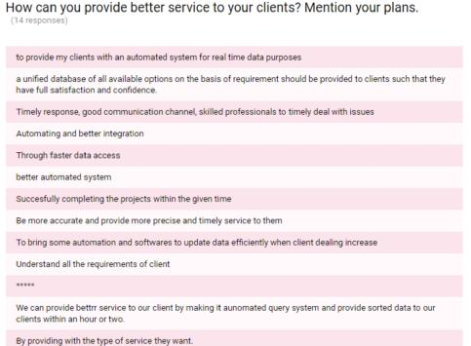

**2.C Observation:**

After having a detailed analysis of the existing system, we observed that the manual system is not much efficient and user friendly as well. If system gets automated then the processing and fetching real time data would be much faster and easier which eventually will lead to the optimal utilization of the available resources. Here are the basic lacunas of the

Page | 12

**2.C.1Existing system:**

1. Not automated.
2. No real time response
3. Data is inconsistent
4. Real time data is not available to both, client and agent.
5. Being a manual system it is very time consuming.
6. Not reliable.
7. Inconsistency leads to redundancy of data.
8. No records for real time money transactions like Advance, down payments, loan etc.
9. No investor policy i.e there is no provision for investing money as system is not automated and worst to handle.

10. No graphical form of property (Photograph) can be stored and might get misplaced.

**2.C.2 Detail Of Problem:**

Regular details are mentioned in the above section. Basic problem is not accessing of data in fast and efficient manner which eventually leads to the slowing down the manual process. Lack of integrity constraints fails to provide the exact data and also becomes less reliable. It takes a lot of time and inconsistency and inaccuracy.

Page | 13

**3.Analysis:**

**3.A Problem Resolving Techniques**

We will implement a smart and intelligent system that will be user friendly and efficient which will eventually save the time and will become a money making factor.

Here are some basic functionality which will help us to achieve the goal and remove the problems mentioned above:

1. Real time data search
2. Data will be arranged in sorted manner
3. Data of all the transactions made will be recorded separately
4. Data accessing will be faster
5. Administrator will be the king ! As he will get all the power and privilege to administrate the system.
6. Reports will be generated daily, weekly and monthly basis for analysis.
7. Logging in to the system from login ID and password provided to the user.

Page | 14

1. User friendly approach.
2. Secure and safe.
3. Storage of photographs of plots and property.
4. Single window multiple access for investors.
5. There will be three user types, General client, administrator and investor.

**4.Users:**

There will be two basic user types, General/Client or Investor and administrator.

**4.A General:**

This type of user consists of two major divisions , Client and Investor. An investor can act as client also that’s why we have given him more privileges.

**4.B. Administrator:**

Administrator will have all the rights , as he can add , drop and modify users and set privileges for users as the security is major concern for this project.

Page | 15