Please follow below steps to Setup the project on every machine.

1. First ensure 32bit **jdk1.8** is installed on the machine
2. Download **eclipse** neon, for java developers
3. Launch eclipse
4. Open the **git** perspective(Add from menu “**Window**>>**Perspective**>>**Open Perspective**”)  
   
5. Click on **clone** a repository button  
   
6. “**Clone Git Repository**” popup will get display  
   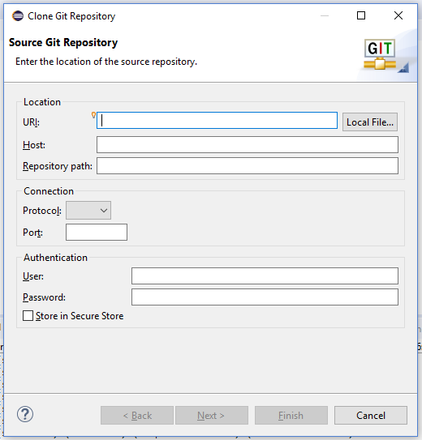
7. Provide **URI** as per the team: “**git@192.168.0.181:/home/git/dteam.git**”  
   and **password** and click on “**Store in Secure Store**” checkbox, then click on **Next** button  
   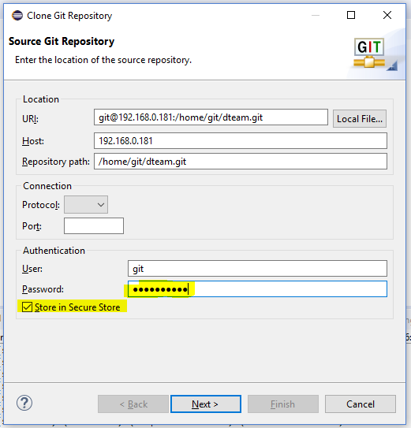
8. Click on **Next** button  
   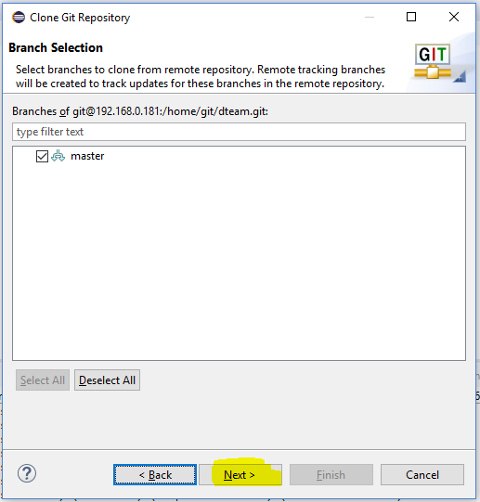
9. Select the “**Import all existing Eclipse projects after clone finishes**” checkbox, then click on **Finish** button  
    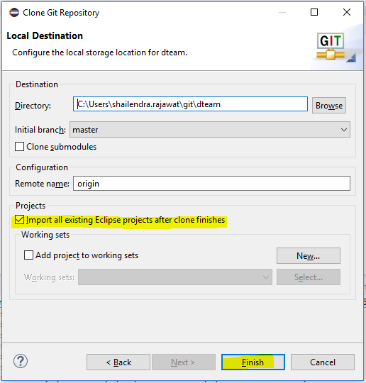
10. Goto **Java** Perspective  
    
11. You can see Team specific Project is added, in “**Package Explorer**” section  
      
    