Once you are done with solving problems, you can submit your codes for evaluation.

Please follow below steps.

1. Right click on your Project, for example, if you are from team A, then right click on “**ATeam**” project  
   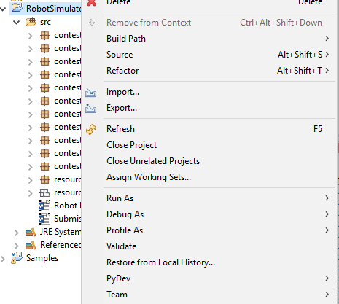
2. Go to “Team”  
   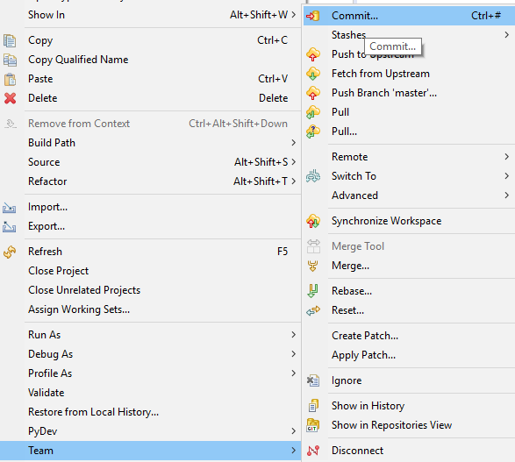
3. Click on “**Commit…**” >> A “**Git Staging**” tab will get displayed in bottom section  
   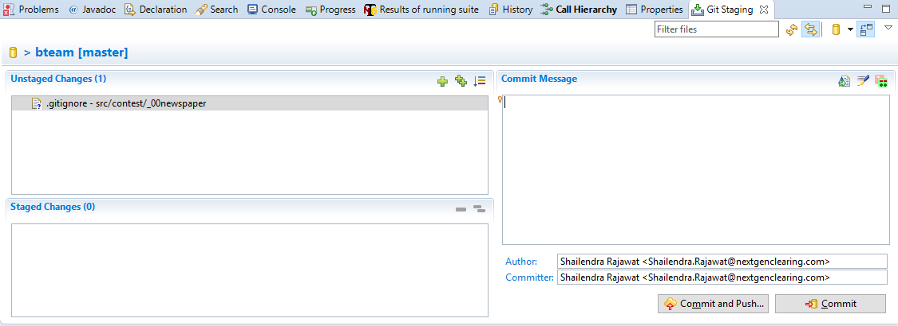
4. Drag all files from “**Unstaged Changes**” Section to “**Staged Changes**” Section  
   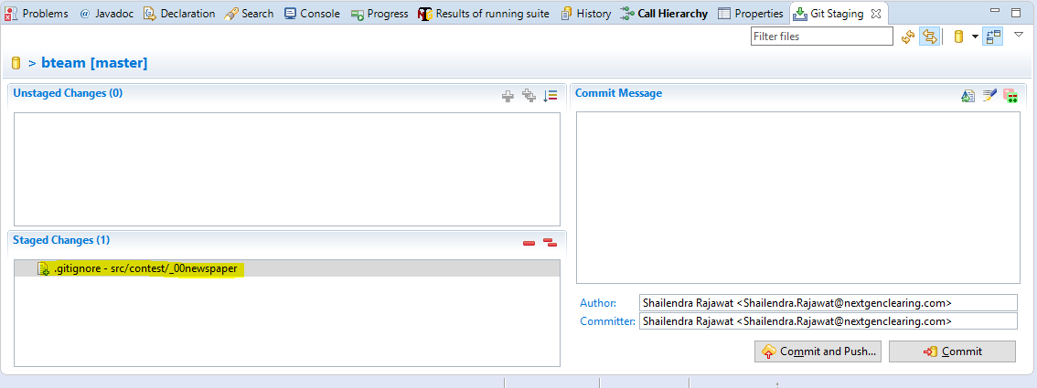
5. Provide appropriate “**Commit Message**”, then click on “**Commit and Push…**” Button  
   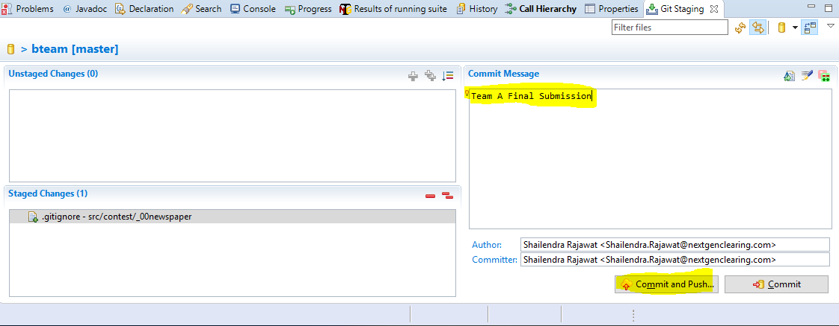
6. Click “**Close**” button on success popup  
   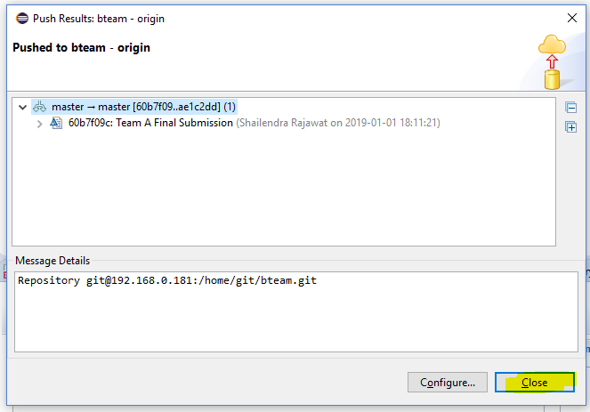

And whoosh… your code is now sent to a central repository..