**Problem Statement FetchNewspaper**

Your first task is to solve a simple story-problem in Robot’s world [***code is provided on the last page***]. Suppose that Robot has settled into its house, which is the square area in the center of the following diagram:

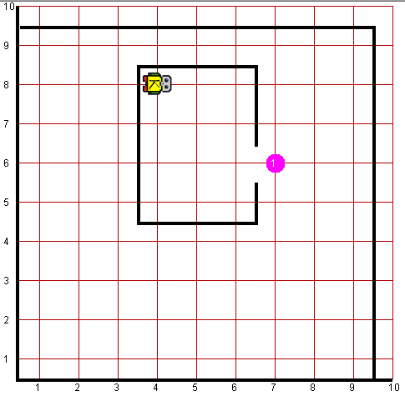

Robot starts off in the northwest corner of its house as shown in the diagram. The problem you need to get Robot to solve is to collect the newspaper—represented (as all objects in Robot’s world are) by a beeper—from outside the doorway and then to return to its initial position.

This exercise is extremely simple and exists just to get you started. You can assume that every part of the world looks just as it does in the diagram. The house is exactly this size, the door is always in the position shown, and the beeper is just outside the door. Thus, all you have to do is write the sequence of commands:

1. Move to the newspaper,
2. Pick it up, and
3. Return to its starting point.

Even though the program is only a few lines, it is still worth getting at least a little practice in **decomposition**. In your solution, include a **private method** for each of the steps shown in the outline.

Robot may count on the following facts about the world:

* Robot starts at 4th Avenue and 8th Street, facing east, with an infinite number of beepers.
* You are limited to the instructions in the Robot booklet—the only variables allowed are loop control variables used within the control section of the for loop.

**Worlds:**

In the Runner class, you can provide following worlds to test your program

1. newspaper.kwld

**Code:**

|  |
| --- |
| **public** **void** run() {  moveToNewsPaper();  pickPaper();  moveBackToStartingPoint();  }  **private** **void** moveBackToStartingPoint() {  //Moving to West Wall  **while** (frontIsClear()){  move();  }    //Turning the robot face to North  turnRight();    //Moving to North Wall, thus our Robot will be at NW corner of the house  **while** (frontIsClear()){  move();  }    //Turning the robot face to East, as it was at starting  turnRight();    }  **private** **void** pickPaper() {  //Moving ahead till we found the paper(beeper)  **while**(noBeepersPresent()){  move();  }    //picking up the beeper  pickBeeper();    //Turning the robot face to West  turnAround();    }  **private** **void** moveToNewsPaper() {    //Moving to East Wall  **while** (frontIsClear()){  move();  }    //Turning robot face to South direction  turnRight();    //Moving ahead till we found the door  **while** (leftIsBlocked()) {  move();  }    //Turning robot face to East direction  turnLeft();    } |