**Problem Statement Beeper Line**

Consider the problem of writing a method createBeeperLine, which creates a line of beepers beginning at Robot’s current corner and proceeding forward to the next wall. For example, if you were to execute createBeeperLine in an empty world, you would see something like the following before-and-after diagram:

*Before: After:*

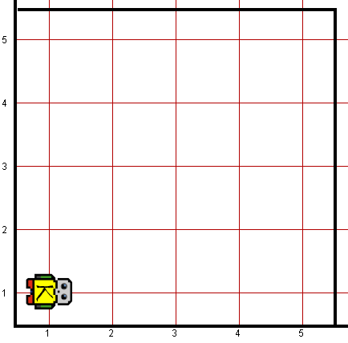 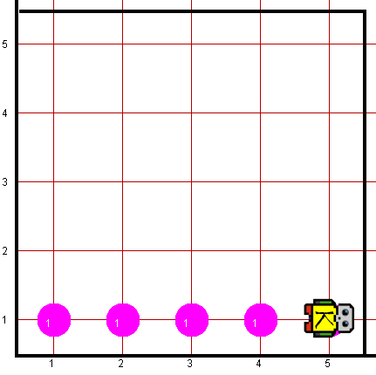

Please note all the corners of 1st street should have beepers at the end of execution.

Robot may count on the following facts about the world:

* Robot starts at 1st Avenue and 1st Street, facing east, with an infinite number of beepers.
* You are limited to the instructions in the Robot booklet—the only variables allowed are loop control variables used within the control section of the for loop.

**Worlds:**

In the Runner class, you can provide following worlds to test your program

1. beeperline10x10.kwld
2. beeperline5x5.kwld