**Problem Statement Quad Repair**

Robot has been hired to repair the damage done to the Quad in the 1989 earthquake. In particular, Robot is to repair a set of arches where some of the stones (represented by beepers, of course) are missing from the columns supporting the arches, as follows:

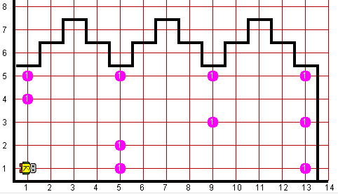

Your program should work on the world shown above, but it should be general enough to handle any world that meets certain basic conditions as outlined at the end of this problem. There are some example worlds mentioned below, and your program should work correctly with all of them. When Robot is done, the missing stones in the columns should be replaced by beepers, so that the final picture resulting from the world shown above would look like this:

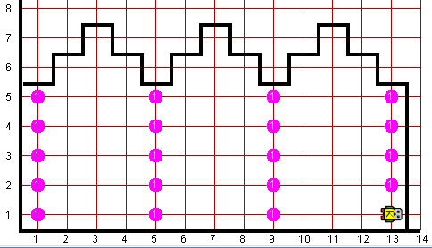

Robot may count on the following facts about the world:

* Robot starts at 1st Avenue and 1st Street, facing east, with an infinite number of beepers.
* The columns are exactly four units apart, on 1st, 5th, 9th Avenue, and so forth.
* The end of the columns is marked by a wall immediately after the final column. This wall section appears after 13th Avenue in the example, but your program should work for any number of columns.
* The top of the column is marked by a wall, but Robot cannot assume that columns are always five units high, or even that all columns are the same height.
* Some of the corners in the column may already contain beepers representing stones that are still in place. Your program should not put a second beeper on these corners
* You are limited to the instructions in the Robot booklet—the only variables allowed are loop control variables used within the control section of the for loop.

**Worlds:**In the Runner class, you can provide following worlds to test your program

1. quad13x8.kwld
2. quad13x10.kwld