**Problem Statement Wall Jumper**

Robot has to take on the challenge of jumping the walls (like a hurdles race, but with arbitrarily large hurdles) where:

* Robot starts at position (1, 1), facing East.
* The steeple chase is guaranteed to be 9 avenues long.
* There can be arbitrarily many hurdles that can be of arbitrary size, located between any two avenues in the world.
* Robot should "jump" each hurdle one at a time. For example, if you were to execute the program, you would see something like the following before-and-after diagram:
* You are limited to the instructions in the Robot booklet—the only variables allowed are loop control variables used within the control section of the for loop.

*Before: After:*

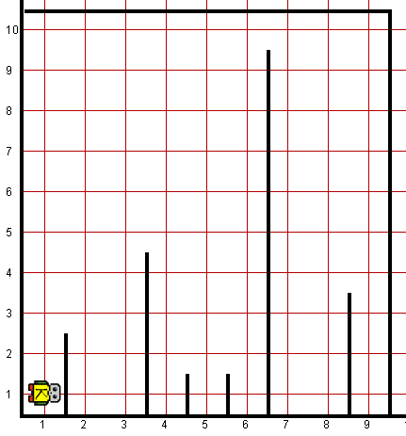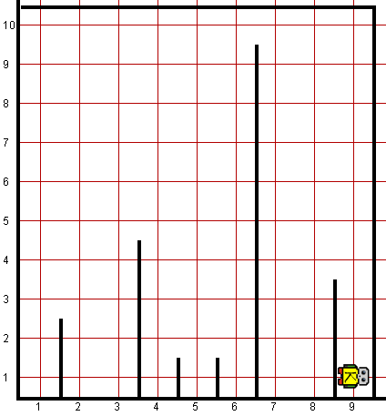

**Worlds:**

In the Runner class, you can provide following worlds to test your program

1. Walljumper9col.kwld