**Problem Statement Cleaning up Scattered Beeper**

Unfortunately, sometimes Robot's world gets a little messy, with beepers strewn around at various corners. We want to help Robot clean up his world by writing a program that has Robot go through the world and pick up any beepers that may be scattered about. We assume that:

* Robot starts at corner (1, 1) facing East
* Each corner of Robot's world may either be empty or contain at least one beeper, and when Robot is done there should be no more beepers on any corner
* Robot can finish his task at any location and orientation
* You are limited to the instructions in the Robot booklet—the only variables allowed are loop control variables used within the control section of the for loop.

If you were to execute your program, you would see something like the following before-and-after diagram

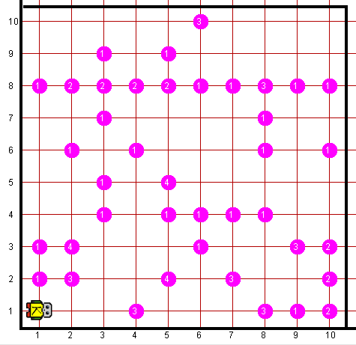*Before: After:*

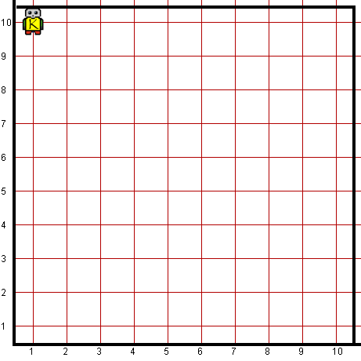

**Worlds:**

In the Runner class, you can provide following worlds to test your program

1. scatteredbeeper10x10.kwld
2. scatteredbeepers10x10.kwld