**Problem Statement Double Beeper**

Interestingly enough, Robot can also do various kinds of math. For example, we can ask Robot to double the number of beepers on some corner in the world. We'd like to write a program where there is a pile of some (finite) number of beepers on the corner directly in front of Robot. We want Robot to double the number of beepers in that pile and return to his original location and orientation. For example, if you were to execute your program in the sample Before world shown below, you would expect to see the corresponding After world (note that the number of beepers on corner (2, 1) has been doubled):

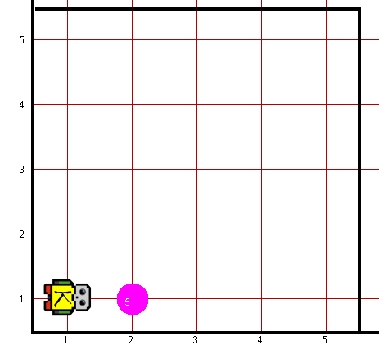*Before: After:*

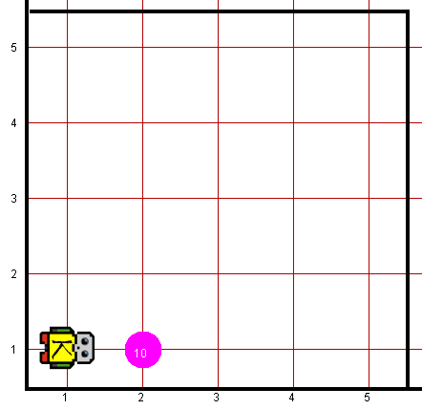

Robot may count on the following facts about the world:

* You can assume that Robot begins with an infinite number of beepers in his beeper bag
* You are limited to the instructions in the Robot booklet—the only variables allowed are loop control variables used within the control section of the for loop.

**Worlds:**

In the Runner class, you can provide following worlds to test your program

1. doublebeeper.kwld