**Problem Statement Inside Border**

We want to write a Robot program which will create an inside border around the world. Each location that is part of the border should have one (and only one) beeper on it and the border should be inset by one square from the outer walls of the world like this:

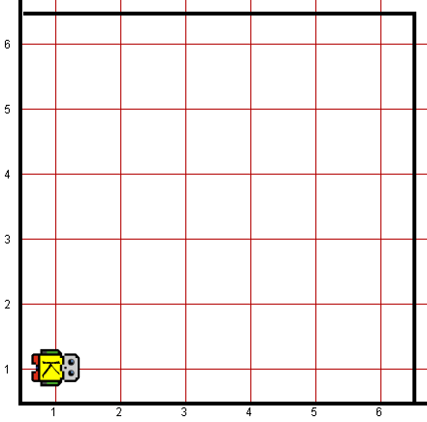 *Before: After:*

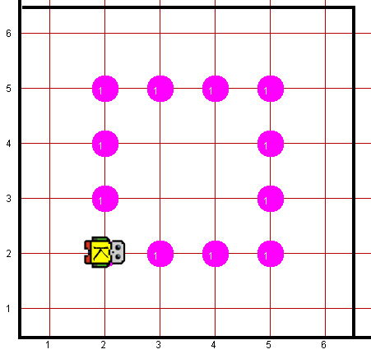

In solving this problem, you can count on the following facts about the world:

* You may assume that the world is at least 3x3 squares. The correct solution for a 3x3 square world is to place a single beeper in the center square.
* Robot starts off facing East at the corner of 1st Street and 1st Avenue with an infinite number beepers in its beeper bag.
* We do not care about Robot’s final location or heading.
* You do not need to worry about efficiency.
* You are limited to the instructions in the Robot booklet—the only variables allowed are loop control variables used within the control section of the for loop.

**Worlds:**

In the Runner class, you can provide following worlds to test your program

1. Insideborder3x3.kwld
2. Insideborder6x6.kwld
3. insideborder9x9.kwld