**Problem Statement Midpoint Finder**

We want to write a Robot program which will place a single beeper at the center of 1st Street. For example, if Robot starts in the world:

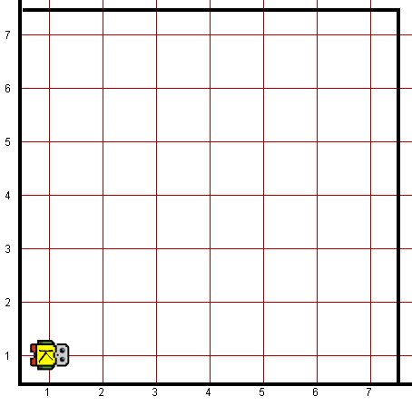

it should end with Robot standing on a beeper in the following position:

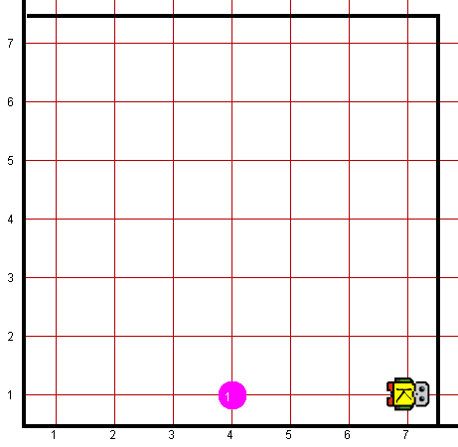

Note that the final configuration of the world should have only a single beeper at the midpoint of 1st Street. Along the way, Robot is allowed to place additional beepers wherever it wants to, but must pick them all up again before it finishes. In solving this problem, you may count on the following facts about the world:

* Robot starts at 1st Avenue and 1st Street, facing east, with an infinite number of beepers in its bag.
* The initial state of the world includes no interior walls or beepers.
* The world need not be square, but you may assume that it is at least as tall as it is wide.
* You are limited to the instructions in the Robot booklet—the only variables allowed are loop control variables used within the control section of the for loop.

Your program, moreover, can assume the following simplifications:

* If the width of the world is odd, Robot must put the beeper in the center square. If the width is even, Robot may drop the beeper on either of the two center squares.
* It does not matter which direction Robot is facing at the end of the run. There are many different algorithms you can use to solve this problem.

**Worlds:**In the Runner class, you can provide following worlds to test your program

1. midpoint3x3.kwld
2. midpoint7x7.kwld
3. midpoint8x8.kwld