**Problem Statement Clear Chad**

We want to write a Robot program which will remove the extra chads(beepers) from the punch-card ballots. To make this more concrete, imagine that Robot is sitting at the extreme left edge of a punch-card ballot that looks like this:

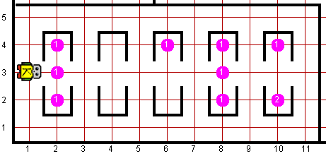

The partially enclosed rectangles in the interior of the world represent the areas of the ballot. On the original ballot, these rectangles are completely filled with beepers, as shown in the ballot rectangles on 2nd and 8th avenues. Unfortunately, some bits of the chad—sometimes end up remaining in the hole, as shown on 6th avenue and 10th avenues.

If there is no beeper in the center square, Robot must check the other two squares in the ballot and remove any and all beepers so that the ballot can be counted correctly. Thus, the final configuration of the ballot after Robot completes the processing should look like this

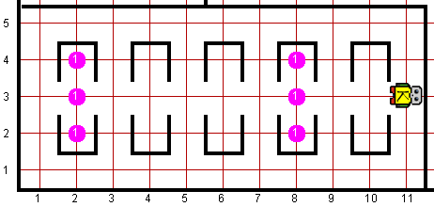

Robot may count on the following facts about the world:

* The world consists of a single row of ballot rectangles that appear on every even intersection, as shown in the sample world. The size of the ballot, however, may be different from the one shown in the example in the sense that it may contain any number of ballot rectangles. In any case, the card will begin one square to the left of the first rectangle and end one square to the right of the last rectangle.
* Every ballot rectangle is exactly one space wide and three spaces high, as shown in the diagram.
* Robot always begins immediately to the left of the first ballot rectangle, facing the hole that gives Robot access to the voting area along the center line of the rectangles.
* Robot must finish execution facing east at the rightmost edge of the ballot. Write a Robot program to clean the chad from a ballot. Remember that your program should not work only for the example shown in the diagram, but for any ballot that meets these conditions
* You are limited to the instructions in the Robot booklet—the only variables allowed are loop control variables used within the control section of the for loop.

**Worlds:**In the Runner class, you can provide following worlds to test your program

1. clearchad11x11.kwld
2. clearchad7x7.kwld