**Problem Statement Chessboard**

We want to write a Robot program which will create a chessboard pattern of beepers inside an empty rectangular world, as illustrated in the following before-and-after diagram:

*Before: After:*

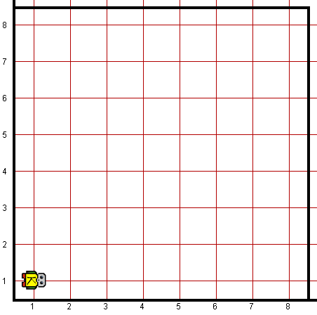 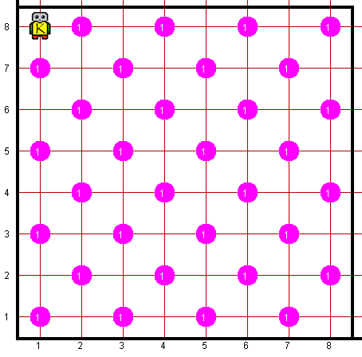

This problem has a nice decomposition structure along with some interesting algorithmic issues. As you think about how you will solve the problem, you should make sure that your solution works with chessboards that are different in size from the standard 8x8 chessboard shown in the example. Odd-sized chessboards are tricky, and you should make sure that your program generates the following pattern in a 5x3 world:

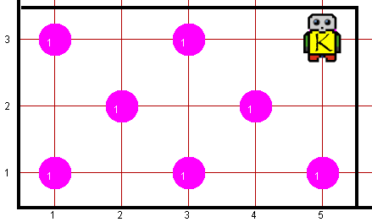

Another special case you need to consider is that of a world which is only one column wide or one row high. The world folder contains several worlds that test these special cases, and you should make sure that your program works for each of them. Robot may count on the following facts about the world:

* Robot starts at 1st Avenue and 1st Street, facing east, with an infinite number of beepers in its bag.
* The initial state of the world includes no interior walls or beepers.
* The world need not be square
* It does not matter which direction Robot is facing at the end of the run
* You are limited to the instructions in the Robot booklet—the only variables allowed are loop control variables used within the control section of the for loop.

**Worlds:**

In the Runner class, you can provide following worlds to test your program

1. chessboard1x10.kwld
2. chessboard3x3.kwld
3. chessboard5x3.kwld
4. chessboard7x7.kwld
5. chessboard8x8.kwld