**Problem Statement Maze**

We want to teach the Robot to escape from a maze. In Robot’s world, a maze might look like this:

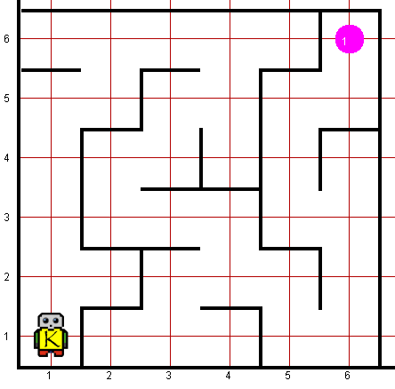

The exit to the maze is marked by a beeper, so that Robot’s job is to navigate the corridors of the maze until it finds the beeper indicating the exit. The program, however, must be general enough to solve any maze, and not just the one pictured here.

There are several strategies you could use for solving such a maze. It is important to note that the code that implements an algorithm may not be very complicated. Indeed, coming up with the right algorithm often leads to extremely simple code.

you may count on the following facts about the world:

* Robot starts at 1st Avenue and 1st Street, facing north, with an infinite number of beepers in its bag.
* The initial state of the world includes many interior walls and one single beeper.
* The world need not be square, but you may assume that it is at least as tall as it is wide.
* It does not matter which direction Robot is facing at the end of the run
* You are limited to the instructions in the Robot booklet—the only variables allowed are loop control variables used within the control section of the for loop.

**Worlds:**

In the Runner class, you can provide following worlds to test your program

1. maze7x7.kwld
2. maze10x10.kwld