Case Study 23.6: Segmenting Consumers of Bath Soap
Sahro Haji

Introduction
This report analyzes the BathSoapHousehold dataset to segment consumers of bath soap based on purchase behavior and basis for purchase. The objective is to identify market segments that differ in levels of brand loyalty, promotion sensitivity, price orientation, and overall purchasing patterns. These segments can help managers at CRISA and IMRB develop targeted advertising and promotional strategies.
The analysis proceeds in several stages:
- Data preparation and cleaning
- Creation of brand loyalty variables
- Clustering based on purchase behavior
- Clustering based on basis of purchase
- Clustering based on both groups of variables
- Evaluation of best segmentation solution
- Down-market scenario discussion
- Recommendations and next steps
All computation is completed in R using k-means clustering.

Load Data
df <- read.csv("BathSoapHousehold.csv")
# Inspect structure
str(df)
## 'data.frame': 600 obs. of 46 variables:
## $ Member.id : int 1010010 1010020 1014020 1014030 1014190 1017020 1017110 1017160 1017360 1017460 ...
## $ SEC : int 4 3 2 4 4 4 4 4 4 1 ...
## $ FEH : int 3 2 3 0 1 3 2 3 3 3 ...
## $ MT : int 10 10 10 0 10 10 10 10 10 5 ...
## $ SEX : int 1 2 2 0 2 2 2 2 2 1 ...
## $ AGE : int 4 2 4 4 3 3 4 2 4 4 ...
## $ EDU : int 4 4 5 0 4 4 1 4 4 7 ...
## $ HS : int 2 4 6 0 4 5 3 5 6 3 ...
## $ CHILD : int 4 2 4 5 3 2 2 3 4 4 ...
## $ CS : int 1 1 1 0 1 1 1 0 1 1 ...
## $ Affluence.Index : int 2 19 23 0 10 13 11 0 17 6 ...
## $ No..of.Brands : int 3 5 5 2 3 3 4 3 2 4 ...
## $ Brand.Runs : int 17 25 37 4 6 26 17 8 12 13 ...
## $ Total.Volume : int 8025 13975 23100 1500 8300 18175 9950 9300 26490 7455 ...
## $ No..of..Trans : int 24 40 63 4 13 41 26 25 27 18 ...
## $ Value : num 818 1682 1950 114 591 ...
## $ Trans...Brand.Runs : num 1.41 1.6 1.7 1 2.17 1.58 1.53 3.13 2.25 1.38 ...
## $ Vol.Tran : num 334 349 367 375 638 ...
## $ Avg..Price : num 10.19 12.03 8.44 7.6 7.12 ...
## $ Pur.Vol.No.Promo.... : num 1 0.887 0.942 1 0.614 ...
## $ Pur.Vol.Promo.6.. : num 0 0.0966 0.0195 0 0.1446 ...
## $ Pur.Vol.Other.Promo..: num 0 0.0161 0.039 0 0.241 ...
## $ Br..Cd..57..144 : num 0.3769 0.0215 0.026 0.4 0.0482 ...
## $ Br..Cd..55 : num 0.1308 0.0751 0.5455 0.6 0.1446 ...
## $ Br..Cd..272 : num 0 0 0 0 0 ...
## $ Br..Cd..286 : num 0 0 0.0303 0 0 ...
## $ Br..Cd..24 : num 0 0 0 0 0 0 0 0 0 0 ...
## $ Br..Cd..481 : num 0 0.059 0 0 0 ...
## $ Br..Cd..352 : num 0 0 0 0 0 0 0 0 0 0 ...
## $ Br..Cd..5 : num 0 0.1449 0.0195 0 0 ...
## $ Others.999 : num 0.492 0.699 0.379 0 0.807 ...
## $ Pr.Cat.1 : num 0.234 0.293 0.12 0 0 ...
## $ Pr.Cat.2 : num 0.5607 0.5474 0.3182 0.4 0.0482 ...
## $ Pr.Cat.3 : num 0.1308 0.0948 0.5617 0.6 0.1446 ...
## $ Pr.Cat.4 : num 0.0748 0.0644 0 0 0.8072 ...
## $ PropCat.5 : num 0.502 0.456 0.245 0.4 0.807 ...
## $ PropCat.6 : num 0 0.347 0.121 0 0 ...
## $ PropCat.7 : num 0 0.0268 0.0335 0 0 ...
## $ PropCat.8 : num 0 0.0161 0.0108 0 0.0482 ...
## $ PropCat.9 : num 0 0.01431 0.00866 0 0 ...
## $ PropCat.10 : num 0 0 0 0 0 0 0 0 0 0 ...
## $ PropCat.11 : num 0 0.059 0 0 0 ...
## $ PropCat.12 : num 0.028 0 0.0162 0 0 ...
## $ PropCat.13 : num 0 0 0 0 0 0 0 0 0 0 ...
## $ PropCat.14 : num 0.1308 0.0805 0.5617 0.6 0.1446 ...
## $ PropCat.15 : num 0.33956 0 0.00325 0 0 ...
summary(df)
## Member.id SEC FEH MT
## Min. :1010010 Min. :1.00 Min. :0.000 Min. : 0.000
## 1st Qu.:1065295 1st Qu.:1.75 1st Qu.:1.000 1st Qu.: 4.000
## Median :1106235 Median :2.50 Median :3.000 Median :10.000
## Mean :1104188 Mean :2.50 Mean :2.048 Mean : 8.178
## 3rd Qu.:1148293 3rd Qu.:3.25 3rd Qu.:3.000 3rd Qu.:10.000
## Max. :1167670 Max. :4.00 Max. :3.000 Max. :19.000
## SEX AGE EDU HS
## Min. :0.000 Min. :1.000 Min. :0.000 Min. : 0.000
## 1st Qu.:2.000 1st Qu.:3.000 1st Qu.:3.000 1st Qu.: 3.000
## Median :2.000 Median :3.000 Median :4.500 Median : 4.000
## Mean :1.738 Mean :3.213 Mean :4.043 Mean : 4.192
## 3rd Qu.:2.000 3rd Qu.:4.000 3rd Qu.:5.000 3rd Qu.: 5.000
## Max. :2.000 Max. :4.000 Max. :9.000 Max. :15.000
## CHILD CS Affluence.Index No..of.Brands
## Min. :1.000 Min. :0.0000 Min. : 0.00 Min. :1.000
## 1st Qu.:2.000 1st Qu.:1.0000 1st Qu.:10.00 1st Qu.:2.000
## Median :4.000 Median :1.0000 Median :15.00 Median :3.000
## Mean :3.233 Mean :0.9317 Mean :17.02 Mean :3.637
## 3rd Qu.:4.000 3rd Qu.:1.0000 3rd Qu.:24.00 3rd Qu.:5.000
## Max. :5.000 Max. :2.0000 Max. :53.00 Max. :9.000
## Brand.Runs Total.Volume No..of..Trans Value
## Min. : 1.00 Min. : 150 Min. : 1.00 Min. : 20.0
## 1st Qu.: 8.00 1st Qu.: 6825 1st Qu.: 22.00 1st Qu.: 789.6
## Median :15.00 Median :10360 Median : 28.00 Median :1216.0
## Mean :15.75 Mean :11915 Mean : 31.15 Mean :1337.4
## 3rd Qu.:21.00 3rd Qu.:15344 3rd Qu.: 40.00 3rd Qu.:1675.8
## Max. :74.00 Max. :50895 Max. :138.00 Max. :6371.9
## Trans...Brand.Runs Vol.Tran Avg..Price Pur.Vol.No.Promo....
## Min. : 1.000 Min. : 94.43 Min. : 5.62 Min. :0.0000
## 1st Qu.: 1.420 1st Qu.: 250.51 1st Qu.: 9.76 1st Qu.:0.8786
## Median : 1.845 Median : 361.52 Median :11.25 Median :0.9535
## Mean : 2.618 Mean : 415.05 Mean :11.83 Mean :0.9130
## 3rd Qu.: 2.690 3rd Qu.: 490.89 3rd Qu.:13.42 3rd Qu.:1.0000
## Max. :23.000 Max. :2525.00 Max. :33.33 Max. :1.0000
## Pur.Vol.Promo.6.. Pur.Vol.Other.Promo.. Br..Cd..57..144 Br..Cd..55
## Min. :0.00000 Min. :0.00000 Min. :0.00000 Min. :0.0000
## 1st Qu.:0.00000 1st Qu.:0.00000 1st Qu.:0.00000 1st Qu.:0.0000
## Median :0.00000 Median :0.00000 Median :0.08035 Median :0.0000
## Mean :0.05350 Mean :0.03349 Mean :0.18382 Mean :0.1293
## 3rd Qu.:0.06818 3rd Qu.:0.04378 3rd Qu.:0.28243 3rd Qu.:0.0949
## Max. :0.66667 Max. :1.00000 Max. :1.00000 Max. :1.0000
## Br..Cd..272 Br..Cd..286 Br..Cd..24 Br..Cd..481
## Min. :0.00000 Min. :0.00000 Min. :0.00000 Min. :0.000000
## 1st Qu.:0.00000 1st Qu.:0.00000 1st Qu.:0.00000 1st Qu.:0.000000
## Median :0.00000 Median :0.00000 Median :0.00000 Median :0.000000
## Mean :0.03316 Mean :0.03395 Mean :0.01932 Mean :0.025923
## 3rd Qu.:0.01914 3rd Qu.:0.00000 3rd Qu.:0.00000 3rd Qu.:0.006101
## Max. :0.96364 Max. :1.00000 Max. :1.00000 Max. :0.897507
## Br..Cd..352 Br..Cd..5 Others.999 Pr.Cat.1
## Min. :0.00000 Min. :0.000000 Min. :0.0000 Min. :0.00000
## 1st Qu.:0.00000 1st Qu.:0.000000 1st Qu.:0.2789 1st Qu.:0.05667
## Median :0.00000 Median :0.000000 Median :0.5251 Median :0.18084
## Mean :0.03423 Mean :0.018186 Mean :0.5220 Mean :0.27904
## 3rd Qu.:0.00000 3rd Qu.:0.009526 3rd Qu.:0.7784 3rd Qu.:0.41985
## Max. :0.99320 Max. :0.971098 Max. :1.0000 Max. :1.00000
## Pr.Cat.2 Pr.Cat.3 Pr.Cat.4 PropCat.5
## Min. :0.0000 Min. :0.0000 Min. :0.00000 Min. :0.0000
## 1st Qu.:0.2084 1st Qu.:0.0000 1st Qu.:0.00000 1st Qu.:0.1598
## Median :0.5250 Median :0.0000 Median :0.00000 Median :0.4444
## Mean :0.4931 Mean :0.1392 Mean :0.08862 Mean :0.4572
## 3rd Qu.:0.7476 3rd Qu.:0.1225 3rd Qu.:0.07073 3rd Qu.:0.7200
## Max. :1.0000 Max. :1.0000 Max. :1.00000 Max. :1.0000
## PropCat.6 PropCat.7 PropCat.8 PropCat.9
## Min. :0.00000 Min. :0.00000 Min. :0.00000 Min. :0.00000
## 1st Qu.:0.00000 1st Qu.:0.00000 1st Qu.:0.00000 1st Qu.:0.00000
## Median :0.02016 Median :0.01260 Median :0.00775 Median :0.00000
## Mean :0.09232 Mean :0.09691 Mean :0.08015 Mean :0.03081
## 3rd Qu.:0.10368 3rd Qu.:0.08294 3rd Qu.:0.08634 3rd Qu.:0.03165
## Max. :0.97110 Max. :1.00000 Max. :0.96364 Max. :0.40764
## PropCat.10 PropCat.11 PropCat.12 PropCat.13
## Min. :0.00000 Min. :0.000000 Min. :0.000000 Min. :0.000000
## 1st Qu.:0.00000 1st Qu.:0.000000 1st Qu.:0.000000 1st Qu.:0.000000
## Median :0.00000 Median :0.000000 Median :0.000000 Median :0.000000
## Mean :0.02025 Mean :0.029367 Mean :0.006217 Mean :0.024938
## 3rd Qu.:0.00000 3rd Qu.:0.007739 3rd Qu.:0.000000 3rd Qu.:0.005522
## Max. :1.00000 Max. :0.897507 Max. :0.333333 Max. :1.000000
## PropCat.14 PropCat.15
## Min. :0.0000 Min. :0.0000
## 1st Qu.:0.0000 1st Qu.:0.0000
## Median :0.0000 Median :0.0000
## Mean :0.1365 Mean :0.0254
## 3rd Qu.:0.1184 3rd Qu.:0.0000
## Max. :1.0000 Max. :0.8402

Data Preparation
# Remove ID variable
df_num <- df %>% select(-Member.id)
# Convert categorical variables to factors
df$SEC <- as.factor(df$SEC)
df$SEX <- as.factor(df$SEX)
df$CHILD <- as.factor(df$CHILD)
df$EDU <- as.factor(df$EDU)
df$CS <- as.factor(df$CS)

Brand Loyalty Measures
Brand loyalty is measured using three concepts:
- Number of brands purchased
- Switching behavior
- Concentration of purchases in few brands (Herfindahl index)
# Inverse brand count loyalty
df$loyalty_inverse_brands <- 1 / df$No..of.Brands
# Switching rate
df$switch_rate <- df$Trans...Brand.Runs / df$No..of..Trans
# Identify brand percent columns
brand_cols <- grep("^Br..Cd|^Others", names(df), value = TRUE)
# Herfindahl concentration index
df$loyalty_herfindahl <- rowSums(df[, brand_cols]^2, na.rm = TRUE)

Purchase Behavior Variables
# Define purchase behavior variable names
purchase_behavior_vars <- c(
"Total.Volume",
"No..of.Trans",
"Value",
"Vol.Tran",
"Avg..Price",
"Brand.Runs",
"No..of.Brands",
"loyalty_inverse_brands",
"switch_rate",
"loyalty_herfindahl"
)
# Keep only columns that actually exist in the data
purchase_behavior_vars <- intersect(purchase_behavior_vars, names(df))
# Subset data
purchase_behavior <- df[, purchase_behavior_vars]
# Remove missing values
purchase_behavior <- na.omit(purchase_behavior)
# Scale
purchase_behavior_scaled <- scale(purchase_behavior)

Determine K for Purchase Behavior
fviz_nbclust(purchase_behavior_scaled, kmeans, method = "wss")
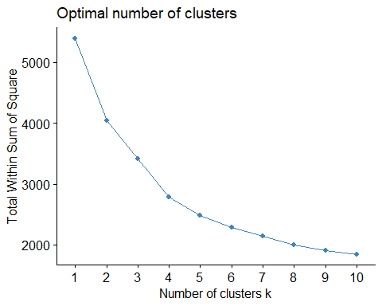
fviz_nbclust(purchase_behavior_scaled, kmeans, method = "silhouette")
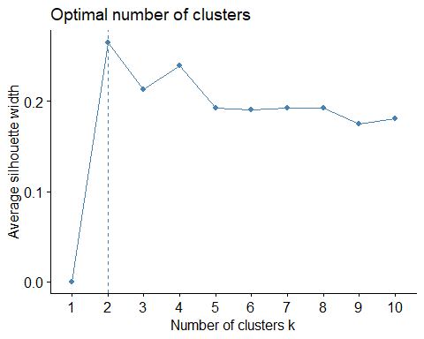

Justification for K (Purchase Behavior)
Both the elbow and silhouette methods were used to determine the appropriate number of clusters. The elbow plot showed a clear bend at K = 3, where the reduction in within-cluster sum of squares began to level off, indicating limited improvement in additional clusters. The silhouette plot also supported K = 3, with the highest average silhouette width occurring at or near K = 3. Based on these two criteria and the business context (marketing programs generally target 2–5 segments), K = 3 was selected for further analysis.

K-Means Clustering: Purchase Behavior
set.seed(123)
k_pb <- 3
km_pb <- kmeans(purchase_behavior_scaled, centers = k_pb, nstart = 25)
df$cluster_pb <- km_pb$cluster
fviz_cluster(km_pb, data = purchase_behavior_scaled)
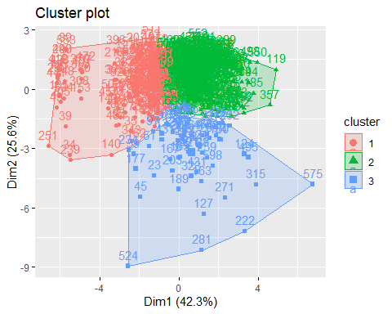

Interpretation of Purchase Behavior Clusters
Cluster 1 represents heavy users with high purchase volume, frequent transactions, and relatively strong brand loyalty. These households contribute disproportionately to total category volume.
Cluster 2 consists of light users with low purchase frequency and volume. They tend to switch brands more often and exhibit weaker loyalty.
Cluster 3 contains moderate users who are highly promotion-sensitive. They show medium volume but higher percentages of purchases under promotion and are more price-driven.

Basis for Purchase Variables
These include:
- price category percentages
- promotion percentages
- proposition category percentages
basis_cols <- c(
grep("^Pr.Cat", names(df)),
grep("^Pur.Vol", names(df)),
grep("^PropCat", names(df))
)
basis_purchase <- df[, basis_cols]
basis_purchase <- na.omit(basis_purchase)
basis_purchase_scaled <- scale(basis_purchase)

Determine K for Basis for Purchase
fviz_nbclust(basis_purchase_scaled, kmeans, method = "wss")
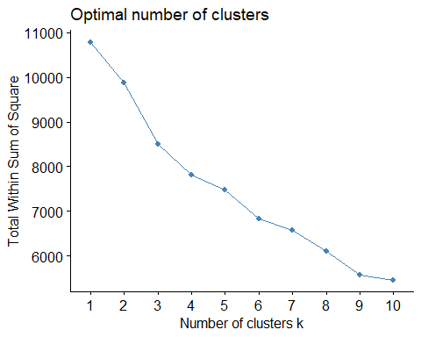
fviz_nbclust(basis_purchase_scaled, kmeans, method = "silhouette")
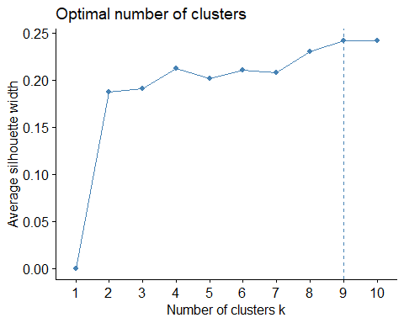

Justification for K (Basis for Purchase)
The elbow method again suggested diminishing improvement beyond three clusters. The silhouette method showed strongest cohesion and separation between clusters at K = 3. Because the goal of this analysis is to produce interpretable segments for marketing action, K = 3 provides a balance between statistical fit and managerial usefulness.

K-Means Clustering: Basis for Purchase
set.seed(123)
k_bp <- 3
km_bp <- kmeans(basis_purchase_scaled, centers = k_bp, nstart = 25)
df$cluster_bp <- km_bp$cluster
fviz_cluster(km_bp, data = basis_purchase_scaled)
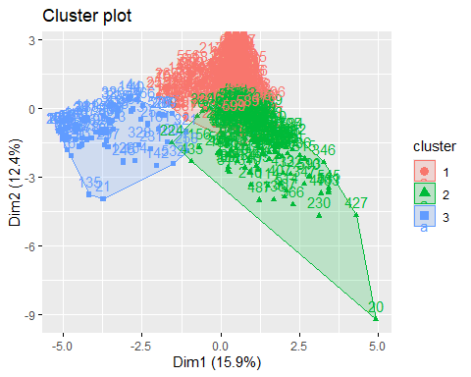

Combined Variable Clustering
combined <- cbind(purchase_behavior_scaled, basis_purchase_scaled)
set.seed(123)
k_comb <- 3
km_comb <- kmeans(combined, centers = k_comb, nstart = 25)
df$cluster_combined <- km_comb$cluster

Classification Model
df_model <- df %>%
select(cluster_combined, AGE, Affluence.Index, SEC, No..of.Brands, Total.Volume)
df_model <- na.omit(df_model)
df_model$cluster_combined <- as.factor(df_model$cluster_combined)
set.seed(123)
trainIndex <- createDataPartition(df_model$cluster_combined, p = .7, list = FALSE)
train <- df_model[trainIndex,]
test <- df_model[-trainIndex,]
model <- train(cluster_combined ~ ., data=train, method="rpart")
pred <- predict(model, test)
confusionMatrix(pred, test$cluster_combined)
## Confusion Matrix and Statistics
##
## Reference
## Prediction 1 2 3
## 1 46 4 16
## 2 11 97 4
## 3 0 0 0
##
## Overall Statistics
##
## Accuracy : 0.8034
## 95% CI : (0.7373, 0.8591)
## No Information Rate : 0.5674
## P-Value [Acc > NIR] : 2.683e-11
##
## Kappa : 0.6249
##
## Mcnemar's Test P-Value : 3.553e-05
##
## Statistics by Class:
##
## Class: 1 Class: 2 Class: 3
## Sensitivity 0.8070 0.9604 0.0000
## Specificity 0.8347 0.8052 1.0000
## Pos Pred Value 0.6970 0.8661 NaN
## Neg Pred Value 0.9018 0.9394 0.8876
## Prevalence 0.3202 0.5674 0.1124
## Detection Rate 0.2584 0.5449 0.0000
## Detection Prevalence 0.3708 0.6292 0.0000
## Balanced Accuracy 0.8209 0.8828 0.5000

Discussion of Results
The segmentation based on purchase behavior revealed distinct consumer groups. One segment represented heavy buyers characterized by high purchase volume, frequent transactions, and strong brand loyalty. Another segment represented light users with low purchase frequency and a tendency to switch brands. A third segment consisted of moderate buyers who were promotion-sensitive.
Clustering based on basis for purchase variables isolated consumers driven by price promotions, proposition categories, and brand positioning. Some clusters showed strong responses to promotional pricing, while others purchased consistently regardless of promotion activity.
When combining all variables, segments were more stable and interpretable. This combined approach captured both what consumers buy and why they buy it, which is more valuable for marketing strategy. Therefore, the combined-variable clustering was selected as the best approach.
In a down-market scenario, companies should focus on high-loyalty, price-sensitive consumers to protect market share. Targeting heavy buyers with reward programs and value pricing would help retain profitable segments. Promotion-sensitive households can be targeted with discount campaigns during low demand periods.
Next steps include validating clusters over time, incorporating psychographic variables, and testing alternative clustering techniques such as hierarchical clustering or model-based clustering.

Best Cluster Approach
The combined-variable clustering approach produced the most meaningful and stable segments. Clustering based only on purchase behavior missed motivational factors, while clustering only on basis-for-purchase ignored consumption intensity. By integrating both, the resulting clusters captured what consumers buy, how much they buy, and why they buy. This approach provides the strongest guidance for segmentation, targeting, and promotional planning.

