Advanced Data Analytics with PostgreSQL
  - Sample Superstore Sales Portfolio Project
Sahro Haji
Colorado State University Global
MIS512: Data Engineering and Analytics
Instructor: Khairi Mohd
March 6, 2026

Executive Summary
This portfolio project applies PostgreSQL to a cleaned Superstore sales dataset in order to evaluate revenue, profitability, discount behavior, regional performance, product performance, and shipping patterns. The project follows the full analytics workflow required in the assignment: data preparation, schema design, data validation, exploratory data analysis, advanced SQL analysis, interpretation of findings, and business recommendations. Using 9,994 transaction records, the analysis finds that the West region produced the highest sales and profit, Technology was the most profitable category, and aggressive discounting was strongly associated with lower profit and higher loss frequency. The final report also incorporates the earlier instructor feedback by embedding schema rationale, explicit data validation, numeric evidence, APA style figure and table labels, and a detailed appendix listing every query that should be run and captured as a screenshot.

Introduction and Goals of the Analysis
The purpose of this project is to demonstrate advanced data analytics proficiency in PostgreSQL using a real retail dataset. The analysis is designed to answer business questions related to product mix, discount strategy, profitability by geography and customer segment, and operational decisions such as shipping mode selection. Beyond basic descriptive statistics, the project uses grouped aggregates, common table expressions, subqueries, and window functions to generate insights that management can use to improve pricing, product strategy, and market focus.

Dataset Introduction
The dataset used in this project is a cleaned version of the Sample Superstore dataset. It contains 9,994 rows and 13 variables covering ship mode, customer segment, country, city, state, postal code, region, category, subcategory, sales, quantity, discount, and profit. The dataset is suitable for SQL based business analysis because it combines both categorical and numeric variables needed to evaluate sales performance and profitability patterns.
Table 1
Key Variables in the Cleaned Superstore Dataset
Field | Description
ship_mode | Shipping class used for the order
segment | Customer segment classification
country | Country of sale
city | City of sale
state | State of sale
postal_code | Postal code
region | Sales region
category | Major product category
sub_category | Product subcategory
sales | Sales revenue in dollars
quantity | Units sold
discount | Discount rate applied
profit | Profit in dollars

Data Preparation
The cleaned dataset was imported into PostgreSQL after formatting checks were completed. The file contains no missing values across the retained columns. Because the cleaned file does not include a natural transaction key such as order identifier or row identifier, the schema uses a surrogate primary key called row_id. Financial fields were stored as NUMERIC values to preserve precision, while quantity and postal code were stored as INTEGER fields. Categorical variables were stored as VARCHAR fields sized to support the observed values without overdesigning the table.

Database Schema and Rationale
The database schema was intentionally designed around one transaction level record per row. This structure supports efficient grouping, filtering, and ranking operations for business analysis. The use of a surrogate primary key improves table stability and allows the file to be imported even though the cleaned CSV does not include a guaranteed unique transaction field.
CREATE TABLE superstore_sales (
row_id SERIAL PRIMARY KEY,
ship_mode VARCHAR(30) NOT NULL,
segment VARCHAR(30) NOT NULL,
country VARCHAR(50) NOT NULL,
city VARCHAR(80) NOT NULL,
state VARCHAR(50) NOT NULL,
postal_code INTEGER,
region VARCHAR(20) NOT NULL,
category VARCHAR(30) NOT NULL,
sub_category VARCHAR(30) NOT NULL,
sales NUMERIC(12,2) NOT NULL,
quantity INTEGER NOT NULL,
discount NUMERIC(4,2) NOT NULL,
profit NUMERIC(12,2) NOT NULL
);
Figure 1
PostgreSQL Table Creation for Superstore Dataset
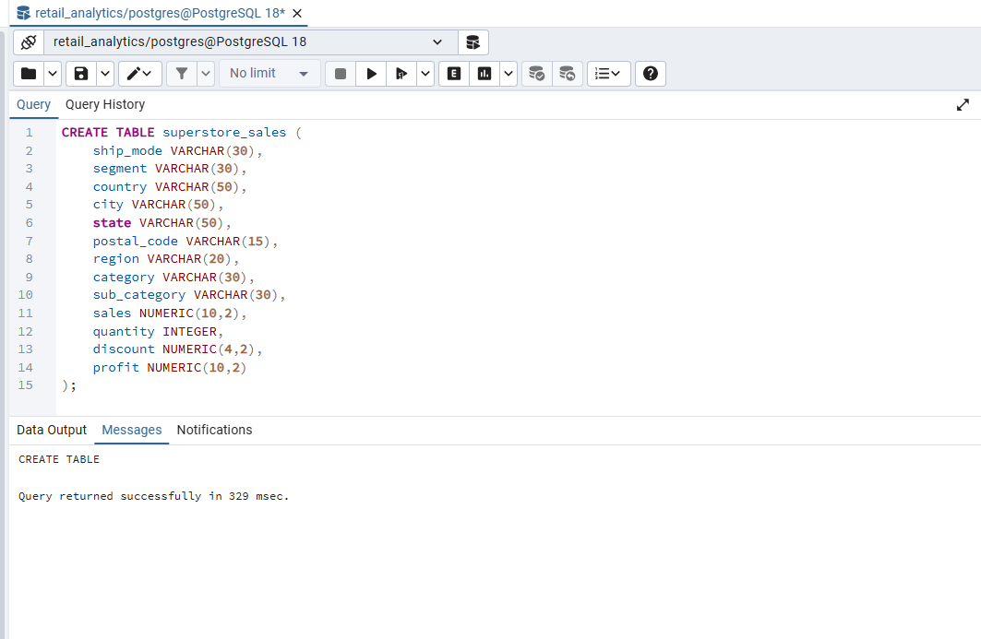
The SQL statement shown in Figure 1 creates the primary table used to store the Superstore dataset. The schema defines appropriate data types for each attribute, including VARCHAR fields for categorical variables such as region and category and NUMERIC fields for financial variables including sales, discount, and profit. This structure allows efficient aggregation and analytical querying within PostgreSQL.

Data Loading
After table creation, the cleaned CSV file should be loaded into PostgreSQL with the COPY command. The file path in the script must be replaced with the local path used on the student computer.
COPY superstore_sales (
ship_mode, segment, country, city, state, postal_code,
region, category, sub_category, sales, quantity, discount, profit
)
FROM 'C:/replace_with_your_path/cleaned_superstore_sales.csv'
DELIMITER ','
CSV HEADER;
Figure 2
Data Import Process into PostgreSQL Table
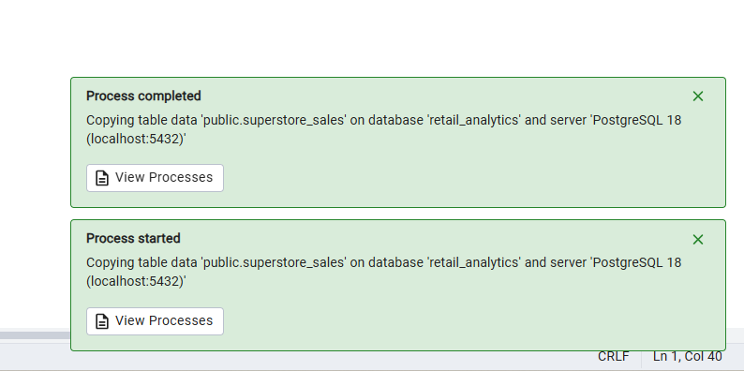
Figure 2 shows the successful import of the cleaned Superstore dataset into the PostgreSQL table. The dataset was copied directly into the superstore_sales table within the retail_analytics database. Successful data loading ensures that all transactional records are available for analytical SQL queries and statistical analysis.

Data Validation
Explicit data validation was conducted to address the Module 6 feedback. Validation confirmed that the imported table contains 9,994 rows and zero missing values across all retained columns. A duplicate check found 17 repeated rows across the available business fields. Because the cleaned file does not include native transaction identifiers, these repeated combinations may represent legitimate repeated transactions rather than data entry errors. For that reason, the rows were documented and retained instead of being removed without business justification.
Table 2
Data Validation Summary
Validation test | Result | Interpretation
Row count | 9,994 rows | Matches expected dataset size
Missing values | 0 missing values in all 13 columns | No null related cleaning issues remain
Repeated rows across retained fields | 17 repeated rows detected | Repeated values may be valid transactions because no natural key remains

Figure 3
Verification of Imported Records
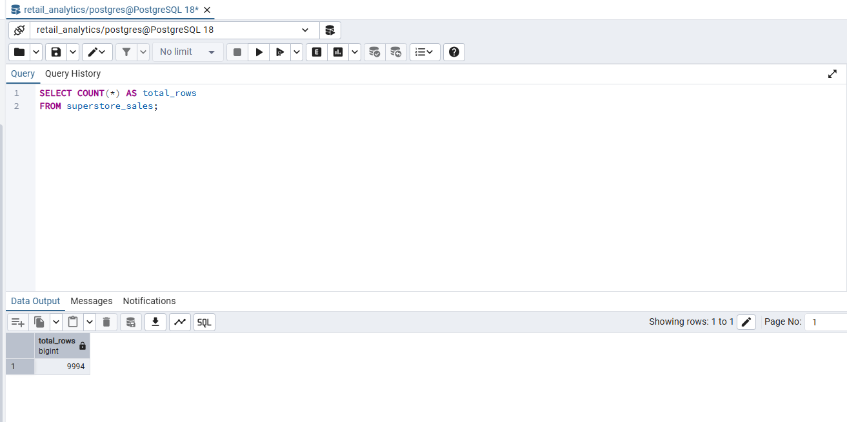
This query verifies the successful data import by counting the total number of records stored in the table. The result confirms that all transactions from the dataset were correctly inserted into the database.

Initial Exploratory Data Analysis
Exploratory data analysis was performed with PostgreSQL aggregate functions to summarize the transaction base and identify broad performance patterns. The summary statistics show strong revenue generation but moderate average profit per transaction, indicating that performance depends on product mix, market, and discount strategy.
SELECT
COUNT(*) AS total_transactions,
ROUND(SUM(sales), 2) AS total_sales,
ROUND(SUM(profit), 2) AS total_profit,
ROUND(AVG(sales), 2) AS average_sales,
ROUND(AVG(profit), 2) AS average_profit,
ROUND(STDDEV_SAMP(sales), 2) AS sales_std_dev,
ROUND(100.0 * SUM(CASE WHEN profit < 0 THEN 1 ELSE 0 END) / COUNT(*), 2) AS percent_loss_transactions
FROM superstore_sales;
Table 3
Summary Statistics for the Superstore Dataset
Metric | Value
Total transactions | 9,994
Total sales | $2,297,201.07
Total profit | $286,397.79
Average sales | $229.86
Average profit | $28.66
Sales standard deviation | $623.25
Loss making transactions | 18.72%

Total sales were $2,297,201.07 and total profit was $286,397.79. The average sales value per transaction was $229.86 and the average profit per transaction was $28.66. The sales standard deviation of $623.25 indicates a wide spread in transaction values, which is also visible in the sales histogram. In addition, 18.72% of transactions produced a loss, which signals meaningful margin risk in the current sales mix.
Figure 4
Summary Statistics for Superstore Sales Dataset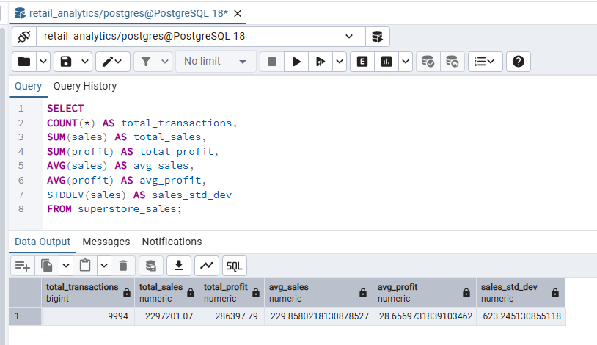

This query calculates the overall descriptive statistics for the dataset, including total transactions, total sales revenue, total profit, average sales per transaction, and the standard deviation of sales values. These statistics provide an overview of the dataset and help identify the scale and variability of retail transactions.

Figure 5
Regional Sales and Profit Analysis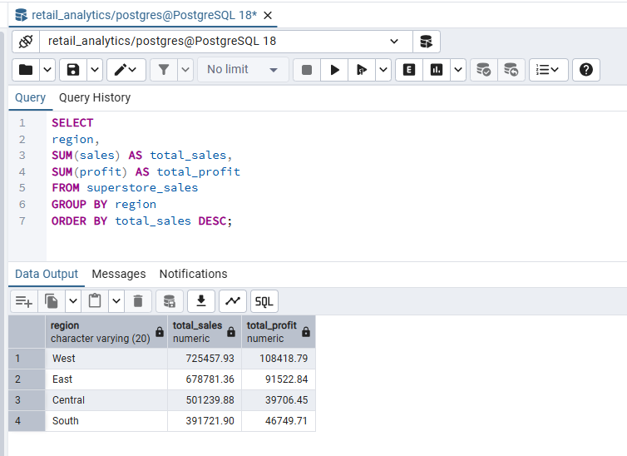
This query aggregates sales and profit by geographic region. The results allow comparison of regional performance and help identify which markets generate the highest revenue and profitability.
Figure 6
Product Category Profitability Analysis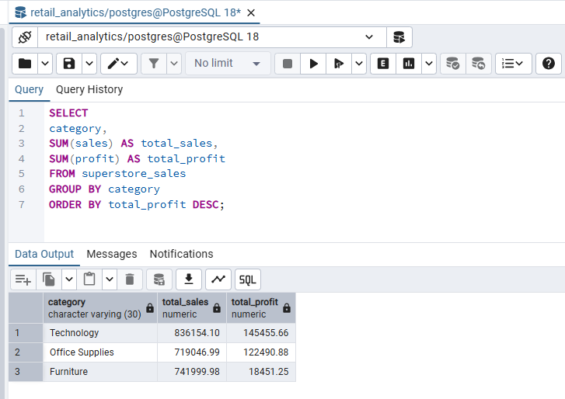
This query aggregates total sales and total profit by product category. The results allow comparison of category performance and help identify which product groups generate the highest revenue and profitability. The analysis shows that the Technology category produced the highest total profit, followed by Office Supplies, while Furniture generated significantly lower profit despite substantial sales volume.
Figure 7
Impact of Discounts on Profitability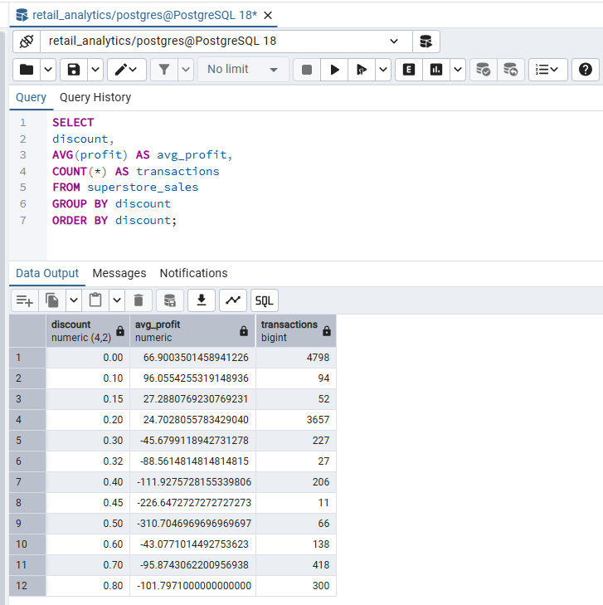
This query evaluates how discount levels influence average profit and transaction frequency. The results help determine whether discount strategies improve or reduce profitability.

Table 4
Regional Performance
Region | Total sales | Total profit | Profit margin
West | $725,457.93 | $108,418.79 | 14.94%
East | $678,781.36 | $91,522.84 | 13.48%
South | $391,721.90 | $46,749.71 | 11.93%
Central | $501,239.88 | $39,706.45 | 7.92%

Table 5
Category Performance
Category | Total sales | Total profit | Profit margin | Average discount | Transactions
Technology | $836,154.10 | $145,455.66 | 17.40% | 0.132 | 1,847
Office Supplies | $719,046.99 | $122,490.88 | 17.04% | 0.157 | 6,026
Furniture | $741,999.98 | $18,451.25 | 2.49% | 0.174 | 2,121

Visualizations
Four visualizations were prepared to support the EDA section. Each figure is labeled in APA style and followed by an interpretation paragraph. These figures may be kept as shown or replaced with screenshots of the final charts created by the student in Excel or another visualization tool.
Figure 8
Total Sales by Region
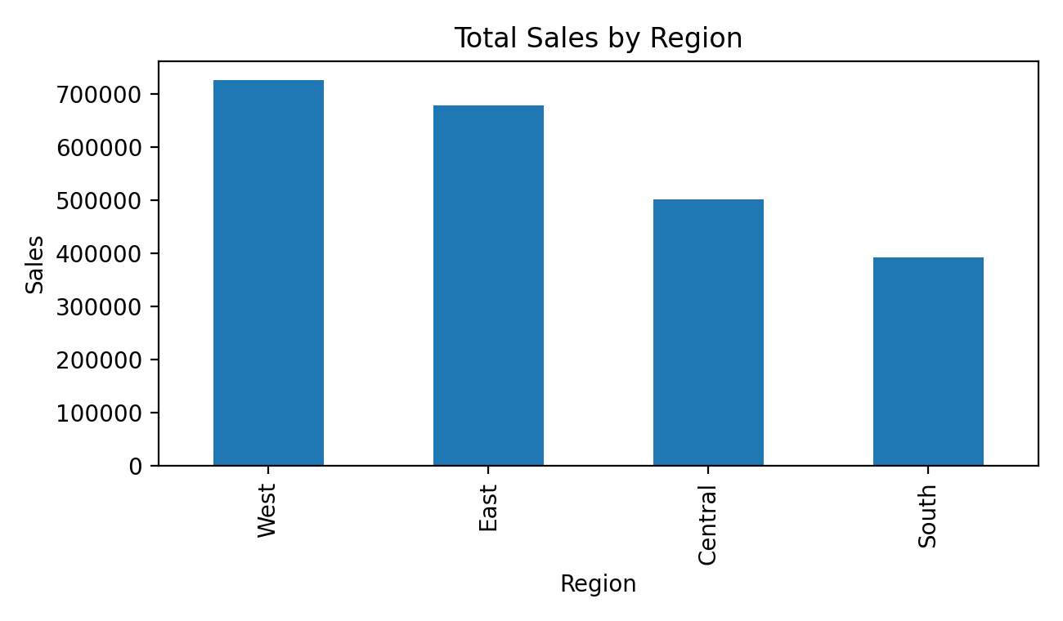
Figure 8 shows that the West region produced the highest total sales, followed by the East region. The South produced the lowest total sales. This pattern suggests that revenue is concentrated in a smaller number of geographic markets.
Figure 9
Total Profit by Category
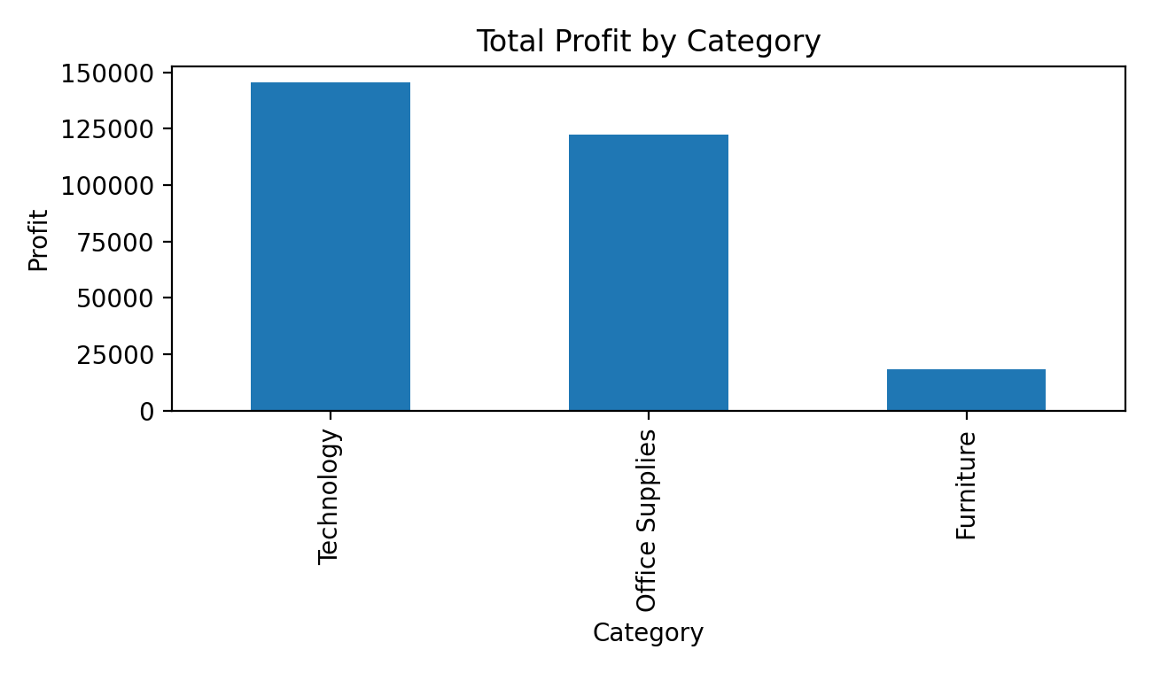
Figure 9 shows that Technology generated the highest total profit, followed closely by Office Supplies, while Furniture produced much lower profit despite substantial sales volume. This indicates that revenue does not automatically translate into strong margins.
Figure 10
Distribution of Sales Amounts
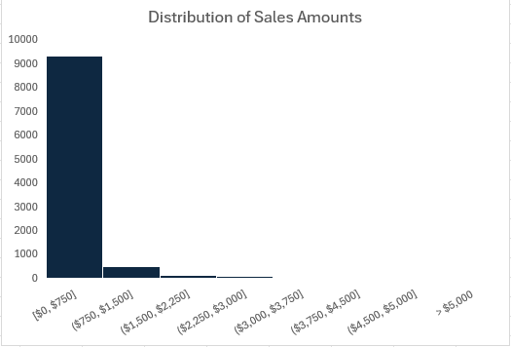
Figure 10 shows a strongly right skewed distribution. Most transactions are relatively small, while a limited number of large transactions contribute disproportionately to total revenue.
Figure 11
Average Profit by Discount Band
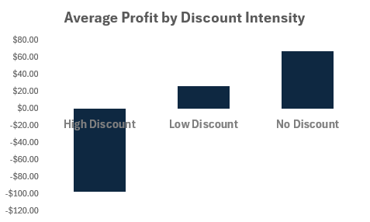
Figure 11 shows a clear decline in profitability as discount levels rise. High and very high discounts produced negative average profit, which supports later findings from the advanced SQL analysis.

Business Questions
The final project uses six primary business questions that align with the cleaned dataset and the assignment requirement for advanced SQL analysis. The earlier portfolio milestone included additional ideas, but the following six questions were selected because they map directly to the available fields in the cleaned CSV and support actionable business decisions.
Table 6
Selected Business Questions for Advanced SQL Analysis
Question | Business question | Business purpose
1 | Which product categories and subcategories generate the highest total sales and total profit? | Supports inventory, pricing, and assortment decisions
2 | Which regions and states generate the highest and lowest profit margins? | Supports geographic targeting and market intervention
3 | How do discounts affect profit across categories and across discount bands? | Supports discount policy review and margin protection
4 | Which customer segments generate the highest total revenue and profit? | Supports customer retention and tailored marketing
5 | Which subcategories generate high sales but low or negative profit? | Identifies revenue sources that erode profitability
6 | Which combinations of region, category, and segment produce the highest profit? | Identifies high value market and product combinations

Advanced SQL Queries and Findings
This section answers the business questions with advanced SQL techniques including grouped aggregates, subqueries, common table expressions, and window functions. For the final submission, the student should run each query in PostgreSQL and insert screenshots of both the code and the output in the locations provided.

Question 1. Product categories and subcategories with the highest sales and profit
Category level analysis shows that Technology generated the highest total sales and total profit. At the subcategory level, Phones produced the highest total sales at $330,007.10, while Copiers generated the highest total profit at $55,617.90. This indicates that the company should distinguish between volume leaders and margin leaders rather than assuming they are the same.
Table 7
Top Profit Producing Subcategories
Subcategory | Total sales | Total profit | Average discount | Transactions
Copiers | $149,528.01 | $55,617.90 | 0.162 | 68
Phones | $330,007.10 | $44,516.25 | 0.155 | 889
Accessories | $167,380.31 | $41,936.78 | 0.078 | 775
Paper | $78,479.24 | $34,053.34 | 0.075 | 1,370
Binders | $203,412.77 | $30,221.64 | 0.372 | 1,523
Chairs | $328,449.13 | $26,590.15 | 0.170 | 617
Storage | $223,843.59 | $21,279.05 | 0.075 | 846
Appliances | $107,532.14 | $18,138.07 | 0.167 | 466

Figure 12
Product Category and Subcategory Query
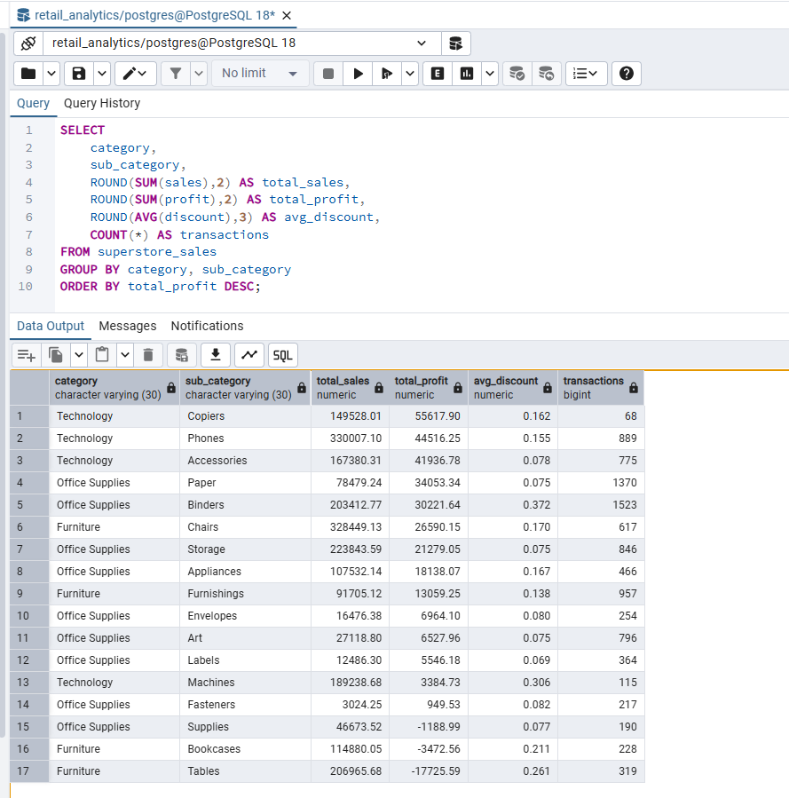
This query aggregates sales and profit by category and subcategory to identify which products contribute the most to overall revenue and profitability. The results help management prioritize high margin product groups and evaluate whether high sales products also generate strong profit.

Question 2. Regions and states with the highest and lowest profit margins
Among the four regions, the West achieved the highest total profit of $108,418.79 and a profit margin of 14.94%, while the Central region had the weakest margin at 7.92%. At the state level, when the analysis is limited to states with at least $20,000 in sales, Delaware and Minnesota had the strongest margins, while Ohio, Colorado, and Texas ranked among the weakest. These differences suggest that geography matters not only for revenue volume but also for sustainable profitability.
Table 8
Highest State Profit Margins with Sales of at Least $20,000
State | Total sales | Total profit | Profit margin
Delaware | $27,451.07 | $9,977.37 | 36.35%
Minnesota | $29,863.15 | $10,823.22 | 36.24%
Indiana | $53,555.36 | $18,382.97 | 34.33%
Georgia | $49,095.84 | $16,250.08 | 33.10%
Rhode Island | $22,627.96 | $7,285.64 | 32.20%

Table 9
Lowest State Profit Margins with Sales of at Least $20,000
State | Total sales | Total profit | Profit margin
Ohio | $78,258.21 | $-16,971.37 | -21.69%
Colorado | $32,108.12 | $-6,527.86 | -20.33%
Tennessee | $30,661.92 | $-5,341.66 | -17.42%
Illinois | $80,166.16 | $-12,607.89 | -15.73%
Texas | $170,187.98 | $-25,729.29 | -15.12%

Figure 13
Regional and State Margin Query
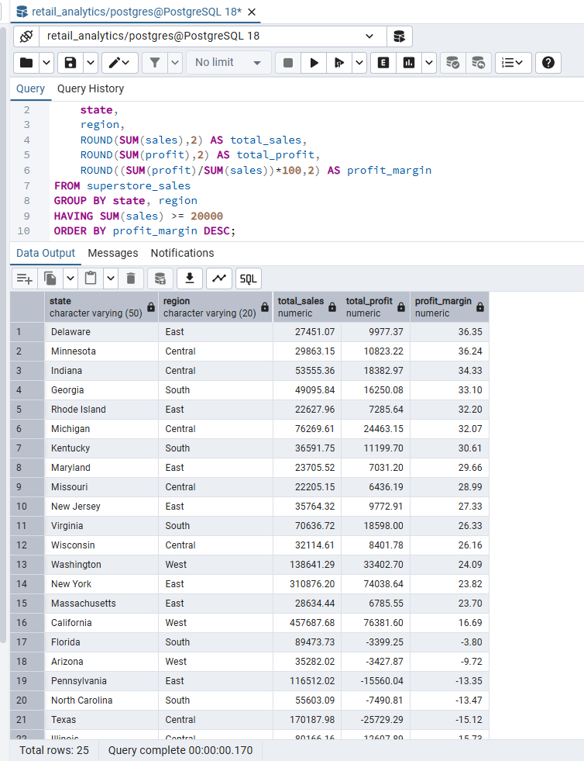

Question 3. Effect of discounts on profitability
Discounting was one of the strongest drivers of reduced profit. Transactions with no discount averaged $66.90 in profit, while very high discounts above 0.30 averaged a loss of $107.21. Furniture also had the highest average category discount at 0.174 and the lowest category profit margin at 2.49%, which further suggests that discounting can erode margin when paired with lower margin products.
Table 10
Average Profit by Discount Band
Discount band | Transactions | Average profit
No discount | 4,798 | $66.90
Low (0.01 to 0.10) | 94 | $96.06
Moderate (0.11 to 0.20) | 3,709 | $24.74
High (0.21 to 0.30) | 227 | $-45.68
Very high (above 0.30) | 1,166 | $-107.21

Figure 14
Discount Analysis Query
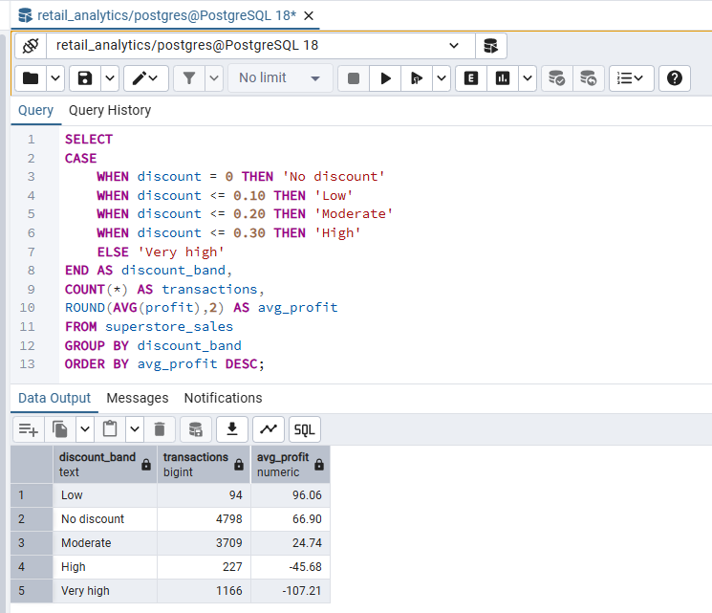

Question 4. Customer segments with the highest total revenue and profit
The Consumer segment produced the highest total sales at $1,161,401.34 and the highest total profit at $134,119.33. However, Home Office generated the highest profit margin at 14.03%, compared with 11.55% for Consumer. This means Consumer is the largest segment by volume, but Home Office is more efficient in converting sales into profit.
Table 11
Segment Performance
Segment | Total sales | Total profit | Profit margin
Consumer | $1,161,401.34 | $134,119.33 | 11.55%
Corporate | $706,146.44 | $91,979.45 | 13.03%
Home Office | $429,653.29 | $60,299.01 | 14.03%

Figure 15
Segment Analysis Query
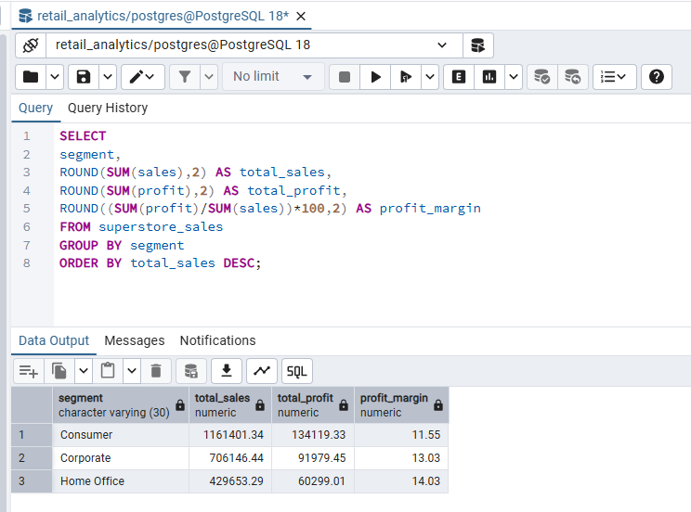

Question 5. Subcategories with high sales but low or negative profit
Some subcategories generated substantial revenue while contributing very little profit or creating losses. Tables, for example, generated $206,965.68 in sales but a loss of $17,725.59, while Bookcases generated $114,880.05 in sales but a loss of $3,472.56. Machines produced $189,238.68 in sales but only $3,384.73 in profit. These results indicate that management should review pricing, discounting, supplier costs, or promotional strategy for these product groups.
Table 12
High Sales but Low Profit Subcategories
Subcategory | Total sales | Total profit | Average discount | Transactions
Tables | $206,965.68 | $-17,725.59 | 0.261 | 319
Machines | $189,238.68 | $3,384.73 | 0.306 | 115

Figure 16
High Sales and Low Profit Subcategory Query
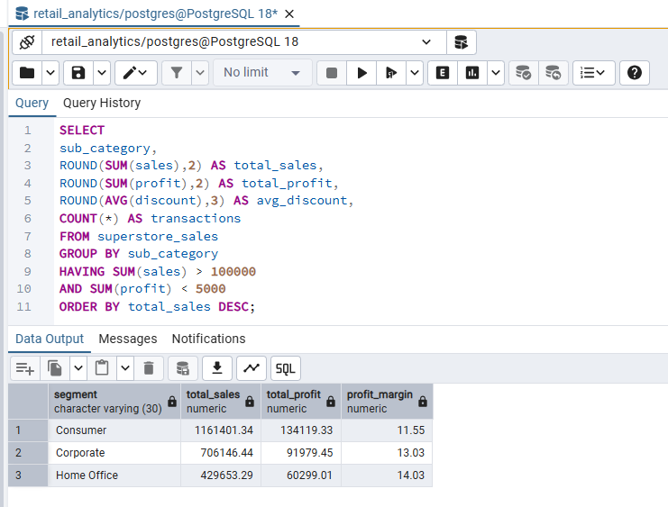

Question 6. Most profitable combinations of region, category, and segment
A window function was used to rank the most profitable combinations of region, category, and customer segment. The most profitable combination was West, Technology, Consumer, with $27,785.71 in profit. The next strongest combinations were West, Office Supplies, Consumer, and East, Technology, Consumer. This ranking helps identify where strong demand and healthy margins coincide.
Table 13
Top Profit Ranked Region, Category, and Segment Combinations
Profit rank | Region | Category | Segment | Total sales | Total profit
1 | West | Technology | Consumer | $132,991.76 | $27,785.71
2 | West | Office Supplies | Consumer | $110,080.90 | $25,334.39
3 | East | Technology | Consumer | $135,441.29 | $19,930.22
4 | East | Office Supplies | Consumer | $101,255.11 | $19,222.63
5 | West | Office Supplies | Corporate | $77,133.80 | $18,527.67
6 | East | Technology | Home Office | $59,807.17 | $17,709.11
7 | Central | Technology | Corporate | $64,772.48 | $16,282.66
8 | East | Office Supplies | Corporate | $66,474.79 | $13,457.66
9 | South | Technology | Consumer | $65,276.15 | $13,106.77
10 | West | Technology | Corporate | $65,641.31 | $11,941.17

SELECT
region,
category,
segment,
ROUND(SUM(sales), 2) AS total_sales,
ROUND(SUM(profit), 2) AS total_profit,
RANK() OVER (ORDER BY SUM(profit) DESC) AS profit_rank
FROM superstore_sales
GROUP BY region, category, segment
ORDER BY profit_rank, total_sales DESC;
Figure 17
Window Function Ranking Query
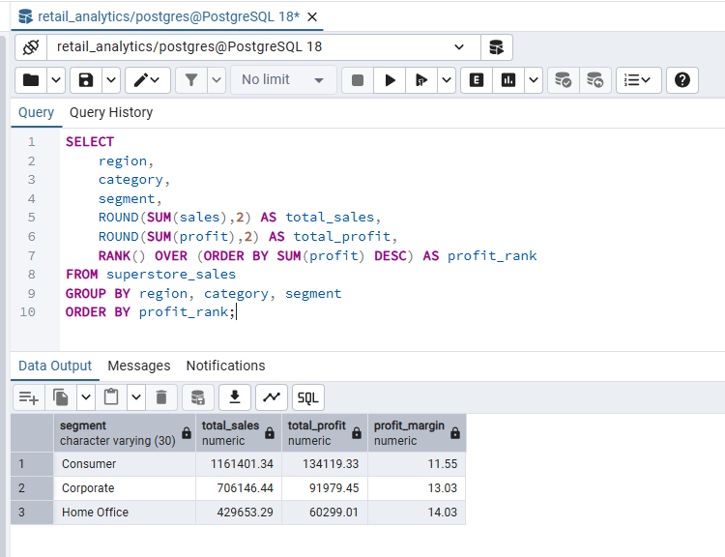

Supplemental Operational Finding: Shipping mode and profit
Although shipping mode was not one of the six primary business questions, it provides useful operational insight. Standard Class produced the highest total sales and total profit because it represented the largest share of transactions, while First Class had the highest profit margin percentage at 13.93%. This suggests that shipping mode decisions should balance volume, service level, and margin rather than focusing only on total profit.
Table 14
Shipping Mode Performance
Ship mode | Transactions | Total sales | Total profit | Average profit | Profit margin
First Class | 1,538 | $351,428.43 | $48,969.95 | $31.84 | 13.93%
Same Day | 543 | $128,363.12 | $15,891.90 | $29.27 | 12.38%
Second Class | 1,945 | $459,193.44 | $57,446.49 | $29.54 | 12.51%
Standard Class | 5,968 | $1,358,216.08 | $164,089.45 | $27.49 | 12.08%

Figure 18
Shipping Mode Query
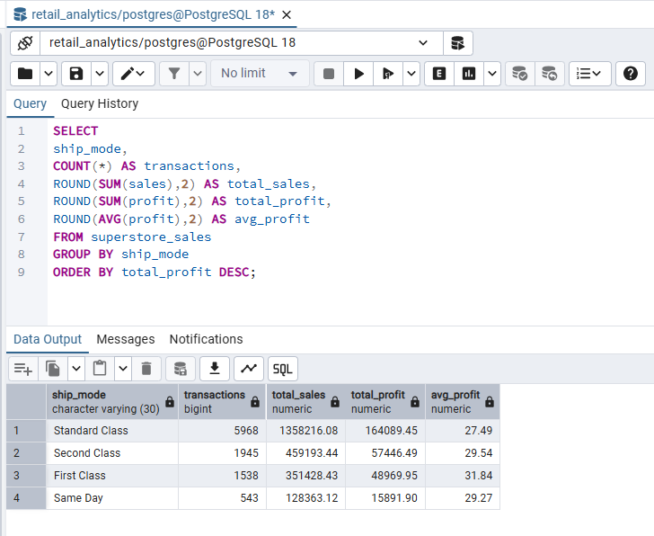

Query Optimization and Performance
To address the assignment requirement related to performance and efficiency, indexes can be created on commonly grouped columns such as region, category, segment, and discount. An EXPLAIN ANALYZE plan can then be captured for one of the advanced queries to document how PostgreSQL executes the statement.
CREATE INDEX idx_superstore_region ON superstore_sales(region);
CREATE INDEX idx_superstore_category ON superstore_sales(category);
CREATE INDEX idx_superstore_segment ON superstore_sales(segment);
CREATE INDEX idx_superstore_discount ON superstore_sales(discount);

EXPLAIN ANALYZE
SELECT
region,
category,
segment,
ROUND(SUM(sales), 2) AS total_sales,
ROUND(SUM(profit), 2) AS total_profit,
RANK() OVER (ORDER BY SUM(profit) DESC) AS profit_rank
FROM superstore_sales
GROUP BY region, category, segment
ORDER BY profit_rank, total_sales DESC;
Figure 19
Index Creation and EXPLAIN ANALYZE Output
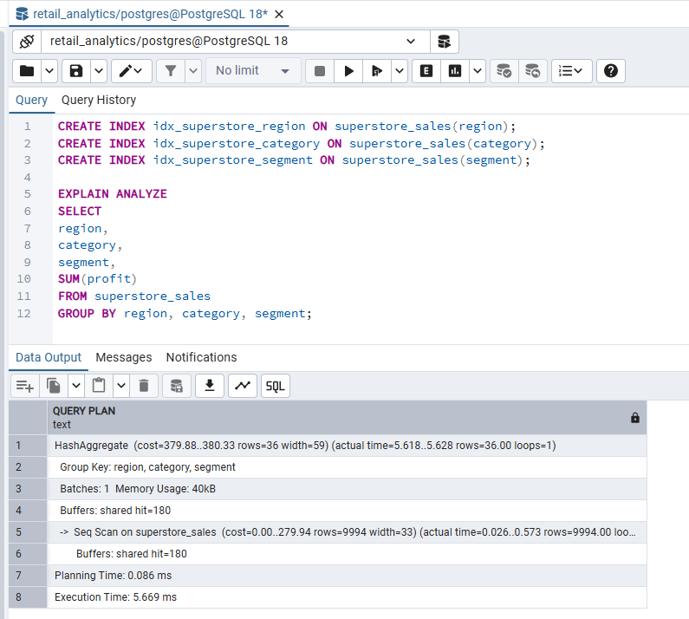.

Final Summary and Business Recommendations
The Superstore analysis reveals four consistent themes. First, profit is concentrated in a limited set of regions and product groups, especially the West region and Technology category. Second, revenue alone can be misleading, because several high sales subcategories such as Tables and Bookcases either underperformed or produced losses. Third, discounting is strongly associated with lower profitability, and very high discounts produced negative average profit. Fourth, different customer segments contribute value in different ways, with Consumer leading in volume and Home Office leading in margin efficiency.
Based on these findings, management should review discount thresholds, prioritize higher margin product categories, investigate loss producing subcategories, and target market combinations that already produce strong profit. The company should also monitor lower performing states for pricing, competitive, or cost related issues. More advanced work in a future phase could incorporate product identifiers, order dates, and customer identifiers to support time series forecasting, repeat purchase analysis, and customer lifetime value modeling.

Conclusion
This portfolio project demonstrates how PostgreSQL can be used to clean, validate, structure, analyze, and interpret a real retail dataset for business decision making. The project satisfies the assignment requirements by presenting schema design, data validation, descriptive statistics, visualizations, business questions, advanced SQL queries, and actionable recommendations. With the addition of PostgreSQL screenshots for the listed queries and outputs, this report is ready to serve as the final submission for the course portfolio project.

References
Kaggle. (n.d.). Sample Superstore dataset. Kaggle. https://www.kaggle.com/datasets/bravehart101/sample-supermarket-dataset
Microsoft Corporation. (2023). Create a histogram chart. Microsoft Support. https://support.microsoft.com/
Montgomery, D. C., & Runger, G. C. (2018). Applied statistics and probability for engineers (7th ed.). Wiley.
PostgreSQL Global Development Group. (2023). PostgreSQL 16 documentation. https://www.postgresql.org/docs/
Shmueli, G., Bruce, P. C., Gedeck, P., & Patel, N. R. (2023). Data mining for business analytics: Concepts, techniques, and applications in Python (2nd ed.). Wiley.

Appendix A. Screenshot Checklist
The following screenshots should be captured in PostgreSQL and inserted into the main report in the matching placeholder locations.
Screenshot | What to capture | Why it matters
1 | CREATE TABLE statement and success message | Documents schema creation
2 | COPY command and row import confirmation | Documents successful data load
3 | Row count, null check, and duplicate review output | Addresses data validation feedback
4 | Summary statistics query and output | Documents descriptive statistics
5 | Category and subcategory profitability query and output | Answers product performance question
6 | Region and state margin analysis query and output | Answers geography question
7 | Discount band analysis query and output | Answers discount strategy question
8 | Segment performance query and output | Answers segment question
9 | High sales but low profit subcategory query and output | Answers low margin exception question
10 | Window function ranking query and output | Documents advanced SQL with window functions
11 | Shipping mode query and output | Adds operational analysis
12 | Index creation statements and EXPLAIN ANALYZE output | Documents query optimization and efficiency

Appendix B. File Delivered with This Report
A separate SQL script named superstore_portfolio_queries.sql is included with this report. The script contains every query needed for table creation, loading, validation, descriptive statistics, advanced analysis, and screenshot capture.

