**Measure Energy Consumption**

**952721104021: SHAJITHA BARVEEN**

**Abstract:**

* + To measure the energy consumption of an abstract algorithm, you can use a simulator to estimate the number of instructions that the algorithm executes and then multiply that number by the power consumption per instruction of the target hardware platform.
  + To measure the energy consumption of an abstract software component, you can use a profiling tool to measure the amount of time that the component spends executing and then multiply that time by the power consumption of the target hardware platform.

**Data source:** [**https://www.kaggle.com/shajithabarveen/ai-phase1/edit**](https://www.kaggle.com/shajithabarveen/ai-phase1/edit)**s**

**Module:**

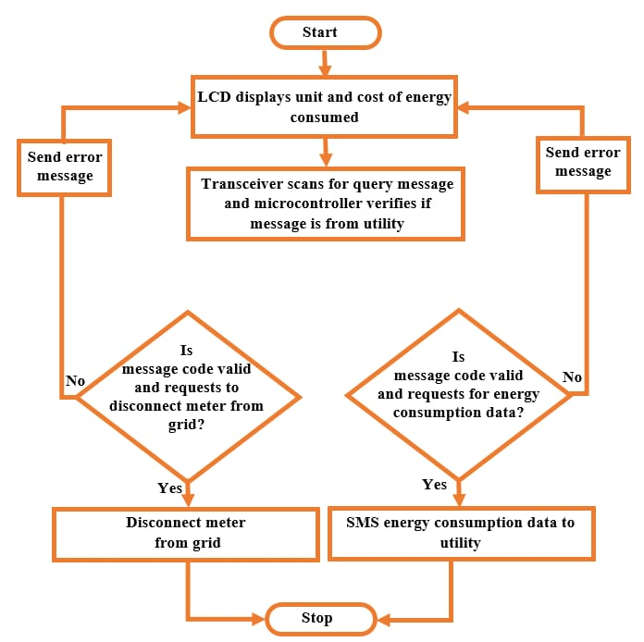

* + To measure the energy consumption of a hardware module, you can connect it to a power meter and measure the power consumption over time.
  + To measure the energy consumption of a software module, you can use a profiling tool to measure the amount of time that the module spends executing and then multiply that time by the power consumption of the target hardware platform.

Once you have measured the energy consumption of an abstract or module, you can use that information to optimize the system for energy efficiency. For example, you can identify and eliminate unnecessary computations, or you can use more efficient algorithms and data structures.

Here are some additional tips for measuring energy consumption for abstract and module:

1. Use a power meter with sufficient accuracy and resolution for your needs.
2. Measure the power consumption of the system under realistic operating conditions.
3. Repeat the measurements multiple times to get an accurate average.
4. Take into account the power consumption of all other components in the system, such as the CPU, memory, and storage devices.

By following these tips, you can get accurate and reliable measurements of the energy consumption of your abstract and module.