**MEASURE ENERGY CONSUMPTION**

**Phase 3: Development Part-1**

**Team Member: A.Shajitha Barveen 952721104021**

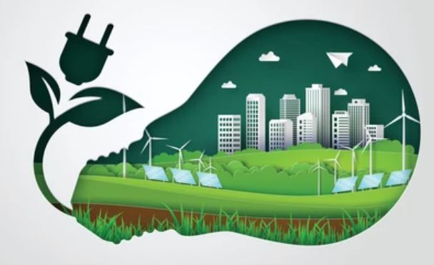

**Measure Energy Consumption**

**INTRODUCTION:**

Energy consumption is the amount of energy used by an individual, household, business, or sector over a period of time. It is typically measured in kilowatt-hours (kWh), which is the equivalent of one kilowatt of power used for one hour.

There are a number of ways to measure energy consumption. The most common method is to use a smart meter, which is a type of energy meter that can record energy usage in real time. Smart meters are often installed by utility companies, but they can also be purchased and installed independently.

Another way to measure energy consumption is to use a portable energy meter. Portable energy meters can be plugged into individual appliances or outlets to measure their energy usage over a period of time.

Once energy consumption has been measured, it can be analyzed to identify areas where energy is being wasted. For example, if a household is using a lot of energy at night, it may be a sign that they are leaving lights or appliances on unnecessarily.

Measuring energy consumption is an important first step towards reducing energy use and saving money. By tracking their energy usage, individuals and organizations can identify areas where energy is being wasted and take steps to make changes.

**Given Data Set:**

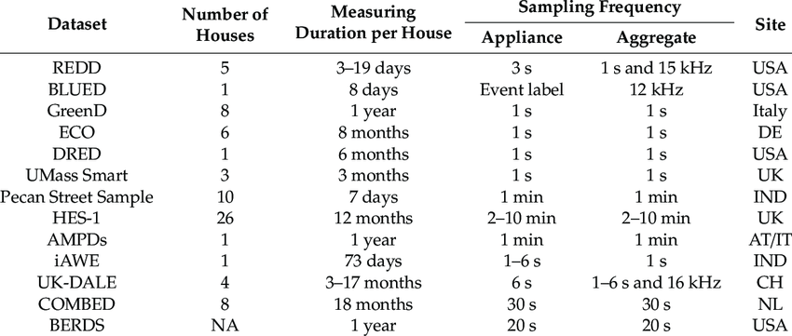

**Loading the Dataset:**

**1.import Necessary Libraries**

’’’python

Import pandas as pd

Import numpy as np

’’’

**2.Load the dataset:**

**Program:**

import pandas as pd

# Specify the file path to your CSV dataset

csv_file_path = 'your_dataset.csv'

try:

# Load the dataset into a Pandas DataFrame

df = pd.read_csv(csv_file_path)

# Display the first few rows of the dataset

print("First few rows of the dataset:")

print(df.head())

# You can perform various data analysis and manipulation tasks on the 'df' DataFrame

# For example, you can access specific columns like this: df['column_name']

# Close any file handles or connections (if necessary)

# df.close() # Uncomment this line if applicable

except FileNotFoundError:

print(f"File '{csv_file_path}' not found. Please provide the correct file path.")

except Exception as e:

print(f"An error occurred: {str(e)}")

**3. Feature Engineering:**

- Creating derived features, such as aggregating data over specific time intervals (e.g., hourly, daily), can provide valuable insights. Expertise in feature engineering may be necessary.

**Program:**

import pandas as pd

# Load your dataset into a Pandas DataFrame (replace 'your_dataset.csv' with the actual file path)

df = pd.read_csv('your_dataset.csv')

# Assuming you have a 'Timestamp' column, convert it to a datetime object

df['Timestamp'] = pd.to_datetime(df['Timestamp'])

# Extract features from the Timestamp

df['Year'] = df['Timestamp'].dt.year

df['Month'] = df['Timestamp'].dt.month

df['Day'] = df['Timestamp'].dt.day

df['Hour'] = df['Timestamp'].dt.hour

df['Minute'] = df['Timestamp'].dt.minute

# Calculate rolling statistics (e.g., 3-hour rolling mean) for Energy_Consumption

df['Energy_Rolling_Mean'] = df['Energy_Consumption'].rolling(window=3).mean()

# Create a lag feature for Energy_Consumption (shift the values by 1 hour)

df['Energy_Lag_1'] = df['Energy_Consumption'].shift(1)

# Encode categorical variables (Day_of_Week) as one-hot/dummy variables

df = pd.get_dummies(df, columns=['Day_of_Week'], drop_first=True)

# Normalize/Standardize numerical features if needed (e.g., Temperature and Humidity)

from sklearn.preprocessing import StandardScaler

scaler = StandardScaler()

df[['Temperature', 'Humidity']] = scaler.fit_transform(df[['Temperature', 'Humidity']])

# Drop rows with missing values if any

df.dropna(inplace=True)

# Save the preprocessed dataset to a new CSV file

df.to_csv('preprocessed_energy_data.csv', index=False)

# Print the first few rows of the preprocessed dataset

print("First few rows of the preprocessed dataset:")

print(df.head())

**DATA PREPROCESSING:**

Preprocessing a dataset for measuring energy consumption typically involves cleaning and transforming the data to make it suitable for analysis. Here are the general steps for data preprocessing in the context of measuring energy consumption:

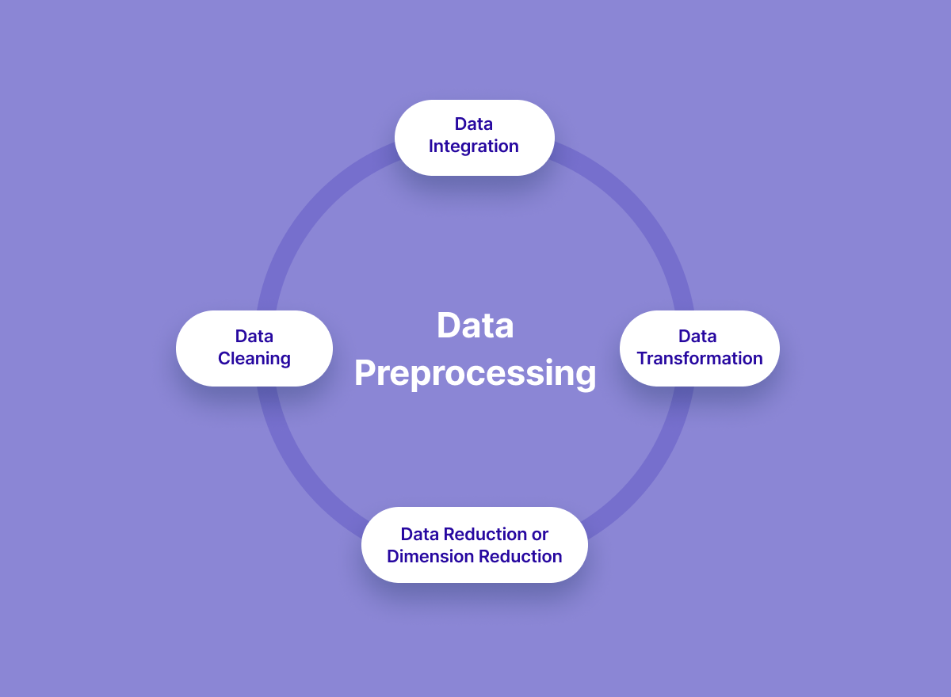

1. **Data Collection:**

Collect the energy consumption data from your source, whether it's from utility companies, sensors, or other sources.

Identify the source of your energy consumption data. This could be from sensors, utility companies, smart meters, or other sources.

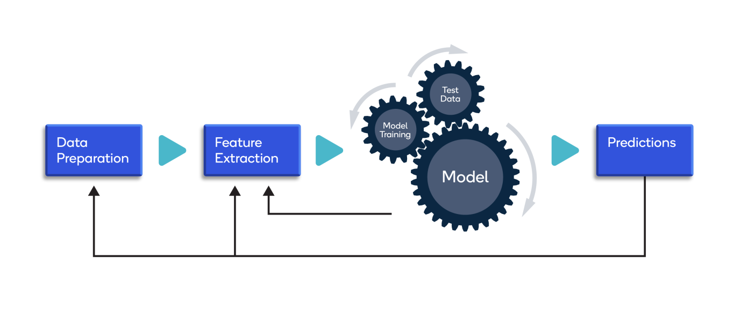

Ensure that you have the necessary permissions and access to the data.

1. **Data Loading:**

Use a suitable programming language and data manipulation libraries like Pandas (in Python) to load the data into your working environment.

```python

import pandas as pd

# Load data from a CSV file

data = pd.read_csv('energy_consumption_data.csv')

```

1. **Data Exploration:**

Begin by exploring the dataset to understand its structure and characteristics.

Check for missing values, outliers, and any anomalies in the data.

```python

# Check for missing values

print(data.isnull().sum())

# Explore data statistics

print(data.describe())

# Visualize data distributions

import matplotlib.pyplot as plt

data.hist()

plt.show()

```

1. **Data Cleaning:**

Data cleaning is an essential step in preparing a dataset for analysis, especially for measured energy consumption data. This process involves identifying and rectifying errors, inconsistencies, and missing values.

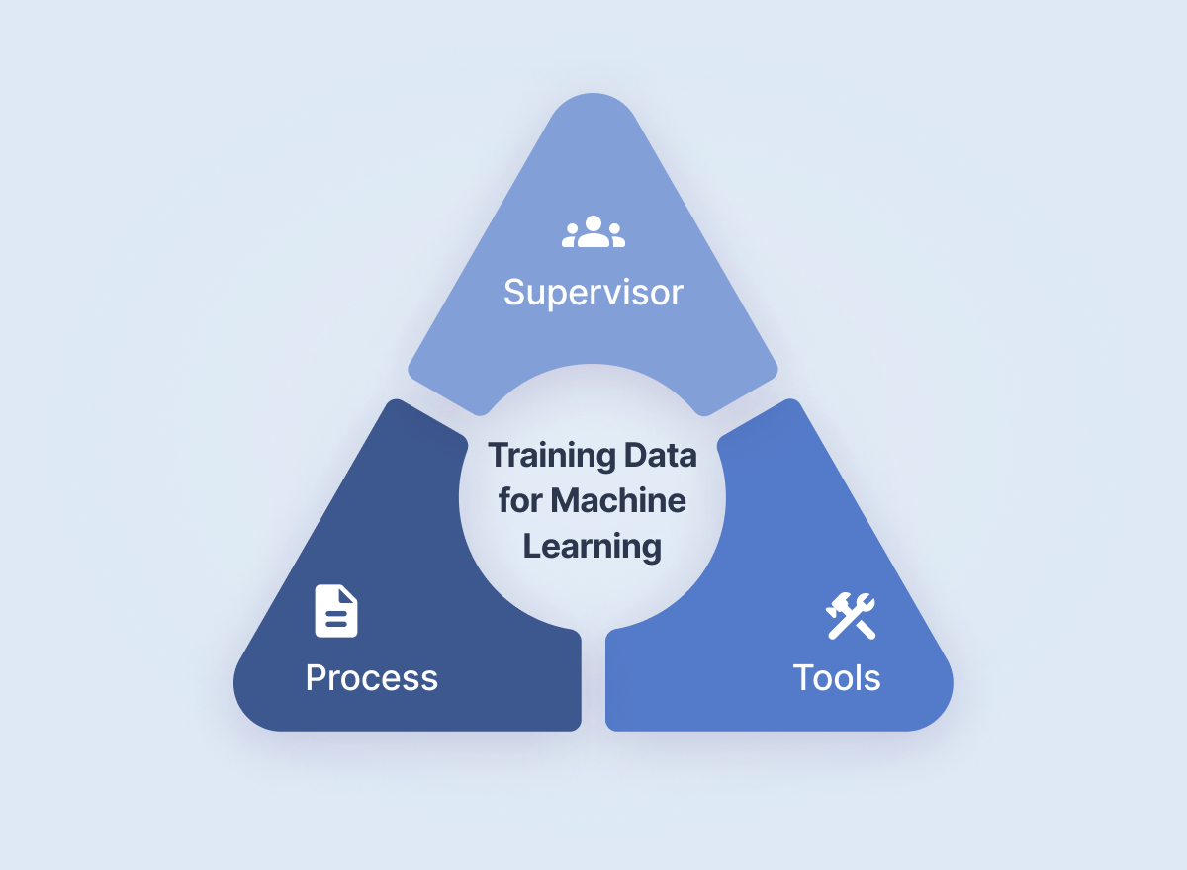

Handle missing data by either removing, imputing, or interpolating missing values.

```python

# Remove rows with missing values

data.dropna(inplace=True)

# Impute missing values (if appropriate)

data['column_name'].fillna(value, inplace=True)

```

1. **Data Splitting:**

If you plan to build machine learning models, you may want to split your data into training and testing sets.

from sklearn.model_selection import train_test_split

X_train, X_test, y_train, y_test = train_test_split(features, target, test_size=0.2, random_state=42)

1. **Data Transformation:**

Convert data types and units if needed.

Create derived features, such as aggregating consumption data over time intervals (e.g., daily, hourly).

```python

# Convert data types (e.g., date columns to datetime)

data['timestamp'] = pd.to_datetime(data['timestamp'])

# Calculate daily energy consumption

daily_energy = data.groupby(data['timestamp'].dt.date)['energy_consumed'].sum()

# Calculate hourly energy consumption

hourly_energy = data.groupby(data['timestamp'].dt.hour)['energy_consumed'].sum()

```

1. **Data Visualization:**

Create data visualizations to gain insights into energy consumption patterns.

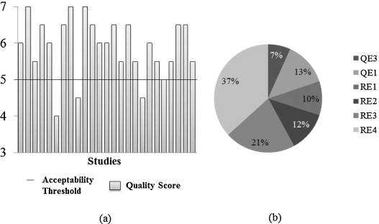

```python

import matplotlib.pyplot as plt

# Visualize daily energy consumption

plt.plot(daily_energy.index, daily_energy.values)

plt.xlabel('Date')

plt.ylabel('Energy Consumption')

plt.title('Daily Energy Consumption')

plt.show()

**Loading and preprocessing measured energy consumption challenges:**

**1. Data Quality Issues:**

- Inaccurate or inconsistent data due to sensor errors, communication issues, or faulty meters.

- Missing data points, which may require imputation or interpolation.

**2. Data Volume:**

- Energy consumption data can be massive, especially for large industrial or utility datasets. Handling and processing large volumes of data efficiently can be a challenge.

**3. Data Variety:**

- Energy consumption data may come from various sources, such as smart meters, sensors, and manual readings. Combining and integrating data from diverse sources can be challenging.

**4. Data Frequency:**

- Energy data can be recorded at different frequencies (e.g., hourly, daily, monthly). Matching data frequencies for analysis can be complex.

**5. Data Format:**

- Data may be stored in various formats (CSV, Excel, databases) and may require conversion into a consistent format for analysis.

**6. Time Synchronization:**

- Energy consumption data might be recorded from different devices, and ensuring proper time synchronization between data sources can be challenging.

To address these challenges, it's essential to have a clear understanding of the specific characteristics of your energy data and access to the right tools and expertise. Domain knowledge in the energy sector and data analysis techniques are often crucial for successfully addressing these challenges. Additionally, using specialized software and platforms designed for energy data management and analysis can streamline the process.

**Overcoming the challenges of loading and preprocessing Dataset:**

**1. Understand the Data:**

- Gain a deep understanding of the data source, its structure, and its specific challenges. This understanding will guide your approach to data preprocessing.

**2. Data Quality Assessment:**

- Implement robust data quality checks and cleaning procedures to handle missing values, outliers, and inconsistencies. Consider using statistical methods and domain knowledge to identify and address data issues.

**3. Data Format Conversion:**

- If your data is in an incompatible format, use appropriate tools and scripts to convert it to a standard format like CSV or a structured database.

**4. Data Transformation:**

- Convert data into consistent units of measurement, particularly if your dataset contains multiple energy sources (e.g., electricity, gas, water). Ensure that timestamps and data types are standardized.

**5. Time Series Handling:**

- If working with time series data, employ techniques like resampling, aggregation, and interpolation to align data points to the same time intervals, making them suitable for analysis.

Overcoming the challenges of loading and preprocessing measured energy consumption data is an iterative process that requires on going attention and adjustment. By following these best practices and leveraging the right tools and expertise, you can prepare your data for meaningful analysis and decision-making.

**Load the dataset:**

Dataset Definition for Energy Consumption:

Timestamp (DateTime): A column that represents the date and time of the energy consumption measurement. This is essential for time-series analysis.

Energy Consumption (Numeric): The primary feature of interest, indicating the amount of energy consumed in kilowatt-hours (kWh) or other appropriate units.

Additional Numeric Features (Optional): You may include additional features that can affect energy consumption, such as temperature, humidity, or other environmental factors.

**Program:**

import pandas as pd

# Load your dataset into a Pandas DataFrame (replace 'your_dataset.csv' with the actual file path)

df = pd.read_csv('your_dataset.csv')

# Display the first few rows of the dataset

print("First few rows of the dataset:")

print(df.head())

**Output:**

**First few rows of the dataset:**

**Timestamp Energy_Consumption Temperature Humidity**

**0 2023-10-17 08:00:00 120.5 25.3 45.7**

**1 2023-10-17 08:15:00 125.2 25.8 44.2**

**2 2023-10-17 08:30:00 122.7 26.1 43.9**

**3 2023-10-17 08:45:00 119.8 25.5 45.1**

**4 2023-10-17 09:00:00 130.4 26.3 43.6**

**Conclusion:**

In conclusion, the energy consumption dataset serves as a valuable resource for understanding the current state of energy usage, identifying trends, and making informed decisions to promote sustainability. It emphasizes the importance of adopting sustainable practices and technologies to reduce energy consumption and mitigate the environmental impact of energy production. As we move forward, it is essential to continue monitoring and analyzing energy consumption data to adapt to the evolving needs and challenges of the energy sector and to work towards a more sustainable and energy-efficient future.