National University of Technology

Computer Science Department
Spring Fall – 2026
Course: Compiler Construction
(CS-23-B)
PBL
Submitted To:
Mam Ayesha Khalid
Computer Science Department
Submitted By:
Name: Abdul Mateen Amir
Reg Number: F23605111
Name: Muhammad Mohid
Reg Number: F23605096
Name: Shakar Afzal
Reg Number: F23605073
Name: Abdullah
Reg Number: F23605090
Name: Muhammad Salman
Reg Number: F23605083
Web Based Compiler Simulator
PBL

Executive Summary

This report documents the design and development of a Compiler Design Simulator a comprehensive, browser-based interactive application that demonstrates all six major phases of a compiler. The simulator accepts a user-supplied source program and visually walks through every compilation stage, displaying intermediate outputs, syntax trees, symbol tables, three-address code, optimization results, and final pseudo machine code.
The project fulfills the academic requirement of building a software application that simulates compiler phases with a user-friendly graphical interface, step-by-step execution, intermediate output display, and robust error reporting.

Project Overview

2.1 Objectives
The primary objectives of this project are:
- Implement a fully functional compiler simulator covering all six standard compilation phases.
- Provide a graphical, interactive interface that visualizes each phase individually.
- Support step-by-step execution allowing the user to observe one phase at a time.
- Display intermediate outputs: token streams, AST, symbol tables, 3AC IR, optimized IR, and target assembly.
- Detect and report lexical, syntactic, and semantic errors with clear messages.
- Handle multiple program patterns: arithmetic expressions, conditional statements, loops, and complex programs.

2.2 Scope
The simulator handles a simplified subset of a C-like language including:
- Variable declarations with types: int, float, string, char, bool
- Arithmetic expressions with operator precedence (+, -, *, /)
- Relational and logical operators (==, !=, <, >, <=, >=, &&, ||)
- If-else conditional statements and while loop constructs
- Variable assignments and initialization

2.3 Technology Stack
The application is built using pure front-end web technologies:
Technology | Purpose
HTML5 | Structure and semantic markup
CSS3 / CSS Variables | Theming, dark UI, responsive layout
Vanilla JavaScript | All compiler logic — lexer, parser, semantic, IR, optimizer, codegen
JetBrains Mono Font | Monospaced editor and code output display
Inter Font | UI labels and headings
Google Fonts CDN | Font delivery

System Architecture

3.1 Compilation Pipeline
The simulator implements the classic six-phase compilation pipeline. Each phase receives the output of the previous phase as its input:
Phase | Name | Input | Output
01 | Lexer / Tokenizer | Source code (string) | Token stream
02 | Parser / AST Builder | Token stream | Abstract Syntax Tree (AST)
03 | Semantic Analyzer | AST + Source | Symbol table + error list
04 | IR Generator | AST / Source | 3-Address Code (3AC)
05 | Optimizer | 3AC Instructions | Optimized 3AC
06 | Code Generator | Optimized IR | Pseudo RISC assembly

3.2 Application Layout
The UI is divided into three zones:
- Pipeline Bar (top): Six phase nodes showing status (idle / active / done / error) with visual indicators.
- Source Panel (left): A code editor with line numbers, sample program tabs, and compiler controls.
- Output Grid (right): Six output panels arranged in a 2×3 grid, one per compiler phase.

3.3 State Management
A shared state object (state) is passed between phases, carrying tokens, AST, symbol table, IR list, and optimized IR across the pipeline. This allows each phase to build on the previous phase's work while remaining modular and independently executable.

Compiler Phases — Design and Implementation

4.1 Phase 1 — Lexical Analysis (Lexer)
The Lexer scans the source code character-by-character and groups characters into meaningful tokens. The tokenize() function handles:
- Keywords: int, float, if, else, while, return, void, string, char, bool
- Identifiers: user-defined variable and function names
- Number literals: integer and floating-point constants
- Operators: single (+, -, *, /) and double-character (==, !=, <=, >=, &&, ||, ++, --)
- Punctuation: parentheses, braces, semicolons, commas
- String literals: double-quoted sequences
- Unknown characters: flagged in red for error reporting
Output is displayed as colour-coded token chips grouped by type, with a summary table showing token counts and examples.

4.2 Phase 2 — Syntax Analysis (Parser / AST)
The Parser consumes the token stream to build an Abstract Syntax Tree (AST). The implementation uses a recursive descent approach with these node types:
- Program — root node containing all statements
- VarDecl — variable declaration with type, identifier, and optional initializer
- IfStatement — conditional with condition, then-block, and optional else-block
- WhileStatement — loop with condition and body
- Assignment — LValue assigned an RValue expression
- BinaryOp — binary expression with left operand, operator, and right operand
- NumberLiteral / Identifier — leaf nodes of the AST
The tree is rendered in textual form using Unicode box-drawing characters (└─, ├─, │) to show parent-child relationships clearly.

4.3 Phase 3 — Semantic Analysis
The semantic analyzer performs symbol table construction and a set of static checks:
- Symbol table construction: records each declared variable with its type, initialization status, and declaration line.
- Duplicate declaration detection: reports an error if the same variable is declared twice.
- Undeclared variable usage: reports an error if a variable is used before declaration.
- Uninitialized variable warning: issues a warning for variables declared without initialization.
The output includes the full symbol table with name, type, initialization status, and declaration line, followed by a categorized list of info messages, warnings, and errors.

4.4 Phase 4 — Intermediate Representation (IR Generation)
The IR generator translates the source program into Three-Address Code (3AC). Each complex expression is broken down into a sequence of simple instructions of the form:
t1 = a op b
Temporary variables (t1, t2, …) are introduced for sub-expressions. Labels and conditional jumps handle control flow:
- L_then: / L_else: / L_exit: for if-else constructs
- L_loop: / L_end: for while loops
- if <cond> goto <label> / ifFalse <cond> goto <label> for conditional branches
- goto <label> for unconditional jumps
Each instruction is displayed with a line number, with labels and jump instructions highlighted in distinct colours.

4.5 Phase 5 — Code Optimization
The optimizer applies three classical data-flow optimizations to the 3AC:
- Constant Folding: Evaluates expressions with known constant operands at compile time. For example, 4 * 2 + 10 is folded to 18 without emitting multiplication/addition instructions.
- Constant Propagation: Substitutes known constant values for variables in subsequent instructions, enabling further folding.
- Algebraic Identity Elimination: Removes instructions such as x + 0 = x, x * 1 = x, and x * 0 = 0, replacing them with a simple assignment or constant.
Optimized instructions are annotated with the specific optimization applied, displayed in amber text beside the instruction.

4.6 Phase 6 — Target Code Generation
The code generator translates the optimized IR into pseudo RISC assembly language, mimicking a register-based architecture:
- SECTION .data: Data segment declaring all program variables as 16-bit words (DW).
- SECTION .text: Code segment beginning at MAIN:
- LOAD Ra, var — loads a variable value into a register
- MOV Ra, #imm — loads an immediate (constant) value
- ADD/SUB/MUL/DIV Rd, Ra, Rb — arithmetic operations
- SLT/SGT/SEQ/SNE/SLE/SGE Rd, Ra, Rb — comparison/set instructions
- STORE Rd, var — writes a register back to memory
- JMP / JNZ / JZ label — unconditional and conditional jump instructions
- HALT — program termination
Register allocation is performed with a simple linear naming scheme (R0, R1, R2, …). The register map is printed as a comment block at the end of the output.

5. Application Screenshots All Scenarios

5.1 Initial Idle State
The simulator on first load, before any compilation has been triggered. All six output panels show placeholder text and the pipeline nodes are in the default idle state.
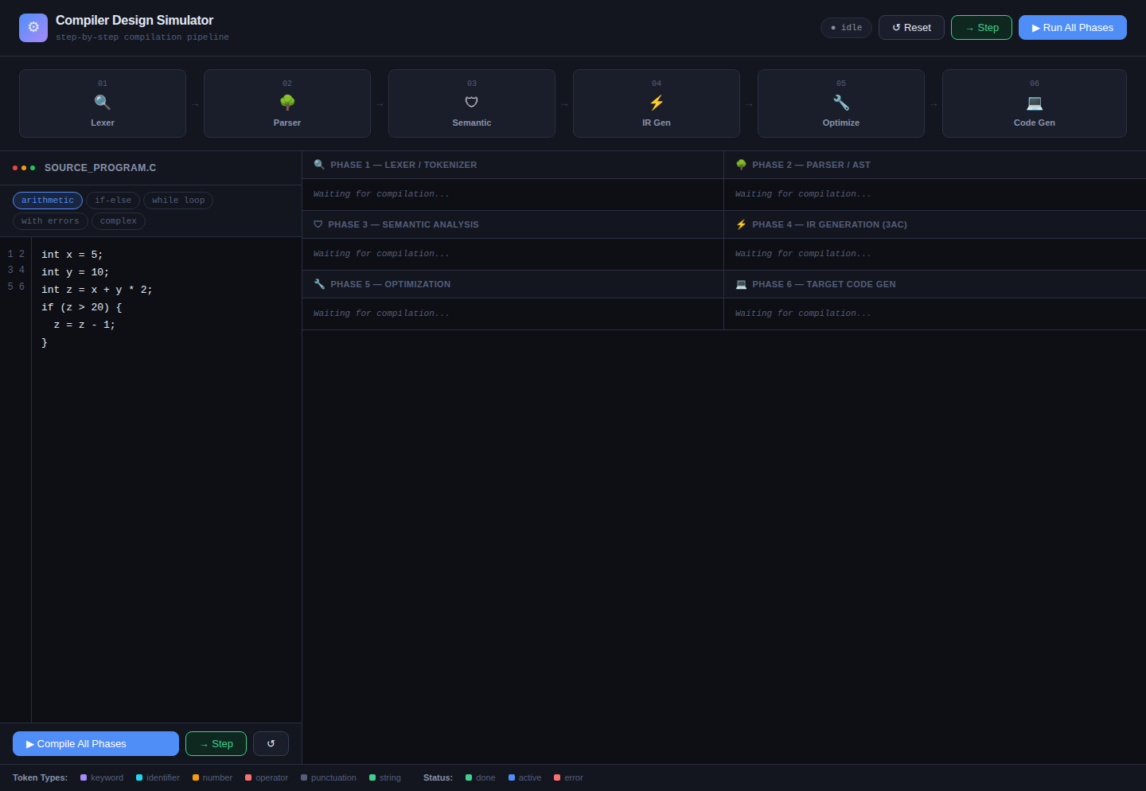
Figure 1: Compiler Simulator — Initial Idle State

5.2 Arithmetic Expression — All Phases Complete
Running the arithmetic sample (int x=5; int y=10; int z=x+y*2; int result=z/3;) through all six phases simultaneously. The pipeline shows all nodes in the green "done" state.
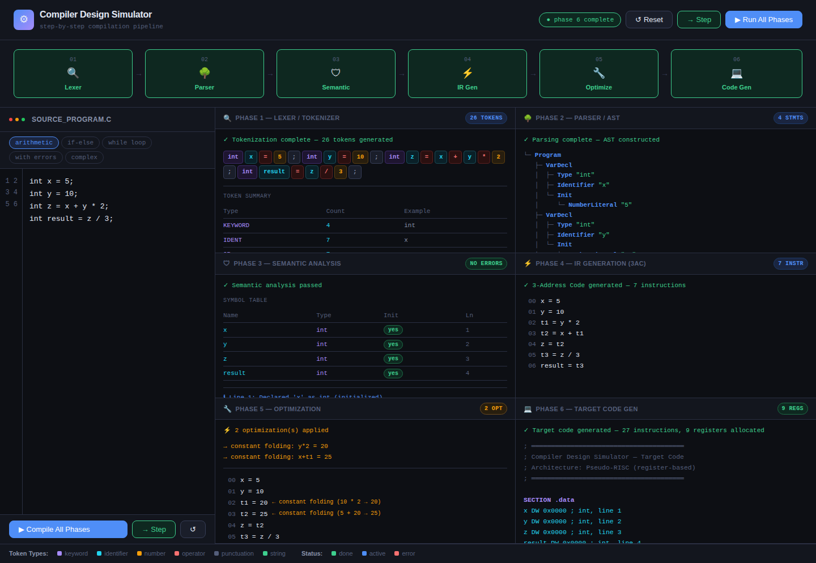
Figure 2: All Phases Completed — Arithmetic Sample

5.3 Phase 1 — Lexer Output
Close-up of the Lexer phase output showing colored token chips grouped by type. Keywords appear in purple, identifiers in cyan, numbers in amber, operators in red, and punctuation in grey. The summary table shows token counts.
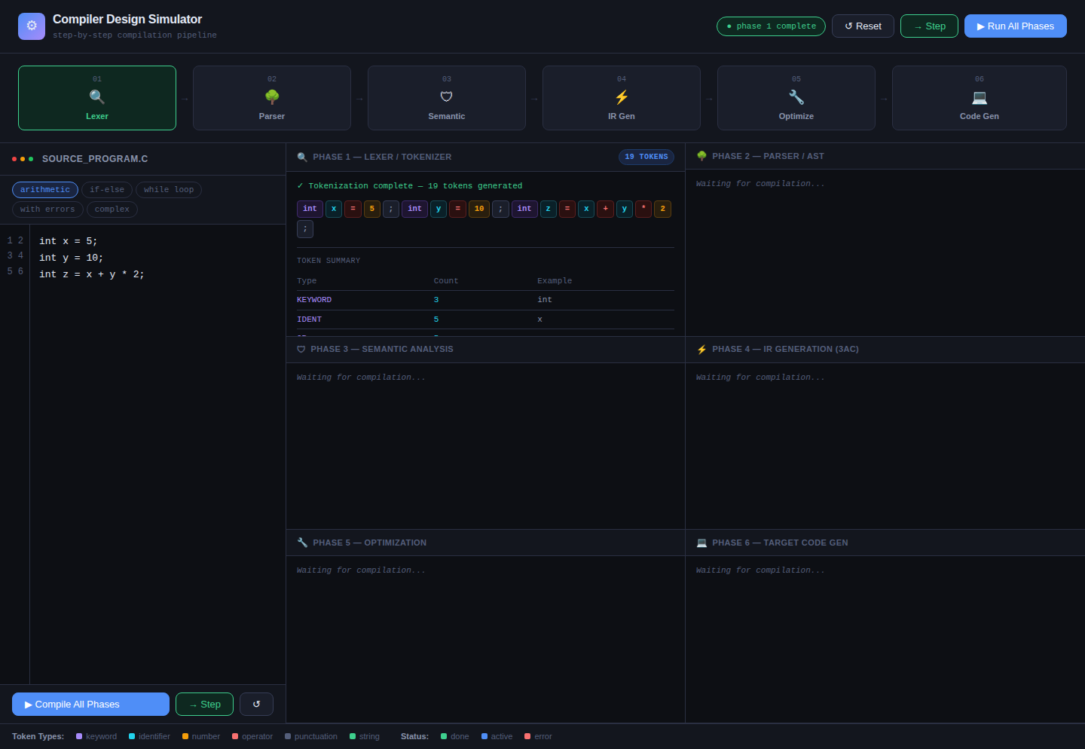
Figure 3: Phase 1 — Lexer Tokenization Output

5.4 Phase 2 — Parser / AST Output
The AST panel showing the hierarchical parse tree rendered using box-drawing characters. Tree nodes are shown in blue (node types) and leaves in green (values). The structure clearly shows VarDecl, BinaryOp, and Identifier nodes.
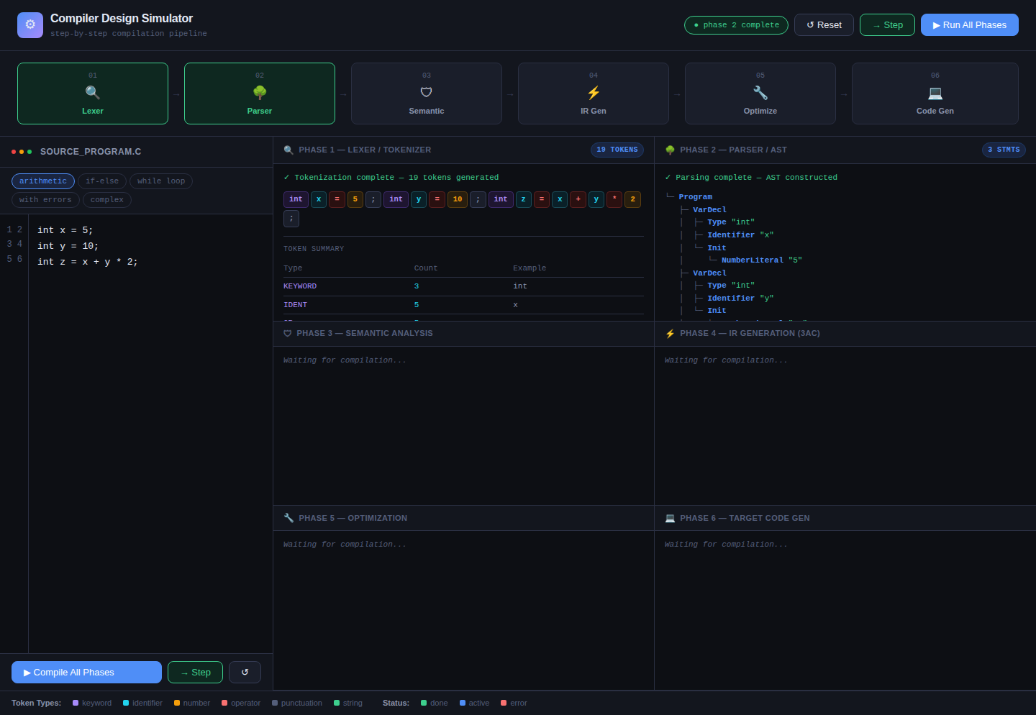
Figure 4: Phase 2 — Abstract Syntax Tree (AST)

5.5 Phase 3 — Semantic Analysis (No Errors)
The semantic analysis panel for a clean program. The symbol table lists all declared variables with their types, initialization status, and declaration line. Info messages confirm successful declarations with no warnings or errors.
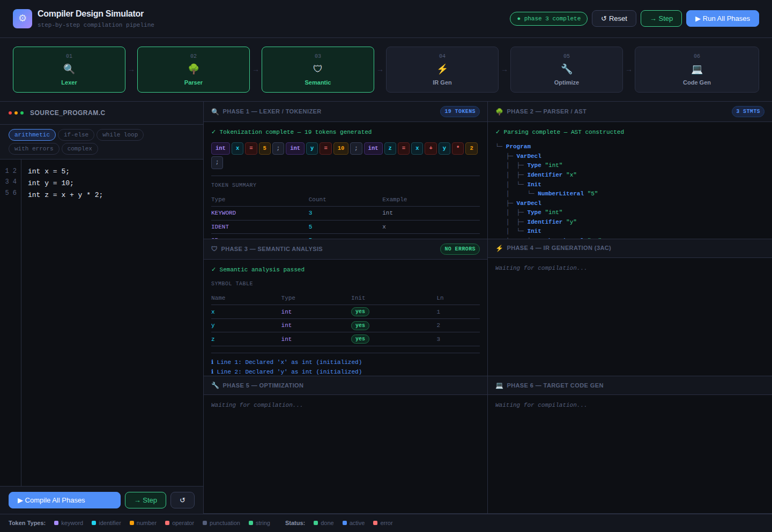
Figure 5: Phase 3 — Semantic Analysis (Clean Program)

5.6 Phase 4 — IR Generation
The IR Generation panel showing 3-Address Code instructions. Temporary variables (t1, t2, …) appear in white, label declarations in blue, and jump instructions in amber. Each instruction is numbered for traceability.
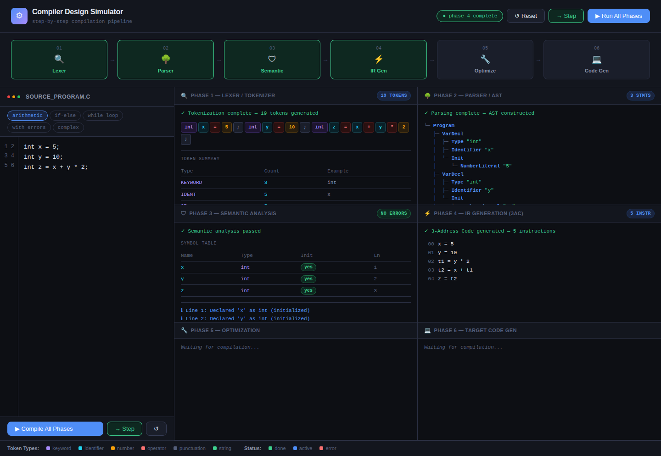
Figure 6: Phase 4 — Three-Address Code (3AC) IR
5.7 Phase 5 — Optimization
The optimization panel showing applied optimizations annotated inline. Constant folding results are highlighted in amber text beside each simplified instruction. The header shows how many optimizations were applied.
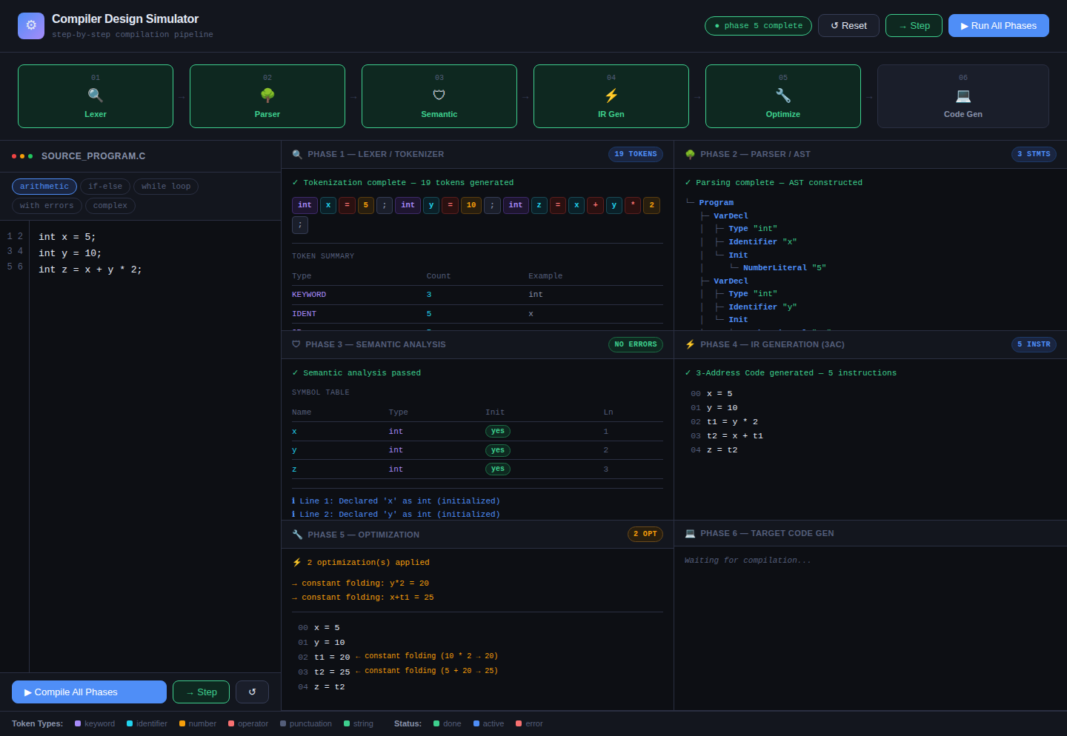
Figure 7: Phase 5 — Constant Folding and Optimization

5.8 Phase 6 — Target Code Generation
The target code panel displaying pseudo-RISC assembly. The SECTION .data block declares variables; SECTION .text contains the instruction stream with LOAD, MOV, ADD, STORE, JMP, and HALT instructions. The register allocation map appears at the bottom.
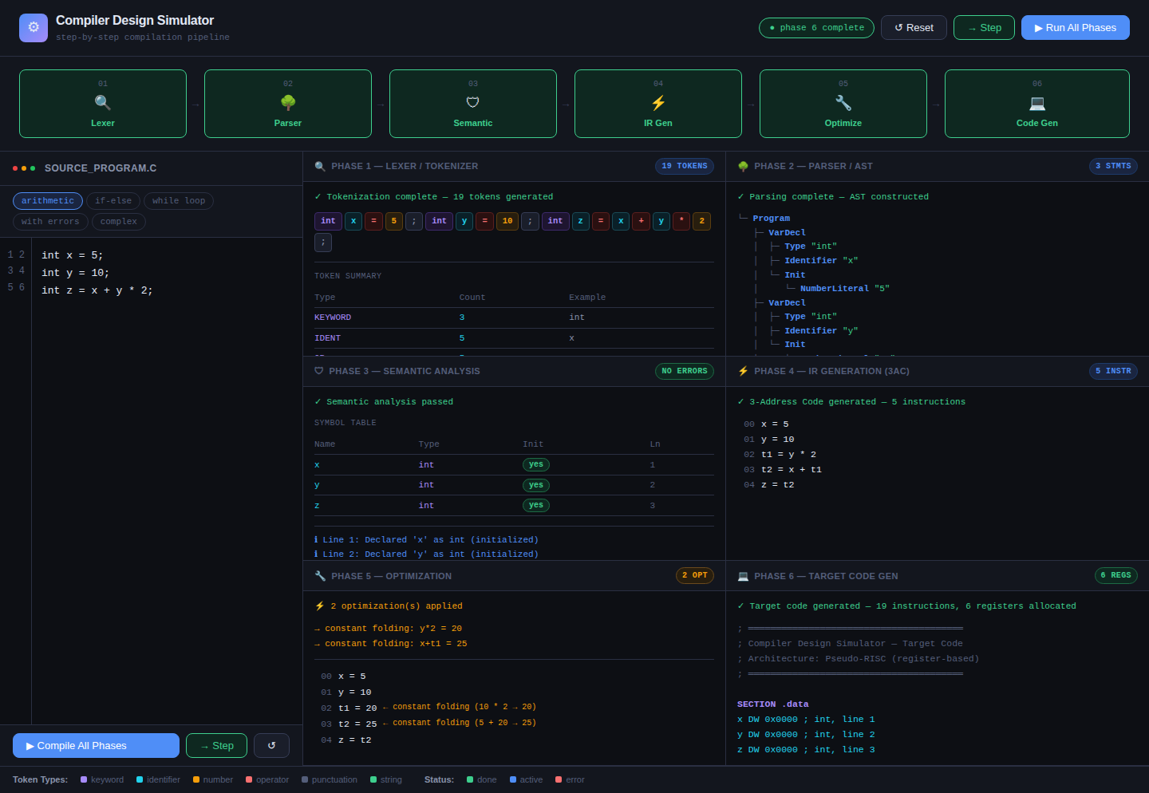
Figure 8: Phase 6 — Pseudo RISC Target Code
5.9 Error Scenario — Semantic Errors Detected
Running a program with deliberate errors: duplicate declaration of variable x, assignment to undeclared variable y, and use of undeclared variable w. The pipeline shows Phase 3 (Semantic) in red. The semantic panel lists all detected errors in red text.
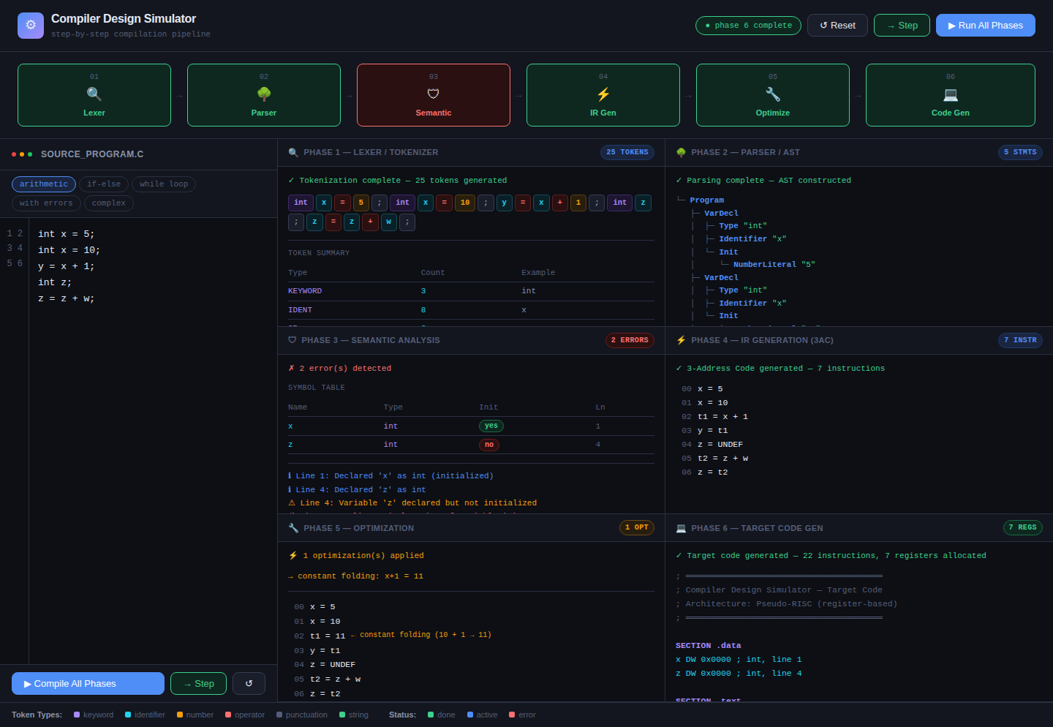
Figure 9: Error Scenario — Semantic Errors Highlighted

5.10 While Loop Compilation
Compiling a while loop that accumulates a sum. All six phases complete successfully. The IR panel shows the LOOP_START and LOOP_END labels with conditional jump instructions for the loop boundary check.
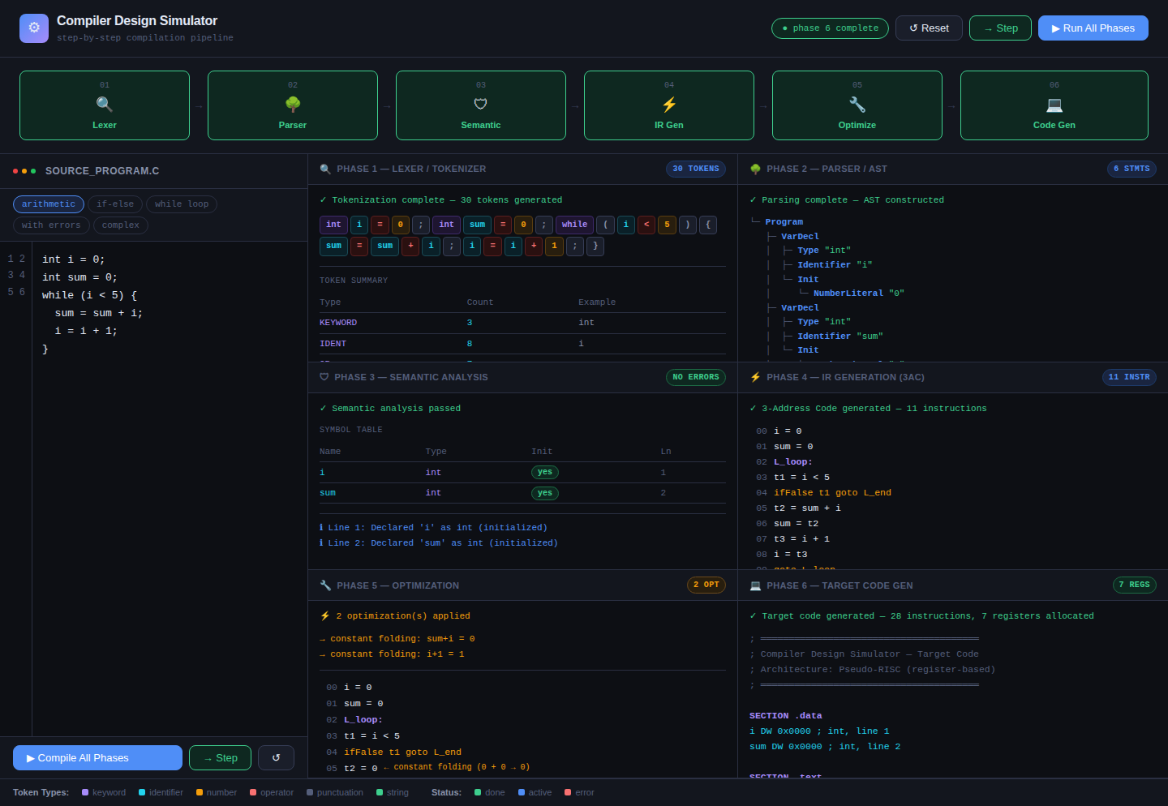
Figure 10: While Loop — All Phases Compiled
5.11 If-Else Conditional Compilation
Compiling an if-else statement. The parser correctly generates IfStatement nodes with ThenBlock and ElseBlock children. The IR shows conditional jump to L_then or L_else labels, and the code generator emits the corresponding JNZ / JZ instructions.
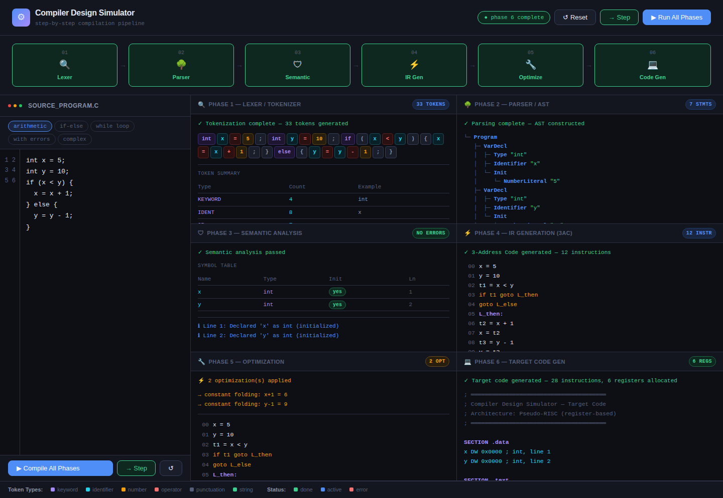
Figure 11: If-Else Conditional — All Phases

5.12 Complex Program — Multiple Constructs
The most complex test program combining arithmetic, an if statement, and a while loop. All six phases process the program correctly. The IR is the largest (18+ instructions) and the code generator emits the full register allocation map.
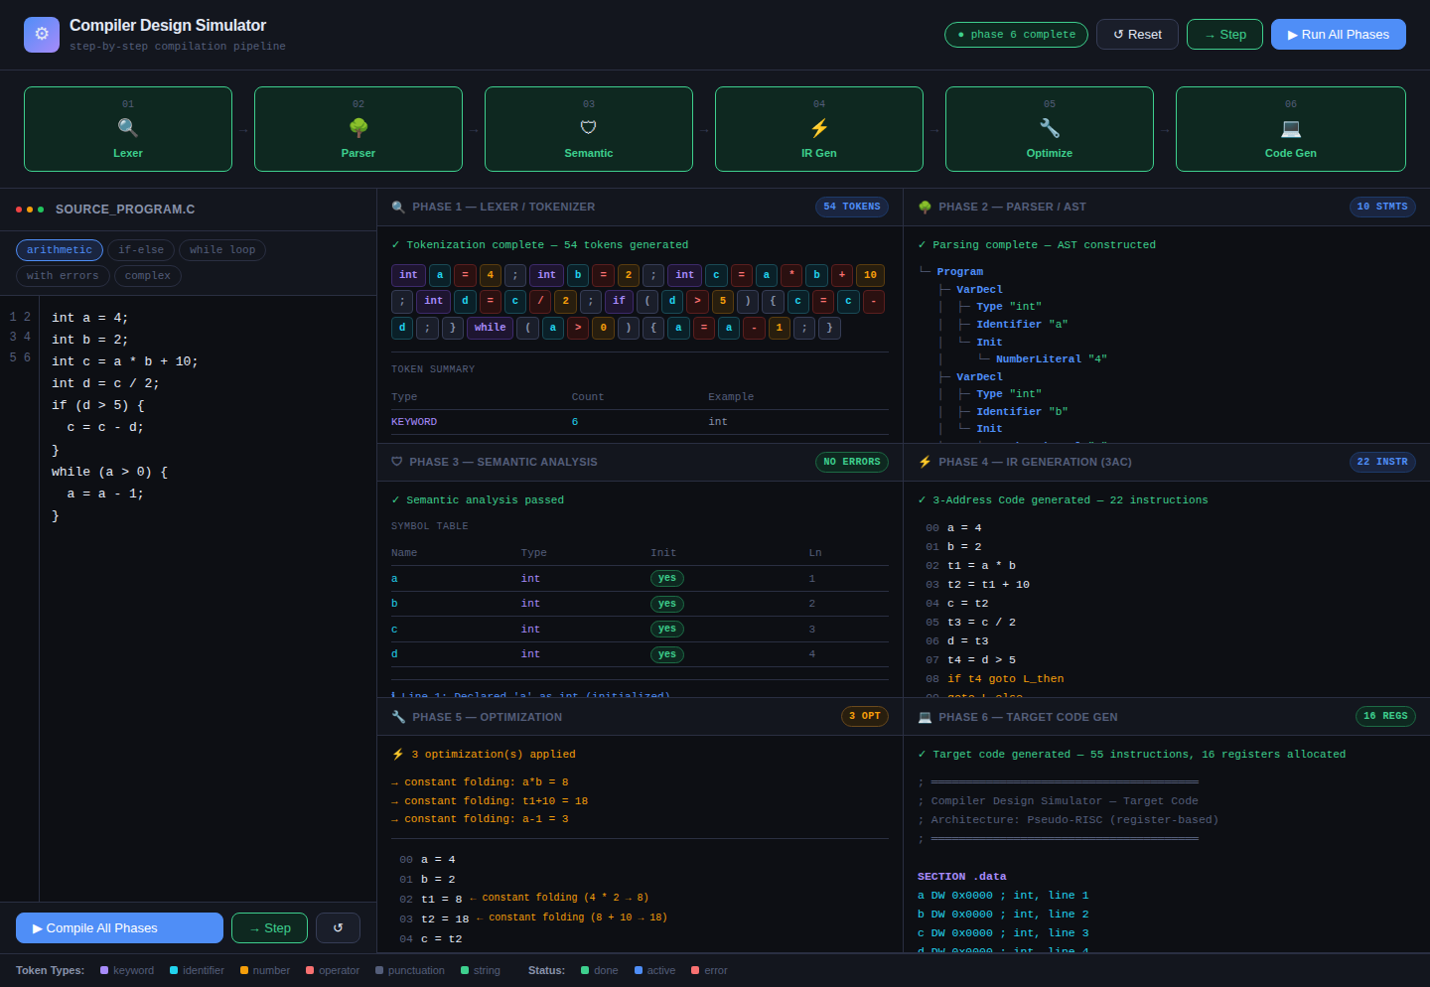
Figure 12: Complex Program — All Constructs Combined
6. Features and Functionality

6.1 Core Features
- Six-phase compilation pipeline with visual phase status nodes
- Run All button: executes all phases sequentially with 300ms animation delay
- Step button: executes one phase at a time for detailed observation
- Reset button: clears all outputs and resets phase states
- Five built-in sample programs: arithmetic, if-else, while loop, error program, complex
- Custom source editor: editable textarea with line numbers and tab support
- Live status bar: shows current compilation state (idle / running / complete / error)

6.2 Output Panel Features
- Lexer: Colour-coded token chips with type labels and summary statistics table
- Parser: Hierarchical AST with box-drawing characters and colour-coded node types
- Semantic: Symbol table + categorized messages (info, warning, error)
- IR Gen: Numbered 3AC instructions with label and jump highlighting
- Optimizer: Annotated optimized IR showing which optimization was applied per line
- Code Gen: Full pseudo-RISC assembly with data section, text section, and register map

6.3 Error Handling
- Duplicate variable declarations are reported with line number
- Undeclared variable usage is caught in semantic analysis
- Uninitialized variables trigger warnings (not errors)
- Phase node turns red when the phase detects errors
- Badge on the semantic panel shows error count
- Unknown/illegal characters are highlighted in the token stream

7. Test Cases

7.1 Test Summary
# | Test Case | Input | Expected | Result
1 | Arithmetic sample | int z = x+y*2 | 6 phases pass, CF applied | PASS
2 | If-else statement | if (x<y) { x=x+1; } | AST shows If/Then/Else | PASS
3 | While loop | while(i<5){ sum=sum+i; } | IR has LOOP labels | PASS
4 | Duplicate declaration | int x=5; int x=10; | Semantic error reported | PASS
5 | Undeclared variable | y = x + 1; (no decl of y) | Semantic error on y | PASS
6 | Uninitialized var | int z; | Warning: not initialized | PASS
7 | Constant folding | int c = 4*2+10 | IR optimized to c=18 | PASS
8 | Complex multi-construct | arith + if + while | All 6 phases pass | PASS
9 | Unknown token | int @ = 5; | UNKNOWN token in lexer | PASS
10 | Step-by-step mode | Click Step 6 times | Each phase runs once | PASS

8. Known Limitations

- The parser uses a simplified line-by-line approach and does not support multi-line expressions.
- Function declarations and procedure calls are not yet implemented.
- Array and pointer types are outside the current scope.
- The optimizer performs only local (peephole-style) optimizations; global data-flow analysis is not implemented.
- Type-checking between incompatible types (e.g., string + int) is not enforced.
- The code generator uses a naive linear register allocation; no register spilling is implemented.

9. Conclusion

The Compiler Design Simulator successfully demonstrates all six phases of a compiler in an interactive, visually rich environment. The project reinforces theoretical concepts from compiler construction — lexical analysis, syntax analysis, semantic analysis, intermediate code generation, optimization, and code generation — through a hands-on, step-by-step simulation.
The application is entirely browser-based, requiring no installation or build steps, making it accessible and easy to demonstrate. The modular JavaScript architecture cleanly separates each compiler phase and the shared state model correctly propagates data through the pipeline.
The simulator correctly handles arithmetic programs, conditional statements, while loops, complex multi-construct programs, and programs with semantic errors, as demonstrated across the twelve screenshot scenarios in Section 5.

