E~Visual Online Examination for Visually

Impaired Students

A.Shakthi Sriharan

UG Scholar

Dept. of Computer Science

B.M.S. College of Engineering

Bengalore

shakthi.amarnath@gmail.com

Dr. K Panimozhi Assistant Professor,

Dept. of Computer Science

B.M.S. College of Engineering, Bangalore. [panimozhi.cse@bmsce.ac.in](mailto:panimozhi.cse@bmsce.ac.in)

Antara Roy Choudhury, Assistant Professor,

Dept of Computer Science

B.M.S ... College of Engineering, Bangalore. [antararc.cse@bmsce.ac.in](mailto:antararc.cse@bmsce.ac.in)

**Abstract:** Vision loss has a significant impact on the lives of those who experience it as well as on their families, their friends and the society. The complete loss or the deterioration of existing eyesight can be very frightening and overwhelming .The main objective of E-visual is for a visually impaired student to write a fully automated online examination system without the help of a scribe. The ability to write an exam without the help of a human, assistance through voice is our primary goal. Using a specific keys on the braille keyboard that acts a text-to-speech function for the questions and a speech recognition which converts the said answer from speech-to-text. This is not only constrained to the visually impaired students but even students who are differently abled can also use this system. Many proficient languages are implemented like HTML, CSS, JAVASCRIPT, IOT APPLICATION.

Keywords- visually impaired students, speech-to-text, text-to-speech, braille keyboard.

1. **INTRODUCTION**

This idea for visually impaired students helps them to connect with the people easily and makes them independent, it also inspires a lot of younger generation to create something that is useful for the society and the people in need.

Unfortunately, every single person is not gifted with the power of sight and they go through twice the day to day struggle a normal person can easily accomplish, there currently about 2.2 billion people suffering from visual impairment. A latest survey proves that there are at least 200,000 children suffering from visual impairment. 15000 are in the blind schools. For now since the market for a braille keyboard and the iot kit is considerably high writing exam using printed paper is more feasible and economical. For a visually impaired student to find a scribe is not easy as it sounds, there are many complications in it. An inadequate scribe or a scribe without a proper knowledge and scribe without a neat handwriting can affect the students indirectly. The entire process is very dependent and time consuming. Often time dues to various government involved process people are not interested to apply for a scribe. According to the survey conducted there are various problems faced between the student and the scribe.

The advent of online examination systems has revolutionized the education landscape, providing convenient and flexible assessment options for students. However, visually impaired individuals often face challenges in accessing and participating in these digital assessments. To address this issue, a automated online examination system that incorporates Radio Frequency Identification (RFID) technology for validation, along with a user-friendly interface developed using HTML, CSS, and JavaScript, can significantly enhance accessibility and inclusivity for visually impaired students. Visually impaired individuals face unique obstacles when it comes to accessing online content. Traditional visual interfaces hinder their ability to perceive and interact with digital elements, making it difficult for them to engage in online examinations. Features such as complex graphics, color-coded instructions, and inaccessible navigation can exclude visually impaired individuals from participating in these assessments. To overcome these challenges, incorporating RFID technology can provide a reliable and efficient method for user identification and validation. RFID tags or cards can be assigned to each visually impaired student, containing their unique identification information.

The remaining sections are organized as follows. Analysis and survey are discussed in Section II. In Section III, Research methodology is well discussed. The working of the functions implemented are presented in Section IV. In Section V the key technology are discussed. The performance measure in Section VI and Section VII concludes the paper. Various references are written which we had referred to for this paper in Section VIII.

1. **LITERATURE SURVEY**

For a visually impaired student to comprehend a concept, learn, study and write it with the help a scribe is not a very easy task. Hence it is better to have a fully automated system for the visually impaired student to write the exam. In regard there are several research paper which have taken into place to support visually impaired students and make their lives a little easier in all some aspects of their livelihood.

Authors of [1] state that this research highly focused on visually impaired students who are unable to read the questions displayed on the computer screen in this online examination system. They missed their braille system which is more familiar to read and write more easily. This is high time to build a proper voice-based online examination system for visually impaired students. This system should read the question that is displayed on the screen and obtain the student's response via voice commands [1].

However, according to the authors of [2] the basic idea of recognizing the speeches of the students using speech signals has its merits and demerits with various studies and approaches, each individual student have their own signals and frequency as these days the system is designed for ASR system with numerous vocabularies that support the student independently in different languages [2].

Further, authors of [3] state that many surveys have been conducted across 39 countries globally where around 275-285 million people are currently visually impaired and in that around 40 million are completely blind as the majority of the impairment are due to uncorrected refractive error (43%) and (33%) are suffering due to cataracts and cataracts are also the first cause of blindness [3].

Authors of [4] state that prior open and distant learning of the online examination system uses voice interface which wasn’t very efficient and accurate which overall decreases the quality of the examination. Since our main goal is to improve and find an alternate method for the students providing a framework that will guide the development of the online examination system [4].

However, according to the authors of [5], The purpose of this study was to explore the effects of the digital material incorporated into Text-to-Speech system for students’ English spelling. The digital material was made on the basis of the Spelling Bee vocabulary list (approximately 300 words) issued by the selected school. 21 third graders from a private bilingual school in Taiwan were selected for this study [5].

Further, authors of [11] To encourage greater participation in their own learning, and to give greater access to different sources of information than traditional methods offers. In the future blind peoples also can-do online exam like a normal human if our project is delivered in real time [11].

Authors of [12] if the student is able to write the exam without the help of a scribe using an automated examination system, it makes the student more independent and can overcome various difficulty in writing the exam. The main goal is for the student to perform and solve the questions without being dependent on another person [12].

# RESEARCH METHODOLOGY

For a visually impaired student to navigate through the entire system the student would require a braille keyboard and RFID tag and reader. There are many advantages for using a braille keyboard where it makes the visually impaired students use a automated system in a structured and convenient but it also has its disadvantage, for example the keyboard cannot be used by a normal person who has had no training in it. When a normal sighted person uses a braille keyboard the student might not be able to differentiate between a mistake and a non-mistake. Currently the visually impaired use the help of a scribe to write the exam and it comes with many problems as he/she are responsible to understand what the student says and translate it into the necessary medium. The scribe sometimes might not understand the solution that the visually impaired student is trying to say. There are also a lot chances of malpractices that an occur or the scribe might answer it incorrectly unintentionally. At exam times sometimes the scribe might cancel his/her appointment.

The main objective of this study is to investigate the effectiveness of an online examination system specifically designed for visually impaired students. The research aims to understand the unique challenges faced by visually impaired students during online examinations and identify ways to enhance the user experience. The study may be limited by the availability and duration of access to visually impaired student participants. The findings of this study may be specific to the chosen sample and the particular online examination system. Generalizing the results to all visually impaired students or different systems may require further research. Direct observations will be conducted to analyze the interaction between visually impaired students and the online examination system. In-depth interviews will be conducted with visually impaired students to gather their experiences, and challenges related to using the online examination system. Structured surveys will be conducted to gather in-depth data regarding user satisfaction, experience, and system stability.

Relevant performance metrics, such as completion time and accuracy, will be collected during the examination process to assess the effectiveness of the system. Prior to participation, all visually impaired students will be provided with detailed information about the study's purpose, procedures, and potential risks or benefits as to help them understand the efficiency and importance of the system.

# FUNCTIONS OF E~VISUAL EXAMINATION SYSTEM

# Various features and functions are implemented in this study which are vital for the performance of the study and are essentially needed for further implementation.

# Module 1

# 

# Module 1 contains the login and registration credentials where the user has to login for validation .

* **Module 2**

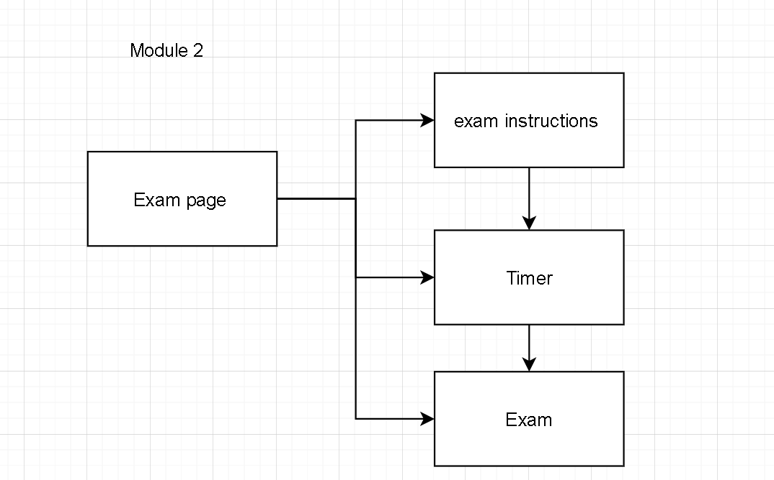

Module 2 contains the exam page where the user can take up the exam after the instructions and timer.

* **Module 3**

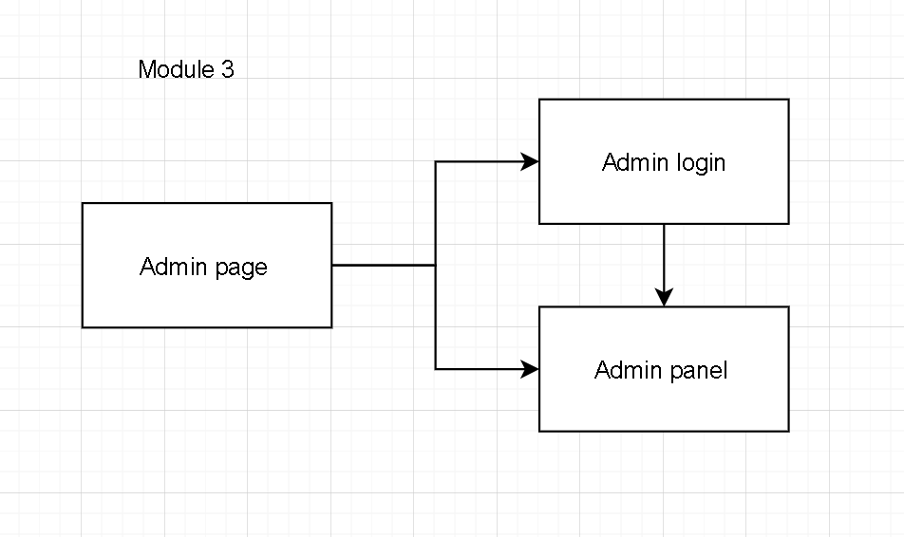

Module 3 contains the admin login and panel which gives the overall access the website where the admin can block/unblock students, change questions.

# RFID Validation

# For a visually impaired student to login using his credentials the student would have to use his/her RFID tag and scan it using a reader where the validation is done using php as the system checks the user_rfid entered with the one stored in the database if the credentials are correct the system redirects the user to the user login panel where his/her information is displayed.

# Speech-To-Text

For a visually impaired student to give his/her answer, the student must press the specified key assigned for recording (SPACEBAR), once the user answers he/she can reread the answer by using another specific key (M) which simultaneously

stops the recording. The entire functionality is worked on javascript where a function is created for each functionality and is fetched using the ‘id’ from the html page.

1. **Text-To-Speech**

For a visually impaired student to listen to his/her question, the student must press a specified key assigned to listen to the question (LEFT ARROW), once the user listens he/she can start answering. The entire functionality is worked on javascript where a function is created for each functionality and is fetched using the ‘id’ from the html page.

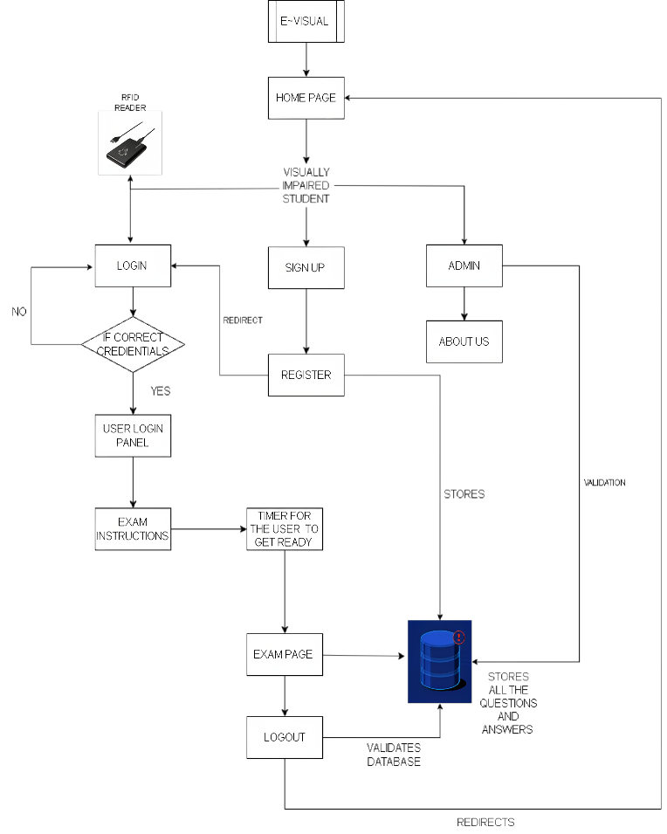

**Fig .1. System Architecture of the e-visual online**

**examination system**

1. **Register**

It is not ideal for a visually impaired student to register on his own so he/she can take the help of the admin to create a user credential which directly gets stored in a database table where the admin can access it anytime.

1. **Exam Instructions**

Every visually impaired student trying to use our architecture might face difficulty in understanding the system so the instructions on how to successfully navigate through the system is clearly mentioned using a python prerecorded file that automatically starts reading when the page is loaded.

1. **Exam Page**

The main exam page integrates both text-to-speech and speech-to-text where the students write their exam without the help of a scribe. The user can reread the answer , listen the questions, save the answer, listen to the answer and also delete the answer if the user is not satisfied with his/her answer.

1. **Cloud Platform (MySQL)**

MySQL is the cloud platform used where the database is the main soul of the examination system where all the questions, answers, users details, and the admin details is stored. Every function is fetched from the database and pushed into it.

It is important to acknowledge the constraints and the non-functional requirements of the study. The findings may be specific to the chosen sample and the particular online examination system, and generalizing the results to all visually impaired students. Future research should implement vast and more diverse samples to obtain a more easy understanding of the challenges faced by visually impaired students in online examinations.

An automated system could overcome these disadvantages. Elimination of a third party scribe may also lead them to be more free and independently. The proposed system is not complex and is very user-friendly and is very efficient and useful for not only blind people but differently abled people also.

1. **Webframe (Php)**

Php webframe is used for the connection between the frontend and the backend where it helps majorly in creating dynamic content and database connection. Php is known for its simplicity, speed, and flexibility.

In conclusion from the validation to the webframe, every function is vital and important for the system to run smoothly without any error or system failure.

**V.KEY TECHNOLOGY IN IMPLEMENTATION AND OUTCOME**

Vanilla javascript is one of the key technologies used in this study where text-to-speech and speech-to-text are implemented for the given output.

1. **PSEUDO CODE**

**Text-To-Speech:**

**//** event handler functions are used to assign a webpage function to a key shown below

**//**each keyboard buttons have a unique keycode

* **Initialize event handler function**
* **Initialize keycode attribute function**
* **If (event handler == keycode function) then**
* **Call speak()**

// for the event handler function to work we have to create a function to import the SpeechSynthesisUtterance libraries.

// we then call the id we created on the html page and initialize it here (myText)

function speak () {

var msg = new SpeechSynthesisUtterance();

msg.text = myText.value;

window.speechSynthesis.speak(msg);

};

**Speech-To-Text:**

**//** event handler functions are used to assign a webpage function to a key shown below

**//**each keyboard buttons have a unique keycode

* **Initialize event handler function**
* **Initialize keycode attribute function**
* **If (event handler == keycode function) then**
* **Call speak()**

// for the event handler function to work we have to create a function to import the SpeechSynthesisUtterance libraries.

// we then call the id we created on the html page and initialize it here (content)

function listen(){

var txtmsg= new SpeechSynthesisUtterance();

txtmsg.text = content.value;

window.speechSynthesis.speak(txtmsg);

};

1. **WORKING OPERATION**
2. Initially the user requires an RFID tag and reader with his/her details already registered. If the student has not registered then he/she can contact their respective admin to proceed further (shown in fig.2).
3. Next the user gets his/her login information and is processed through speech-to-text utterance synthesis
4. The user further gets familiar with the exam instructions and the system functionality.
5. The user is given a total of 120 seconds to get ready for the exam.
6. Once the user enters the exam he/she can start listening to the questions and try to answer them(shown in fig.3)
7. For the user to listen to the question he/she should press the left arrow key.
8. For the user to answer he/she should press spacebar for the recording to begin.
9. To stop the recording the user must press M key which simultaneously stops recording the answer and rereads the answer to the user.
10. The user can press enter to navigate to the next question the user can also use the number keys to navigate to the specified question.
11. The user can go back to the previous question and listen to the saved answer that he/she answered before. Using L key.
12. If the user is not satisfied with the saved answer he/she can use the D key to delete the saved answer and can answer them again.
13. Once the user finishes his/her exam he/she can logout and end the exam.
14. If the user forgets his/her system functionality mentioned in the above points then he/she can use the I key to listen to the instructions again.

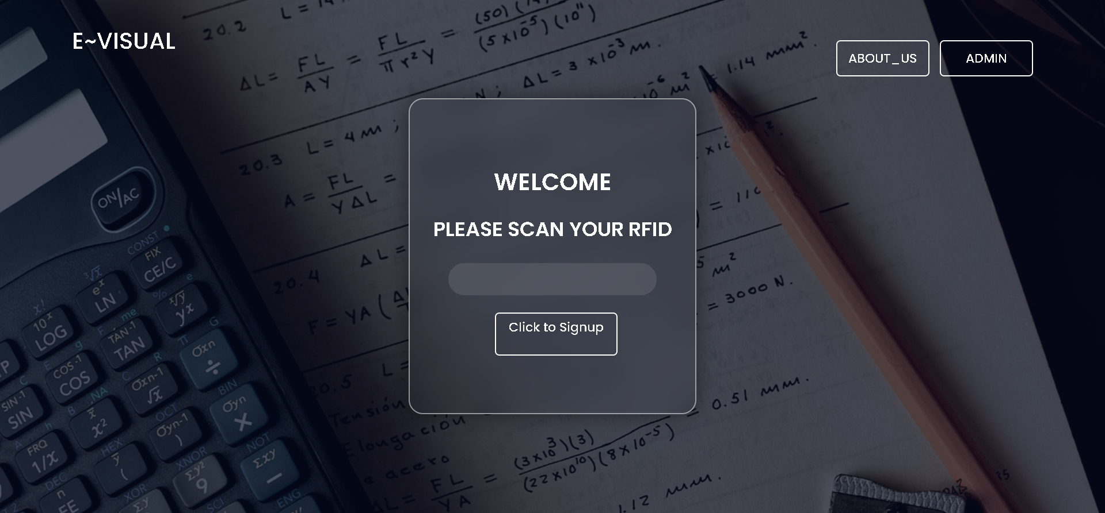

**Fig .2. Home page of e~visual online examination**

The above mentioned **figure.2** is the home page of the examination system where the user uses to login or Signup.

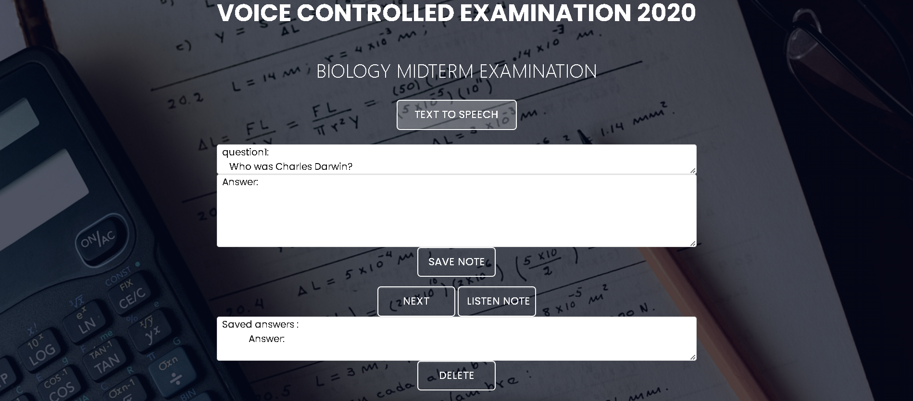

**Fig .3. Exam page of e~visual online examination**

The above mentioned **figure.3** is the main page of the examination system where the user can start answering.

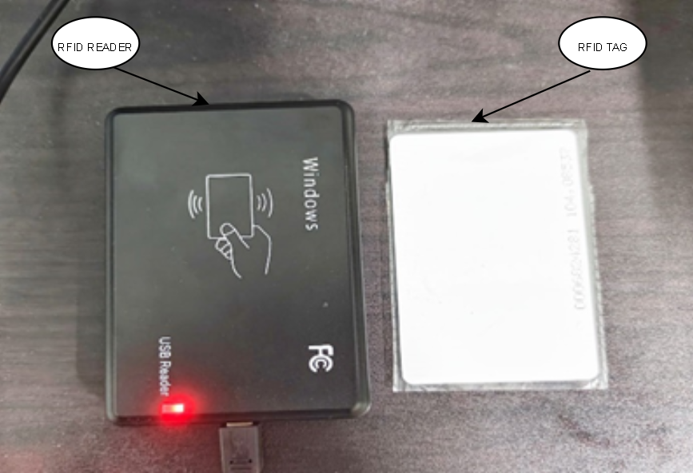

**Fig .4. RFID used in e~visual online examination**

The above mentioned **figure.4** is the actual image of the physical RFID reader and the tag where the use uses it for his/her validation.

**C.CLOUD PLATFORM (MYSQL)**

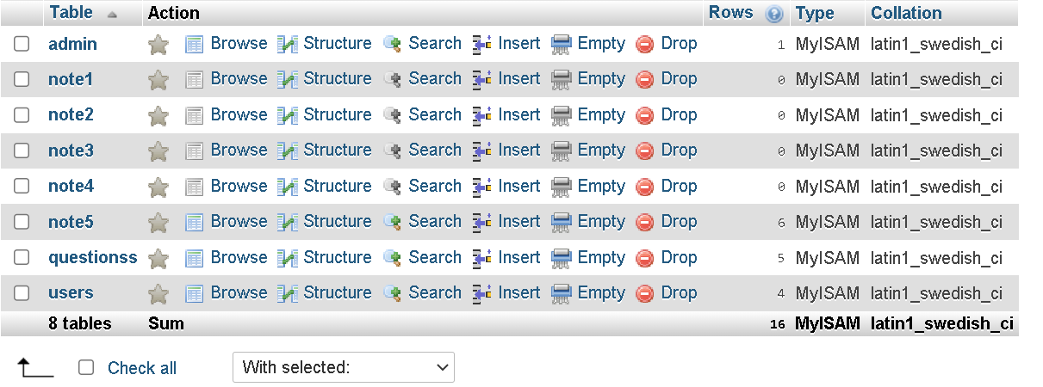

**Fig .5. Backend database of e~visual online examination**

The above mentioned **figure .5** is the MySQL database where all the answers, questions, login credentials , are stored.

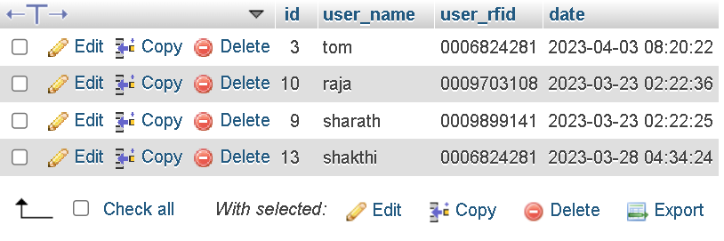

**Fig .6. database of the users registered on e~visual online examination**

The above mentioned **figure.6** is the MySQL database of the users that are already registered using their **user_rfid** which is integrated to the users RFID tag

**VI. PERFORMANCE MEASURE**

Various performance measures have been done where the results are shown in the below figures

1. **Content size by Content type**

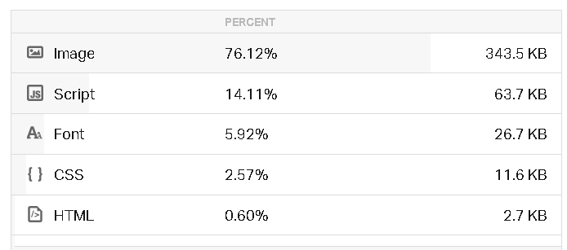

**Fig .7. contains the types of contents used in the**

**study according to their size.**

Theabove mentioned figure.7 is the table which contains all the information regarding contents that are used in the study

1. **Performance metrics**

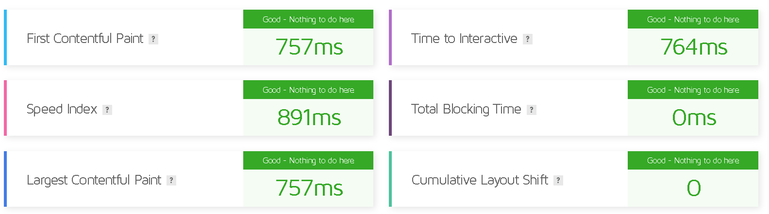

**Fig .8.** **The following metrics are generated**

**using Lighthouse Performance data.**

The above mentioned figure.8 is the generated data of various metrics such as speed index,TOI,TBT, cumulative layout shift etc.

1. **Waterfall Model**

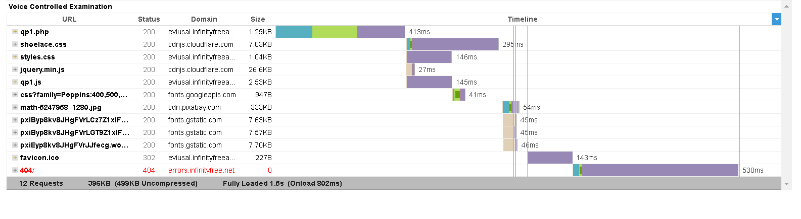

**Fig .9.**  **Total size of the study using waterfall model**

The above mentioned figure.9 is the waterflow model

which explains the size of the project is distributed file by file.

1. **GTmatrix**

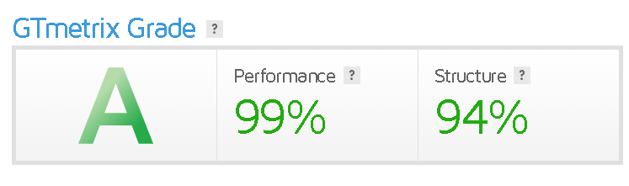

**Fig .10.**  **Total score simulated in GTmatrix**

The above mentioned figure.10 is the complete score of the efficiency and performance of the project.

# VII.CONCLUSION

In conclusion, the development and implementation of an online examination system for visually impaired students hold great promise in improving the assessment process. This study aimed to investigate the usability and effectiveness of such a system on the unique challenges faced by visually impaired students during online examinations.

Secondly, user feedback and performance provided valuable information of user satisfaction and system effectiveness. It became clear that an intuitive user interface, easy navigation, and appropriate time management features significantly contributed to the positive experience of visually impaired students all around.

**VIII.FURTURE ENHANCEMENT**

Our website contains all the functionalities from the user registering his account to writing the exam. As a future enhancement the study can be further developed by adding the admin page and panel mentioned in module 3 where the teacher for instance can evaluate the answers written by each student and check for the total number of users and can also add exam subjects, delete exam subjects, add users , delete users , modify the user details etc.

The study can be further implemented by using face recognition modules and fingerprint recognition software for the users validation.

**IX.ACKNOWLEDGEMENT**

I would like to express my sincere gratitude to B.M.S College of Engineering for their support of my study which allowed me to complete my study. I am also grateful for the use of the college's facilities, which were essential to the success of my study.

**X.REFERENCES**

1. Yurtay, Nilufer, Yuksel Yurtay, and M. Fatih Adak. "An education portal for visually impaired." Procedia-Social and Behavioral Sciences 171 (2015): 1097-1105.
2. Suman K. Saksamudre, P.P. Shrishrimal and R.R. Deshmukh, "A Review on Different Approaches for Speech Recognition System", International Journal of Computer Applications, vol. 115, no. 22, 2015.
3. Barry Hampshire,”Working with Braille: a study of Braille as a medium of communication”; 1981
4. Ambrose A. AZETA, Itorobong A. INAM and Olawande DARAMOLA, "A voice-based e-examination framework for visually impaired students in open and distance learning", Turkish Online Journal of Distance Education-TOJDE, vol. 19, no. 2, pp. 34-46, 2018.
5. Anupriya, A., and S. Vijayalakshmi. "An efficient examination system for blinds with real time voice interface." J. Comput. Sci. Mob. Comput 4, no. 3 (2015): 345-348
6. Chapaneri and Santosh, "Spoken Digits Recognition using Weighted MFCC and Improved Features for Dynamic Time Warping", International Journal of Computer Applications, vol. 2, no. 4, pp. 6-12, 2012.
7. Akriti Vats, Apoorv Tandon, De epam Varshney and Amit Sinha, "Voice Operated Tool-Examination Portal for Blind Persons", International Journal of Computer Applications, vol. 142, no. 14, pp. 0975-8887, 2016.
8. Eungjum Kim, Hoijin Yoon and Wonuk Cha, "Text-based testing environment for voice-based service", 25th Asis-Pacific software engineering conference (APSEC), 2018.
9. Balasuriya, B. K., N. P. Lokuhettiarachchi, A. R. M. D. N. Ranasinghe, K. D. C. Shiwantha, and C. Jayawardena. "Learning platform for visually impaired children through artificial intelligence and computer vision." In *2017 11th International Conference on Software, Knowledge, Information Management and Applications (SKIMA)*, pp. 1- 7. IEEE, 2017
10. Kumar, M. Naveen, PC Linga Chandar, A. Venkatesh Prasad, and K. Sumangali. "Android based educational Chatbot for visually impaired people." In *2016 IEEE International Conference on Computational Intelligence and Computing Research (ICCIC)*, pp. 1-4. IEEE, 2016.
11. S. Khan, S. Verma, S. Agarwal, P. K rishnatrey and S. Sharma, "Voice Based Online Examination for Physically Challenged", MIT International Journal of Computer Science and Information Technology, vol. 5, no. 2, pp. 58-61, 2015.
12. K. A. Bharadwaj, M. M. Joshi, N. S. Kumbale, N. S. Shastry, K. Panimozhi and A. Roy Choudhury, "Speech Automated Examination for Visually Impaired Students", 2nd International Conference on Innovative Mechanisms for Industry Applications (ICIMIA), 2020.
13. Mulloy, Austin M., Cindy Gevarter, Megan Hopkins, Kevin S. Sutherland, and Sathiyaprakash T. Ramdoss. "Assistive technology for students with visual impairments and blindness." In *Assistive technologies for people with diverse abilities*, pp. 113-156. Springer, New York, NY, 2014.
14. Bose, Prince, Apurva Malpthak, Utkarsh Bansal, and Ashish Harsola. "Digital assistant for the blind." In *2017 2nd International Conference for Convergence in Technology (I2CT)*, pp. 1250-1253. IEEE, 2017
15. Yurtay, Nilufer, Yuksel Yurtay, and M. Fatih Adak. "An education portal for visually impaired." *Procedia-Social and Behavioral Sciences* 171 (2015): 1097-1105.
16. Wafa Elmannai, Khaled Elleithy, “Sensor- Based Assistive Devices for Visually-Impaired People: Current Status, Challenges, and Future Directions”, Sensors (Besel) journal, 2017 Mar; 17(3): 565,Published online 2017 Mar 10,doi: 10.3390/s17030565
17. Ghali, Neveen I., Omar Soluiman, Nashwa El-Bendary, Tamer M. Nassef, Sara A. Ahmed, Yomna M. Elbarawy, and Aboul Ella Hassanien. "Virtual reality technology for blind and visual impaired people: reviews and recent advances." In Advances in Robotics and Virtual Reality, pp. 363-385
18. American Foundation for the Blind, ”blindness and low vision” © Copyright 2019 American Foundation for the Blind.
19. Rahi JS1, Sripathi S, Gilbert CE, Foster A ,International Centre for Eye Health, Department of Preventive Ophthalmology, “Childhood blindness in India: causes in 1318 blind school students in nine states.” ( Pt 5):545-50.
20. Manoharan, S. (2019). A Smart Image Processing Algorithm for Text Recognition, Information Extraction and Vocalization for the Visually Challenged. Journal of Innovative Image Processing (JIIP), 1(01), 31-38.