**VISVESVARAYA TECHNOLOGICAL UNIVERSITY**

**“Jnana Sangama”, Belgaum -590014, Karnataka.**



**PROJECT WORK-2 REPORT**

**On**

**“ONLINE EXAMINATION SYSTEM”**

***Submitted by***

**SHAKTHI(1BM20CS144)**

**SANSKAR SHAH(1BM20CS142)**

**SHREYAS J(1BM20CS155)**

**SHATAKSHI UPADHYAYA(1BM20CS149)**

***Under the Guidance of***

**Dr.K.Panimozhi**

**Assistant Professor,**

**Department of CSE**

***in partial fulfillment for the award of the degree of***

**BACHELOR OF ENGINEERING**

***in***

**COMPUTER SCIENCE AND ENGINEERING**



**B.M.S. COLLEGE OF ENGINEERING**

**(Autonomous Institution under VTU)**

**BENGALURU-560019**

**May–September 2022**

**B. M. S. College of Engineering,**

**Bull Temple Road, Bangalore 560019**

(Affiliated To Visvesvaraya Technological University, Belgaum)

**Department of Computer Science and Engineering**



**CERTIFICATE**

This is to certify that the project work entitled **“ONLINE EXAMINATION SYSTEM”** carried out by **SHAKTHI(1BM20CS144), SANSKARSHAH (1BM20CS142), SHREYASJ(1BM20CS155), SHATAKSHI UPADHYAYA** **(1BM20CS149)** who are bonafide students of **B. M. S. College of Engineering.** It is in partial fulfillment for the award of **Bachelor of Engineering in Computer Science and Engineering** of the Visveswaraiah Technological University, Belgaum during the year 2022 The project report has been approved as it satisfies the academic requirements in respect of **ProjectWork-2 (19CS4PWPW2)** work prescribed for the said degree.

Signature of the Guide                 Signature of the HOD **Dr.K.PANIMOZHI** **Dr.** **JYOTHI S NAYAK**

Assistant Professor Prof & Head of Dept of CSE

BMSCE, Bengaluru BMSCE, Bengaluru

External Viva

Name of the Examiner                                                               Signature with date

**B.M.S. College of EngineerinG**

**DEPARTMENT OF COMPUTER SCIENCE AND ENGINEERING**



**DECALARATION**

We, **SHAKTHI(1BM20CS144), SANSKAR SHAH(1BM20CS142), SHREYAS J(1BM20CS155), SHATAKSHI UPADHYAYA(1BM20CS149)** students of 4th Semester, B.E, Department of Computer Science and Engineering, BMS College of Engineering, Bangalore, hereby declare that, this Project Work-2 entitled **"ONLINE EXAMINATION SYSTEM"** has been carried out by us under the guidance of Prof. Dr.K.Panimozhi, Department of CSE, B.M.S. College of Engineering, Bangalore during the academic semester May-September 2022.

We also declare that to the best of our knowledge and belief, the development reported here is not from part of any other report by any other students.

Signature

**SHAKTHI(1BM20CS144)**

**SANSKAR SHAH (1BM20CS142)**

**SHREYAS J (1BM20CS155)**

**SHATAKSHI UPADHYAYA (1BM20CS149)**

**TABLE OF CONTENTS**

|  |  |  |
| --- | --- | --- |
| **Serial No.** | **TITLE** | **PAGE NO.** |
| 1 | **Chapter-1:Introduction**  1.1 Overview  1.2 Motivation | 1 |
| 2 | **Chapter-2:Software Requirement Specification**  2.1 Hardware Requirements  2.1 Software Requirements | 2 |
| 3 | **Chapter-3:ER diagram of the project** | 3 |
| 4 | **Chapter-4:Schema of project** | 4 |
| 5 | **Chapter-5:User Interface Design**  5.1 Login Page  5.2 Dashboard  5.3 Admin Login/Access  5.4 Result Page | 5  6  7  8  9 |
| 6 | **Chapter-6:Advantages of Online Examination System**  **Chapter-7:Disadvantages of Online Examination System** | 10 |
| 7 | **Chapter-8:Backend/no of tables** | 11 |
| 8 | **Chapter-9:Future Enhancements of our Project** | 12 |
| 9 | **Chapter-10:Languages Used** | 13 |
| 10 | **Chapter-11:References** | 10 |

**CHAPTER – 1**

**INTRODUCTION**

* 1. **Overview**

Online Examination System is a technology-driven way to simplify examination activities like defining exam patterns with question banks, defining exam timer, objective/ subjective question sections, conducting exams using the computer or mobile devices in a paperless manner.

* 1. **Motivation**

In customary framework directing exam is extremely repetitive work for analyst and educator too. The entire procedure of allocating exam and assessing their score after the test was done physically till date. Be that as it may, online examination framework is absolutely electronic framework. The framework goes for diminishing expenses connected with directing exams over a timeframe and accomplishing complete computerization of examination framework related assignments like enlistment, distribution of results, which prompts a high level of framework effectiveness. In the wake of experiencing huge numbers of reference papers at long last we are concluded that we can manufactured one examination framework that can be give easy to understand access to establish for directing exam and investigation of result.

**CHAPTER -2**

**SOFTWARE REQUIREMENTS**

**2.1 Hardware Requirements:**

* A PC with the following or greater specifications:
  + Intel Core i3or higher
  + 8 GB RAM
  + 500 GB Hard Drive
* A stable internet connection (2Mbps or higher)

**2.2Software Requirements:**

* Operating system : Windows,
* Front end technologies are : HTML, CSS, JavaScript,PHP
* IDE : VS Code, Sublime text
* Back end requirement : PHP
* Server : XAMPP server

**CHAPTER-3**

**ER DIAGRAM OF THE PROJECT**

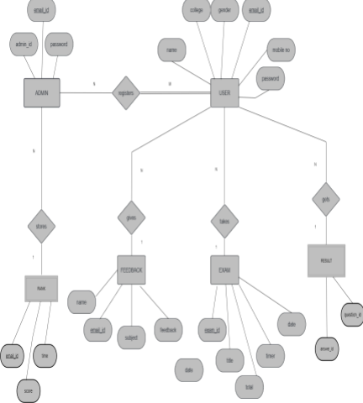

**Fig: 3.1 ER DIAGRAM**

* The admin table is a strong entity with a primary key of admin_id
* And attributes of email-id and password
* The admin table is connected to the user, rank, history, and feedback table
* The user table is a strong entity with a user_id as the primary key
* with attributes like college, name, usn, gender
* the exam table stores the no of exams present
* the feedback table consists of the feedbacks of the student
* the result page consists of the results of the student

**CHAPTER-4**

**SCHEMA OF THE PROJECT**

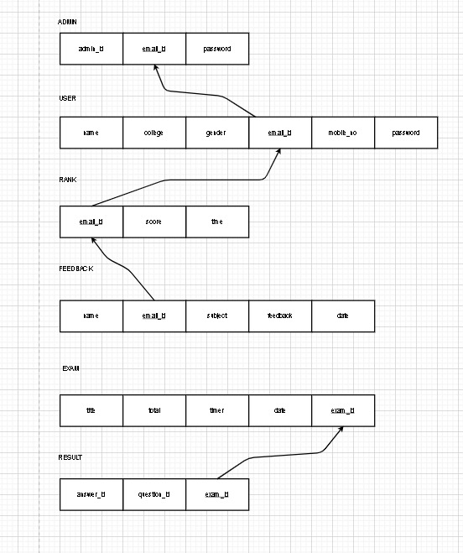

**Fig:4.1 SCHEMA DIAGRAM**

**CHAPTER-5**

**USER INTERFACE DESIGN**

**LOGIN PAGE**

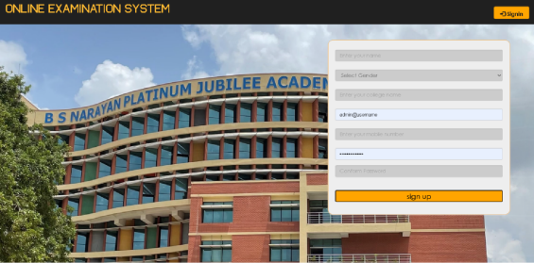

**Fig:5.1**

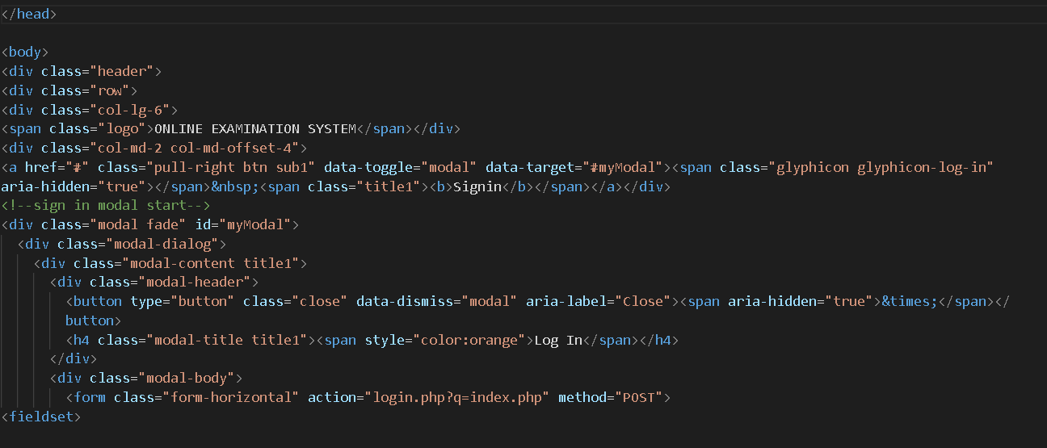

**Fig:5.2**

**FEATURES OF LOGIN PAGE**

**FIRST CLICK ON THE SIGN IN BUTTON:**

⚫There will be specific user_id and a password to enter for each student.

YOU CAN ALSO ACCESS:

⚫Admin login page

⚫Developers page

⚫Feedback page

⚫About us page

**YOU CAN ALSO ACCESS/SIGN UP IF THE STUDENT DOES NOT HAVE AN ACCOUNT**

⚫Enter your name

⚫Select your gender

⚫Enter your college name

⚫Admin@username

⚫Enter mobile no

⚫Password

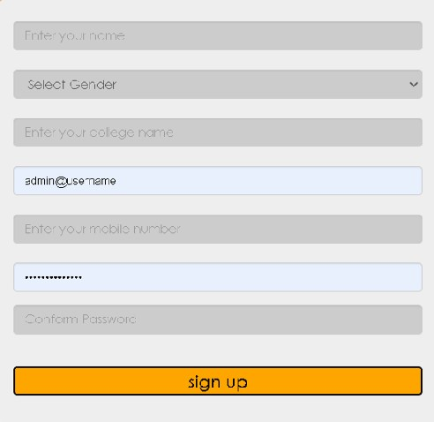

**Fig:5.3**

**DASHBOARD**

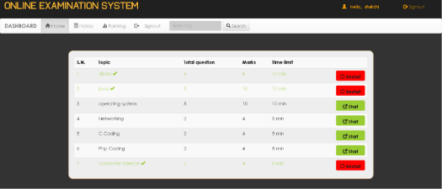

**Fig:5.4**

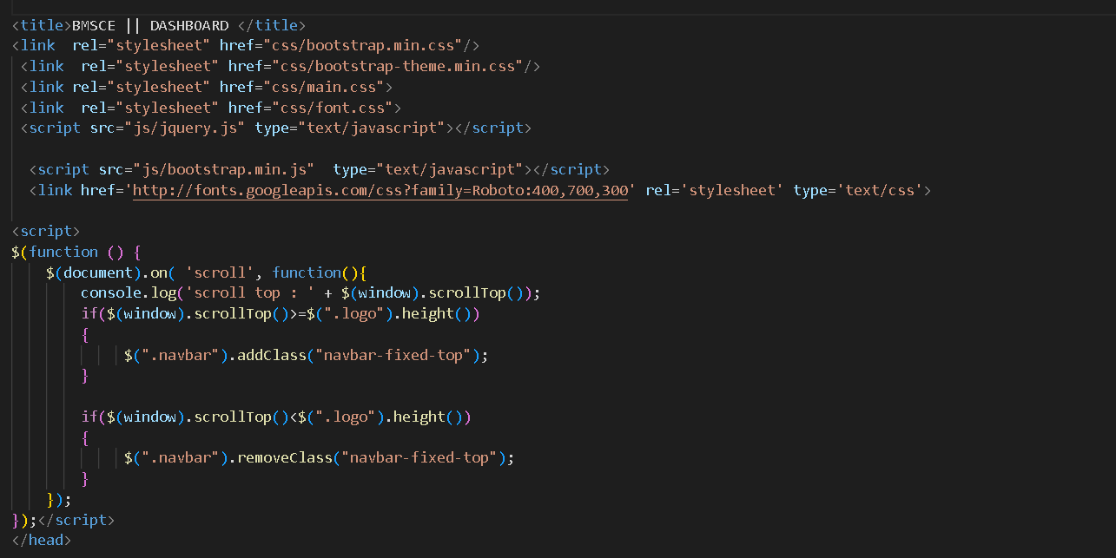

**Fig:5.5**

**FEATURES OF OUR DASHBOARD**

1. Once the user/student log’s into the dashboard he/she can start the respective exam
2. The user can also view his/her history to see the previous attempts of the

examination

3 The user can view their ranking and compare their marks among themselves

4 The user has a negative marking for each question he/she answers , he/she gets a minus of 1 mark

1. For each wrong attempt once the user finishes the exam he/she can sign out and exit

**ADMIN/LOGIN ACCESS**

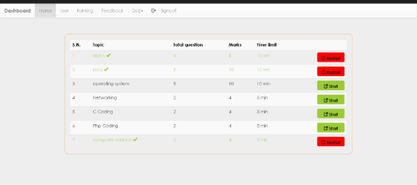

**Fig:5.6**

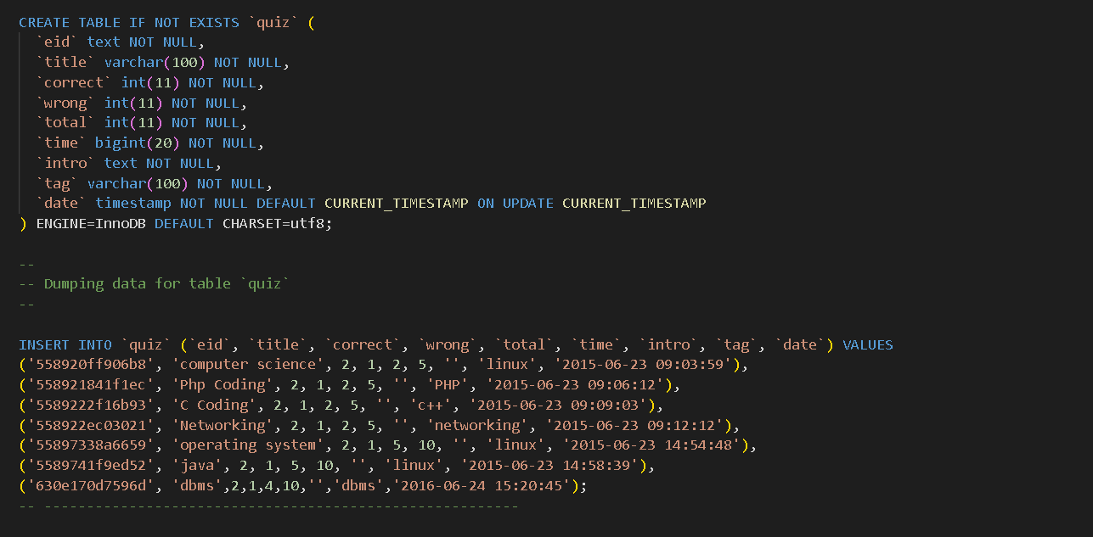

**Fig:5.7**

**FEATURES OF ADMIN PAGE**

1. The admin controls the all over access of the online examination website
2. The admin can see the number of users present
3. The admin can see the ranking of the users present
4. The admin can see the feedback(comments) of the students regarding their exam
5. The admin can also add/remove the quiz anytime .

**RESULT PAGE**

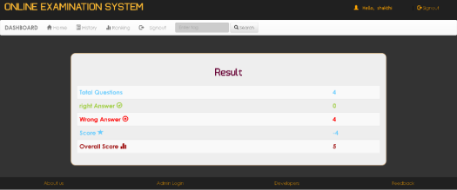

**Fig:5.8**

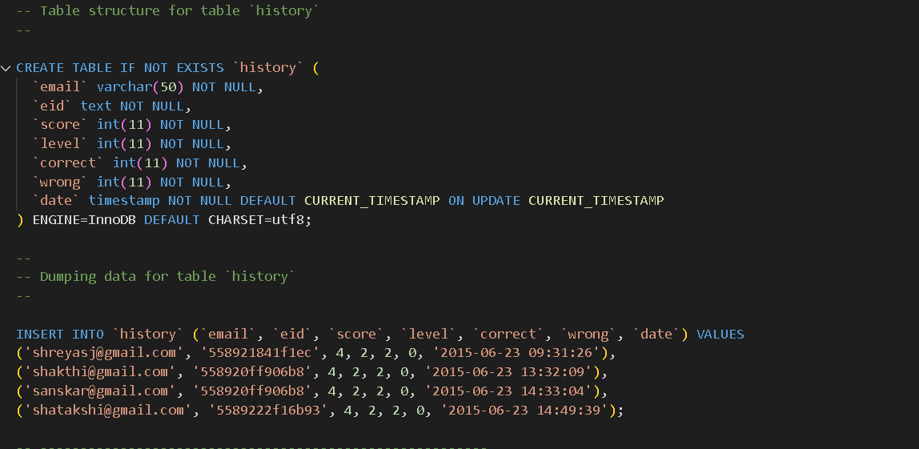

**Fig:5.9**

**FEATURES OF RESULT PAGE**

1. The user gets his/her result as soon as the exam is completed
2. The result is also stored in the history page and can be accessed anytime
3. The ranking among the students is ranked based on the result the user gets

**CHAPTER-5**

**ADVANTAGES OF ONLINE EXAMINATION SYSTEM**

1. **Environmentally friend:**Pen-and-paper examinations require a lot of paper to print question and answer sheets. There is also a lot of waste due to printing errors or over-estimation of learner numbers, hence we can avoid that using online exams
2. **Saves you money** : Since everything is online, there are no printing costs and no logistics costs. You also save money on examination facilities and having to pay facilitators and invigilators to oversee the exams
3. **Saves time, big time** : Not only is there less time between the setting of the ‘paper’, but it also saves students time by eliminating the time it takes to travel to-and from examination locations, then waiting for the papers to be handed out and collected
4. **It's convenient** : Examiners can set papers using question banks, and by consulting a database of previous papers, then easily upload it to the examination system. Students can select exam times that suit them best and since the exams are online, do it

**CHAPTER-6**

**DISADVANTAGES OF ONLINE EXAMINATION SYSTEM**

1. **Challenges of tech** : he transition from traditional pen-and-paper to online may be difficult for some, especially older learners who are not computer literate.
2. **Infrastructure problems** : One of the biggest hurdles of online examinations is learner access to technology, including computers/tablets and/or a stable internet connection.
3. **Not all grading is the same** : instant or near-instant grading is a big advantage of online examinations, however, not all types of exams lend themselves to auto-assessment.
4. **Susceptible to cheating** : No matter what platform an exam is taken on, whether it be online or traditional pen-and-paper, there will always be cheating. However, online examinations can be especially vulnerable to cheating like screen sharing with other exam-takers

**CHAPTER-7**

**BACKEND/NO OF TABLES CREATED**

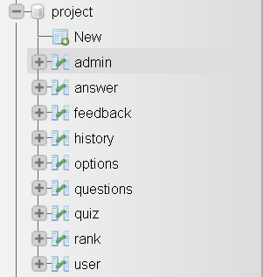

**Fig:7.1**

**ADMIN TABLE**

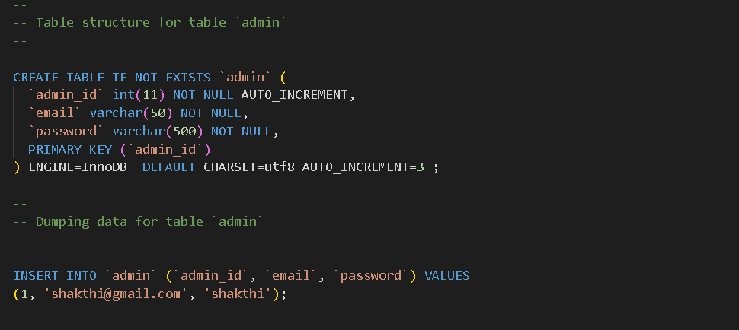

**Fig:7.2**

**FEEDBACK TABLE**

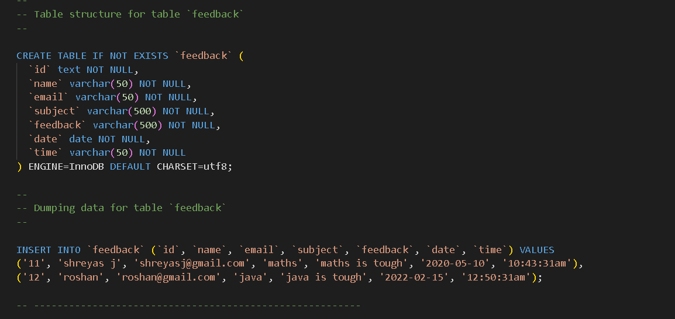

**Fig:7.3**

**ANSWER TABLE**

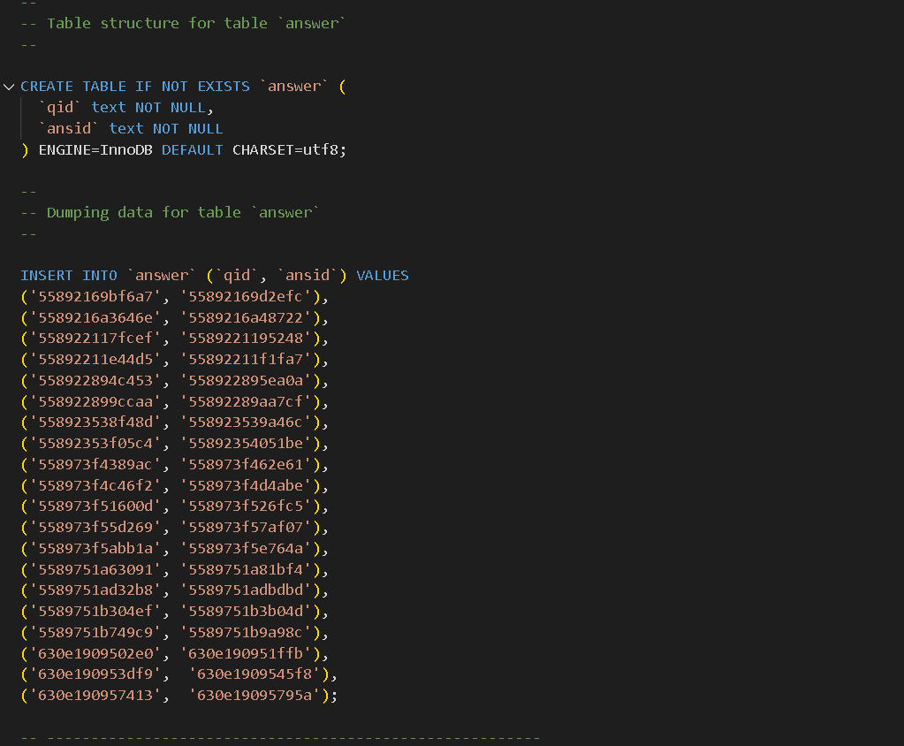

**Fig:7.4**

**HISTORY TABLE**

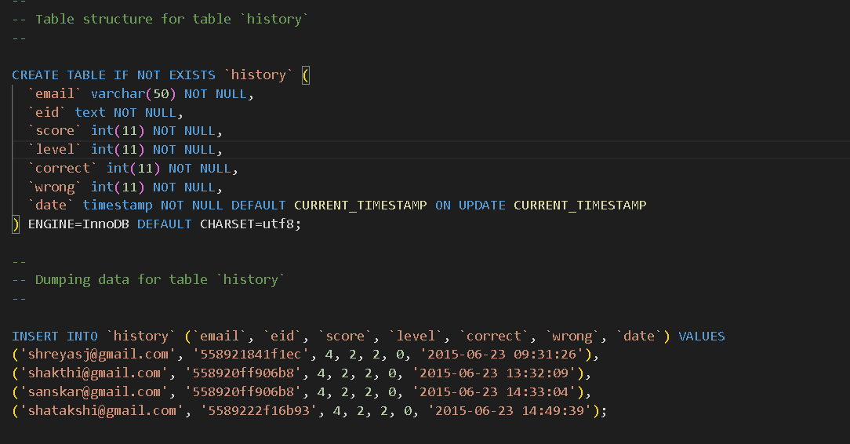

**Fig:7.5**

**OPTIONS TABLE**

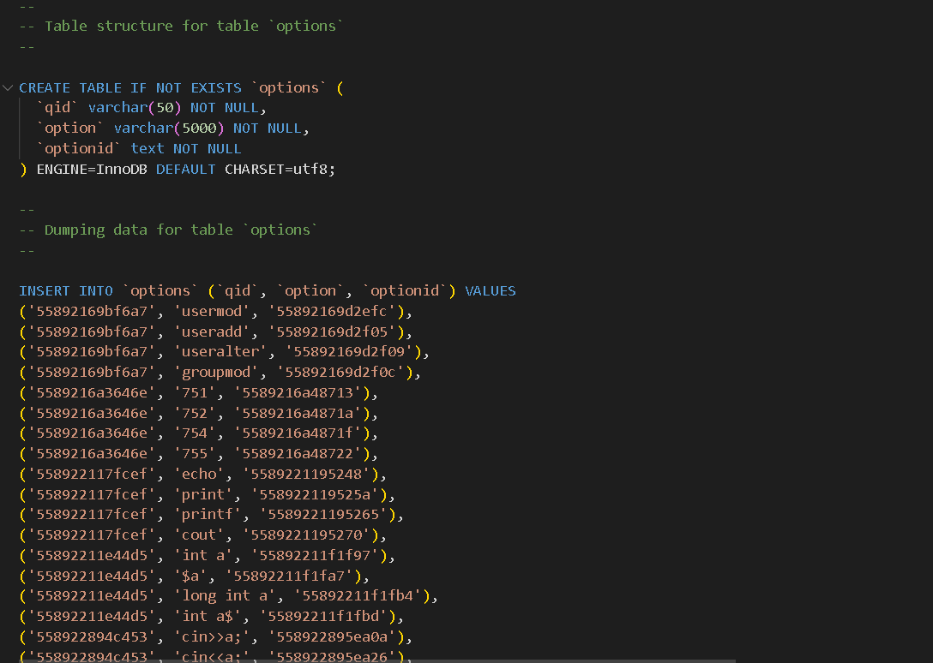

**Fig:7.6**

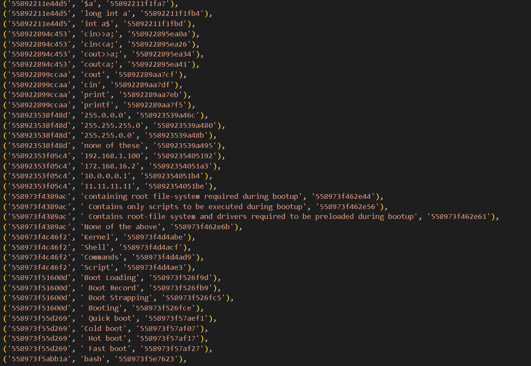

**Fig:7.6(continuation)**

**QUESTIONS TABLE**

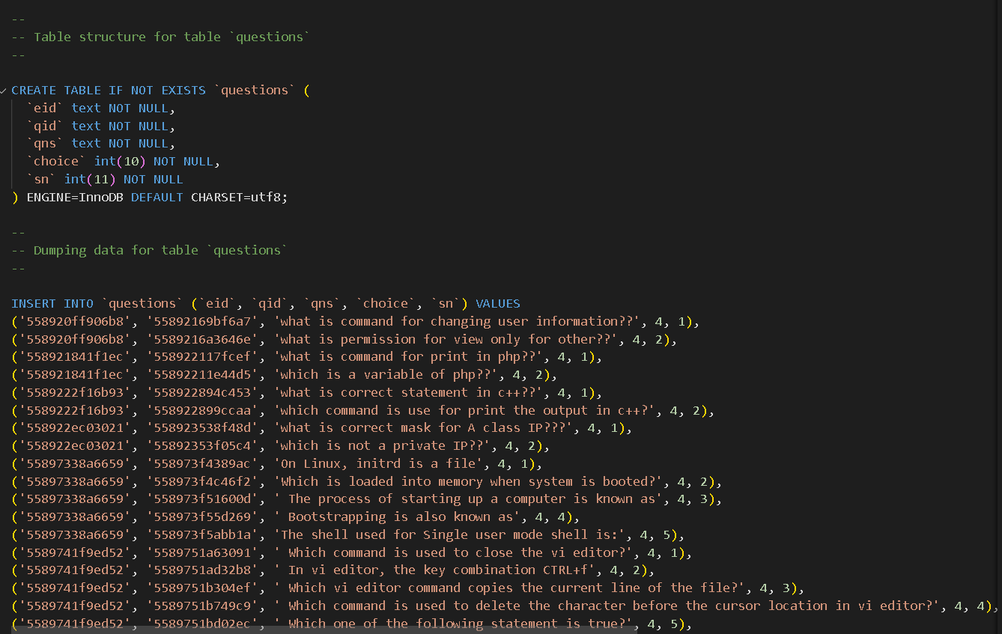

**Fig:7.7**

**QUIZ TABLE**

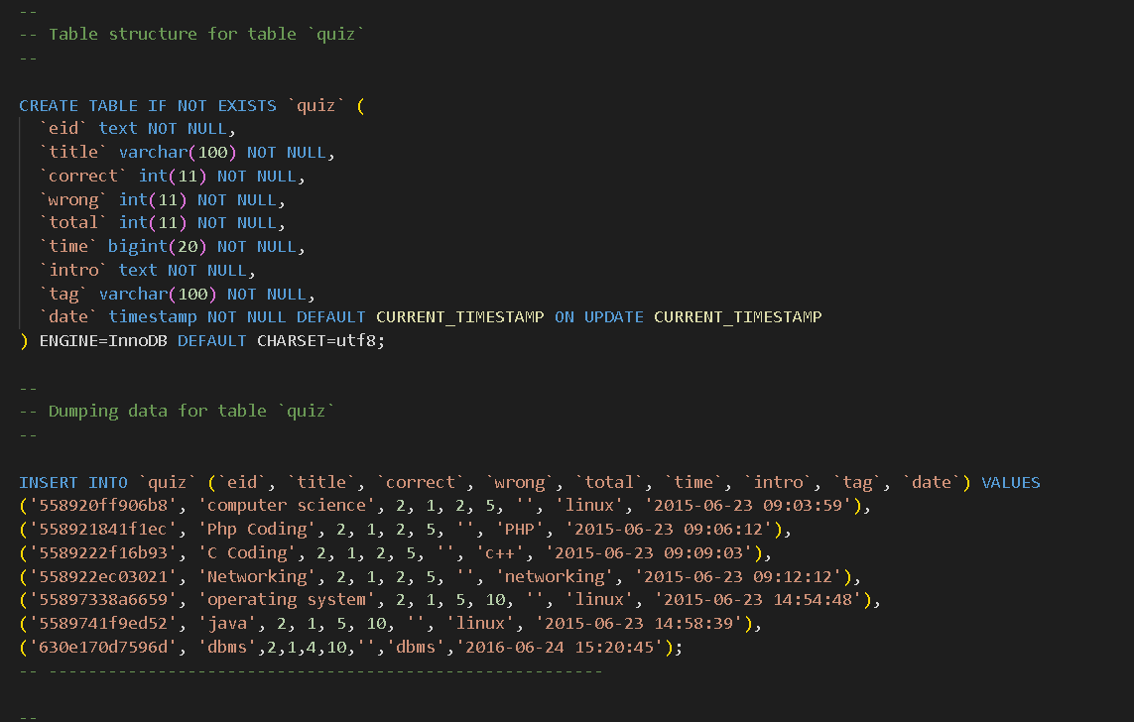

**Fig:7.8**

**RANK TABLE**

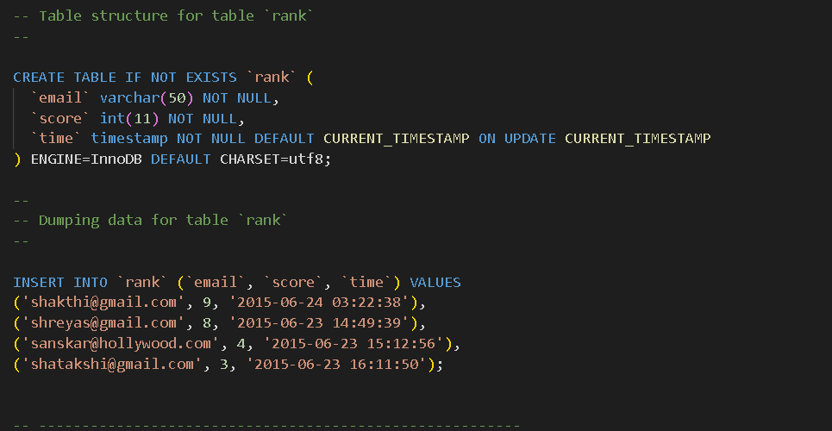

**Fig:7.9**

**USER TABLE**

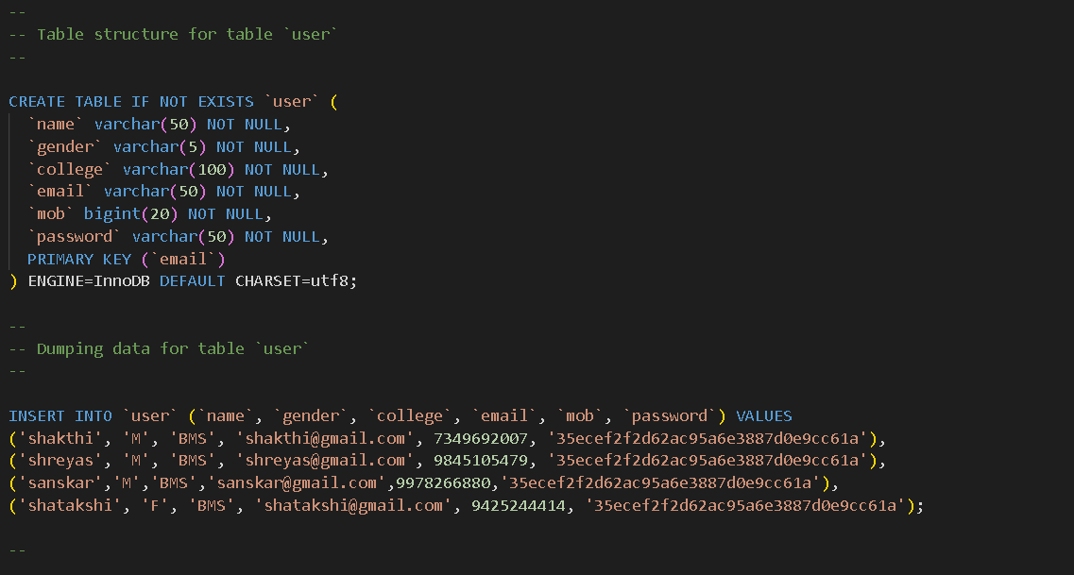

**Fig:7.10**

**CHAPTER-8**

**FUTURE ENHANCEMENTS OF OUR PROJECT**

1. Automation Of Planning And Scheduling.
2. Assessment Pattern Creation.
3. Question Bank Management.
4. Configuration Of Questions
5. Easy Approval.
6. Multi-Language Support

**CHAPTER-10**

**LANGAUGES USED**

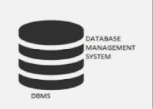

**The languages used are:**

**DBMS**

**PHP**

**CSS(STYLING)**

**JAVASCRIPT**

**HTML**

**REFERENCES:**

**[1] .** [**https://www.youtube.com/watch?v=R1djM9B0ay0**](https://www.youtube.com/watch?v=R1djM9B0ay0)

**[2].** [**https://www.youtube.com/watch?v=2HVKizgcfjo**](https://www.youtube.com/watch?v=2HVKizgcfjo)

**[3].** **https://www.youtube.com/watch?v=WYufSGgaCZ8**