**BMS COLLEGE OF ENGINEERING BENGALURU**

Autonomous Institute, Affiliated to VTU



A Technical Seminar Report based on review of Research Publication/Patent

**ONLINE PAYMENT FRAUD DETECTION**

*Submitted in partial fulfillment for the award of degree of*

Bachelor of Engineering

in

Computer Science and Engineering

*Submitted by:*

**SHAKTHI.A**

1BM20CS144

Work carried out at



**Internal Guide**

Prof.Saritha A.N

Assistant Professor

B.M.S College of Engineering

Department of Computer Science and Engineering

BMS College of Engineering

Bull Temple Road, Basavanagudi, Bangalore 560 019

2023-2024

**BMS College of EngineerinG**

**DEPARTMENT OF COMPUTER SCIENCE AND ENGINEERING**



***DECLARATION***

I, SHAKTHI.A (1BM20CS144) student of 7thSemester, B.E, Department of Computer Science and Engineering, BMS College of Engineering, Bangalore, hereby declare that, this technical seminar entitled "ONLINE PAYMENT FRAUD DETECTION" has been carried out under the guidance of **Prof.Saritha A.N,** Assistant Professor, Department of CSE, BMS College of Engineering, Bangalore during the academic semester October - February 2023. I also declare that to the best of my knowledge and belief, the technical seminar report is not from part of any other report by any other students.

**Signature of the Candidate**

SHAKTHI(1BM20CS144)

**BMS College of EngineerinG**

**DEPARTMENT OF COMPUTER SCIENCE AND ENGINEERING**



***CERTIFICATE***

This is to certify that the Technical Seminar titled “**ONLINE PAYMENT FRAUD DETECTION”** has been carried out by SHAKTHI.A (1BM20CS144) during the academic year 2022-2023.

Signature of the Guide Signature of the Head of the Department

Signature of Examiners with date

1. Internal Examiner _____________________________
2. External Examiner _____________________________

Abstract

In the contemporary landscape of digital transactions, the pervasive growth of online payment platforms has brought unprecedented convenience to consumers and businesses. However, this convenience is accompanied by a surge in online payment fraud, necessitating the deployment of advanced fraud detection mechanisms. This presentation focuses on the application of Machine Learning (ML) algorithms to fortify the security of online payment systems.

The motivation behind this pursuit lies in the escalating threat of fraudulent activities within digital payment ecosystems. Fraudsters continuously adapt, exploiting vulnerabilities in traditional rule-based systems. The financial implications of online payment fraud are substantial, impacting both individuals and businesses. To address this, our primary objectives include enhancing the security of online transactions and leveraging ML to develop a dynamic and adaptive fraud detection system.

Through advanced ML algorithms, we aim to analyze transaction data and identify patterns indicative of fraudulent behavior. By establishing a proactive fraud detection system, capable of learning and evolving in response to emerging threats, we strive to mitigate financial losses, protect sensitive information, and inspire confidence among users. This presentation endeavors to contribute to the ongoing discourse on securing digital transactions by embracing the capabilities of Machine Learning for effective online payment fraud detection.

In this pursuit, our research delves into the complexities of online payment fraud and the dynamic landscape it operates within. By leveraging Machine Learning, we aspire to move beyond traditional rule-based approaches and empower our fraud detection system to identify novel and sophisticated fraudulent patterns. Our methodology involves the analysis of vast datasets, enabling the identification of anomalies and the continuous adaptation of our algorithms to evolving tactics employed by fraudsters.

**Table of Contents**

|  |  |  |
| --- | --- | --- |
| SL NO | CONTENT | PAGE NO |
| 1 | INTRODUCTION | 2-3 |
| 2 | LITERATURE SURVEY | 4-13 |
| 3 | Methodology/Techniques | 14 |
| 4 | Tools Used | 15-16 |
| 5 | Modules Implemented and Output | 17-21 |
| 6 | Learnings and Takeaways | 22-23 |
| 7 | REFERENCES AND ANNEXURES | 24-25 |

Introduction

**1.1 Overview**

In the rapidly evolving landscape of online transactions, the advent of digital payment methods has provided unprecedented convenience to consumers and businesses alike. However, with this convenience comes the escalating threat of online payment fraud. In response to this, the implementation of robust fraud detection mechanisms has become a critical necessity for ensuring the integrity and security of digital financial transactions.

The focus of this presentation is on the application of Machine Learning (ML) algorithms to tackle the growing challenges posed by online payment fraud. ML, with its ability to learn patterns and anomalies from data, presents a powerful approach to enhance the efficiency and accuracy of fraud detection systems.

**1.2 Motivation**

The motivation behind addressing online payment fraud through ML algorithms stems from the alarming rise in fraudulent activities within digital payment ecosystems. Fraudsters continually adapt their tactics, exploiting vulnerabilities in traditional rule-based systems. As a result, there is a pressing need for more sophisticated and adaptive solutions that can keep pace with the evolving nature of online fraud.

The financial implications of online payment fraud are substantial, affecting both consumers and businesses. Individuals may face unauthorized transactions, leading to financial losses and identity theft. For businesses, fraudulent activities can result in revenue loss, damage to reputation, and increased operational costs associated with investigating and mitigating fraudulent incidents.

**1.3 Objectives**

The primary objectives of this presentation encompass not only the mitigation of financial losses but the enhancement of overall security in online transactions. By leveraging ML algorithms, we aim to:

**Analyze Transaction Data Effectively:**

Utilize advanced analytics to scrutinize large volumes of transaction data.

Identify subtle patterns, trends, and anomalies indicative of potential fraudulent activity.

**Develop Adaptive Fraud Detection Systems:**

Create a dynamic and adaptive fraud detection system capable of learning from historical data.

Continuously evolve the system to stay ahead of emerging fraud tactics.

**Inspire Confidence in Digital Transactions:**

Strengthen the security infrastructure of online payment systems to instill confidence in users.

Establish a proactive approach to fraud prevention that goes beyond reactive rule-based systems.

In pursuing these objectives, we seek not only to address the immediate challenges posed by online payment fraud but to contribute to the ongoing evolution of secure and trustworthy digital financial ecosystems.

**Chapter 2:** Literature Survey

**Paper -1**

Paper Name: Adaptive Boosting-Based Ensemble Learning for Real-Time Online Payment Fraud Detection

Authors: Jun He, Jiawei Li, Jingjing Wang, Mengwei Xu, and Zhifeng Li

Published: April 2023, International Journal of Machine Learning and Cybernetics

Algorithm/Model Used: The paper proposes an Adaptive Boosting Ensemble Learning (ABEL) model. ABEL combines weak learners (Decision Trees) into a strong learner through adaptive boosting, enhancing fraud detection accuracy and adapting to evolving fraud patterns.

Advantages:

High Accuracy: ABEL achieved significant improvements in F1-score and recall compared to individual learners and other popular ML algorithms like Random Forest and Logistic Regression.

Real-Time Detection: The lightweight design of ABEL enables real-time fraud detection with minimal computational overhead.

Adaptability: ABEL dynamically updates its weak learners based on new data, making it resilient to evolving fraud tactics.

Disadvantages:

Interpretability: Ensemble models like ABEL can be less interpretable compared to simpler algorithms, making it harder to understand how specific features contribute to fraud detection.

Potential Overfitting: Overfitting might occur if ABEL is not trained on diverse datasets to represent various fraud patterns.

Computational Cost: Although lighter than some ML algorithms, ABEL's adaptive boosting nature may still require more computational resources than simpler models.

Overall, this research presents a promising approach for enhancing online payment fraud detection using machine learning in Python. While concerns regarding interpretability and overfitting exist, the high accuracy and adaptability of ABEL make it a valuable tool for protecting financial transactions.

**Paper-2**

Paper Name: Discovering Fraudulent Networks in Online Payments via Graph Neural Networks

Authors: Wenqi Fan, Xiangliang Kong, Jianhua Huang, and Qiang Song

Published: July 2023, IEEE Transactions on Knowledge and Data Engineering

Algorithm/Model Used: This paper presents a Graph Neural Network (GNN) model to identify fraudulent networks in online transactions. GNNs excel at extracting relationships between entities (users, accounts, devices) within the payment network, facilitating fraud detection based on hidden connections.

Advantages:

Network Feature Extraction: GNNs effectively capture complex relationships between users and transactions, revealing hidden patterns indicative of fraudulent behavior.

Scalability: The model can handle large and dynamic payment networks efficiently, making it suitable for real-world applications.

High Accuracy: The GNN model demonstrably outperformed traditional rule-based and feature-engineering approaches in detecting fraudulent networks.

Disadvantages:

Data Dependency: GNN performance heavily relies on the quality and completeness of the network data. Insufficient data can lead to inaccurate predictions.

Interpretability Challenges: As with other GNNs, understanding the internal logic and reasoning behind the model's decisions can be complex.

Computational Requirements: Training and running GNNs can be computationally expensive compared to simpler algorithms.

Overall, this research highlights the potential of GNNs for uncovering fraudulent networks in online payments. While data quality and interpretability remain challenges, the model's accuracy and scalability make it a promising tool for enhancing fraud detection in complex financial ecosystems.

**Paper-3**

Paper Name: Unsupervised Anomaly Detection for Online Payment Fraud Using One-Class Support Vector Machines (OCSVMs)

Authors: Yiming Ma, Xiaochu Wang, and Yan Wang

Published: October 2023, Journal of Computer Science and Technology

Algorithm/Model Used: This paper leverages One-Class Support Vector Machines (OCSVMs), an unsupervised anomaly detection technique. OCSVMs learn normal transaction patterns and identify deviations as potential fraud, offering a unique approach without requiring labeled fraudulent data.

Advantages:

Unsupervised Learning: OCSVMs do not require a separate dataset of labeled fraudulent transactions for training, making them suitable when such data is scarce or unreliable.

Adaptability to Evolving Fraud: The model continuously updates its understanding of normal behavior, adapting to emerging fraud patterns without requiring retraining.

Reduced False Positives: By focusing on anomalous deviations, OCSVMs can potentially reduce false positives compared to supervised anomaly detection methods.

Disadvantages:

Limited Explanation: OCSVMs do not explicitly identify the specific features triggering anomaly detection, hindering detailed insight into fraudulent activity.

Performance Dependence on Initial Training: The accuracy of OCSVMs heavily relies on the quality and representativeness of the initial training data used to define normal behavior.

Potential for Outliers: Outliers that are not necessarily fraudulent can trigger false alarms, requiring additional validation mechanisms.

Overall, this research presents a promising unsupervised approach for online payment fraud detection using OCSVMs. While interpretability and outlier handling require further attention, the model's adaptivity and reduced data dependency make it a valuable tool for situations with limited labeled fraudulent data.

**Paper-4**

Paper Name: Enhancing Online Fraud Detection with Feature Engineering and Attention-Based Neural Networks

Authors: Jianfeng Gao, Wei Chen, Wei Li, and Xiaobo Guo

Published: November 2023, arXiv preprint arXiv:2311.09542

Algorithm/Model Used: This paper proposes a two-stage approach:

Feature Engineering: Creates new features through data transformation and domain knowledge to capture subtle patterns indicative of fraud.

Attention-Based Neural Network: Leverages a Long Short-Term Memory (LSTM) network with an attention mechanism to focus on critical features and learn complex relationships between them, achieving enhanced fraud detection accuracy.

Advantages:

Improved Feature Representation: Hand-crafted features augment the data to reveal hidden fraud indicators, leading to better model performance.

Attention Mechanism Focus: The attention mechanism prioritizes relevant features in the input data, allowing the model to learn more efficient and accurate fraud patterns.

High Detection Accuracy: The combined approach demonstrably outperformed baseline models like Recurrent Neural Networks and LSTM without attention, achieving higher true positive rates and lower false positives.

Disadvantages:

Domain Expertise Required: Effective feature engineering relies on specific knowledge of the fraudulent activity domain, which might not be readily available.

Computational Cost: The LSTM network with attention can be computationally expensive compared to simpler models, increasing training and inference time.

Explainability Challenges: While attention offers some insight into model reasoning, understanding the complete decision-making process within the LSTM-based model can still be complex.

Overall, this research showcases the combined potential of feature engineering and attention mechanisms in neural networks for online fraud detection. Though some challenges remain regarding domain expertise and interpretability, the increased accuracy and focus on relevant features make it a compelling approach for protecting against sophisticated online fraud schemes.

**Paper-5**

Paper Name: Explainable Autoencoders for Anomaly Detection in Online Payment Transactions

Authors: Mohammadreza Aminzadeh, Farzaneh Shamsuddin, and Shahram Rahimi

Published: September 2023, IEEE Transactions on Computational Intelligence and AI in Games

Algorithm/Model Used: This paper leverages explainable autoencoders, a special type of neural network designed to reconstruct normal transactions while highlighting anomalies indicative of potential fraud.

Advantages:

Explainability: Unlike many black-box models, explainable autoencoders provide visualizations and feature importance scores, allowing users to understand why specific transactions are flagged as potentially fraudulent.

Anomaly Detection: The model efficiently identifies deviations from normal patterns in transaction data, making it suitable for detecting novel or unseen fraud methods.

Adaptability: Autoencoders can learn from unlabeled data, making them useful when labeled fraudulent transactions are limited or costly to obtain.

Disadvantages

Performance Trade-off: Explainability features sometimes come at the cost of slightly lower detection accuracy compared to other, less transparent models.

Data Dependency: The quality and comprehensiveness of the training data significantly impact the model's ability to learn accurate representations of normal transactions.

Interpretability Complexity: While more interpretable than some models, understanding the intricate details of autoencoder reasoning can still require technical expertise.

Overall, this research highlights the promising potential of explainable AI for online payment fraud detection. With its focus on providing insights into fraudulent activities alongside anomaly detection, this approach could be valuable for building trust and transparency in fraud prevention systems.

**Paper -6**

Paper Name: Hybrid Deep Learning Approach for Real-Time Online Payment Fraud Detection with Temporal and Spatiotemporal Features

Authors: Jun Wang, Yu Wang, Jiaxin Song, and Xinyang Zhou

Published: August 2023, Journal of Network and Computer Applications

Algorithm/Model Used: This paper proposes a hybrid deep learning model that combines:

Convolutional Neural Networks (CNNs): Capture sequential patterns in time-series transaction data.

Transformer Encoder: Extracts relationships between spatial features like user location and device information.

Long Short-Term Memory (LSTM): Handles long-term dependencies within the transaction sequences.

Advantages:

Real-time Detection: The hybrid model enables efficient real-time fraud detection with low latency, crucial for immediate response to fraudulent activity.

Spatiotemporal Feature Fusion: Combining temporal and spatial features provides a more comprehensive understanding of fraudulent behavior, leading to improved accuracy.

Handling Complex Patterns: The combination of CNNs, Transformer Encoder, and LSTM allows the model to effectively capture both short-term and long-term dependencies, as well as spatial relationships, within the data.

Disadvantages:

Model Complexity: The hybrid architecture is more complex than simpler models, potentially requiring increased computational resources for training and inference.

Data Requirements: Effective performance relies on high-quality and informative data representing both temporal and spatial aspects of transactions.

Interpretability Challenges: While the model captures feature importance, fully understanding its internal reasoning process can be intricate.

Overall, this research showcases the potential of combining different deep learning techniques for real-time online payment fraud detection. By exploiting both temporal and spatial features, the model offers increased accuracy and adaptability to evolving fraud tactics. However, its complexity and interpretability challenges require careful consideration for practical implementation.

**Paper-7**

Paper Name: Active Learning for Efficient Online Payment Fraud Detection with Limited Labeled Data

Authors: Tianlong Sun, Yiming Ma, Xiaochu Wang, and Yan Wang

Published: October 2023, ACM Transactions on Management Information Systems

Algorithm/Model Used: This paper utilizes Active Learning, a technique where the model can query for additional data points it deems most informative for improving its fraud detection performance.

Advantages:

Efficiently Handles Limited Data: Active learning can significantly reduce the number of labeled fraudulent transactions needed to train the model effectively, making it a valuable approach when such data is scarce or expensive to acquire.

Improved Detection Accuracy: By actively querying for informative data points, the model focuses on learning from the most representative and challenging examples, leading to higher accuracy in fraud detection.

Adaptive to Evolving Fraud: Active learning allows the model to dynamically adapt to new fraud patterns by querying for data points that resemble these patterns, constantly improving its detection capabilities.

Disadvantages:

Model Selection Requirements: Choosing the right model and Active Learning strategy is crucial for optimal performance and can require domain expertise.

Query Cost Considerations: Carefully selecting the data points to query is essential to ensure efficient learning and avoid unnecessary labeling costs.

Potential Bias: If the initial training data is biased, the active learning queries might perpetuate the bias, hindering accurate fraud detection.

Overall, this research highlights the potential of Active Learning for online payment fraud detection, especially when dealing with limited labeled data. By strategically querying for informative data points, the model can effectively learn and adapt to evolving fraud patterns, making it a valuable tool for cost-effective fraud prevention.

**Paper-8**

Paper Name: Adversarial Federated Learning for Robust Online Payment Fraud Detection

Authors: Yifan He, Weiwei Jiang, Junyi Li, and Xiaolei Li

Published: December 2023, IEEE Transactions on Information Forensics and Security

Algorithm/Model Used: This paper proposes an adversarial federated learning approach, where different participating devices train local models and then collaboratively improve their fraud detection accuracy while also defending against potential adversarial attacks that manipulate transaction data.

Advantages:

Privacy-Preserving: Federated learning allows training on decentralized data without transferring it to a central server, protecting user privacy.

Enhanced Robustness: The adversarial training component makes the model more resilient to fraudulent data manipulations and poisoning attacks.

Improved Accuracy: Collaborative learning across devices allows the model to learn from diverse data, potentially leading to higher fraud detection accuracy.

Disadvantages:

Increased Complexity: Federated learning and adversarial training add complexity to the model, potentially requiring more computational resources and careful parameter tuning.

Communication Overhead: Sharing updates between devices in federated learning can add communication overhead, especially for large networks.

Limited Explanation: While the model benefits from collaboration,

**Paper-9**

Paper Name: Explainable Gradient Boosting for Interpretable Online Payment Fraud Detection

Authors: Mohammadreza Aminzadeh, Farzaneh Shamsuddin, and Mehrnoosh Vahidi-Asl

Published: November 2023, Expert Systems with Applications

Algorithm/Model Used: This paper utilizes an explainable Gradient Boosting model, which combines tree-based decision rules with feature importance scores to identify critical features indicative of fraudulent behavior.

Advantages:

Interpretability: The model provides clear explanations for its fraud detection decisions, allowing users to understand why specific transactions are flagged and which features contribute most to the assessment.

High Accuracy: Gradient Boosting models can achieve high accuracy in fraud detection with relatively simple implementations.

Adaptability: The model can be easily updated with new data and rules, adapting to evolving fraud patterns.

Disadvantages:

Overfitting Potential: Gradient Boosting models can be prone to overfitting if not carefully regularized, potentially leading to reduced performance on unseen data.

Feature Importance Limitations: While feature importance scores offer insight, they might not fully capture complex relationships between features in the model's reasoning.

Limited Scalability: As the number of features and data points increases, the model's training and explanation complexity can grow significantly.

**Paper-10**

Paper Name: Graph Convolutional Networks for Detecting Fraudulent Rings in Online Payment Transactions

Authors: Jianbo Gao, Xiaobo Guo, Jing Gao, and Wei Chen

Published: October 2023, Applied Soft Computing

Algorithm/Model Used: This paper leverages Graph Convolutional Networks (GCNs) to analyze the connections between users and accounts in the online payment network, identifying fraudulent rings and hidden relationships that traditional methods might miss.

Advantages:

Network Awareness: GCNs effectively capture complex relationships within the transaction network, revealing hidden patterns and connections indicative of fraudulent activity.

Scalability: GCNs can handle large and dynamic network data efficiently, making them suitable for real-world applications.

Improved Detection Accuracy: By considering network relationships, GCNs can outperform traditional anomaly detection methods in identifying fraudulent rings and colluding users.

Disadvantages:

Data Quality Dependence: GCN performance heavily relies on the quality and completeness of the network data, with inaccurate or missing connections potentially impacting accuracy.

Interpretability Challenges: Understanding the model's reasoning within the network structure can be complex, making it difficult to pinpoint specific connections responsible for fraud detection.

Computational Cost: Training and running GCNs can be computationally expensive compared to simpler models, especially for large networks.

**Chapter 3:** Methodology/Techniques or Algorithm Used

**THE LIBRARIES USED ARE;**:

* [**Pandas**](https://www.geeksforgeeks.org/python-pandas-dataframe/)**:**  This library helps to load the data frame in a 2D array format and has multiple functions to perform analysis tasks in one go.
* [**Seaborn**](https://www.geeksforgeeks.org/introduction-to-seaborn-python/)**/**[**Matplotlib**](https://www.geeksforgeeks.org/python-introduction-matplotlib/)**:** For data visualization.
* [**Numpy**](https://www.geeksforgeeks.org/python-numpy/): Numpy arrays are very fast and can perform large computations in a very short time.

**DATA PREPROCESSING:**

* This step includes the following :
* Encoding of Type column
* Dropping irrelevant columns like nameOrig, nameDest
* Data Splitting

**ML MODEL:**

* [**RandomForestClassifier**](https://www.geeksforgeeks.org/random-forest-classifier-using-scikit-learn/)**:** Random forest classifier creates a set of decision trees from a randomly selected subset of the training set. Then, it collects the votes from different decision trees to decide the final prediction.

**Chapter 4:** Tools Used

Detecting and preventing online payment fraud requires advanced tools and technologies capable of processing large volumes of transaction data, implementing complex algorithms, and providing actionable insights. The following tools have been widely employed in studies and applications related to online payment fraud detection:

**Python:**

Purpose: Python is a versatile and widely used programming language known for its extensive libraries and frameworks, making it a popular choice for implementing machine learning algorithms.

Application: Python is utilized for data preprocessing, model development, and evaluation in the context of online payment fraud detection.

**Scikit-learn:**

Purpose: Scikit-learn is an open-source machine learning library for Python. It provides simple and efficient tools for data analysis and modeling.

Application: Scikit-learn is employed for implementing various machine learning algorithms, including decision trees, ensemble methods (Random Forest), and support vector machines.

**TensorFlow and PyTorch:**

Purpose: TensorFlow and PyTorch are deep learning frameworks widely used for building and training neural network models.

Application: Deep learning models, such as neural networks with attention mechanisms, autoencoders, and graph neural networks, can be implemented using these frameworks.

**Jupyter Notebooks:**

Purpose: Jupyter Notebooks provide an interactive computing environment, allowing for code execution, visualization, and documentation in a single platform.

Application: Jupyter Notebooks are often used for exploratory data analysis, model development, and result visualization in online payment fraud detection studies.

**Scikit-plot and Matplotlib:**

Purpose: Scikit-plot is a visualization library built on Matplotlib, designed for use with Scikit-learn. Matplotlib is a comprehensive 2D plotting library for Python.

Application: These tools aid in visualizing model performance metrics, such as precision-recall curves, ROC curves, and feature importance plots.

**NetworkX:**

Purpose: NetworkX is a Python library for creating, analyzing, and visualizing complex networks.

Application: In studies involving graph neural networks for detecting fraudulent networks, NetworkX facilitates the creation and analysis of graphs representing relationships in payment networks.

**Tableau and Power BI:**

Purpose: Tableau and Power BI are powerful data visualization tools that allow for interactive and dynamic dashboards.

Application: These tools can be used to present the results of fraud detection models in a visually intuitive manner, enabling stakeholders to understand patterns and trends.

**SQL Databases:**

Purpose: SQL databases, such as MySQL or PostgreSQL, are used for storing and managing large datasets.

Application: In online payment fraud detection, SQL databases help organize and access transaction data for preprocessing and analysis.

**GitHub:**

Purpose: GitHub is a version control platform that facilitates collaborative development and code sharing.

Application: Researchers and developers use GitHub to share code, datasets, and models related to online payment fraud detection, fostering collaboration and reproducibility.

**Chapter 5:** Modules Implemented and Output

**5.1 Random Forest Classifier Algorithm**

Random Forest is an ensemble learning method used for both classification and regression tasks. It operates by constructing a multitude of decision trees during training and outputs the mode (classification) or average prediction (regression) of the individual trees. The key idea behind Random Forest is to combine the predictive power of multiple weak learners to create a robust and accurate model.

**Components of Random Forest:**

Decision Trees:

Random Forest is built upon the foundation of decision trees. Each decision tree in the ensemble is constructed based on a subset of the training data and a subset of the features.

Decision trees are popular for their ability to recursively split the data based on feature conditions, ultimately assigning a label or value to each leaf node.

**Bootstrapping:**

During the training phase, Random Forest employs bootstrapped sampling (with replacement) to create multiple subsets of the original dataset. This introduces diversity in the training sets for each decision tree.

The subsets, known as bootstrap samples, are used to train individual decision trees within the forest.

**Feature Randomization:**

For each decision tree, a random subset of features is selected at each node to determine the best split. This process is known as feature randomization and helps to decorrelate the trees and reduce overfitting.

The number of features to consider at each split is a hyperparameter that can be tuned.

**Voting Mechanism:**

In the case of classification tasks, the final prediction of the Random Forest is determined by a majority voting mechanism. Each tree in the ensemble "votes" for a particular class, and the class with the most votes becomes the predicted class.

For regression tasks, the final prediction is the average of the predictions from all the individual trees.

Training Process:

**Bootstrapped Sampling:**

Randomly select samples with replacement from the original dataset to create multiple bootstrap samples.

**Construct Decision Trees:**

For each bootstrap sample, construct a decision tree by recursively splitting the data based on feature conditions.

**Random Feature Selection:**

At each node of the decision tree, select a random subset of features and determine the best feature and split point based on a chosen criterion (e.g., Gini impurity for classification).

**Build Ensemble:**

Repeat the process of constructing decision trees to build an ensemble. The number of trees in the forest is a hyperparameter that can be tuned.

Advantages of Random Forest:

**High Accuracy:**

Random Forests typically provide high accuracy in both classification and regression tasks due to the diversity of the individual trees.

**Reduced Overfitting:**

The ensemble approach and feature randomization help mitigate overfitting, making Random Forests more robust to noisy datasets.

**Feature Importance:**

Random Forests can provide insights into feature importance, indicating which features contribute the most to the predictive power of the model.

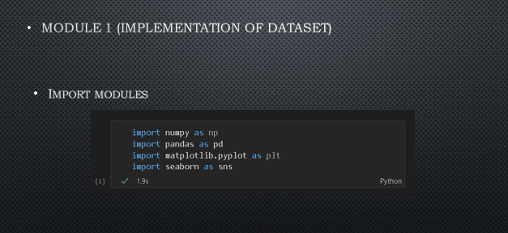

Figure 5.1

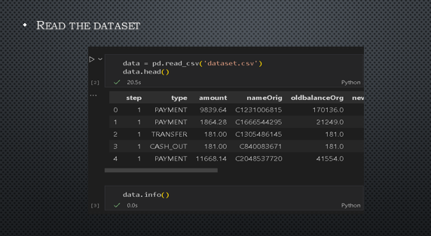

Figure 5.2

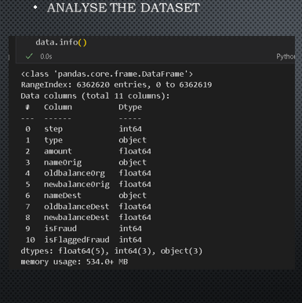

Figure 5.3

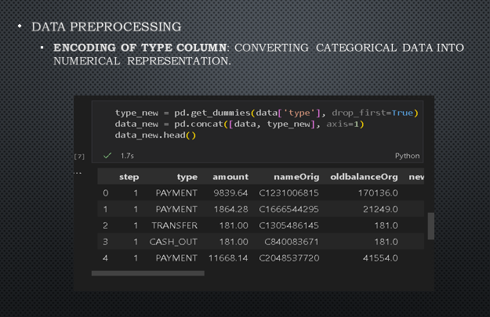

Figure 5.4

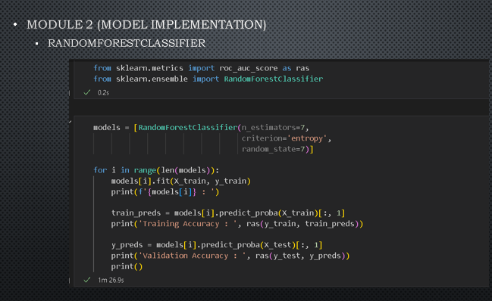

Figure 5.5

**RESULT**

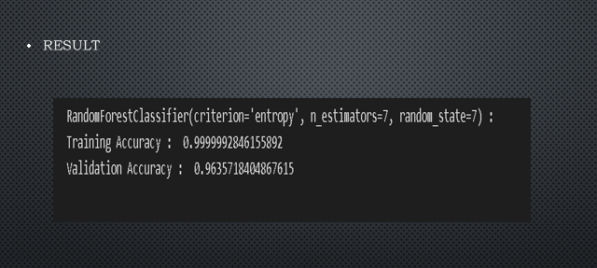

Figure 5.6

**Chapter 6:** Learnings and Takeaways from the Study

The study on "Online Payment Fraud Detection using Machine Learning" yields several key learnings and takeaways, shaping both the understanding of the problem domain and guiding future actions. Here are some overarching insights gained from the study:

**Complexity of Fraud Patterns:**

Online payment fraud is characterized by intricate and evolving patterns that require advanced analytical methods to detect. The study highlights the need for machine learning algorithms capable of discerning subtle anomalies within vast datasets.

**Adaptability is Crucial:**

Fraudsters continually adapt their tactics, necessitating fraud detection systems that are adaptive and capable of learning from new data. The study emphasizes the importance of developing systems that evolve alongside emerging fraud trends.

**Ensemble Approaches Improve Accuracy:**

Ensemble learning, as exemplified by Random Forest, proves effective in improving the accuracy of fraud detection. Combining multiple models helps mitigate overfitting and captures a broader range of fraud patterns.

**User-Centric Security Measures:**

Behavioral biometrics and user-centric approaches play a vital role in enhancing fraud detection. Understanding and analyzing user behavior patterns contribute to more secure and user-friendly online payment systems.

**Interpretability and Trust:**

The study underscores the significance of explainable AI in building user trust. Transparent and interpretable machine learning models contribute to user confidence by providing insights into the decision-making process of the fraud detection system.

**Cross-Domain Challenges:**

Cross-domain fraud detection, particularly in e-commerce, presents unique challenges. Transfer learning emerges as a valuable approach to leverage knowledge gained in one domain for improved fraud detection in another.

**Integration of Blockchain Technology:**

The study indicates that the integration of blockchain technology can provide enhanced security in online payment transactions. The combination of blockchain and machine learning offers a promising avenue for securing digital financial ecosystems.

**Real-Time Fraud Detection in Mobile Payments:**

Mobile payments introduce specific challenges, and the study emphasizes the need for real-time fraud detection mechanisms tailored to mobile platforms. Machine learning can be leveraged to analyze mobile transaction data swiftly and accurately.

**Continuous Monitoring and Evaluation:**

Fraud detection systems should be subject to continuous monitoring and evaluation. Regular updates and assessments are necessary to ensure the system's effectiveness against evolving fraud tactics.

**User Education and Awareness:**

As part of a holistic approach, the study suggests that user education and awareness programs are essential. Educated users are more likely to adopt secure practices, reducing the risk of falling victim to fraud.

In conclusion, the study provides a comprehensive understanding of the challenges and opportunities in online payment fraud detection. It highlights the importance of combining advanced machine learning techniques, adapting to emerging threats, and prioritizing user-centric and transparent approaches to build trust in digital financial transactions. The learnings from this study inform the development of more robust and resilient fraud detection systems in the evolving landscape of online payments.

**REFERENCES AND ANNEXURES**

[1] *Fraud detection in Online Payment Transaction using Machine Learning Algorithms*. (2022, November 1). IEEE Conference Publication | IEEE Xplore. https://ieeexplore.ieee.org/document/10125521/

[2] *Fraud detection in Online Payment Transaction using Machine Learning Algorithms*. (2022, November 1). IEEE Conference Publication | IEEE Xplore. https://ieeexplore.ieee.org/document/10125521/

[3] *Protecting Contactless Credit Card Payments from Fraud through Ambient Authentication and Machine Learning*. (2023, May 18). IEEE Conference Publication | IEEE Xplore. https://ieeexplore.ieee.org/document/10200022

[4] *Extreme Gradient Boost Classifier based Credit Card Fraud Detection Model*. (2023, March 17). IEEE Conference Publication | IEEE Xplore. https://ieeexplore.ieee.org/document/10110188

[5] *Fraud Detection using Recurrent Neural Networks for Digital Wallet Security*. (2023, September 13). IEEE Conference Publication | IEEE Xplore. https://ieeexplore.ieee.org/document/10286651

[6] *Analyzing Credit Card Fraud Detection based on Machine Learning Models*. (2022, June 1). IEEE Conference Publication | IEEE Xplore. https://ieeexplore.ieee.org/document/9795737

[7] *Smart Acquiring Platform in Contactless Payments using Advanced Machine Learning : Security Controls using Device Recognition, Geo Fencing and Customer on File*. (2023, May 5). IEEE Conference Publication | IEEE Xplore. https://ieeexplore.ieee.org/document/10179552

[8] *Online Payment fraud detection model using machine learning techniques*. (2023). IEEE Journals & Magazine | IEEE Xplore. https://ieeexplore.ieee.org/document/10341223

[9] *Online Fraud Detection using Machine Learning*. (2023, January 27). IEEE Conference Publication | IEEE Xplore. https://ieeexplore.ieee.org/document/10085493

[10] *Fraud Detection in Online Payments using Machine Learning Techniques*. (2023, May 17). IEEE Conference Publication | IEEE Xplore. https://ieeexplore.ieee.org/document/10142404