Date :07.03.2025 TASK 3

OPEN AEM

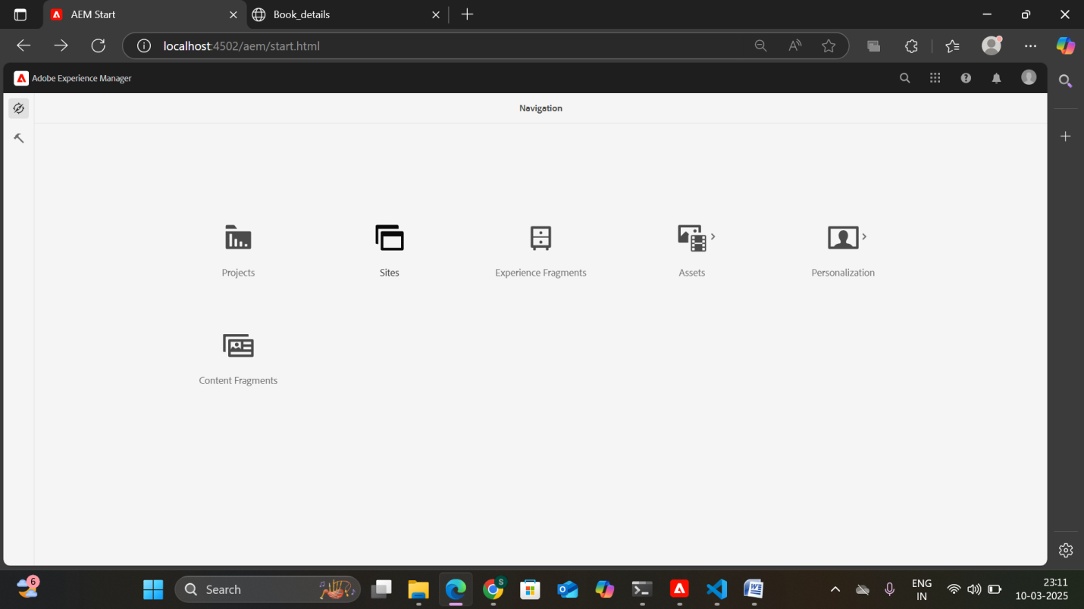

INSIDE TOOLS🡪 TEMPLATES

Select book template and click edit

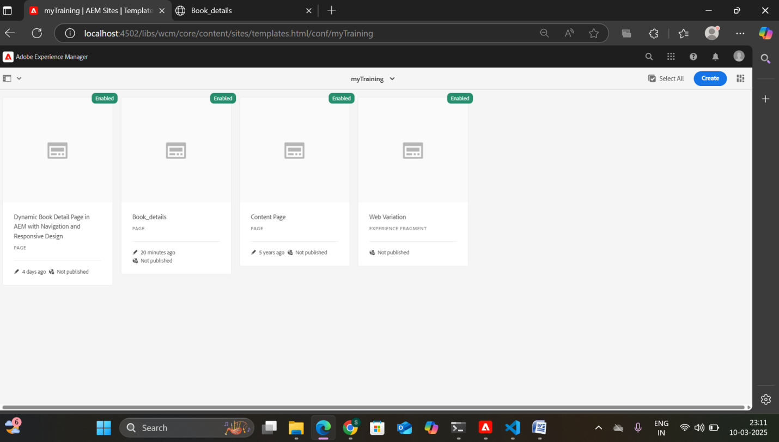

Inside vs code open myTraining project folder

myTraining-> UI.FRONTEND ->SRC -> MAIN -> COMPONENTS -> create file header.scss and footer.scss

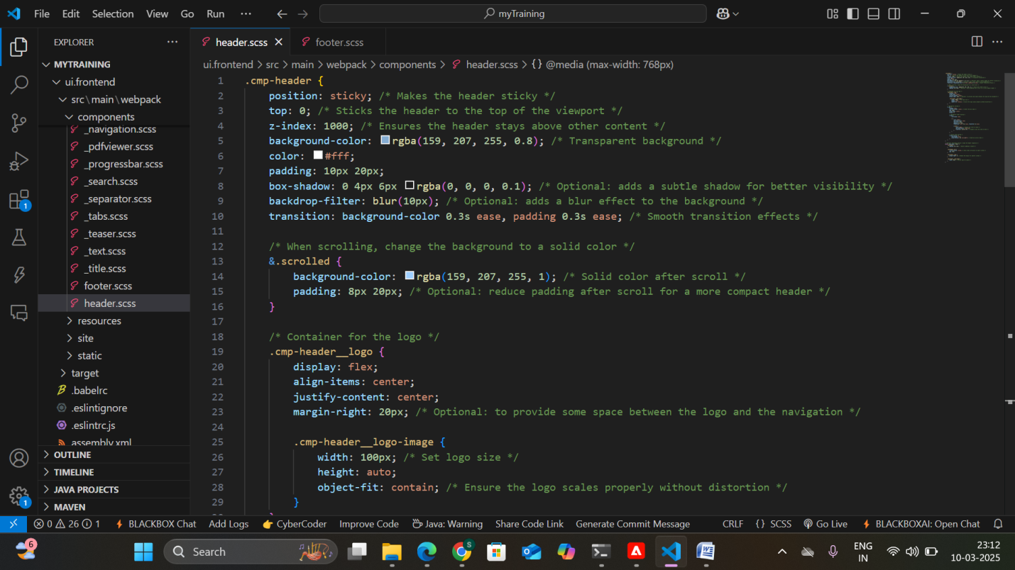

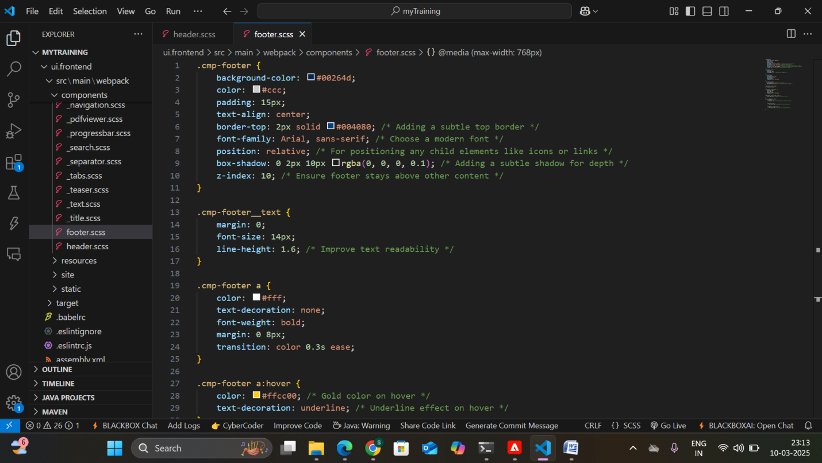

Add Experience fragments (Header,Footer)to the book template.

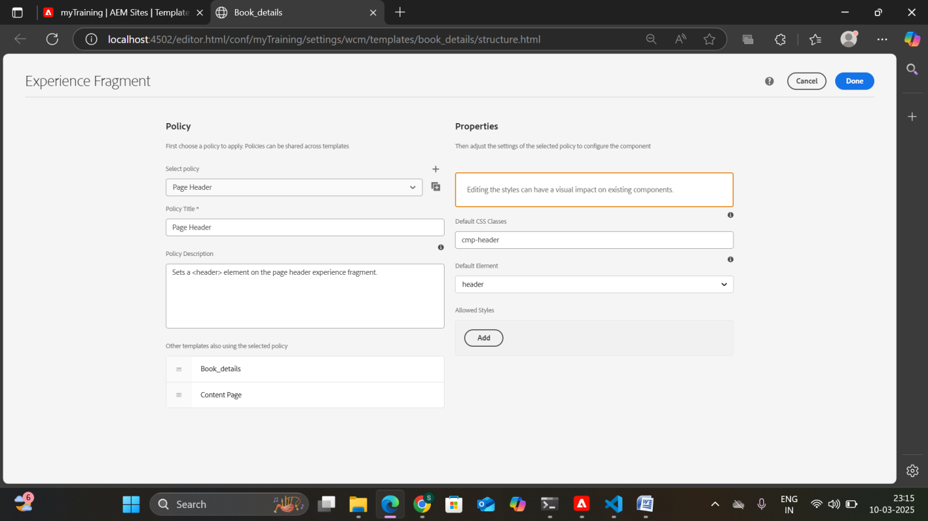

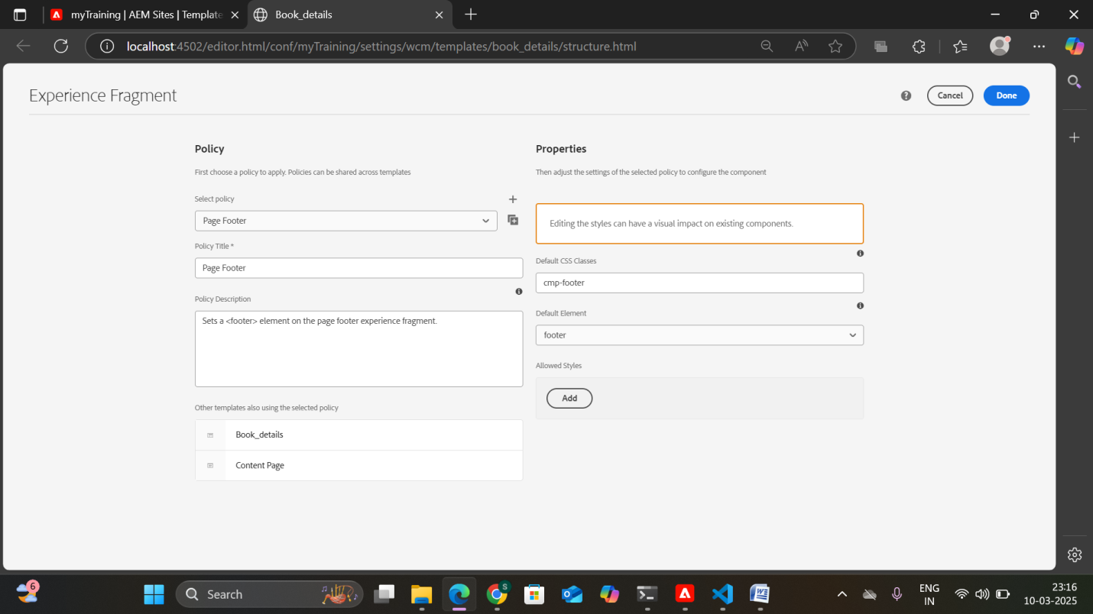

Run the project using the command **mvn clean install -PautoInstallPackage -Dmaven.test.skip=true**

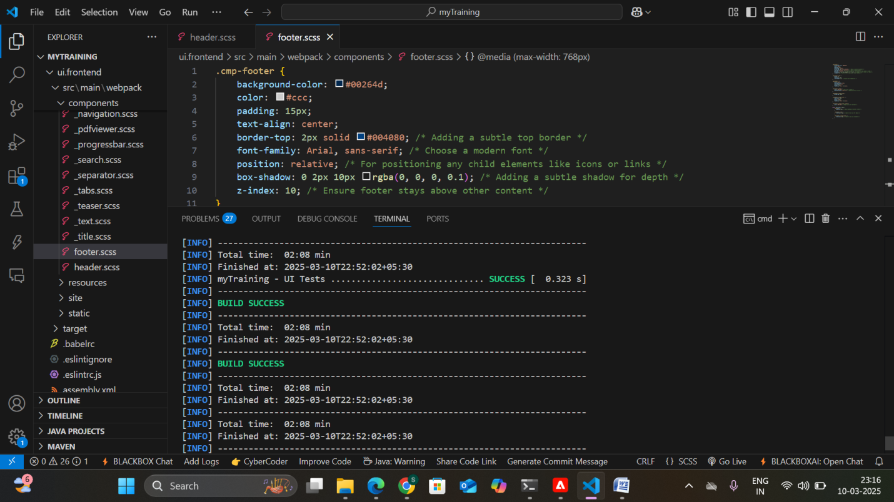

Output:

