***aem local setup***

created separate folders for aem jar download and codebase

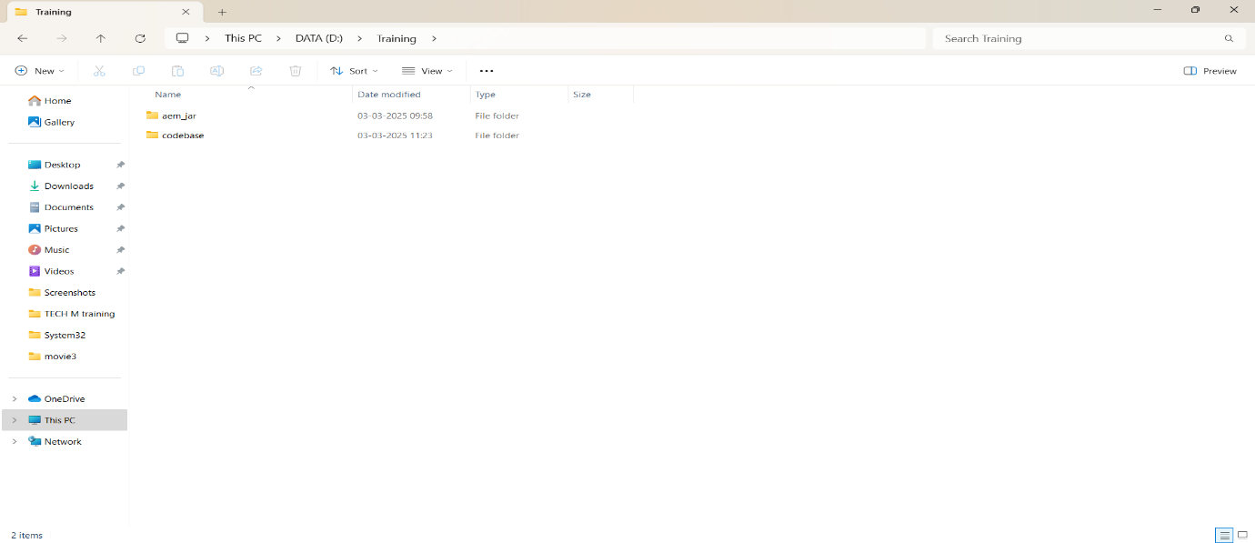

jdk 11 ,maven installation and aem jar file

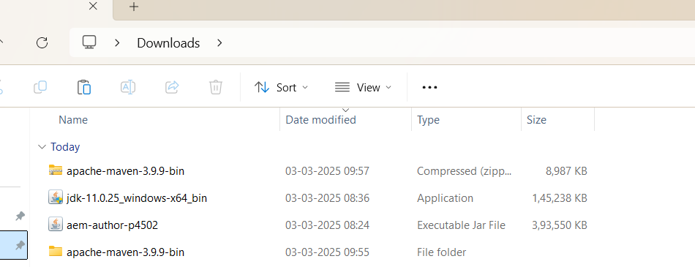

inside aem jar folder

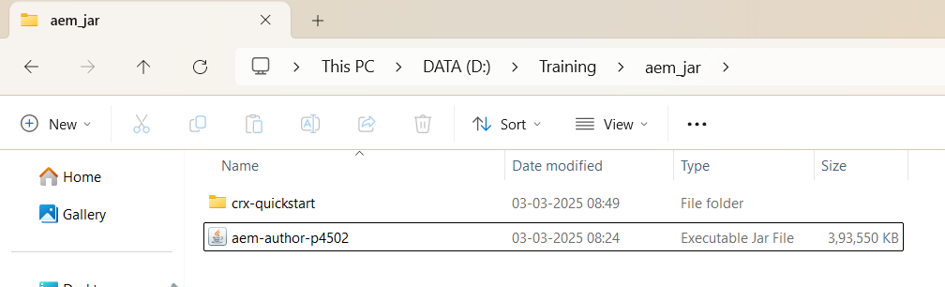

opening aem

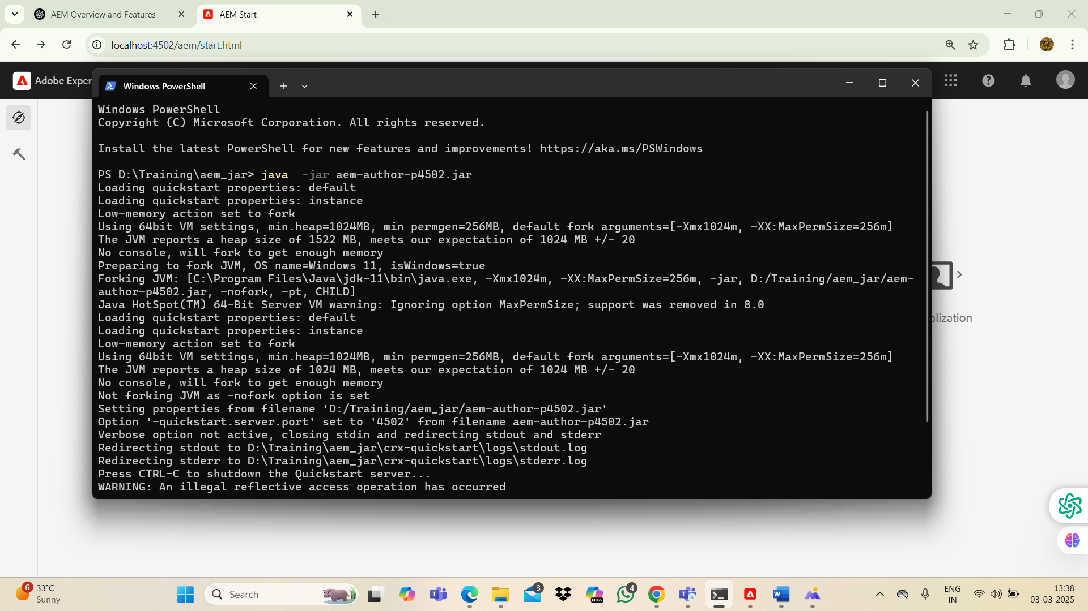

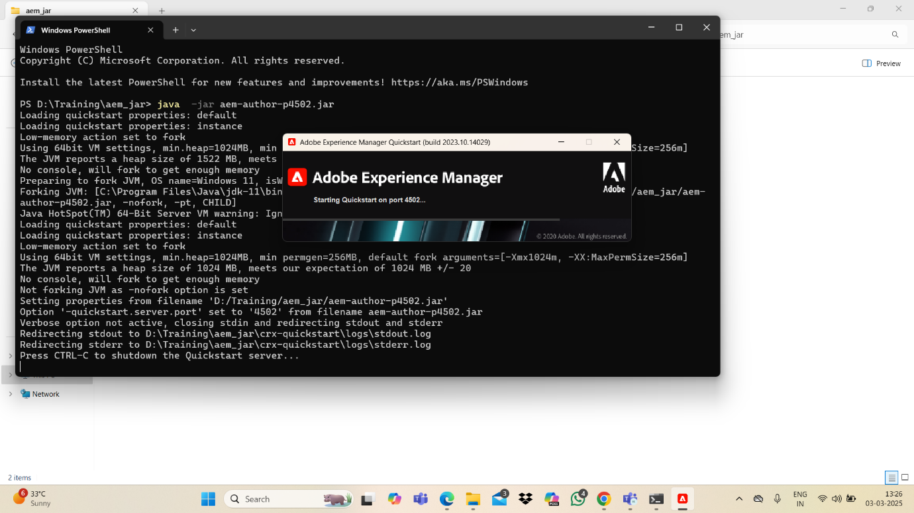

username-admin

password-admin

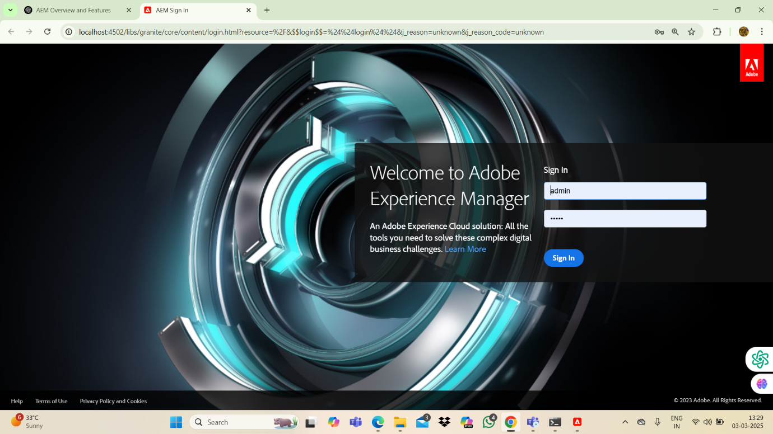

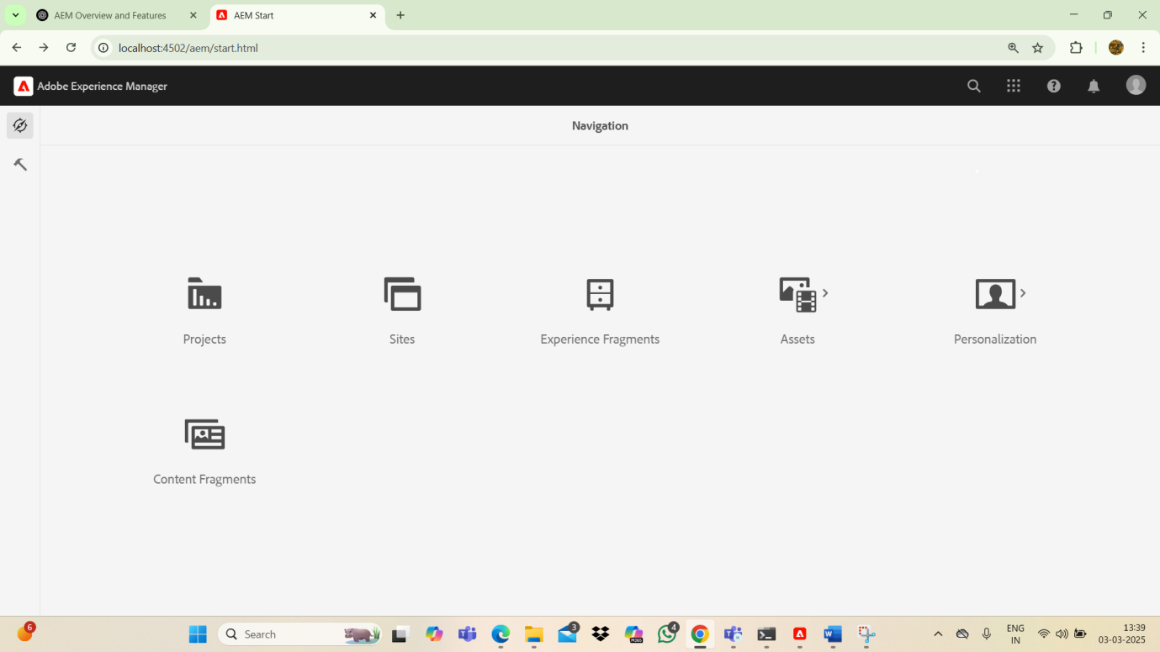

after executing -

mvn -b org.apache.maven.plugins:maven-archetype-plugin:3.2.1:generate -d archetypegroupid=com.adobe.aem -d archetypeartifactid=aem-project-archetype -d archetypeversion=39 -d apptitle="mytraining" -d appid="mytraining" -d groupid="com.mytraining" -d aemversion=6.5.5 -d includeexamples=n -d includeerrorhandler=y

**got build success**

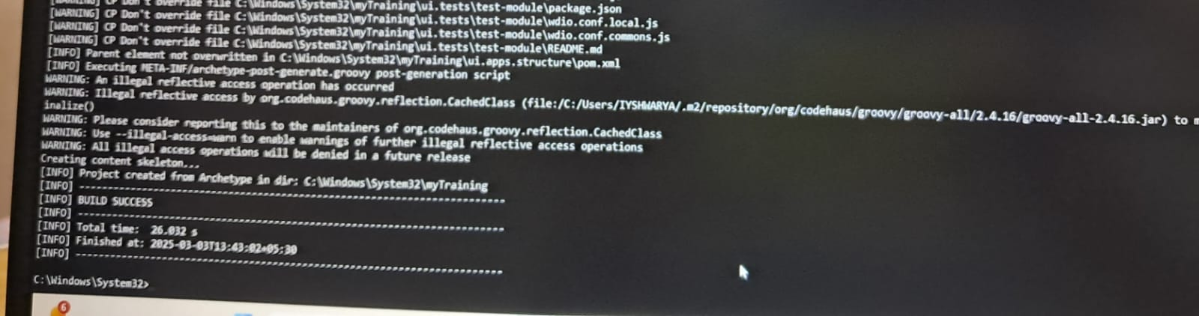

project structure got created inside codebase folder

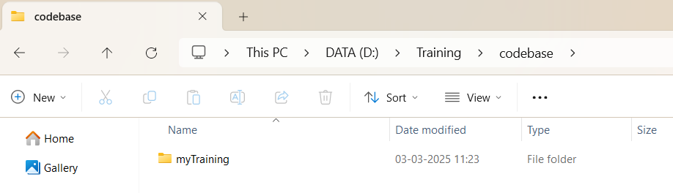

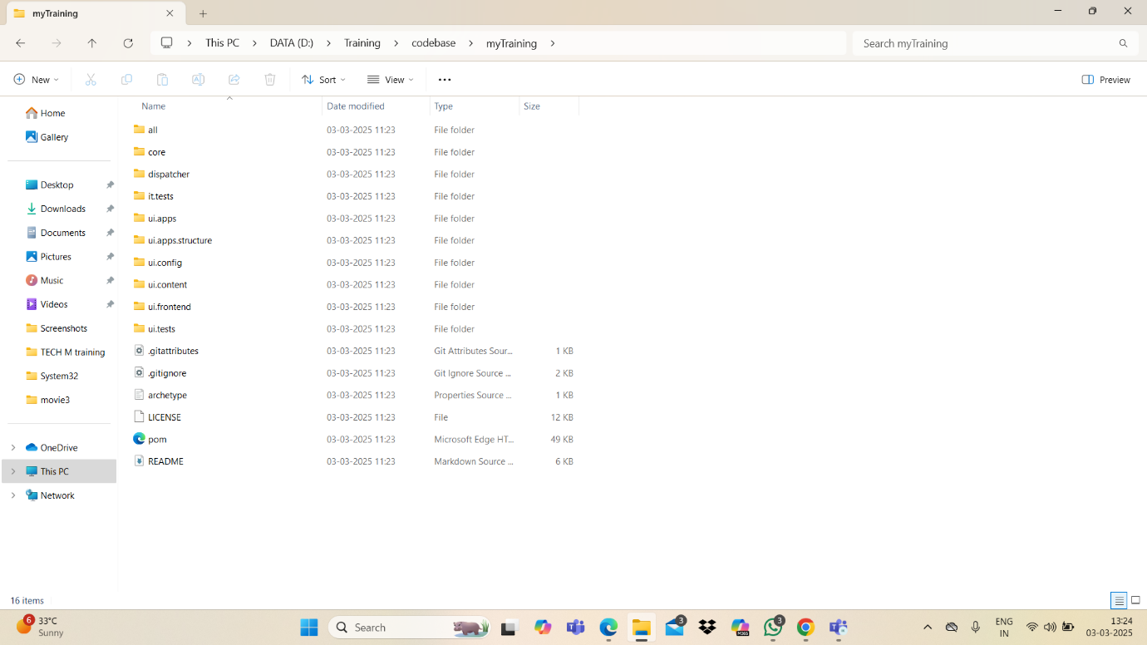

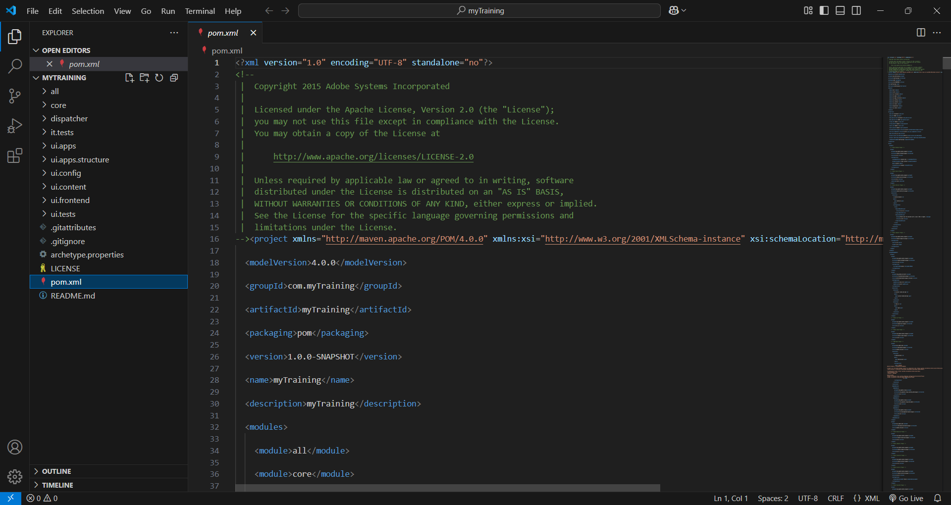

iyshwarya k