**1. Header Implementation**

**Header Code:**

<header>

<table width="100%">

<tr>

<td width="15%">

<img src="/content/dam/myTraining/text-ar.png" alt="Anne Rice" width="100">

</td>

<td width="13%"><a href="/content/myTraining/us/en/home.html" style="color: hotpink; text-decoration: underline;">HOME</a></td>

<td width="15%"><a href="/content/myTraining/us/en/about-me.html" style="color: hotpink; text-decoration: underline;">ABOUT ME</a></td>

<td width="15%"><a href="/content/myTraining/us/en/reach-me.html" style="color: hotpink; text-decoration: underline;">REACH ME</a></td>

<td width="15%" class="dropdown">

<a href="/content/myTraining/us/en/books.html" style="color: hotpink; text-decoration: underline;">BOOKS ▼</a>

<ul class="dropdown-menu">

<li><a href="/content/myTraining/us/en/books/the-god-of-small-things.html">The God of Small Things</a></li>

<li><a href="/content/myTraining/us/en/books/the-ministry-of-utmost-happiness.html">The Ministry of Utmost Happiness</a></li>

<li><a href="/content/myTraining/us/en/books/field-notes-on-democracy">Field Notes on Democracy</a></li>

<li><a href="/content/myTraining/us/en/books/capitalism-a-ghost-story">Capitalism: A Ghost Story</a></li>

<li><a href="/content/myTraining/us/en/books.html"><strong>Other Books</strong></a></li>

</ul>

</td>

<td width="28%">

<form action="/search" method="GET" style="display: flex; align-items: center; gap: 5px; justify-content: center;">

<input type="text" name="q" placeholder="Search..."

style="padding: 5px; border: 1px solid #ccc; border-radius: 5px; width: 150px;">

<button type="submit"

style="padding: 6px 12px; background-color: transparent; color: hotpink; border: 2px solid hotpink; border-radius: 5px; cursor: pointer;">

Search

</button>

</form>

</td>

</tr>

</table>

</header>

**2. Footer Implementation**

**Footer Code:**

**Books Section**

<footer>

<center>

<h4 style="font-size: 20px; font-weight: 900; text-transform: uppercase; color: gold;">📚 BOOKS</h4>

<a href="/content/myTraining/books.html" style="color: gold; font-size: 18px; font-weight: 800; text-decoration: none;">➤ See Resource</a>

</center>

</footer>

**About Us Section**

<footer>

<center>

<h4 style="font-size: 20px; font-weight: 900; text-transform: uppercase; color: gold;">ℹ️ ABOUT US</h4>

<p style="color: gold; font-size: 16px; font-weight: 700;">We provide <b>powerful reviews</b> and <b>detailed summaries</b> of popular books.</p>

<a href="/content/myTraining/aboutme.html" style="color: gold; font-size: 18px; font-weight: 800; text-decoration: none;">➤ Learn More</a>

</center>

</footer>

**Reach Me Section**

<footer>

<center>

<h4 style="font-size: 20px; font-weight: 900; text-transform: uppercase; color: gold;">📞 REACH ME</h4>

<p style="color: gold; font-size: 16px; font-weight: 700;">📧 Email: <b>ArundhatiRoy@gmail.com</b></p>

<p style="color: gold; font-size: 16px; font-weight: 700;">📱 Phone: <b>+91 1234567890</b></p>

<a href="/content/myTraining/reachme.html" style="color: gold; font-size: 18px; font-weight: 800; text-decoration: none;">➤ Contact Page</a>

</center>

</footer>

**Follow Us Section**

<footer>

<center>

<h4 style="font-size: 20px; font-weight: 900; text-transform: uppercase; color: gold;">🌎 FOLLOW US</h4>

<a href="https://facebook.com" style="color: gold; font-size: 18px; font-weight: 800; text-decoration: none;">📘 Facebook</a> <br>

<a href="https://twitter.com" style="color: gold; font-size: 18px; font-weight: 800; text-decoration: none;">🐦 Twitter</a><br>

<a href="https://instagram.com" style="color: gold; font-size: 18px; font-weight: 800; text-decoration: none;">📷 Instagram</a>

</center>

</footer>

**Header Styling (header.scss)**

.cmp-header {

position: sticky;

top: 0;

z-index: 1000;

background: linear-gradient(90deg, #121212, #8B0000, #A52A2A);

color: #E0C097;

padding: 20px 30px;

box-shadow: 0 4px 10px rgba(139, 0, 0, 0.4);

transition: all 0.4s ease-in-out;

}

.cmp-header__logo {

display: flex;

align-items: center;

justify-content: center;

}

**Footer Styling (footer.scss)**

.cmp-footer {

background: linear-gradient(90deg, #121212, #700000);

color: #D4AF37;

padding: 25px;

text-align: center;

font-family: "Arial", sans-serif;

position: relative;

border-top: 2px solid #8B0000;

box-shadow: 0 -4px 10px rgba(139, 0, 0, 0.3);

}

.cmp-footer__social-icons i:hover {

color: #B8860B;

transform: scale(1.1);

}

**Integration in Experience Fragments**

* The header and footer have been added under the **policy** of the header and footer in the **Experience Fragment**.
* The styles are placed in ui.frontend > src > main > webpack > components > header.scss and footer.scss.

In crxde lite

Adding components to author component to call from thirdpartyAPI and displaying them as cards .

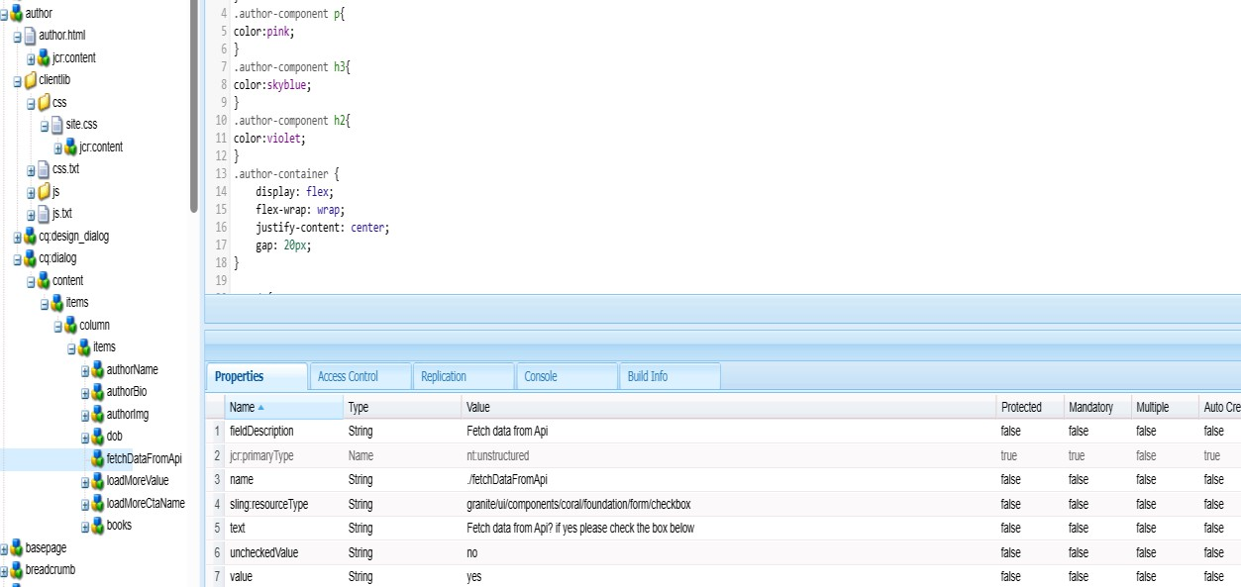

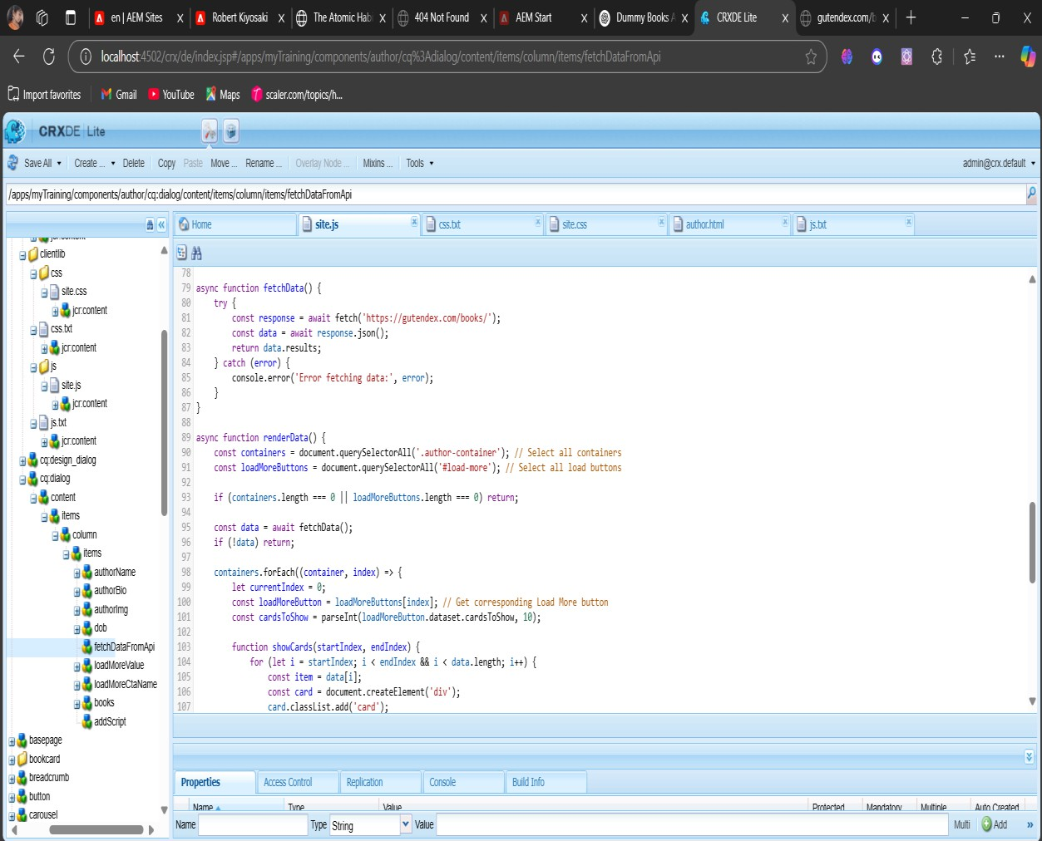

Call them using data-sly in author.html file

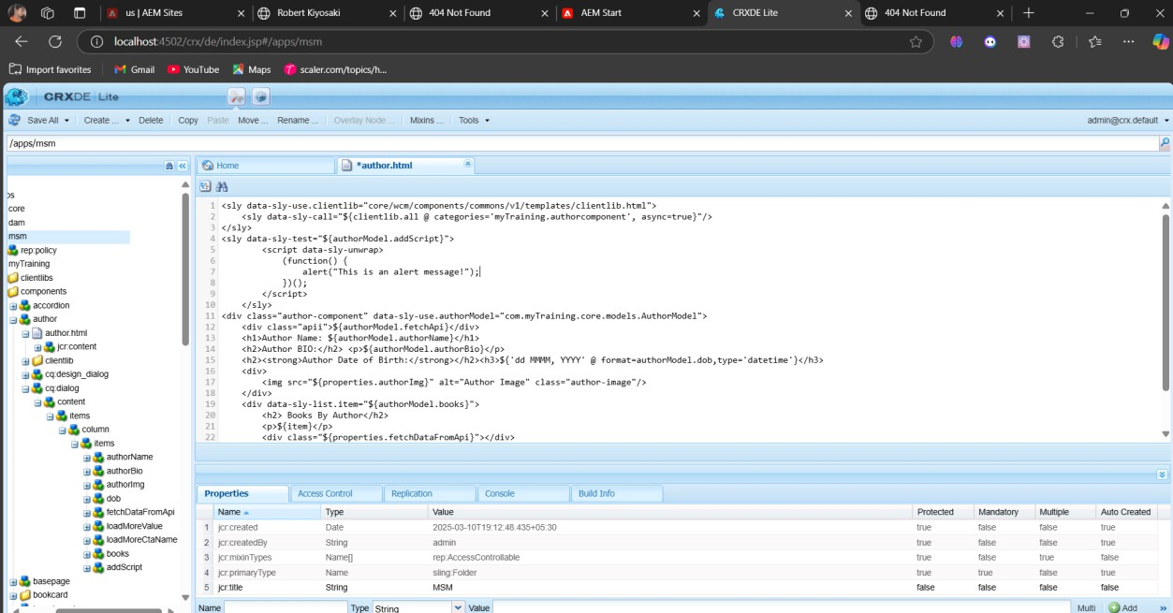

styling

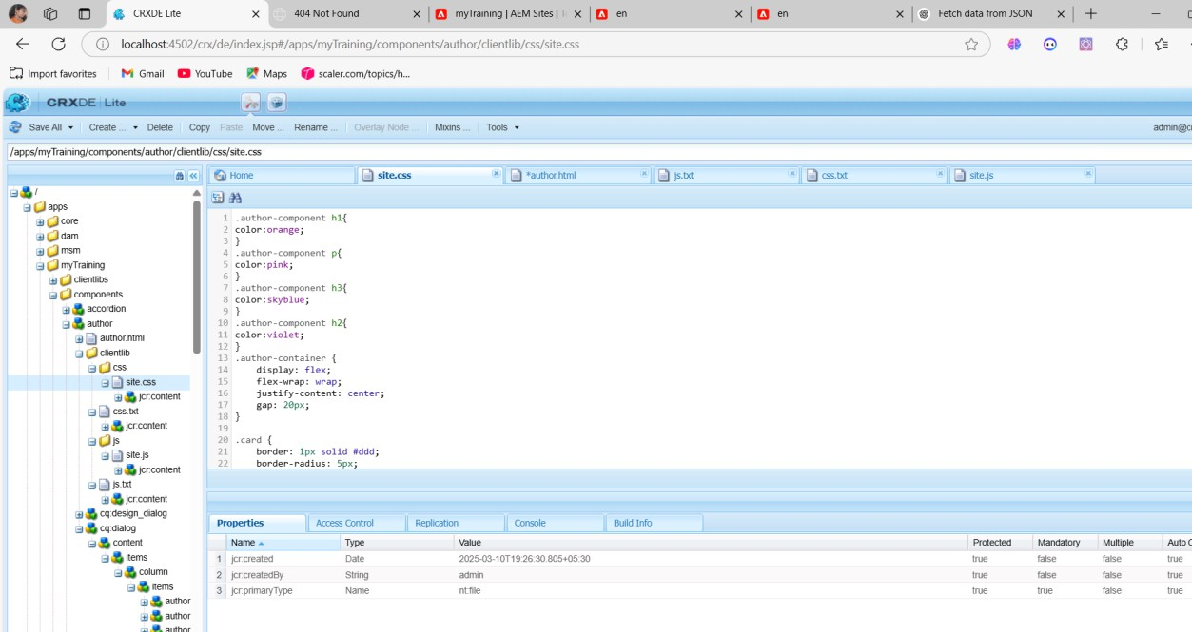

book component

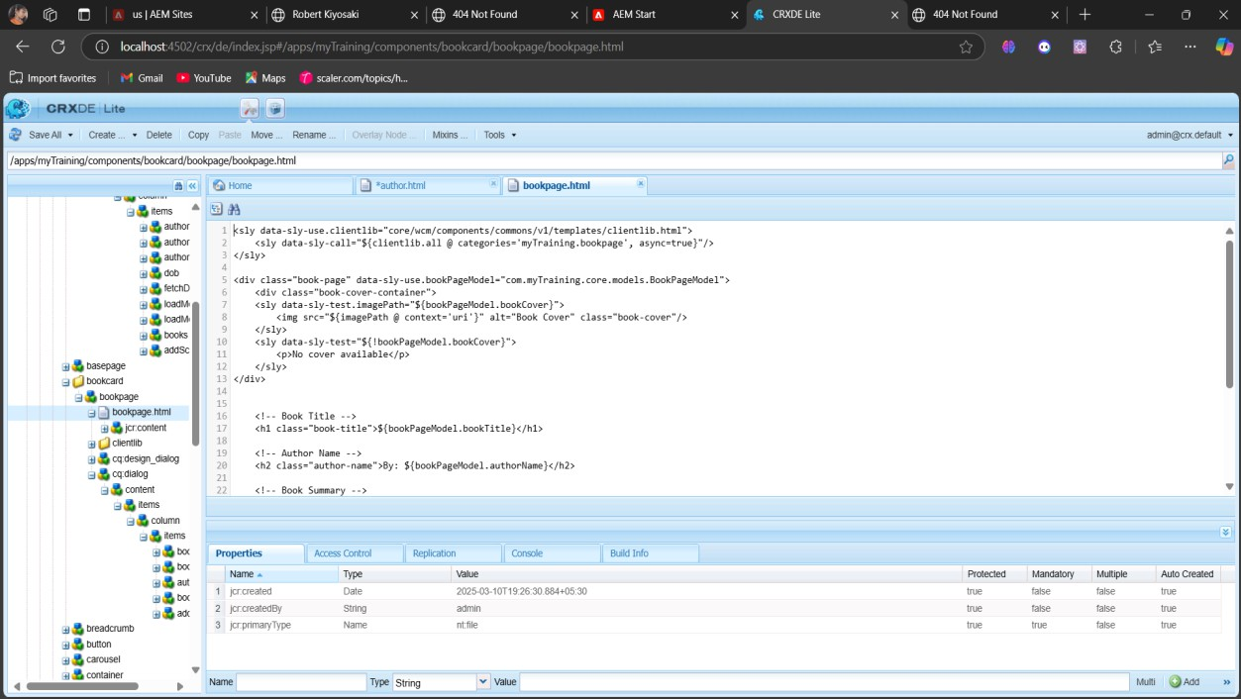

Author Model

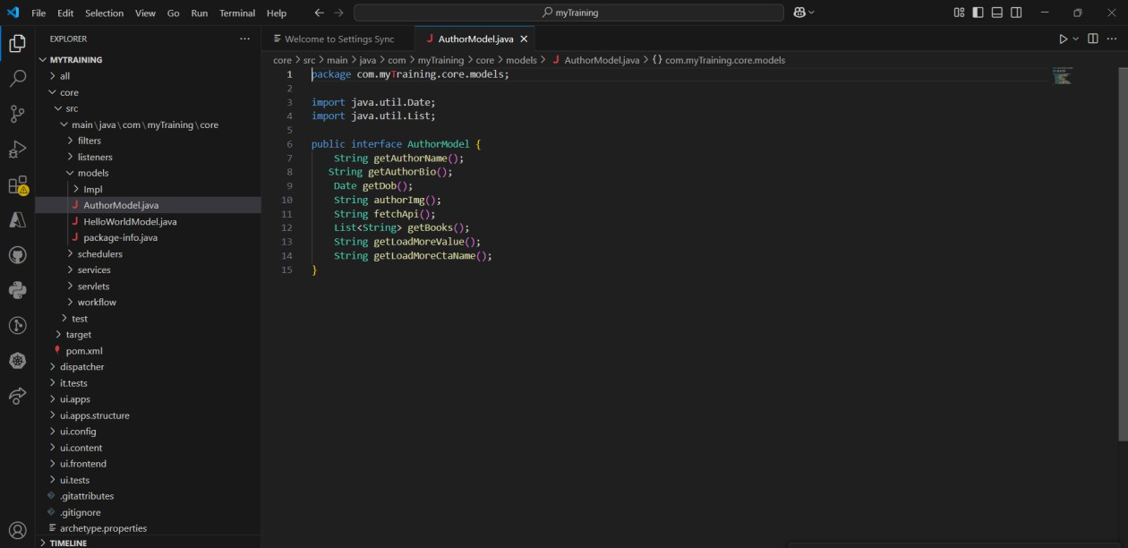

STEP7:Author Model Impl

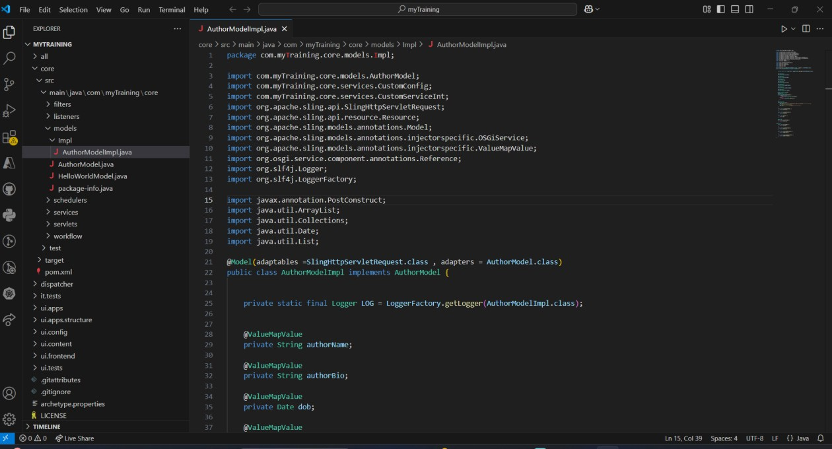

JSON file

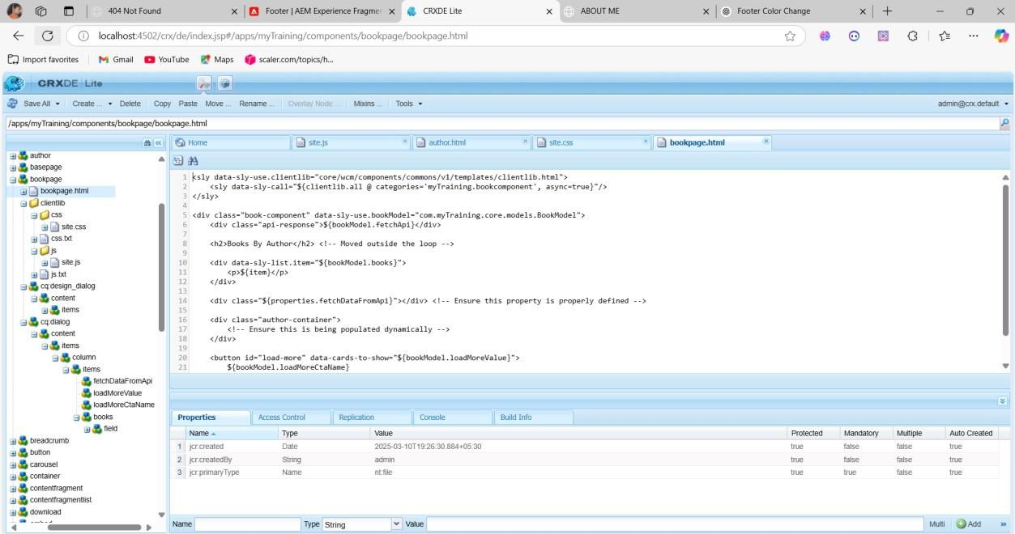

STEP5:Book Model Impl(sling)



Contents of json

**Book List from books.json**[

  {

    "bio": "A magical realist novel set in Kerala, India, it tells the story of twins Estha and Rahel, exploring their family’s tragic past, caste divides, and forbidden love. Roy's lyrical prose and intricate narrative structure won her the Booker Prize.",

    "name": "The God of Small Things (1997)",

    "url": "https://i.cbc.ca/1.4223910.1501161009!/fileImage/httpImage/image.png_gen/derivatives/original_780/book-cover-the-god-of-small-things-by-arundhati-roy.png"

  },

  {

    "bio": " A sprawling, multi-character novel that explores India's political and social turmoil, featuring a transgender woman named Anjum and diverse narratives about love, identity, and war. It blends magic realism with the harsh realities of modern India.",

    "name": "The Ministry of Utmost Happiness (2017)",

    "url": "https://th.bing.com/th/id/OIP.AfsslN6mkYJbY-_if6dGZQHaJ4?pid=ImgDet&w=208&h=277&c=7&dpr=1.5"

  },

  {

    "bio": "A collection of political essays critiquing the state of Indian democracy, focusing on corruption, militarization, and the rise of Hindu nationalism. Roy examines the erosion of democratic ideals in contemporary India.",

    "name": "Field Notes on Democracy (2002)",

    "url": "https://th.bing.com/th/id/OIP.A3rYWxGKlNY21UrCeh7nEwAAAA?pid=ImgDet&w=163&h=240&c=7&dpr=1.5"

  },

  {

    "bio": "Roy critiques the corporate takeover of India, the government's role, and the resulting environmental and social injustices, highlighting the exploitation of the marginalized in favor of corporate interests.",

    "name": "Capitalism: A Ghost Story (2014)",

    "url": "https://th.bing.com/th/id/OIP.VRYjcLrgl-zwIwIPasDtZAAAAA?pid=ImgDet&w=192&h=291&c=7&dpr=1.5"

  },

  {

    "bio": "A collection of essays where Roy explores the rise of fascism, militarization, and authoritarianism in India. She critiques the government's repression of minorities and the erosion of civil liberties under political pressures.",

    "name": "Listening to Grasshoppers: Field Notes on Democracy (2009)",

    "url": "https://th.bing.com/th/id/OIP.r9m-qDpWvjEXZ4y4AIAXvAHaKR?pid=ImgDet&w=192&h=266&c=7&dpr=1.5"

  },

  {

    "bio": "Roy critiques India's nuclear policy, arguing that nuclear weapons bring the world closer to destruction. This collection discusses the dangers of nuclear proliferation and the moral implications of militarization.",

    "name": "The End of Imagination (1997)",

    "url": "https://th.bing.com/th/id/OIP.QoI9gbwIN3-wAuUkC_ciigAAAA?w=115&h=180&c=7&r=0&o=5&dpr=1.5&pid=1.7"

  },

  {

    "bio": "This essay examines the Narmada Dam project, which displaced thousands of Indigenous people and caused environmental destruction. Roy criticizes the corporate and government interests that prioritize development over human rights and sustainability.",

    "name": "The Greater Common Good (1999)",

    "url": "https://th.bing.com/th/id/OIP.6hlq2882baNEwdRA4VstLQHaD4?pid=ImgDet&w=192&h=100&c=7&dpr=1.5"

  },

  {

    "bio": "A collection of essays that explores the global impact of war, particularly the U.S. invasion of Iraq. Roy condemns imperialism and military violence, advocating for peace and social justice.",

    "name": "War Talk (2003)",

    "url": "https://th.bing.com/th/id/OIP.5AxS1tkKxNI2UadTB17WZgAAAA?w=115&h=180&c=7&r=0&o=5&dpr=1.5&pid=1.7"

  }

  ]