**Title: AEM Project Documentation - Author potfolio**

**1. Introduction**

* The project involves the development of an **Author Awards** website using **Adobe Experience Manager (AEM)**.
* The website provides information about the author, **Arundhati Roy**, including her achievements, books, and contact details.
* The project includes the creation of **templates, components, client libraries, and styling** to ensure a seamless and interactive user experience.

**2. Project Scope and Objectives**

* Develop an **author_awards** template.
* Implement a **header and footer** across all pages.
* Apply **CSS styling** to enhance the website’s UI/UX.
* Design and develop **multiple pages**:
  + **Home**
  + **About Me**
  + **Reach Me**
  + **Books**
* Implement a **books dropdown** in the header for easy navigation.
* Include a **manually created JSON file** for book data storage.

**3. Website Structure & Flow**

**3.1 Overall Flow Description**

* The **Header** contains a **logo, navigation menu (Home, About Me, Reach Me, Books), a search bar, and a books dropdown**.
* The **Home Page** includes a **teaser component** that navigates to the **Awards Page**.
* The **About Me Page** holds **text and images** of the author.
* The **Reach Me Page** features a **contact form** for communication.
* The **Books Page** contains a **list of books with names, descriptions, and URLs**, navigable through the **books dropdown**.
* Each **book card redirects** to its **specific book page**.
* The **Footer** includes **Books, About Me, Reach Me, and Follow (social media links)**.

**3.2 Flow Diagrams for Each Page**

**Home Page Flow** 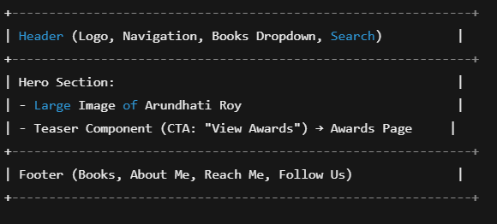

* **Header**
* **Teaser Component (CTA button navigates to Awards Page)**
* **Footer**

**About Me Page Flow** 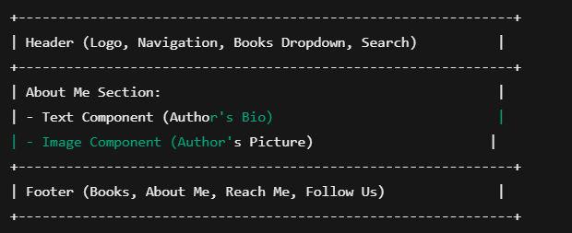

* **Header**
* **Text Component** (Author details)
* **Image Component**
* **Footer**

**Reach Me Page Flow** 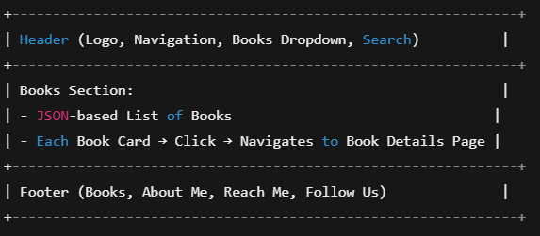

* **Header**
* **Contact Form**
* **Social Media Links**
* **Footer**

**Books Page Flow** 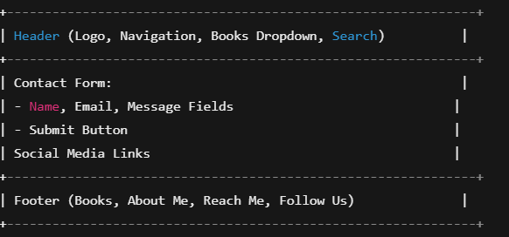

* **Header**
* **Book Cards (Fetched from JSON)**
* **Click on Book Card (Navigates to Specific Book Page)**
* **Footer**

**3.3 Header & Footer Implementation**

* **Header** (Designed using **Embed Component**) contains:
  + **Logo**
  + **Navigation Menu**: Home, About Me, Reach Me, Books
  + **Search Functionality**
  + **Books Dropdown** (Displays a manually created list of books)
  + 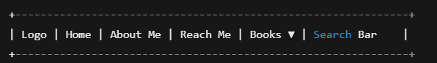
* **Footer** (Designed using **Embed Component**) contains:
  + **Books**
  + **About Me**
  + **Reach Me**
  + **Follow (Social Media Links)**
  + 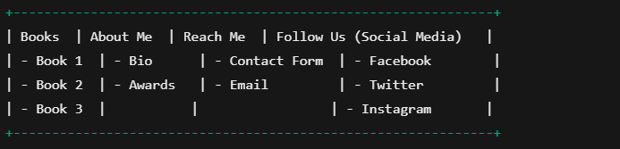

**4. Implementation Procedure**

**4.1 Creating the AEM Project**

* Use **AEM Maven archetype** to generate the project structure.
* Deploy the project in **AEM Author Instance**.

**4.2 Creating the Template (author_awards)**

* Navigate to **AEM > Tools > Templates**.
* Create a new template **(author_awards template)**.
* Define the page structure using **Layout Container**.
* Allow components such as **teaser, text, image, books list**.

**4.3 Developing Components**

**4.3.1 Header & Footer Component**

* Implement the **header and footer** using the **Embed Component**.
* Design the **header** to include navigation links and a books dropdown.
* Develop the **footer** with Books, About Me, Reach Me, and Follow links.

**4.3.2 Teaser Component**

* Create a **Teaser component** with **CTA button**.
* Ensure the CTA redirects users to the **Awards Page**.

**4.3.3 About Me Component**

* Develop a **text and image component** for displaying author details.
* Ensure content is editable via **AEM Dialog**.

**4.3.4 Reach Me Component**

* Create a **contact form component**.
* Use **AEM Forms** to capture user input.
* Integrate submission handling for storing inquiries.

**4.3.5 Books Component**

* Develop a **Books component** that displays book cards.
* Use **HTL (Sightly) and JavaScript** to populate the book list.
* On clicking a book, navigate to a **manually created book page**.

**4.4 Configuring JSON Data**

* Create a **manually managed JSON file** with book details.
* Store it within **AEM DAM or as a client library file**.
* Fetch JSON data using **JavaScript and HTL** to populate the book list.

**4.5 Applying Styling (CSS & JS)**

* Create **ClientLibs** for styling and interactive behavior.
* Define **CSS rules** for responsive design.
* Use **extraClientLibs** for enhancing UI elements.

**4.6 Deployment & Testing**

* Deploy the project on **AEM Publish Instance**.
* Test functionality across all pages.
* Validate JSON data retrieval and book navigation.
* Ensure responsiveness across devices.

PROCESS:

TEMPLATE CREATION

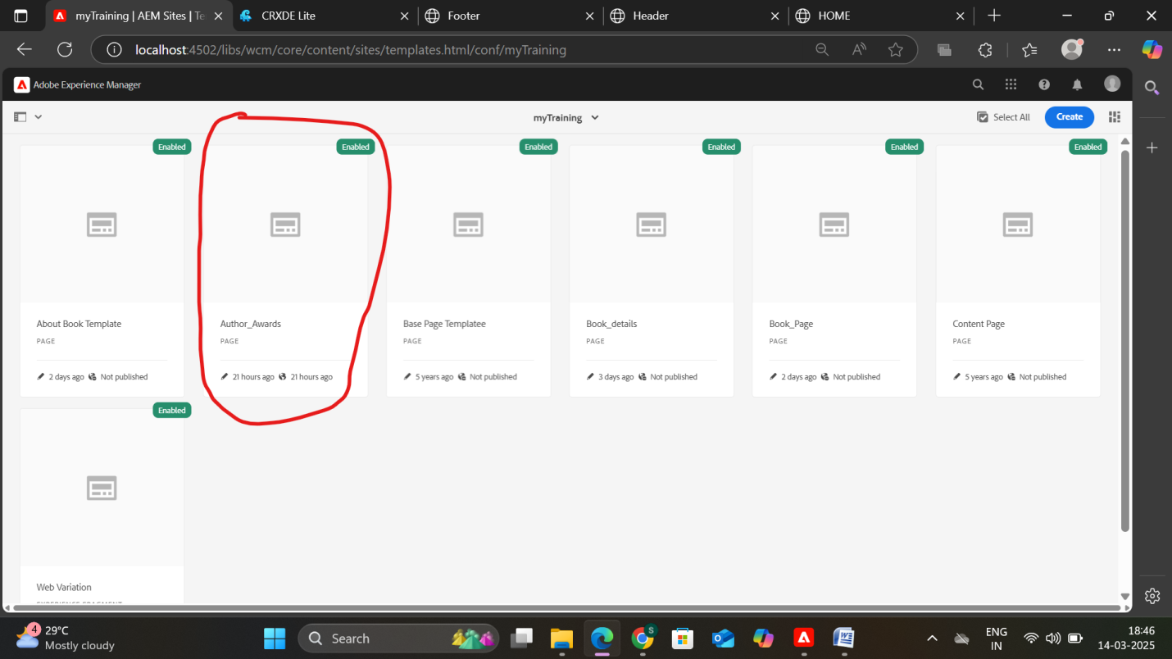

CREATION OF PAGES

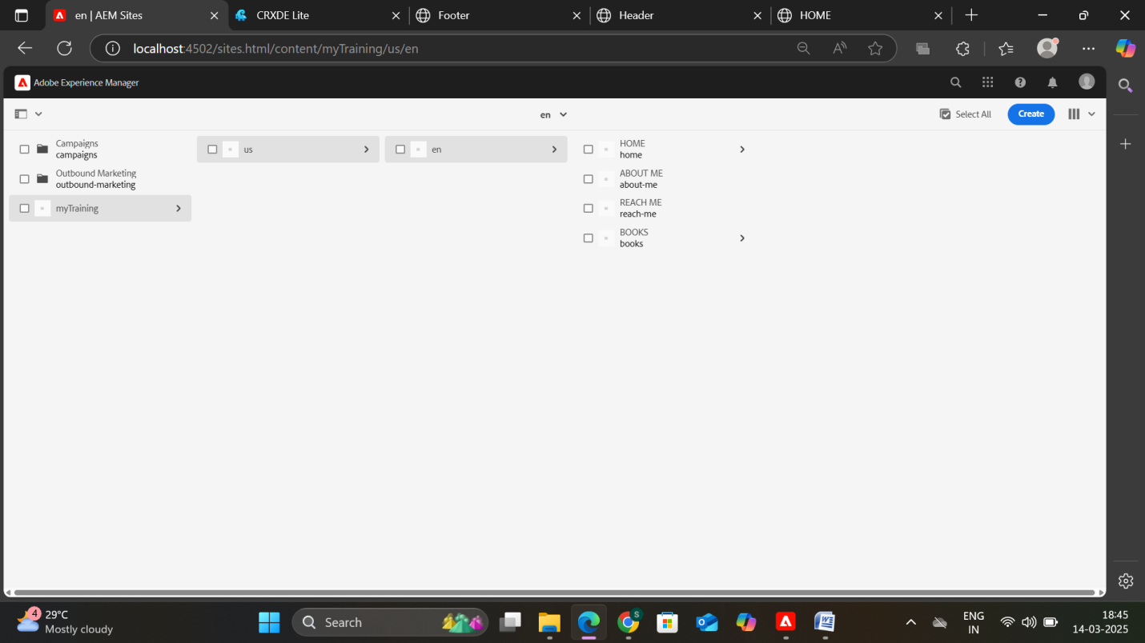

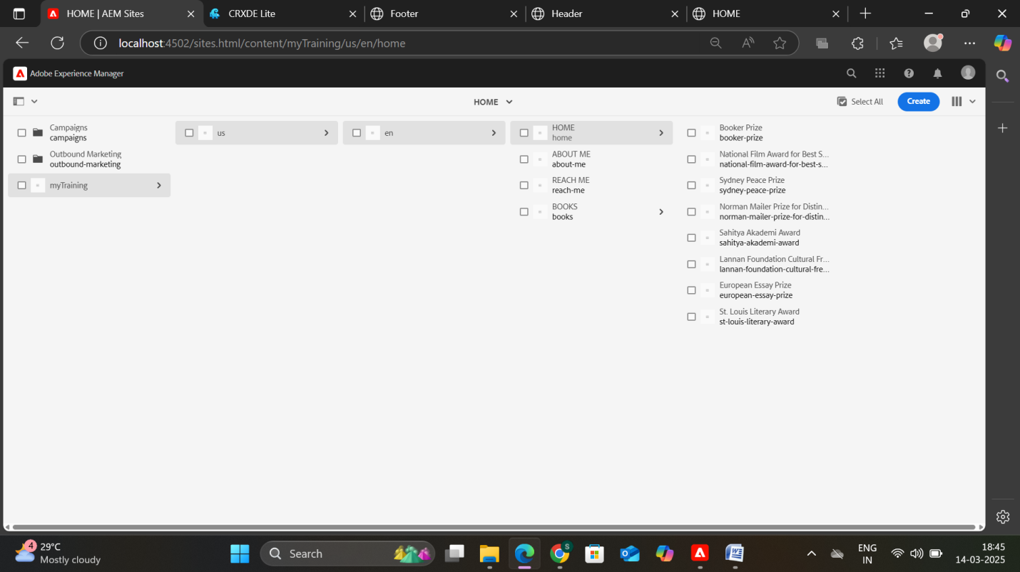

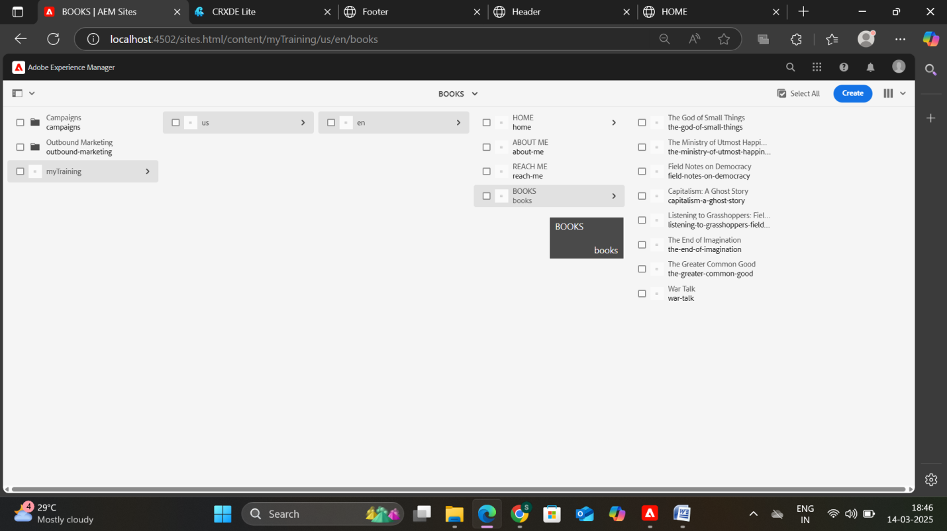

HEADER AND FOOTER IN EXPERIENCE FRAGMENTS

