Case Study Report



**Tech Saksham**

Data Analytics with Power BI

**“Analysis of commercial electricity consumption in Indian states ”**

**“A.P.C Mahalaxmi College For Women”**

|  |  |
| --- | --- |
| **NM ID** | **NAME** |
| **CD82BC29AE8E6481AF4F70FDA8968A6** | **A.SHALI BELINDA** |

Trainer Name : R.Uma Maheshwari

Master Trainer:R.Uma Maheshwari

|  |  |
| --- | --- |
|  |  |
|  |  |
|  |  |

**ABSTRACT**

Energy has been universally recognized as one of the most important input for economic growth and human development. Generally, it has defined as "Capacity to do work" thereby, for bring out desirable design on economic level there must be need of intensive of energy performance in various sectors of the country. Perceiving commercial energy at the one of economic viability consumption has equip the present status of economic level to be boost and reach global advance in due period with identification of which are highly consumes among public and the statistics of this has brought out in this study. Electricity, LPG, kerosene, coal and natural gas are the chosen commercial energy and data for the specified years have collected from central electricity authority CAE and Energy statistics 2015 for 2007-2014.

**INDEX**

|  |  |  |
| --- | --- | --- |
| **Sr. No.** | **Table of Contents** | **Page No.** |
| 1 | Chapter 1: Introduction | 4 |
| 2 | Chapter 2: Services and Tools Required | 6 |
| 3 | Chapter 3: Project Architecture | 7 |
| 4 | Chapter 4: Modeling and Result | 9 |
| 5 | Conclusion | 18 |
| 6 | Future Scope | 19 |
| 7 | References | 20 |
| 8 | Links | 21 |

**CHAPTER 1**

**INTRODUCTION**

* 1. **Problem Statement**

Popularly, Energy meant that strengthen of physical for execute our daily attributes towards successful progress. But, in macro analytical programme considered the ENERGY is “Capacity to do work” this is a mean which applying in the Economic aspects.Because, energy is live blood of modern economics . So, the Energy is how prominent to physical, same like significant for the economic development or any nation’s maturity in the Economic views. Therefore, countries altogether persisting for attain maturity in all aspects with the execution of natural and artificial energies. Our country India has undertaking four kinds of sectors towards progressive trends with proposed targets through utilization of Energy efficiently. But, the consumption of Energy is inconsiderable one that availing still in nature with fluctuating ratio. Indeed, it also one of challenge to calculate the national outcomes among which areconsuming kinds of Energies. Commonly, Energy has classified in to two types such as, renewable and non-renewable resources. Here, the energy meant as resources and classified as commercial and non-commercial type. This study described commercial type of energy and analyzedtotal consumption of India.

* 1. **Proposed Solution**

An energy source is a necessary element of socio-economic development. The increasing economic growth of developing nations in the last decades has caused an accelerated increase in energy consumption. This trend is anticipated to grow . A prediction of future power consumption is essential for the investigation of adequate environmental and economic policies . Likewise, an outlook to future power consumption helps to determine future investments in renewable energy. Energy supply and security have not only increased the essential issues for the development of human society but also for their global political and economic patterns . Hence, international comparisons are helpful to identify past, present, and future power consumption.

* 1. **Feature**
* **Real-Time Analysis**: To finalize the methodology of load forecast
* **Customer Segmentation**: To forecast the year wise electricity demand projection for each State.
* **Trend Analysis**: Assessing impact of renewable penetration on power demand.
* **Predictive Analysis**: The current state wise growth pattern will remain similar in future also.
  1. **Advantages**

A long-run link exists between agricultural growth and electricity consumption.

Overall, causality flows from economic growth to electricity consumption.

Causality runs from electricity consumption to agricultural growth.

Existence of causality from industrial growth to electricity consumption

* 1. **Scope**

The demand for energy has been increasing over the years in India, which may be the result of its rapid economic growth trajectory. In this context, this study examines the direction of the Granger-causal relationship between electricity consumption and economic growth at the state and [sectoral](https://www.sciencedirect.com/topics/engineering/sectoral) levels in India. In doing so, the panel cointegration tests with the structural break, the heterogeneous panel causality test, and the panel [VAR](https://www.sciencedirect.com/topics/engineering/autoregression) based impulse-response model are employed. The study covers overall economic growth and growth in agricultural and industrial sectors for eighteen major Indian states for the period 1960–61 to 2014–15. The results provide evidence in support of a long-term relationship between economic growth and electricity consumption only in the agriculture sector. Further, the results provide evidence for the presence of unidirectional Granger-causality flowing in the direction of overall economic growth to electricity consumption at the aggregate state level.

**CHAPTER 2**

**SERVICES AND TOOLS REQUIRED**

**2.1 Services Used**

* **Identify and electrify the remaining 2.43 per cent unelectrified households.**
* **Review and consistently implement**[**ultra-low tariffs**](https://www.ceew.in/tariffs-regulations)**for poor households with lifeline consumption to sustain electricity use affordably.**
* **Improve information on real-time supply quality through the meters installed in distribution transformers to identify areas with poor supply quality.**

**2.2 Tools and Software used**

**Tools**:

* **PowerBI**: The main tool for this project is PowerBI, which will be used to create interactive dashboards for real-time data visualization.
* **Power Query**: This is a data connection technology that enables you to discover, connect, combine, and refine data across a wide variety of sources.

**Software Requirements**:

* **PowerBI Desktop**: This is a Windows application that you can use to create reports and publish them to PowerBI.
* **PowerBI Service**: This is an online SaaS (Software as a Service) service that you use to publish reports, create new dashboards, and share insights.
* **PowerBI Mobile**: This is a mobile application that you can use to access your reports and dashboards on the go.

**CHAPTER 3**

**PROJECT ARCHITECTURE**

**3.1 Architecture**

**USER FRONTEND BACKEND**

|  |  |  |
| --- | --- | --- |
|  | **HTML 5** | **NODEJS 14.0**  **Database** |

Here’s a high-level architecture for the project:

We have undertaken the econometric regression analysis using both Univariate and Multivariate1 regression methods. However, we did not find a substantial change in either of the analyses and therefore, we refer to all scenarios hereby as multivariate regression analysis, unless otherwise mentioned separately. The multivariate regression has been formulated under various machine learning methods based on python language, and are analysed endogenously. Figure 4 shows the independent and dependent variables used in the econometric forecasts for each end use sector. As seen in Figure 4, the sectoral electricity demand is the major dependent variable driver, while the other variables mentioned in the sectoral box represent all the independent variables. In order to understand the impact of various independent variables on overall electricity consumption, data was collected from multiple sources including CEA General Review report while the macroeconomic data such as GDP, Sectoral Gross Value Added (GVA), Gross Irrigated Area, etc., were sourced from the Reserve Bank of India (RBI). In the econometric analysis, we have e�sured to fit the model with data availability to a maximum extent and as exhaustively possible obtain the historical trend of various input data closely. We have considered FY 2015-16 as our first year of data availability and although this may not represent a long history of data related to the sector; it eliminates in consistency.

**CHAPTER 4**

**MODELING AND RESULT**

**Manage relationship**

There are several independent variables that influence the electricity demand, varying from climatic conditions, demography, structure of the economy etc. It is quite evident from the past experiences across the globe that countries evolving from developing status to developed go through a structural change with sectors evolving in the process (IMF, 2013). Thus, it is crucial to understand this transition that eventually shapes the electricity demand.

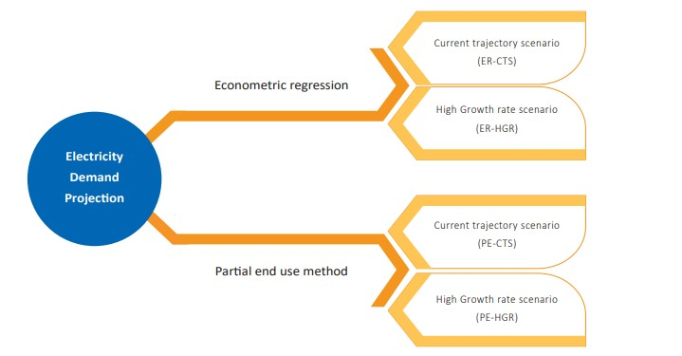

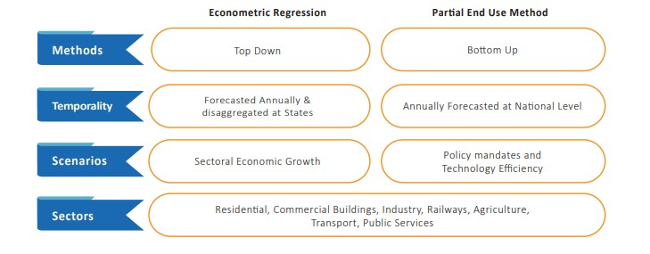

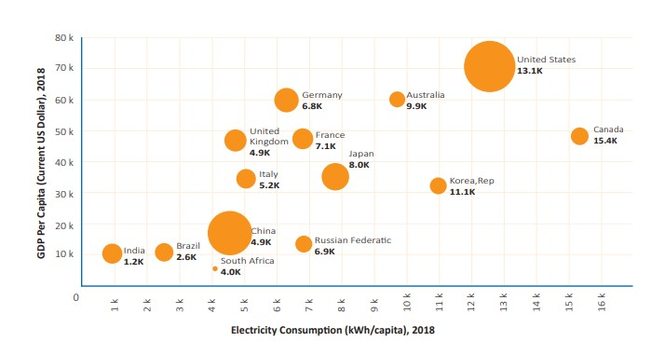

**Modelling for Gender and Age data**

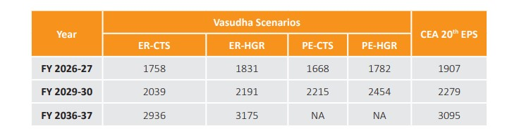

ECONOMETRIC FORECAST

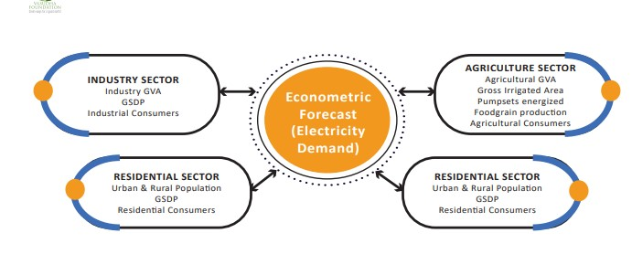

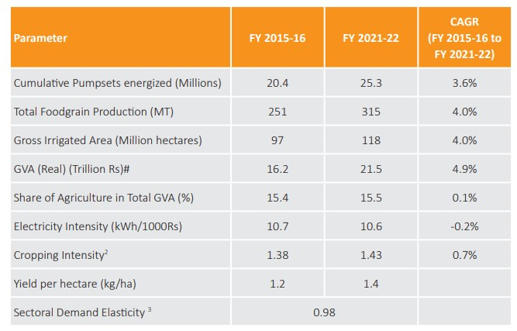

**Replacing values**

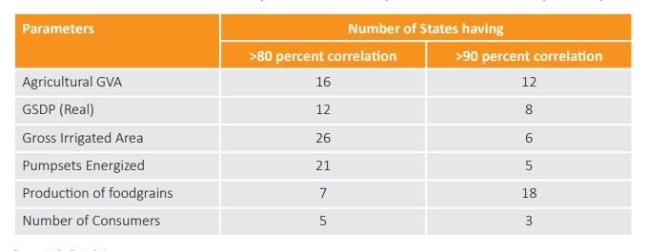

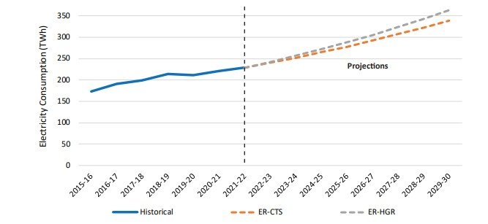

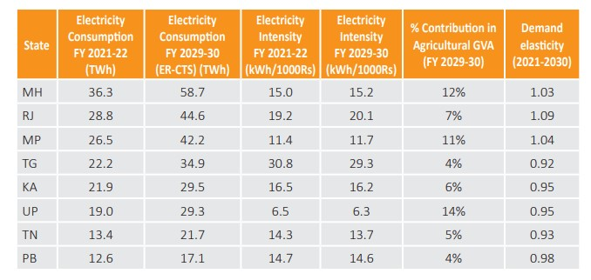

**Grouping of age by ranges**

. In the pre-covid period (2016 to 2020), the electricity consumption grew by ~5.8 percent, whereas the GVA grew at 7.3 percent at a moderately faster rate. The electricity intensity of the sectoral GVA stood at 2.23 kWh/1000 Rs in FY 2021-22, compared to 2.5 kWh/1000 Rs in FY 2015-16. With the compliance of BEE norms for Energy Efficiency in Commercial Spaces with regard to space cooling and energy conservation measures, the energy intensity has

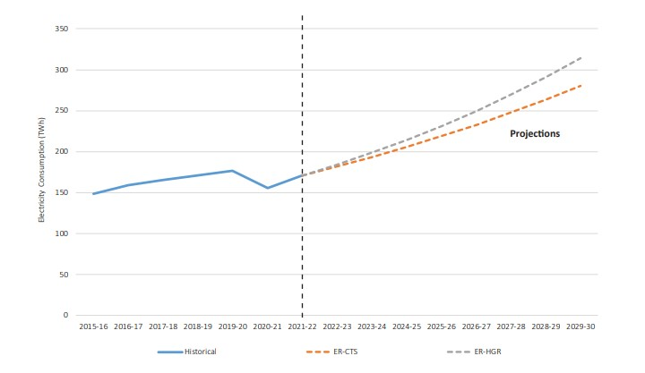

**Credit Rating and Loan Status**

Based on our estimates of the ER-CTS and ER-HGR the electricity consumption of the services sector is expected to grow to ~281 and 304 TWh, respectively by FY 2029-30. It is projected to grow at a rate of 6.4-7.5 percent annually as compared to 4.9 percent during the period 2015 to 2022. According to the econometric forecasts, the electricity consumption has a strong correlation with the sectoral value added (R2 =0.97). Continuing to account for 17-18 percent of country’s total electricity demand, the sectoral trend does not appear to have a drastic change, and is just a few percentage points higher than the current demand. Even though the electricity consumption is expected to grow by 2020, the electricity intensity remains moderately similar in the range of 2.7-2.83. The Exhibit 2 compares the electricity intensities of some of the Indian states during FY 2015-16 with that of FY 2029-30.

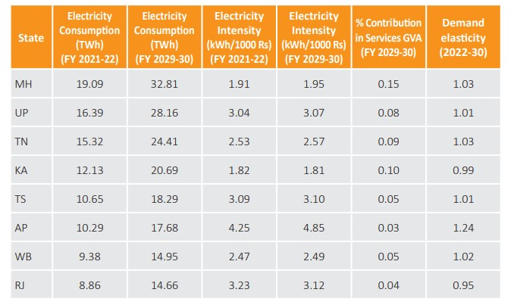

**Dashboard**

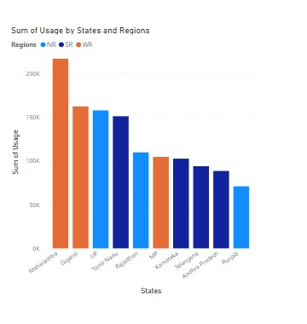

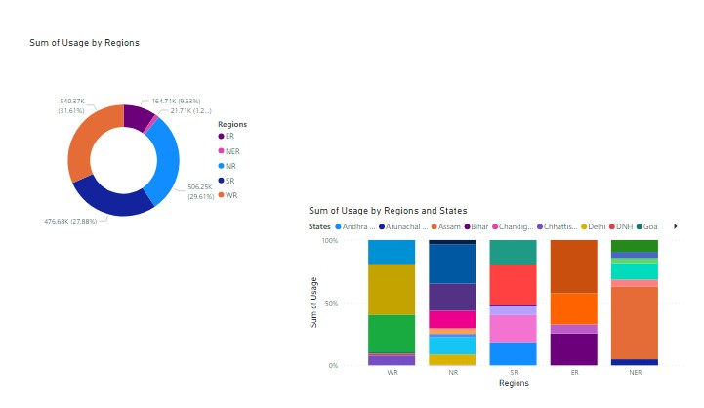

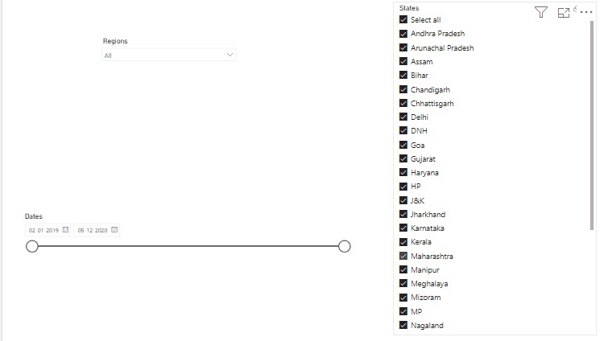

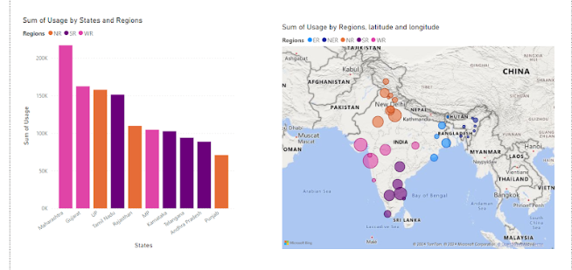

**CONCLUSION**

The project “Real-Time Analysis of Bank Customers” using PowerBI has successfully demonstrated the potential of data analytics in the banking sector. The real-time analysis of customer data has provided valuable insights into customer behavior, preferences, and trends, thereby facilitating informed decision-making. The interactive dashboards and reports have offered a comprehensive view of customer data, enabling the identification of patterns and correlations. This has not only improved the efficiency of data analysis but also enhanced the bank’s ability to provide personalized services to its customers. The project has also highlighted the importance of data visualization in making complex data more understandable and accessible. The use of PowerBI has made it possible to present data in a visually appealing and easy-to-understand format, thereby aiding in better decision-making.

**FUTURE SCOPE**

The transport sector, both road and railways, is poised to undergo a transformative shift with electrification initiatives. The projected rise in road transport registrations and the surge in private ownership of four-wheelers emphasize the need for strategic planning to meet the evolving electricity demands of this sector. The services sector, driven by growth in commercial floor space and heightened air conditioning needs, is expected to contribute significantly to the overall electricity demand. However, it is essential to note the divergence in demand between air-conditioned and non-air-conditioned spaces within this sector. The report acknowledges the challenges posed by the lack of comprehensive end-use demand data in India. The wide range of outcomes resulting from different forecasting methodologies underscores the importance of transparency and data dissemination at both state and national levels. Addressing this data gap is crucial for enhancing the accuracy of future electricity forecasts and supporting optimal planning to meet the nation's growing electricity requirements. As India navigates the complexities of a post-pandemic economic recovery, electrification of the transport sector, and ambitious manufacturing growth, strategic and adaptive planning becomes imperative. The insights provided by this report serve as a valuable resource for policymakers, industry stakeholders, and planners to develop robust strategies that ensure affordable, reliable, and sustainable power for the nation's continued progress.

**REFERENCES**

https://cea.nic.in/wp-content/uploads/general/2022/GR_2022_FINAL.pdf

**LINK**

<https://github.com/githubtraining/hellogitworld.git>