Title of the project:
ONLINE MEDICATION AND PRESCRIPTION TRACKER
Submitted by: Team-B
Karmankar Nilvana

Under the Guidance of
Mr. Vinay Prashant
1. Project Overview
The Online Medication and Prescription Tracking system is designed to provide a digital platform for managing prescriptions and medication schedules efficiently. It allows doctors to create and update prescriptions online, while patients can access their medication details anytime. The system also provides reminders for timely medication intake and supports tracking of adherence.
By centralizing all prescription-related information, the system improves coordination between patients, healthcare providers, and caregivers. It aims to reduce medication errors, prevent missed doses, and enhance overall healthcare management through a secure and user-friendly solution.
The system is designed to be simple, accessible, and efficient for everyday use. It supports secure data handling and role-based access to ensure that only authorized users can view or modify information. By integrating features such as automated alerts, centralized records, and easy sharing of prescriptions, the platform enhances patient engagement and helps healthcare providers make better-informed decisions. Overall, the system contributes to improved treatment outcomes and more organized healthcare management.

2. Problem Statement
In the current healthcare system, medication and prescription management is largely manual and fragmented. Patients often depend on paper-based prescriptions, personal memory, or scattered digital records to manage their medications. This approach leads to common issues such as lost prescriptions, difficulty in understanding handwritten instructions, missed doses, and incorrect medication usage.
Patients with chronic illnesses or multiple prescriptions face greater challenges in maintaining proper medication schedules. At the same time, healthcare providers do not have a centralized system to access a patient’s complete medication history, which increases the risk of duplicate prescriptions and harmful drug interactions. Caregivers also lack proper tools to monitor whether patients are taking medications as prescribed.
Therefore, there is a need for a centralized, secure, and user-friendly online system that can manage prescriptions digitally, provide timely reminders, track medication adherence, and improve communication among all stakeholders to ensure safe and efficient healthcare delivery.

3. Proposed Solution
MedLink is an online medication and prescription tracking system designed to provide a centralized platform for managing prescriptions and medication schedules. It allows doctors to create and update prescriptions digitally, ensuring accurate and easily accessible medical records.
Through MedLink, patients can view their prescriptions anytime and receive automated reminders for timely medication intake, reducing missed doses. The system also enables tracking of medication adherence and sends notifications for prescription refills to avoid interruptions in treatment.
Additionally, MedLink allows caregivers to monitor patient medication usage and ensures secure, role-based access to sensitive data. By improving coordination between patients, doctors, and caregivers, MedLink offers an efficient, reliable, and user-friendly solution for better medication management and enhanced healthcare outcomes.

4. Objectives
- To develop MedLink, a system for digital management of prescriptions and medications.
- To provide timely medication reminders to help patients take medicines regularly.
- To create a centralized platform where patients and doctors can access prescription records.
- To reduce medication errors, missed doses, and lost prescriptions.
- To allow doctors to easily create and update prescriptions online.
- To enable caregivers to monitor patient medication intake.
- To improve communication between patients, doctors, and caregivers for better healthcare management.
5. Scope of Requirements
- MedLink will provide digital storage and management of prescriptions in a centralized system.
- The system will allow doctors to create, update, and share prescriptions online.
- Patients will be able to view medication details such as dosage, timing, and duration.
- The system will send automatic reminders for medication intake and prescription refills.
- It will support tracking of medication adherence by recording user activity.
- Caregivers will have access to monitor patient medication status.
- The system will ensure secure login and role-based access control for all users.
- MedLink will maintain a complete medication history for each patient.
- Basic reports and notifications will be generated to improve medication management.
6. Target Users
- Patients
The primary users who access prescriptions, receive reminders, and track their medication intake.
- Doctors
Responsible for creating, updating, and managing patient prescriptions.
- System Administrator
Manages the system, handles user accounts, and ensures data security and smooth operation.
7. Technology Stack
- Frontend: React.js for creating a highly responsive and dynamic user interface.
- Backend: Java-based Spring Boot for building a robust and high-scalability server logic.
- Architecture: RESTful Web Services to handle seamless communication between the client and server.
- Persistence: MongoDB providing a high-performance NoSQL database solution for medical records.
- Security: Spring Security coupled with JWT (JSON Web Tokens) for role-based access control.
- Dev Tools: VS Code for coding, Postman for API validation, and Git for version management.

8. Workflow
- User Registration and Login
Users (patients, doctors, caregivers) create an account and log in securely to access the system.
- Prescription Creation
Doctors create digital prescriptions by entering medicine details such as name, dosage, and duration.
- Prescription Storage
The system stores all prescriptions in a centralized database for easy and secure access.
- Medication Scheduling
Based on the prescription, the system generates a medication schedule for the patient.
- Reminder Notifications
MedLink sends automatic reminders to patients for timely medication intake and refills.
- Medication Tracking
Patients mark medicines as taken, and the system records adherence.

9. Expected Outcome
The MedLink system is expected to provide an efficient and centralized platform for managing prescriptions and medication schedules. It will help patients take medicines on time through automated reminders and reduce missed doses. The system will improve accuracy by eliminating paper-based prescriptions and minimizing medication errors.
Additionally, MedLink will enable easy access to complete medication history, improving decision-making for doctors. Caregivers will be able to monitor patient adherence, ensuring better support. Overall, the system will enhance coordination among users, improve medication compliance, and contribute to better healthcare outcomes.

11. Future Enhancements

- AI Integration: Implementing AI for analyzing potential side effects and drug-to-drug interactions.
- Pharmacy Collaboration: Real-time integration with retail pharmacies for automated drug ordering and delivery.
- Cross-Platform Support: Launching dedicated iOS and Android mobile applications.
- Telemetry Sync: Syncing health data from smartwatches and other wearable medical devices.
- Telehealth Support: Integrating video consultation features directly into the MedLink dashboard.
- Calendar Integration
Appointment scheduling synchronized with external calendars using iCal standards
- AI-powered health chatbot to provide real-time medical guidance, medication reminders, and personalized patient support within the MedLink application.

12. Results
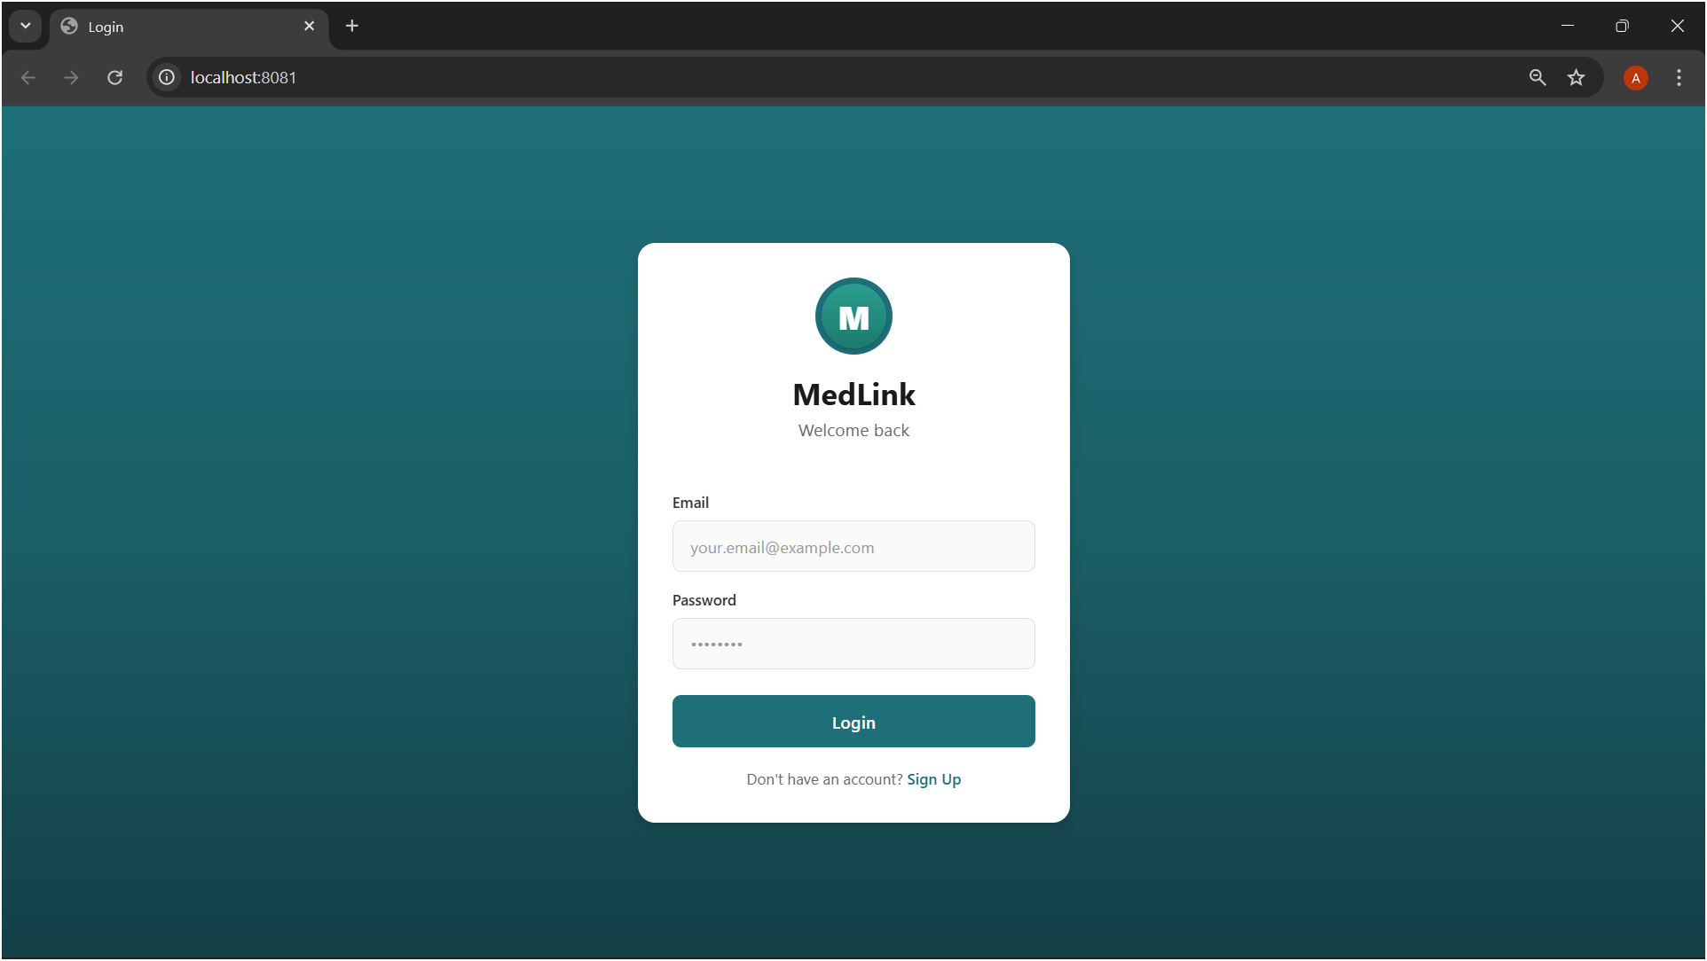
Registration and Login Page

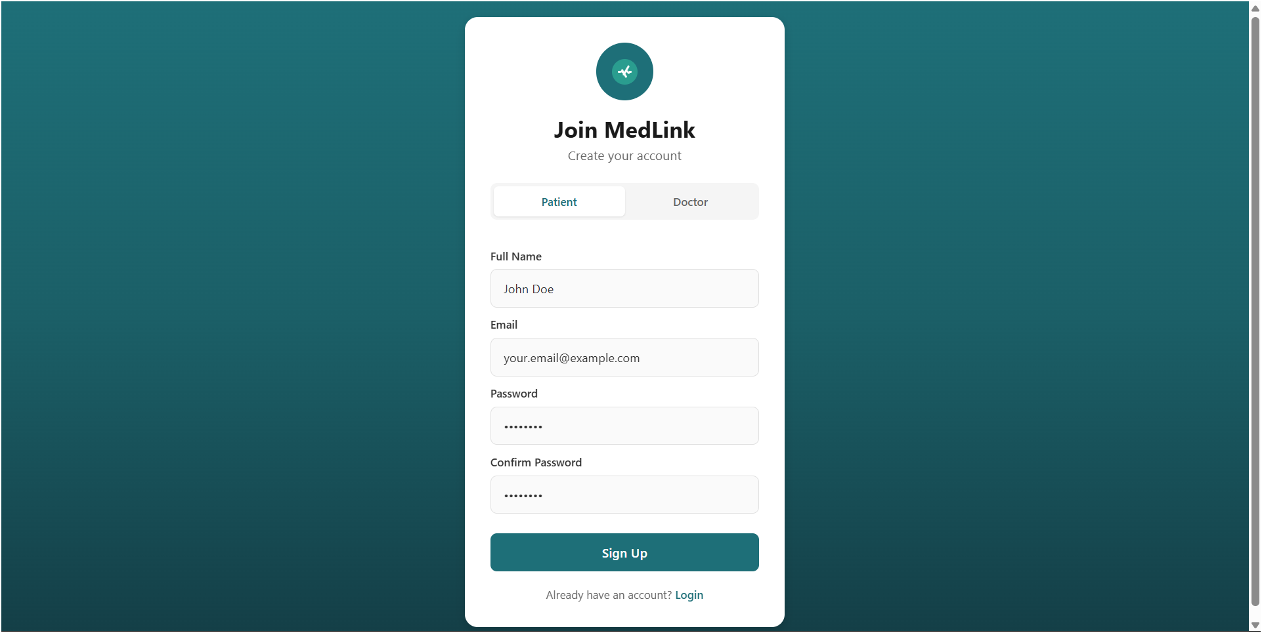
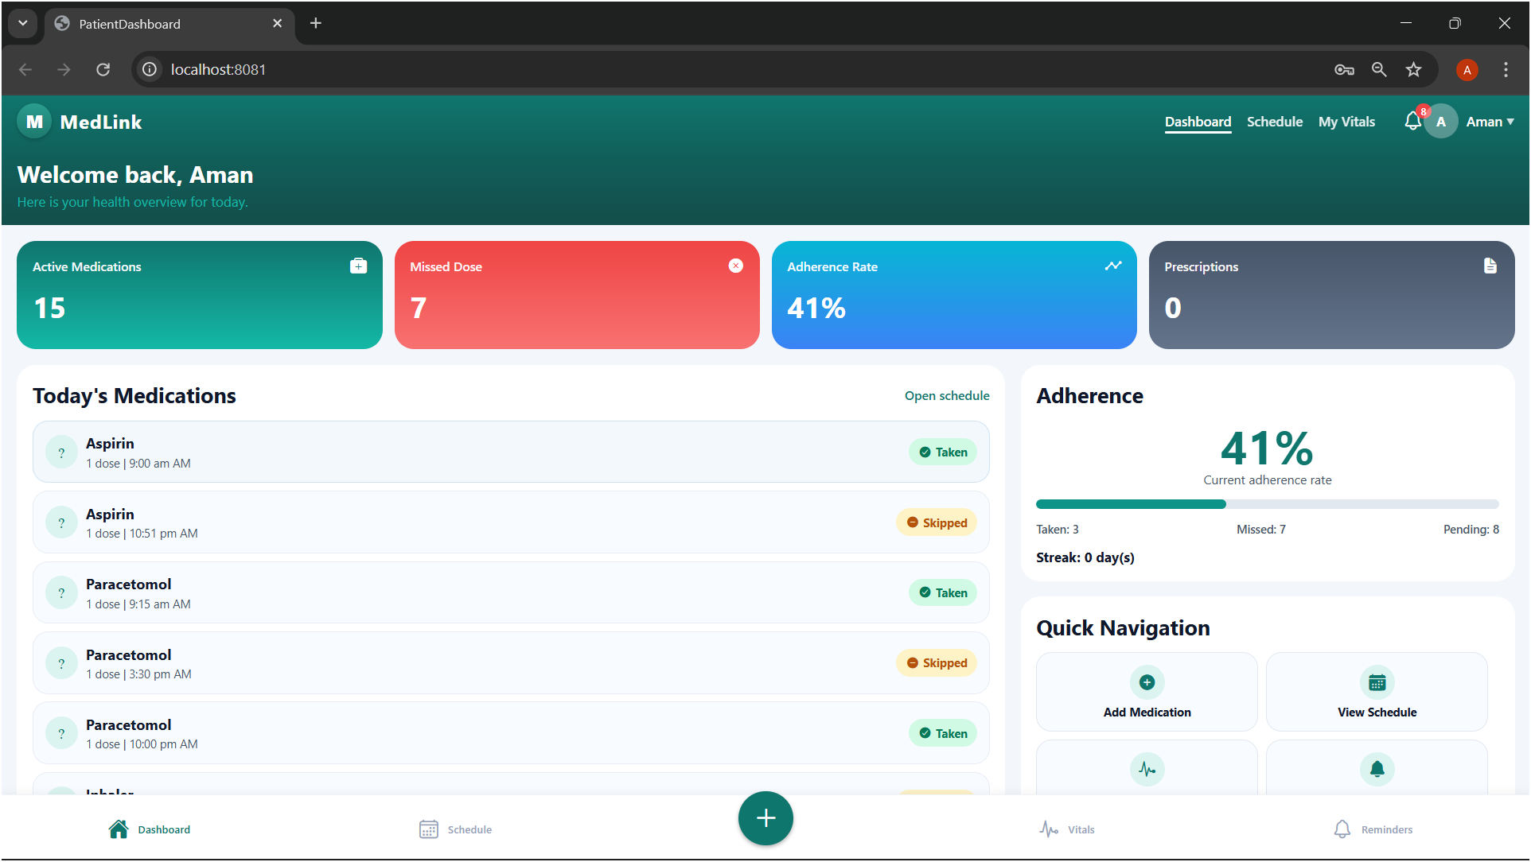
Patient Dashboard

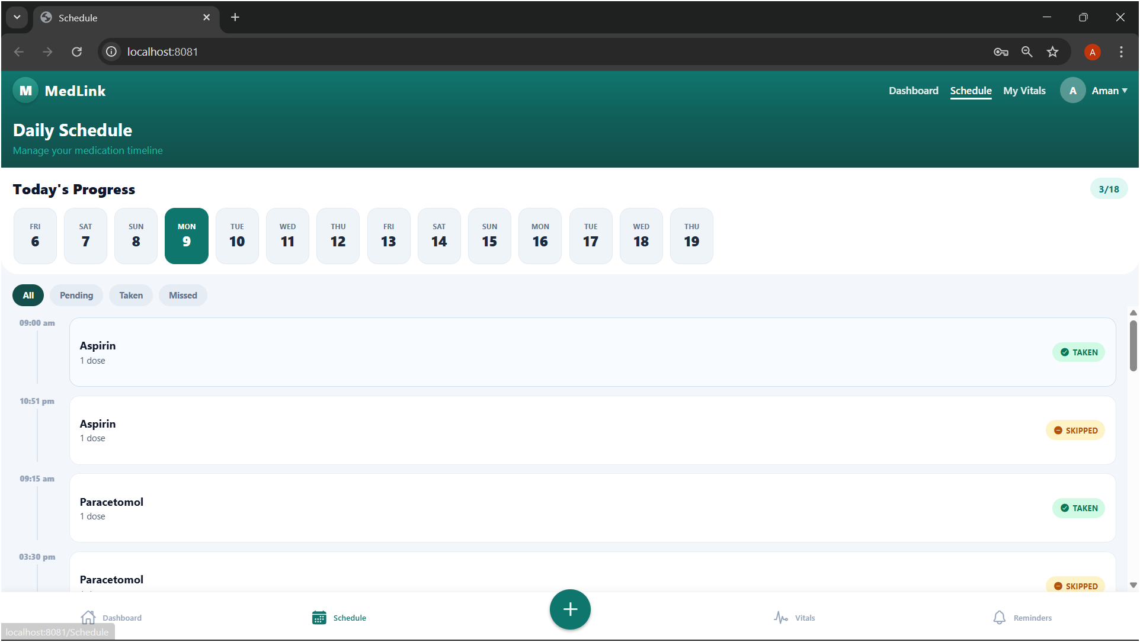
Daily Scheduling Page
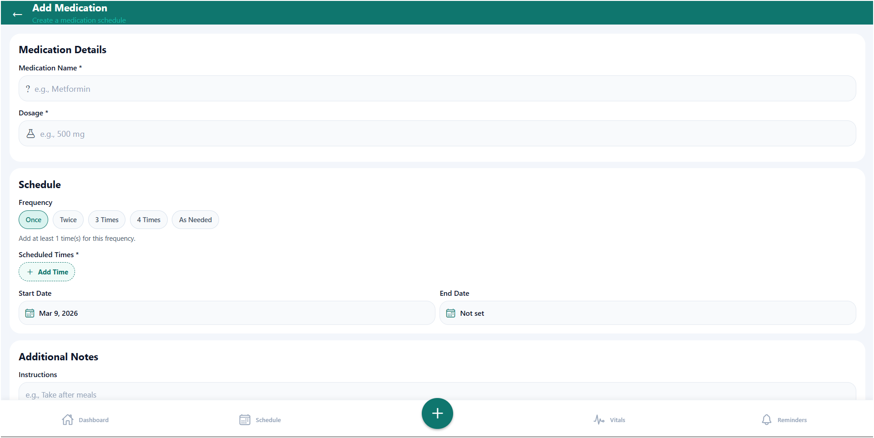
Add Medication Page
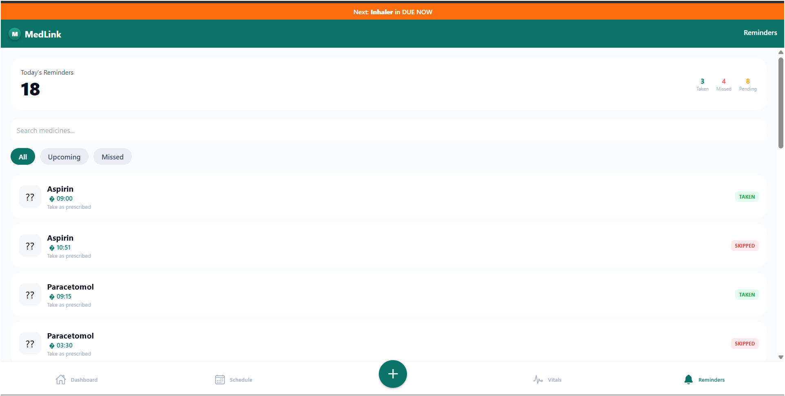
Reminder

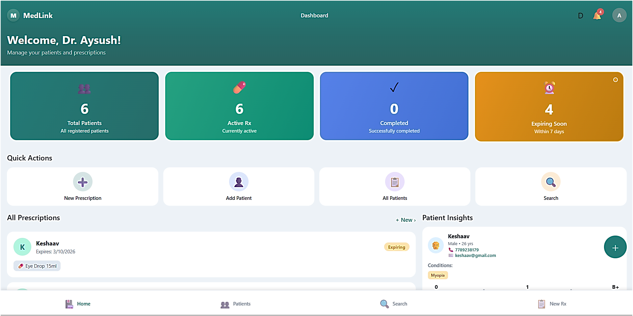
Doctor Dashboard
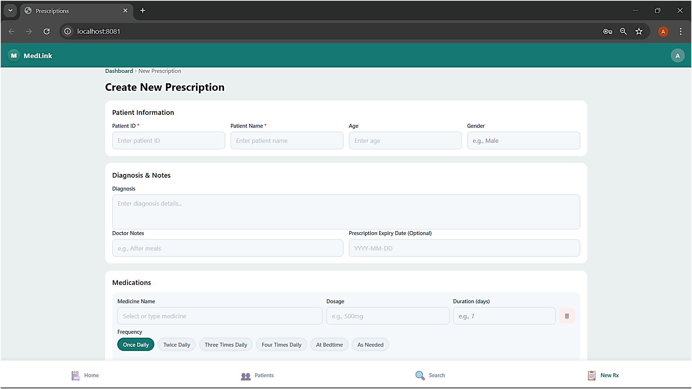
Add Prescription Page
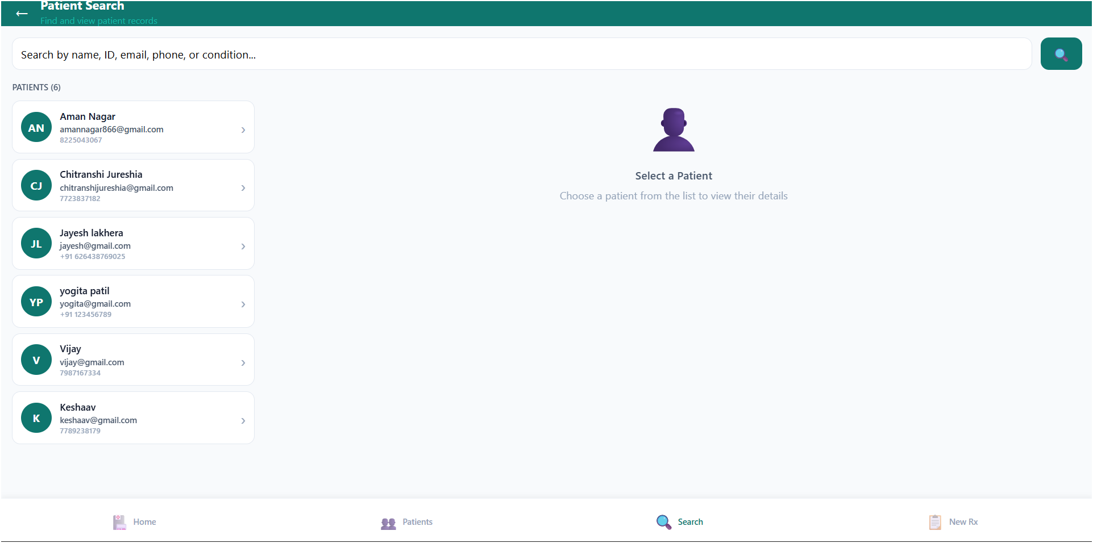
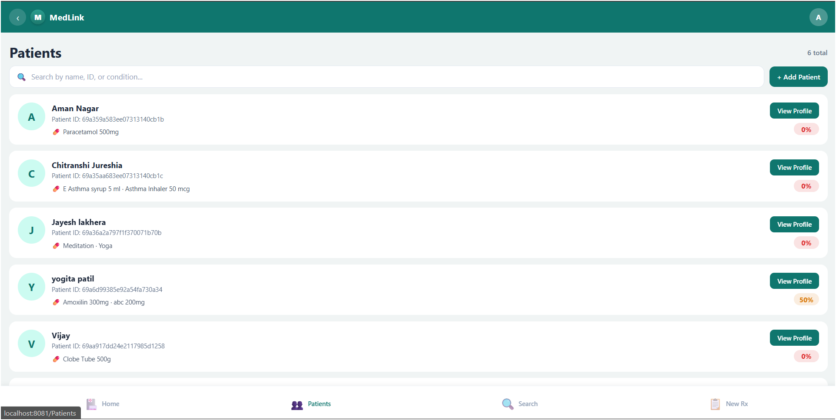
Add and View Patient

12. Conclusion

MedLink provides an effective solution for managing medications and prescriptions in a digital and organized manner. By replacing manual and paper-based methods, the system reduces errors, prevents missed doses, and ensures easy access to medical records. It improves communication between patients, doctors, and caregivers, leading to better coordination and treatment outcomes.

Overall, MedLink enhances medication adherence, ensures data security, and simplifies healthcare management, making it a reliable and user-friendly system for modern healthcare needs.

