# Arduino

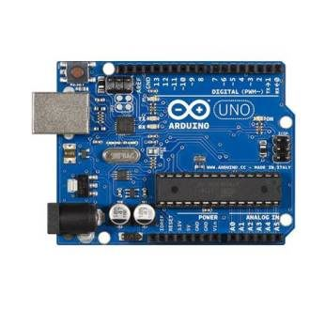

Arduino is an open-source microcontroller project that is literally changing the world. Originally developed in Italy and named after the bar that was frequented by its developers, the Arduino and Arduino clones are now manufactured by companies around the world and are available in several different configurations. You can even build your own Arduino clone very easily using inexpensive components that are readily available.

The real beauty of the Arduino is in its simplicity. Arduino programs (or “Sketches”) are very simple to write and debug, so even people with little or no programming experience can grasp the concepts and write useful code quickly. Arduino Hardware is also simple-to-use and there is a wealth of add-ons (or “Shields”) that can connect to your Arduino and expand its capabilities greatly. Only a very elementary knowledge of electronics is necessary to start building all sorts of wonderful devices using the Arduino.

We’ll be using the Arduino to create all sorts of things from robots to quadcopter controllers and devices for The Internet of Things. With the Arduino if you can imagine it you can probably build it. Best of all, Arduinos are easily obtainable and very affordable so just about anyone can get up and running with the Arduino right away.