# ESP32

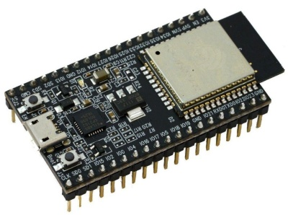

The ESP32 is a 32-bit microcontroller manufactured by Expressive Systems. It is an upgrade to the popular ESP8266 and features integrated Wi-Fi, Bluetooth and BLE. It is available in a number of popular modules and is the perfect microcontroller for IoT devices and designs that require IoT and Internet access.

The ESP32 can be programmed using several different programming environments and using several programming languages, including micro-Python and C++. It is a 3.3-volt device that is capable of operating in an ultra-low-power mode, making it ideal for battery-powered applications. Many ESP32 modules have an integrated battery charger and connector for a 3.7-volt Lippo battery.

Some ESP32 modules have additional integrated perceptions, including displays, microSD card sockets and even cameras.

The ESP32 is a low-cost device that can be the basis for very powerful designs.