**IOT BASED FIRE DETECTION SYSTEM**

**S. SHALOMSHAN**

**AIT190806**

**NF44247**

This Dissertation is submitted to the Department of Computing, School of Computing, British College of Applied Studies in partial fulfilment of the Requirements of the BTEC Higher National Diploma in Computing.

**Department of Computing**

**School of Computing**

**British College of Applied Studies**

**2021**

**Contents**

DECLARATION iv

CERTIFICATION v

ACKNOWLEDGEMENT vi

ABSTRACT 1

CHAPTER ONE 2

INTRODUCTION 2

1.1 Proposed Solution 3

CHAPTER TWO 7

LITERATURE REVIEW 7

2.1 Problem 7

2.2 Existing System 8

2.3 Comparison of Proposed System with Existing Systems 10

2.3.1 Existing Systems 10

2.3.2 Advantages & Disadvantage of Existing Fire Detection Systems 11

2.3.3 Proposed System 12

2.3.4 Advantages of Proposed System 13

CHAPTER THREE 15

IDENTIFIED TECHNOLOGIES 15

3.1 Internet of Things (IoT) 15

3.2 Fire Detection 15

3.3 Computer Vision 16

3.4 Color Conversion 16

3.5 HSV Color Algorithm 16

3.5.1 Algorithm Steps 17

3.5.2 Improvements / Other Methods 19

3.6 Generate Alert on Fire 19

3.7 Play Sound (pip install playsound) 20

3.8 OpenCV 21

3.8.1 OpenCV-Python 22

3.9 Algorithm & Technologies 23

3.9.1 Tools 23

CHAPTER FOUR 24

DESIGN & IMPLEMENTATION OF THE SYSTEM 24

4.1 Top Level Architecture 24

4.2 Modules 25

4.2.1 Raspberry Pi 25

4.2.2 Pi Camera 25

4.3 Conceptual Flow Chart 26

4.4 Testing 27

4.5 Result 28

CHAPTER FIVE 29

CONCLUSION 29

REFERENCES 30

# DECLARATION

I do hereby declare that this work has been originally carried out by me under the guidance of Mr. A.R. Mohamed Nizzad, Senior Lecturer, Department of Computing, and this work has not been submitted elsewhere for any other diploma or degree.

I certify that this dissertation does not incorporate without due acknowledgement of any material previously submitted for diploma or degree in any institution or university nor it does not contain any material previously published or unpublished by another person except where due reference is made in the text.

……………………….

Signature of Candidate

SHALOMSHAN

NF44247

# CERTIFICATION

This is to certify that the dissertation titled “**IoT Based Fire Detection System”** is submitted by **S. SHALOMSHAN** having the PEARSON Registration No **NF44247** to the Department of Computing School of Computing, British College of Applied Studies in partial fulfillment of the requirements for the award of the BTEC Higher National Diploma in Computing.

I also certify that this is his original work based on the studies carried out independently by him during the period of study under my guidance and supervision.

This is also to certify that the above dissertation has not been previously formed the basis for the award of any degree, diploma, fellowship or any other similar title.

……………………………

(Signature of Supervisor)

A.R. Mohamed Nizzad

Senior Lecture

Department of Computing

School of Computing

British College of Applied Studies

………………………………..

Date

# ACKNOWLEDGEMENT

With immense gratitude and accomplishment, I write this note of acknowledgement where I must thank my module lecturer Mr. K.M Ishraque and my supervisor Mr. A.R Mohamed Nizzad who supported and guided me to achieve this milestone.

I also take this moment to thank my parents, family and friends who supported me in one or the other to complete my research work in a successful manner.

# ABSTRACT

Fire present significant threat to life due to its severe hazards and ability to spread rapidly. Fire detection systems, specially computer vision-based systems offers flame detection prior to any loss or destruction. In this present model, IoT based computer vision device is designed which works on Raspberry Pi and Pi Cam detects flame (visible part of fire). An immediate alert is generated on Gmail application. Here in, HSV color combination is used for proposed model and changes in flame color and texture is studied.

**Keywords: -** Fire Detection, IoT, Computer Vision, HSV Color Algorithm, Gmail, Raspberry pi

# CHAPTER ONE

## INTRODUCTION

Fire is a serious threat to life and property worldwide. It is usually caused by combustion of materials which releases heat and light in larger amounts. Fire detection systems have been designed to detect via sensing different fire related change. Two types of fire detectors have been used so far, normally traditional/sensor based and vision-based systems. Former responds against smoke, heat, temperature, and pressure, whereas later rely on the light detection. Among the two systems used, traditional detectors have several disadvantages associated with them. These include high host, slow response time and limited detection range additionally, these systems are not feasible as outdoor detectors due to excessive sunlight and wind pressure.

Besides, vision-based detectors can respond to flames quickly and can analyze location of fire. In these detectors, flame which is the vision part of the fire can be analyzed via its color shape and movement based on spectral and spatial models, although, vision-based detectors have several advantages, however, false detections limit their utilities. Therefore, there is still dire to design new models that are more efficient and can solve problems associate with previously reported models. The reason behind proposing a system of like fire detection is to prevent from the loss and damages done by fire very before by generating an alert.

There are many fire detection systems are working in different areas in different manners but mostly are senser based and detect fire through heat and smoke. But the method of fire detection by using sensors are now not very effective because they generate alerts when fire has reached its maximum level which is very dangerous that is why the systems is proposed that detects fire in the being which is very important to stop it very before so the loss or damages cannot be done by it.

### Proposed Solution

I here am proposing an IOT based Smart Fire Alarm system that has the ability to think and recognize pattern based on experience aka collected data and algorithm that has a heigh probability of resulting in unwanted hazardous fire.

Here we are proposing components fire alarm system.

1. **Raspberry Pi**

The purpose is to create a hardware which can detect fire from far away. This device supports the Raspberry Pi platform and windows platform. Fire is a dangerous thing which can bring a lot of harm to anything. To prevent from loss, sensors are installed but these sensors are not effective. Sometimes they get destroyed by heat or fire or sometimes they generate alert very late until the damage has been done. In contrast Raspberry Pi is very useful because it consumes low power and it is of low cost and it does not need any sensors because the camera will detect the fire and generate the alert immediately to the users or the members of the organization, where this system is installed.

1. **Pi Camera**

* Pi Camera module is a camera which can be used to take pictures and high-definition video.
* Raspberry Pi Board has CSI (Camera Serial Interface) interface to which we can attach Pi Camera module directly.
* This Pi Camera module can attach to the Raspberry Pi’s CSI port using 15-pin ribbon cable.

1. **Buzzer**

A fire alarm is a standalone device or a complete network of devices, installed in a building or an area, which gives audible and/or visible warning of an outbreak of fire in that building or area.

1. **Internet of Things (IoT)**

Internet of things (IoT) is the network of programmable software, sensors, electronics, and communication facility that helps to gather and transfer data. The objective of the designed system is to alert the user and send the email fire engine service while the fire accidents occur. This system can be easily installed at any remote locations from where fire can be easily detected by camera. Therefore, sensors are not required for this purpose. The Raspberry Pi controller processes the camera input and detects fire using heat signatures. By using image processing method, the report is automatically generated and sends to the person immediately after the fire is being detected using Wi-Fi. This intern triggers the emergency mode of system. Advantages including remote monitoring for immediate actions and sending the information at any time or place, are main attributes of this method.

1. **Fire Detection**

The fire detection system is a security system. The primary punction of this system is to detect fires and turn on alarm to warn fire accidents. This system is written in python with OpenCV computer vision module. It is using the HSV color algorithm to detect fires.

This system provides a computer vision-based technique for detecting fire and identifying hazardous fire by processing the video data generate by an ordinary camera.

1. **Computer Vision**

Computer vision is an interdisciplinary scientific field that deals with how computers can be made to gain high-level understanding from digital images or videos. From the perspective of engineering, it seeks to automate tasks that the human visual system can do.

1. **Color Conversion**

In fire detection systems each color combination responds to the basic spectrum factors of red R, green G, and blue B in the RGB model. The color model is based on the Cartesian coordinate system. The images or video captured in the form of framed by the Camera are then converted from RGB to XYZ color space. The color conversion is very important and in fire detection system the RGB model converted into HSV (Hue, Saturation Value) that is very important for the detection of fire on very high scale because it gives the fire detection at very minimum to high scales.

Color isolation can be achieved by extracting a particular HSV (Hue, Saturation, Value) from an image. The algorithm is simple, and the main steps are follows:

* Step 1 – RGB to HSV Conversion
* Step 2 – Apply a Threshold Mask

1. **Generate Alert on Fire**

The main motive of using this system is to prevent from the loss of life or any other damages to the company or the organization Few years back the system that were installed are now obsolete because they detect fire or smoke when it reaches the maximum level and until that time the loss was already done. The fire detection system is used to detect fire in air through camera in real time monitoring system based on Raspberry Pi. The main feature of system is to alert generate when fire is started or reached it minimum level to prevent from the loss of lives and damages of any other property or valuable things that are useful for the company or any place where it is installed.

# CHAPTER TWO

## LITERATURE REVIEW

### 2.1 Problem

We have had fire service for a very long time all over the world. Fire detection, fire extinction, equipment transportation, are all in most countries based on very outdated technology. Notification systems are still based on human anticipation, it goes off only after individual responsible pulls a lever or notifies the fire service. By the time fire services can come to the site can depend on the time of the day and place as traffic can be an obstacle in densely populated areas where the scope of fire spreading and causing huge damage both monetary and of life is larger.

We need to better manage these issues both from a logistic perspective and from time management standpoint to an acceptable status. A lot of the urban fire causes so much damage due to the fact that the notification system is slow and the response time is large. With a digitized system based on the internet we can easily cut this delay significantly with ease.

### 2.2 Existing System

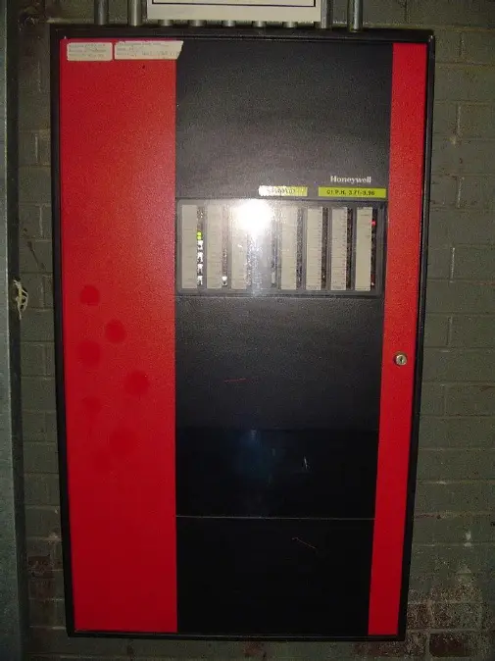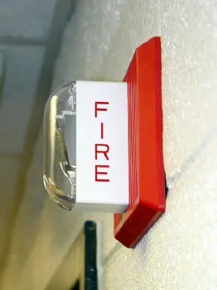The existing Fire Alarm System that is broadly used is not quite digitized. The sensors usually used are smoke and fire detectors. Notification’s systems are pull stations or sound alarms. Inputs from these various sensors are collected in fire alarm control unit where the data is monitored. This component, the hub of the system, monitors inputs and system integrity, controls outputs and relays information. This existing system is an electrical hardware system that is used in a localized environment with huge deployment cost and is to a point outdated.

Figure 1 Fire alarm control unit

Figure 2Fire Alarm Notification appliance

Primary power supply used for these fire alarms are usually the non-switched 120 or 240-voltalternating current source supplied from a commercial power utility and batteries, generators as backup. This component uses energy supplied from the fire alarm system or other stored energy source, to inform the proximate persons of the need to take action, usually to evacuate. This is done by means of a pulsing incandescent light, flashing strobe light, electro mechanical horn, siren, electronic horn, chime, bell, speaker, or a combination of these devices. Strobes are either made of a xenon tube (most common) or recently LEDs.

Notification Appliances utilize audible, visible, tactile, textual or even olfactory stimuli (odorize)to alert the occupants of the need to evacuate or take action in the event of a fire or other emergency. Evacuation signals may consist of simple appliances that transmit encoded information, coded appliances that transmit a predetermined pattern, and or appliances that transmit audible and visible textual information such as live or pre-recorded instructions, and illuminated message displays.

### 2.3 Comparison of Proposed System with Existing Systems

### 2.3.1 Existing Systems

The existing Fire Alarm System that is broadly used is not quite digitized. The sensors usually used are smoke and fire detectors. Notification’s systems are pull stations or sound alarms. Inputs from these various sensors are collected in fire alarm control unit where the data is monitored. This component, the hub of the system, monitors inputs and system integrity, controls outputs and relays information. This existing system is an electrical hardware system that is used in a localized environment with huge deployment cost and is to a point outdated.

Primary power supply used for these fire alarms are usually the non-switched 120 or 240-voltalternating current source supplied from a commercial power utility and batteries, generators as backup. This component uses energy supplied from the fire alarm system or other stored energy source, to inform the proximate persons of the need to take action, usually to evacuate. This is done by means of a pulsing incandescent light, flashing strobe light, electro mechanical horn, siren, electronic horn, chime, bell, speaker, or a combination of these devices. Strobes are either made of a xenon tube (most common) or recently LEDs.

Notification Appliances utilize audible, visible, tactile, textual or even olfactory stimuli (odorize)to alert the occupants of the need to evacuate or take action in the event of a fire or other emergency. Evacuation signals may consist of simple appliances that transmit encoded information, coded appliances that transmit a predetermined pattern, and or appliances that transmit audible and visible textual information such as live or pre-recorded instructions, and illuminated message displays.

### 2.3.2 Advantages & Disadvantage of Existing Fire Detection Systems

An existing fire detection system is the most basic commercial system available – and generally the lowest cost system in terms of parts. The system operators on single wire basis with detectors and manual call points being located along the wire, finishing with an End of Line Unit (EOL).

The advantages of a conventional system are that they tend to be cheap to put in place, providing a simple solution for buildings of low risk and simple structures where there are not many rooms.

The main disadvantage is the volume of cable required to be installed – meaning that they can be labor intensive to install and commission. Faults and alarms also knock out entire zones rather than individual devices – this means that a fire/fault can only be identified in a single zone rather than pinpointing to a specific location within the building.

It is a requirement of conventional systems that alarm circuits be separated from sounder circuits to ensure the sounders can continue to function when a zone is activated.

### 2.3.3 Proposed System

Fire is a serious threat to life and property worldwide. It is usually caused by combustion of materials which releases heat and light in larger amounts. Fire detection systems have been designed to detect via sensing different fire related change. Two types of fire detectors have been used so far, normally traditional/sensor based and vision-based systems. Former responds against smoke, heat, temperature, and pressure, whereas later rely on the light detection. Among the two systems used, traditional detectors have several disadvantages associated with them. These include high host, slow response time and limited detection range additionally, these systems are not feasible as outdoor detectors due to excessive sunlight and wind pressure.

Besides, vision-based detectors can respond to flames quickly and can analyze location of fire. In these detectors, flame which is the vision part of the fire can be analyzed via its color shape and movement based on spectral and spatial models, although, vision-based detectors have several advantages, however, false detections limit their utilities. Therefore, there is still dire to design new models that are more efficient and can solve problems associate with previously reported models. The reason behind proposing a system of like fire detection is to prevent from the loss and damages done by fire very before by generating an alert.

There are many fire detection systems are working in different areas in different manners but mostly are senser based and detect fire through heat and smoke. But the method of fire detection by using sensors are now not very effective because they generate alerts when fire has reached its maximum level which is very dangerous that is why the systems is proposed that detects fire in the being which is very important to stop it very before so the loss or damages cannot be done by it.

I here am proposing an IOT based Smart Fire Alarm system that has the ability to think and recognize pattern based on experience aka collected data and algorithm that has a heigh probability of resulting in unwanted hazardous fire.

### 2.3.4 Advantages of Proposed System

First of all, IOT based fire alarm system compared to what is widely deployed right now will be alert faster, in real time. flames quickly and can analyze location of fire. In these detectors, flame which is the vision part of the fire can be analyzed via its color shape and movement based on spectral and spatial models, although, vision-based detectors have several advantages, however, false detections limit their utilities. Therefore, there is still dire to design new models that are more efficient and can solve problems associate with previously reported models. The reason behind proposing a system of like fire detection is to prevent from the loss and damages done by fire very before by generating an alert.

There are many fire detection systems are working in different areas in different manners but mostly are senser based and detect fire through heat and smoke. But the method of fire detection by using sensors are now not very effective because they generate alerts when fire has reached its maximum level which is very dangerous that is why the systems is proposed that detects fire in the being which is very important to stop it very before so the loss or damages cannot be done by it.

As the notification system is real time that can cut the response time significantly. When the fire has not spread significantly it gives us better access to that area to deal with the fire and can be dealt with pre-installed fire hose or fire extinguisher. Even when the fire has spread the heat signature collected from the data would enable us to identify how the fire spread and thus give us better insight on how to best deal with it.

Unlike existing solutions as this can be a smart solution, continuous collection and storage of data would give us insight on better identifying underlying causes on how to best prevent such scenarios. Through analytics done on the collected data and research we would be able to better correlate a fire happening to different events and thus would let us configure alert systems based on a combination of data rather than just increase of temperature. For example, depending where the system is installed like if it has more flammable objects or fire sparks can occur more often or does not have immediate access to water or fire extinguisher, we can configure our alert system on that so these areas can be prioritized or labeled as high risk at low temperature increase and deploy needed monitoring system.

Every object has its own heat signature and thus every event would register in the data if it causes significant heat variation. Once we start collecting data and associate sets of data to different events, we would be able to identify different events based on these collected data and use it as a future reference. And so, with in a margin of error we would be able to identify these events and have real time data to monitor to look for anomalies that may result in fire.

# CHAPTER THREE

## IDENTIFIED TECHNOLOGIES

### 3.1 Internet of Things (IoT)

Internet of things (IoT) is the network of programmable software, sensors, electronics, and communication facility that helps to gather and transfer data. The objective of the designed system is to alert the user and send the email fire engine service while the fire accidents occur. This system can be easily installed at any remote locations from where fire can be easily detected by camera. Therefore, sensors are not required for this purpose. The Raspberry Pi controller processes the camera input and detects fire using heat signatures. By using image processing method, the report is automatically generated and sends to the person immediately after the fire is being detected using Wi-Fi. This intern triggers the emergency mode of system. Advantages including remote monitoring for immediate actions and sending the information at any time or place, are main attributes of this method.

### 3.2 Fire Detection

The fire detection system is a security system. The primary punction of this system is to detect fires and turn on alarm to warn fire accidents. This system is written in python with OpenCV computer vision module. It is using the HSV color algorithm to detect fires.

This system provides a computer vision-based technique for detecting fire and identifying hazardous fire by processing the video data generate by an ordinary camera.

### 3.3 Computer Vision

Computer vision is an interdisciplinary scientific field that deals with how computers can be made to gain high-level understanding from digital images or videos. From the perspective of engineering, it seeks to automate tasks that the human visual system can do.

### 3.4 Color Conversion

In fire detection systems each color combination responds to the basic spectrum factors of red R, green G, and blue B in the RGB model. The color model is based on the Cartesian coordinate system. The images or video captured in the form of framed by the Camera are then converted from RGB to XYZ color space. The color conversion is very important and in fire detection system the RGB model converted into HSV (Hue, Saturation Value) that is very important for the detection of fire on very high scale because it gives the fire detection at very minimum to high scales.

### 3.5 HSV Color Algorithm

Color isolation can be achieved by extracting a particular HSV (Hue, Saturation, Value) from an image. The algorithm is simple, and the main steps are follows:

* Step 1 – RGB to HSV Conversion
* Step 2 – Apply a Threshold Mask

### 3.5.1 Algorithm Steps

**Step 1 – RGB to HSV Conversion**

We want to convert the image to HSV because working with HSV value is much easier to isolate colors. In the HSV representation of color, hue determines the color you want, saturation determines how intense the color is and value determines the lightness of the image. As can be seen in the image bellow, 0 on the wheel would specify a middle red color and would specify a blue color.

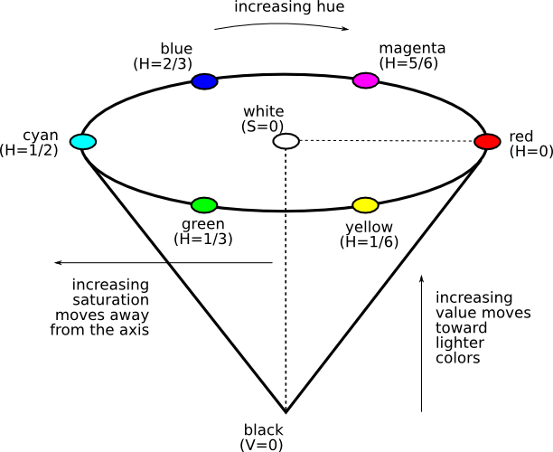

**Step 2 – Apply a Threshold Mask**

To isolate the colors, we have to apply multiple masks. A low threshold and high threshold mask for hue, saturation and value. Anything pixel within these thresholds will be set to 1 and the remaining pixels will be zero. In my algorithm, I applied a mask to get all of the red hues in the color wheel as can be seen below:

### 3.5.2 Improvements / Other Methods

This method of color isolation may not work so well if the image is noisy. This is quite common because a camera uses an ADC which can create noise in an image. One potential solution would be to apply a Gaussian blur before running this algorithm.

Color segmentation can also be achieved using K-means clustering, however, this method may be slow as it can requires multiple iterations to get the correct color.

### 3.6 Generate Alert on Fire

The main motive of using this system is to prevent from the loss of life or any other damages to the company or the organization Few years back the system that were installed are now obsolete because they detect fire or smoke when it reaches the maximum level and until that time the loss was already done. The fire detection system is used to detect fire in air through camera in real time monitoring system based on Raspberry Pi. The main feature of system is to alert generate when fire is started or reached it minimum level to prevent from the loss of lives and damages of any other property or valuable things that are useful for the company or any place where it is installed.

### 3.7 Play Sound (pip install playsound)

The playsound module contains only one thing - the function (also named) playsound.

It requires one argument - the path to the file with the sound you’d like to play. This may be a local file, or a URL.

There’s an optional second argument, block, which is set to True by default. Setting it to False makes the function run asynchronously.

On Windows, uses windll.winmm. WAVE and MP3 have been tested and are known to work. Other file formats may work as well.

On OS X, uses AppKit.NSSound. WAVE and MP3 have been tested and are known to work. In general, anything QuickTime can play, playsound should be able to play, for OS X.

On Linux, uses GStreamer. Known to work on Ubuntu 14.04 and ElementaryOS Loki. I expect any Linux distro with a standard gnome desktop experience should work.

If you’d like other Linux distros (or any other OS) to work, submit a PR adding in support for it, but please make sure it passes the tests (see below).

### 3.8 OpenCV

OpenCV was started at Intel in 1999 by Gary Bradsky, and the first release came out in 2000. Vadim Pisarevsky joined Gary Bradsky to manage Intel's Russian software OpenCV team. In 2005, OpenCV was used on Stanley, the vehicle that won the 2005 DARPA Grand Challenge. Later, its active development continued under the support of Willow Garage with Gary Bradsky and Vadim Pisarevsky leading the project. OpenCV now supports a multitude of algorithms related to Computer Vision and Machine Learning and is expanding day by day.

OpenCV supports a wide variety of programming languages such as C++, Python, Java, etc., and is available on different platforms including Windows, Linux, OS X, Android, and iOS. Interfaces for high-speed GPU operations based on CUDA and OpenCL are also under active development.

OpenCV-Python is the Python API for OpenCV, combining the best qualities of the OpenCV C++ API and the Python language.

### 3.8.1 OpenCV-Python

OpenCV-Python is a library of Python bindings designed to solve computer vision problems.

Python is a general-purpose programming language started by Guido van Rossum that became very popular very quickly, mainly because of its simplicity and code readability. It enables the programmer to express ideas in fewer lines of code without reducing readability.

Compared to languages like C/C++, Python is slower. That said, Python can be easily extended with C/C++, which allows us to write computationally intensive code in C/C++ and create Python wrappers that can be used as Python modules. This gives us two advantages: first, the code is as fast as the original C/C++ code (since it is the actual C++ code working in background) and second, it easier to code in Python than C/C++. OpenCV-Python is a Python wrapper for the original OpenCV C++ implementation.

OpenCV-Python makes use of Numpy, which is a highly optimized library for numerical operations with a MATLAB-style syntax. All the OpenCV array structures are converted to and from Numpy arrays. This also makes it easier to integrate with other libraries that use Numpy such as SciPy and Matplotlib.

### 3.9 Algorithm & Technologies

The HSV or Hue, Saturation and Value of a given object is the color space associated with the object in OpenCV where Hue represents the color, Saturation represents the greyness and Value represents the brightness and it is used to solve the problems related to computer vision because of its better performance when compared to RGB or Red, Blue and Green color space and the Hue range in HSV is [0,179], the Saturation range in HSV is [0,255] and the Value range in HSV is [0,255] and to perform object detection, finding the range of HSV is necessary.

### 3.9.1 Tools

Python is an interpreted high-level, general-purpose programming language. Created by Guido van Rossum and first released in 1991, Python has a design philosophy that emphasizes code readability, notably using significant whitespace. It provides constructs that enable clear programming on both small and large scales. OpenCV (Open-source computer vision) is a library of programming functions mainly aimed at real-time computer vision. HSV color algorithm is used here HSV is Hue Saturation Value. It uses HSV component and works well in image processing. Using this filter, an object with a specific color can be detected and to reduce the influence of light intensity from the outside. Anaconda is a free and open-source distribution of the Python and R programming languages for scientific computing (data science, machine learning applications, large-scale data processing, predictive analytics, etc.) that aims to simplify package management and deployment. Package versions are managed by the package management system Conda ("Conda – Conda documentation".). The Anaconda distribution is used by over 6 million users and includes more than 1400 popular data-science packages suitable for Windows, Linux, and MacOS. (www.anaconda.com). The Canny edge detector is an edge detection operator that uses a multi-stage algorithm to detect a wide range of edges in images.

# CHAPTER FOUR

## DESIGN & IMPLEMENTATION OF THE SYSTEM

### 4.1 Top Level Architecture

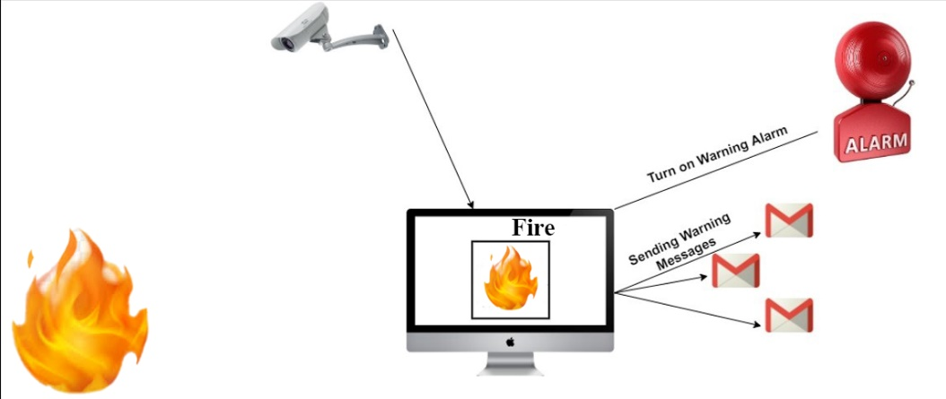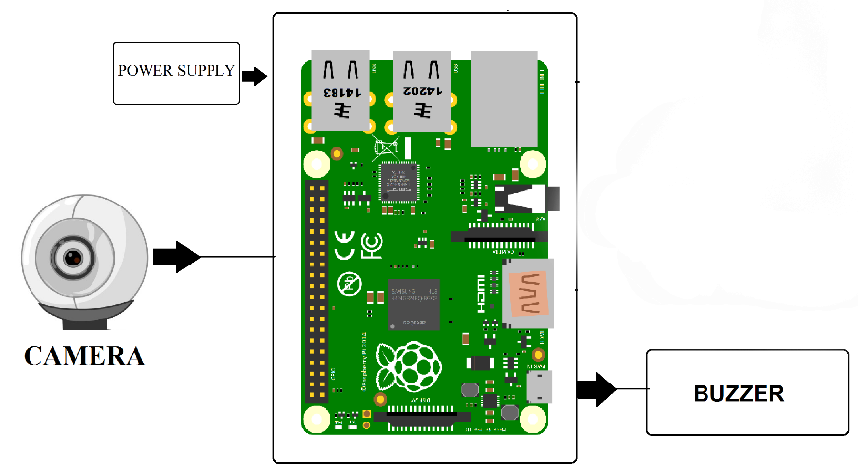

The above diagram illustrates the steps required to recognized the fire detection. The major steps involve in this process are fire detection and turn on warning alarm or sending warning messages to fire engine service. If we look at how this system works, a warning alarm will sound immediately when a fire is detected by the camera at the place where the system is implemented, and a warning message will be sent via email to the fire engine service. This system is implemented using Computer Vision. What is Computer Vision? Computer vision is an interdisciplinary scientific field that deals with how computers can be made to gain high-level understanding from digital images or videos. From the perspective of engineering, it seeks to automate tasks that the human visual system can do. Next, the HSV color algorithm is used. This system is programmed and implemented in the python programming language using Computer Vision and the HSV color algorithm.

### 4.2 Modules

### 4.2.1 Raspberry Pi

The purpose is to create a hardware which can detect fire from far away. This device supports the Raspberry Pi platform and windows platform. Fire is a dangerous thing which can bring a lot of harm to anything. To prevent from loss, sensors are installed but these sensors are not effective. Sometimes they get destroyed by heat or fire or sometimes they generate alert very late until the damage has been done. In contrast Raspberry Pi is very useful because it consumes low power and it is of low cost and it does not need any sensors because the camera will detect the fire and generate the alert immediately to the users or the members of the organization, where this system is installed.

### Pi Camera

* Pi Camera module is a camera which can be used to take pictures and high-definition video.
* Raspberry Pi Board has CSI (Camera Serial Interface) interface to which we can attach Pi Camera module directly.
* This Pi Camera module can attach to the Raspberry Pi’s CSI port using 15-pin ribbon cable.

### 4.3 Conceptual Flow Chart

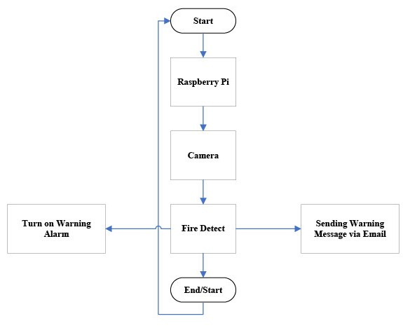

Our implementation of fire detection is used facilitates the organization or companies to prevent from the loss of lives and damages of valuable assets. The moment when the fire detected and to generate turn on warning alarm and sending warning message via email to fire engine service. The algorithm is designed in such a way so that everyone can understand it. The algorithm is defined below which is very important parts of this research and project or the main part of the project.

* Step 1: Start
* Step 2: Camera captured video continuously on real time
* Step 3: Fire detect
* Step 4: Turn on warning alarm & Sending warning message via email
* Step 5: Stop

### 4.4 Testing

The software testing consists of Gmail application working and testing part which is essential and is very useful. Following are the User Interface of Gmail application given down below to understand the send and received mails and the use of it.



Figure Send Mail



Figure Received Mail

### 4.5 Result

The final result of our fire detection system is that it started detecting fire when fire comes up in front of camera and the system is working correctly and without any delay. But we are still working on the system to overcome the false alerts as the system doesn't know the exact shape and color of fire so it detects the other objects of same color and fire and generate an alert. We are working on our algorithm and making it more efficient so it can detect the exact shape and color of fire and don't get confuse between another shape of other objects and don’t generate false alerts.

The fire detection system is very good approach in modern world so that the losses and damages done by fire before will not be repeated again and no other lives will be harm. The main advantage of system is that it is portable and can be carry anywhere but very carefully and is very cost effective and is working very well.

# CHAPTER FIVE

## CONCLUSION

Few years back the fire is detected through sensors or any other method or by smoke. But these methods are now old and are not effective because in these methods the fire detects when it reaches maximum level and it was sometimes too late because the damage was already done. To prevent from this and to stop fire when it starts researchers have explored the idea to replace the sensors and to detect fire through internet or by another means that was cheap and useful and beneficial for others.

IoT is very useful way to detect fire and to detect fire by using computer vision. The idea is that is to give a camera a power of human eye and to detect fire when it starts but that is not a easy job. The researchers then design and implement different algorithms using programming languages and they come up with a algorithm of fire detection using camera but it has some flaws. The algorithm that are design until now are not able to detect fire completely but they also detect some other objects in the color combination of fire and generate a false alarms or notification. The working on it are still going and researchers are working to minimize the rate of false alarms or notifications.

A fire detection system is proposed using Raspberry Pi connected with a camera and operates via image processing and HSV Color algorithm. This system uses RGB color models to detect fire color and texture. Proposed model works well and we are working on its fire detection algorithm for more effective results and to overcome the problems of false alarms. False alarms are generated sometimes due to objects of orange color and shapes. Consequently, the proposed system will result in the reduction of loss and destruction. In future, this system will help the fire fighters or rescue team to rescue someone immediately and fire fighters will stop the fire immediately by tracing the source or location of fire.

# REFERENCES

[1] A. Mehrabian and M. Wiener, "Decoding of inconsistent communications," Journal of Personality and Social Pyschology, vol. 6, no. 1, pp. 109-114, 1967.

[2] P. Ekman, "Facial Expression and Emotion," American Psychologist, vol. 48, no. 4, pp. 384-392, 1993.

[3] P. Ekman and W. Friesen, Facial Action Coding System: A Technique for the Measurement of Facial Movement, Palo Alto: Consulting Psychologists Press, 1978.

[4] L. F. Barrett, How Emotions are Made: The Secret Life of the Brain, Boston: Houghton Mifflin Harcourt, 2017.

[5] P. Ekman, Emotions Revealed, New York: Times Books , 2003.

[6] P. David, M. Alan and G. Randy, Computational Intelligence: A Logical Approach, New York: Oxford University Press, 1998.

[7] D. H. Ballard and C. M. Brown, Computer Vision, New Jersey: Prentice Hall, 1982.

[8] C. M. Bishop, Pattern Recognition and Machine Learning, Berlin: Springer, 2006. 12

[9] D. R. Frischholz, "The Face Detection Homepage," Face Recognition Homepage, 02 06 2003. [Online]. Available: https://facedetection.com/. [Accessed 08 12 2019].

[10] M. B. Lewis and H. D. Ellis, "How we detect a face: A survey of psychological evidence," International Journal of Imaging Systems and Technology, vol. 13, pp. 3-7, 2003.

[11] P. Viola and M. Jones, "Robust Real-time Object Detection," International Journal of Computer Vision, pp. 1-3, 2001.

[12] C. Cortes and V. N. Vapnik, "Support-vector networks," Machine Learning, vol. 20, no. 3, p. 273–297, 1995.

[13] J. J. Hopfield, "Neural networks and physical systems with emergent collective computational abilities," Proc Natl Acad Sci U S A, vol. 79, no. 8, p. 2554–2558, 1982.

[14] A. F. Vermeulen, Industrial Machine Learning: Using Artificial Intelligence as a Transformational Disruptor, New York: APress, 2019.

[15] D. He and L. Wang, "Texture Unit, Texture Spectrum, And Texture Analysis," IEEE Transactions on Geoscience and Remote Sensing, vol. 28, pp. 509-512, 1990.

[16] J. Canny, "A Computational Approach To Edge Detection," IEEE Transactions on Pattern Analysis and Machine Intelligence, vol. 8, no. 6, pp. 679-698, 1986.

[17] P. Lucey, J. F. Cohn, T. Kanade, J. Saragih, Z. Ambadar and I. Matthews, "A complete facial expression dataset for action unit and emotion-specified expression," in IEEE Workshop on CVPR for Human Communicative Behavior Analysis, California, 2010.

[18] M. J. Lyons, S. Akamatsu, M. Kamachi and J. Gyoba, "Coding Facial Expressions with Gabor Wavelets," in 3rd IEEE International Conference on Automatic Face and Gesture Recognition, Nara, Japan, 1998.