**Q1: How responsive are the teachers at the college level?**

I would like to share the main observations which I found during my data exploration stage

Here are the statistical observations of timeliness in seconds across each college in the dataset

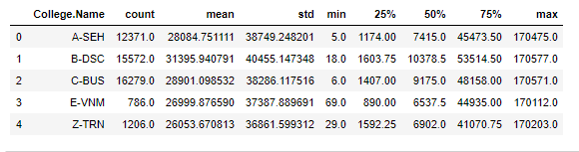

From the above analysis, it’s clear that E-VNM and Z-TRN are very few in number. Also the mean value is directly proportional to the number of observations across each college group. So this is not an apt method to analyze the response time across universities.

But from this statistical table, there is an interesting finding which says College A-SEH responded back within 5 seconds and C-BUS responded within 6 seconds (Minimum value)

**Fig1: Overall Analysis**

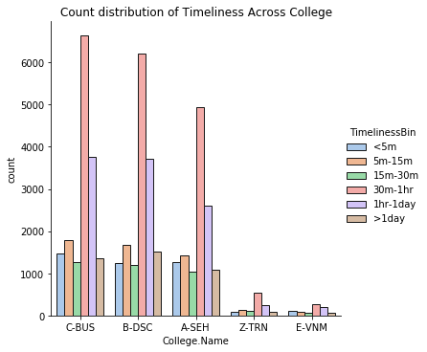

**Fig 1** shows count of response groups across different colleges. This analysis helps us to find out the response behavior of each college across the entire dataset.

Surprisingly, all colleges shows almost same pattern in the response behavior. In every College the greatest number of Timeliness is between 30 minutes to one hour followed by one hour to one day. It’s obvious that for the lowest number of response time is in the category between 15minute to 30 minute. Less than 5 minutes is in the second last position in the number of counts except the college ”E-VNM”, Here, 5 minute to 15 minute is in the second last position in terms of count.

The above analysis is not suitable in the overall characteristic search because, It’s not taking care about the contribution of each college across different response category. To understand the response behavior more thoroughly, I plotted the response time percentage of each college across entire dataset which is more informative in this scenario.

**Fig 2:Percentage of Timeliness Across Colleges**

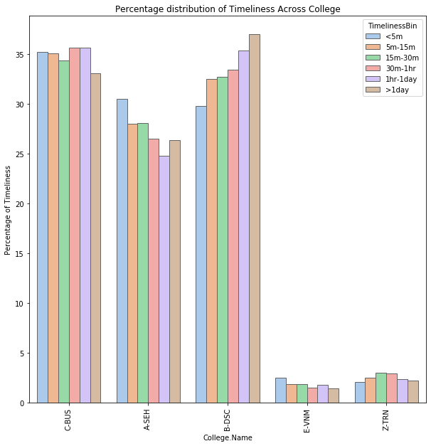

**Fig2­­** gives more idea about the response characteristics in different colleges

From the figure its clear that A-SEH and E-VNM are the best colleges in terms of response time. Because, among their response characteristic growing down from less than one minute to one day. They responded back within 5 minutes in most of the cases followed by 5-15v min,30 min etc. The worst behavior is from the college B-DSC because, their graph falling up from <5 min to more than one day.

Attaching the python scripts for the above observations below.

