**Q2: Do you think that the responsiveness on a weekly basis of "College of Business" has improved from Span 1 to Span 2? Is this improvement statistically significant assuming independence between the data points?  
Span 1. => 4 March 2019 to 23 June 2019 (12 Weeks)  
Span 2. => 22 July 2019 to 13 October 2019 (12 Weeks)  
Week Starting should be considered to be Monday  
Please share your code/script (as applicable) along with the answer to the question listed above.**

Steps Followed:

1. Extract the data corresponding to College of business
2. Create two datasets, one for time span 1 and other for time span 2

(There is a mistake in time span 1, it have 16 weeks instead of 12)

-Here I took first 12 weeks data starting from 4 th may 2019

1. Calculate weekly mean in two datasets
2. Perform pre requisites for independent sample t test
3. Perform Parametric Statistical Hypothesis Test (Independent)

Code( Independent Ttest):

import researchpy as rp

descriptives, results = rp.ttest(df1['Timeliness_second'], df2['Timeliness_second'])

descriptives

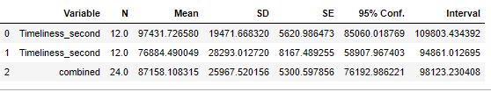

Results

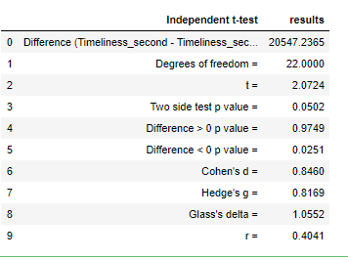

**Two sampled T-test :-**The Independent sample t test or 2-sample t-test compares the means of two independent groups in order to determine whether there is statistical evidence that the associated population means are significantly different.

H0: µ1 - µ2 = 0 ("the difference between the two population means is equal to 0")  
*H*1*:*µ1 - µ2 ≠ 0 ("the difference between the two population means is not 0")

Interpretation of Results:

The purpose of the current study was to test if there is a significant difference in the “Timeliness” between the timespan 1 and timespan 2. Timespan 1’s average timeliness in seconds (M= 97431, SD= 19471) is convergent and has slightly greater variation than timespan2 (M= 76884, SD= 28293).

An independent t-test was used to test for a difference. Results says that there is no statistically significant difference between the Timeliness of span1 and span 2 (t(22)= 2.0724, p> 0.0001, r= 0.4041).Assume alpha=.01

**Conclusion: The responsiveness on a weekly basis of "College of Business" has not improved from Span 1 to Span 2**

Please find the Python code attached below:

