**Q3:  
Which schools, do you think, need to improve on their timeliness of response to the students?  
Support your answer using visualization.**

Visualizing the Box plot of timeliness in second for the schools below (**Fig1**).

From **figure 1** it’s clear that the median of ‘SHE College Office” and “Ctre of English Language” are higher as compared to the other Schools. Also, the lower and upper quintiles are up as compared to others. To support this argument, a bar plot (**Figure2**) was drawn with the percentage of contribution in timeliness(< 1 hour and < 1 hour) are plotted across every schools.

For every college, commonly, the percentage Timeliness within “1 hour” is less than the percentage “greater than 1 hour”

Over the 29 colleges, 3 colleges shows very poor percentages as compared to other colleges. They are

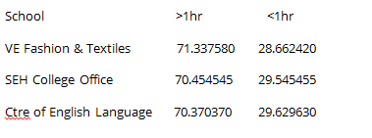

From the Figure 2, its clearly visible that ” VE Fashion& Textiles” ,”SEH College Office” and “ctre of English Language” shows poor performance in response. Their percentage of response to the messages within one hour is less than 30%. All the other colleges show more performance than these 3 colleges.

Even though there are some colleges like “Vocational Business Education” and “VE Education” comes near to the above 3 colleges in terms of performance, when we consider from the overall point of view, the first 3 colleges needs to improve their timeliness of responses are VE Fashion & Textiles, SEH College Office and Ctre of English Language

**Figure 1:**

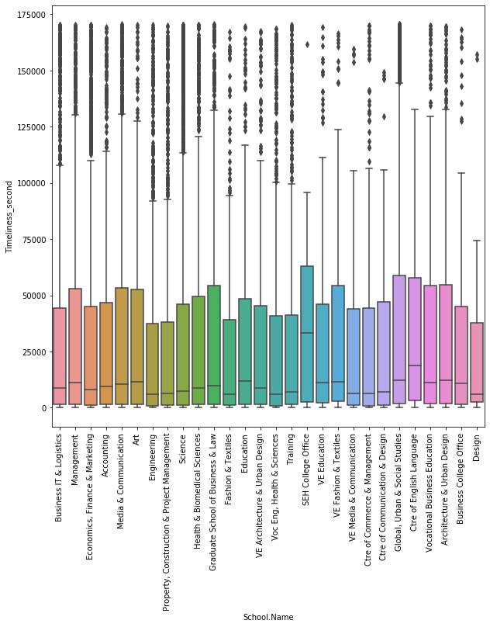

**Figure 2:**

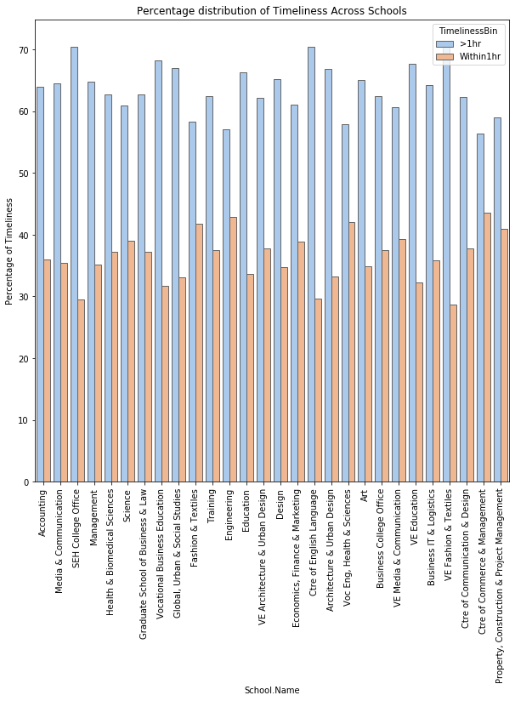**:**

**Supporting Information: (% of Timeliness across colleges)**

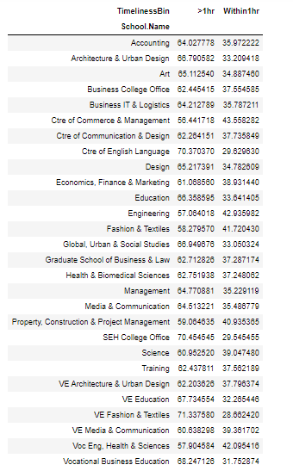

Please find the attached Python scripts for reference:

