**Q4: Can you think of any examples of poor responsiveness and share any strategies which could improve the timeliness of response?**

Listing out the top 20 poor response from the given dataset below

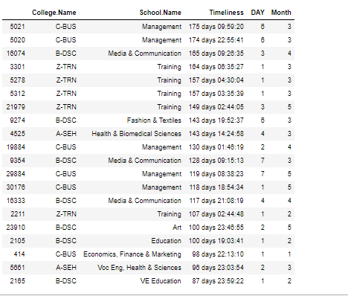

I did a thorough analysis of the response rate across different months in 2019 and different days in 2019.Plotting the findings below.

|  |  |
| --- | --- |
|  |  |

From the above plots it’s clear that the months, January, February ,June, July and October has the lowest number of responses. This makes sense because these are off-university days and the peak response count timings are March, April, August and September.

Also, when it comes into days, weekdays starting from Monday to Friday have the highest response rate and that is decreasing from Monday to Saturday and then slightly increases to Sunday.

To understand this scenario, more clear, I plotted a chart which shows divided performance of days and months separately. Please find the figure below:

If we consider the performance across days, we can see that week days are really well in terms of performacace. But weekends are really bad at performance and most of the messages take more than 1 day to response.

Also, we can see that peak months such as March, April, May and September shows poor performance .All of this months responded back within more than 1 day time span. And off- peak university months shows better performance in terms of response when we compare to peak university days and months.

|  |  |
| --- | --- |
|  |  |

Suggestions to Improve Timeliness of response:

1. Since weak days shows lower performance, It’s better to appoint more assistant staff to respond back on weekday
2. Like week days, peak months shows poor performance, so university can hire more casual staffs at off peak hours to reply back to student messages.
3. Instead of human interaction, RMIT chat bot can improve the performance ability by answering the general questions. So, no need to direct the students to wait the response for general queries.
4. Use the maximum use of canvas facility. Instead of asking all the questions to the teacher, they can participate in discussion in the discussion forum in canvas.
5. When we consider some schools, the amount of queries getting are considerably higher (this may due to the number of students or may be because of some common queries related to their academics) In these situations, for these particular schools, adopt specialized methods to increase the performance.
6. According to my experience, most of the students queries are related to assignment submission and clarifications. Tutors can take care of all the assignment related questions. In this way, the main lecturer can concentrate on teaching and other activities

Please find the python code below:

