

**Course name:** SOFTWARE REQUIREMENT ENGINEERING

**Course Teacher:** FARZANA BENTE ALAM

**Section:** A

**Project name:** METROPOLITAN BUS EXPRESS

**Group members:**

|  |  |
| --- | --- |
| Name | Id |
| ABDULLAH FAISAL | 17-33471-1 |
| SHANJIDA AKER HRIDE | 17-33570-1 |
| BHUIYAN FOKRUL ISLAM | 17-33535-1 |
| ISLAM HEDAETUL | 17-33554-1 |

**1. Introduction**

**1.1 Purpose:**

Dhaka is the most densely populated city among all the cities of Bangladesh. Everyday a lot of people come to Dhaka for their work staffs and also a lot of people leave Dhaka. Since inside the city to move from one place to another is very usual, for this purpose as well as being the cheapest way to travel the city buses are most popular. But most of the time general people who are new in the city as passengers face some difficulties when travelling in the city buses. The purpose of this document is to build a mobile application to give information of local city buses to ease the journey.

#### **1.2 Document Conventions:**

#### **Main Section Titles**

* Font: Times New Roman
* Face: Bold
* Size: 14

**Sub Section Titles**

* Font: Times New Roman
* Face: Bold
* Size: 12

**Other Text Explanations**

* Font: Times New Roman
* Face: Normal
* Size: 12

**1.3 Project Scope:**

In this digital age, most of the people use smartphone. So, Metropolitan Bus Express is designed to run on any smartphone with internet connection and location service and to allow users to register in the system. The system can only be used inside Dhaka and Chittagong city. All the data will be held securely in an access database on the company’s server.

**1.4 References:**

* Fundamentals of database systems by ramez elmarsi and shamkant b.navathe
* http://www.nwstbus.com.hk/content/default.aspx?intLangID=1&section=footer&page=ApptermsOfUse
* https://github.com/oppasource/City-Bus-Tracking-Android-App
* <https://github.com/topics/bus-route>

**2. Overall Description:**

2.1 **Product Perspective:**

Metropolitan Bus Express is a GPS-based, real-time bus-tracking and navigation application, with community-based traffic data. The app allows the user to create their accounts in the system and provides features of viewing available bus for particular route, real-time road condition, save used road, location sharing and many more.

**2.3. User classes and Characteristics:**

* **General User:** They will enter into the system to get access the services that the system provides. They can also view their account information in the system. They can also provide crowd-sourcing data by reporting traffic accidents, technical difficulties, or other factors that could affect travel time.
* **Administrator:** They are the core users who basically manage the system. They can view in real time what a user is performing right now and sell e-tickets. They can also give promotional offers.
* **Bus Conductor:** They will be in a position to check tickets of the e-ticket holders.
* **Bus Owner:** They can add their buses in the system via admin. They will set ticket fare by doing agreement with admin panel.

**2.4. Operating Environment :**

Operating environment for the Metropolitan Bus Express is as listed below.

* **Platform:** Java, PHP
* **Database:** Mongo DB
* **Operating System:** iOS, Android
* **Geographical Location:** API of google map
* **Server System:** Linux

**2.5. DESIGN and IMPLEMENTATION CONSTRAINTS:**

Each user must keep their password as confidential. Moreover the users must have individual ID for login in the system.

Only Administrator can control system modification like including/deleting bus and update bus information.

Mobile banking payment is the only option for purchasing e-ticket.

## **3. SYSTEM FEATURES:**

**3.1. Description of feature:**

* **E-Ticket:** Regular passenger of same route can buy a permanent ticket for a week or a month.
* **Discount Ticket:** If passenger buy e-ticket additional discount on tickets will be given.
* **Online Payment System:** E-Ticket buyer can pay through online using their mobile banking service.
* **Time Estimation:** The system will show estimated time that how long it will take to go from one place to another.
* **Bus Stoppage:** Places of bus stop will be shown in map.
* **Live Traffic Update:** Realtime traffic condition will be shown inside the application through map.

**3.2. Functional Requirements:**

* The user shall be signed in to use the system.
* The user shall be triggered to bus information page after choosing route.
* The user shall get promotional offers with pop up notification at any time inside the system.
* The server shall turn on private mode in the time of online payment gateway.
* The user shall use map service.
* The user shall get traffic update.
* The system shall record user history.
* The system shall record passenger’s first name.
* The system shall record passenger’s last name.
* The system shall record passenger’s phone number.
* The system shall generate a unique QR code for each e-ticket.
* The system shall record the payment type of ticket purchasing.

**3.3. User Story:**

* As a passenger I want to see bus name so that I can choose one.
* As a passenger I want to see bus type so that I can select my desirable type.
* As a passenger I want to search buses by location so that I can select bus for my destination.
* As a passenger I want to know bus fare so that I can choose according to my budget.
* As a passenger I want to see bus stoppage so that I can go to nearest bus stop.
* As a passenger I want to register using my phone/email so that I can use the service.
* As a passenger I want to see time estimation from one place to another so that I can figure out approximately when I will reach my destination.
* As a passenger I want to call helpline so that I can get help in time of emergency.
* As a passenger I want to give bus rating so that the service provider makes them even better.
* As a passenger I want to get offers so that I can save extra money.
* As a passenger I want to reserve bus so that I can use it for business/family tour or for different work purpose.
* As an admin I want to respond to user’s questions so that they can get answers of particular issue.
* As an admin I want to give notices so that user get notification on different circumstances.
* As an admin I want to update every information of buses so that user get proper information.
* As an admin I want to give offers so that the users get attracted.
* As an admin I want to see bus location so that I can handle emergency cases.
* As an admin I want to update/delete user information so that I can prevent unethical movements.

## 

## **4. External Interface Requirements:**

**4.1. User interface:**

**Login Page:**

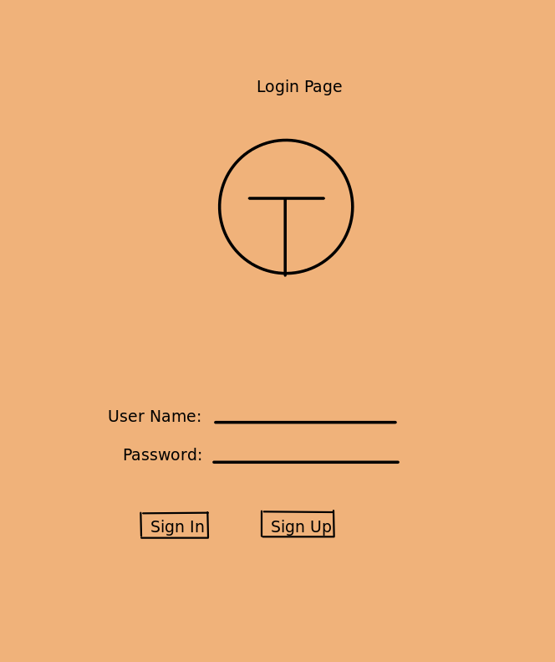

**Sign Up:**

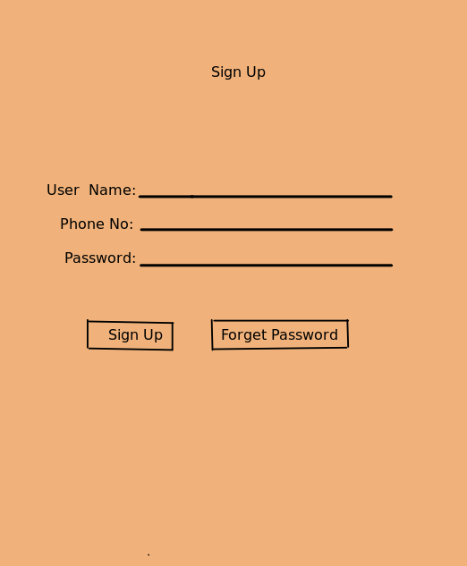

**HomePage:**

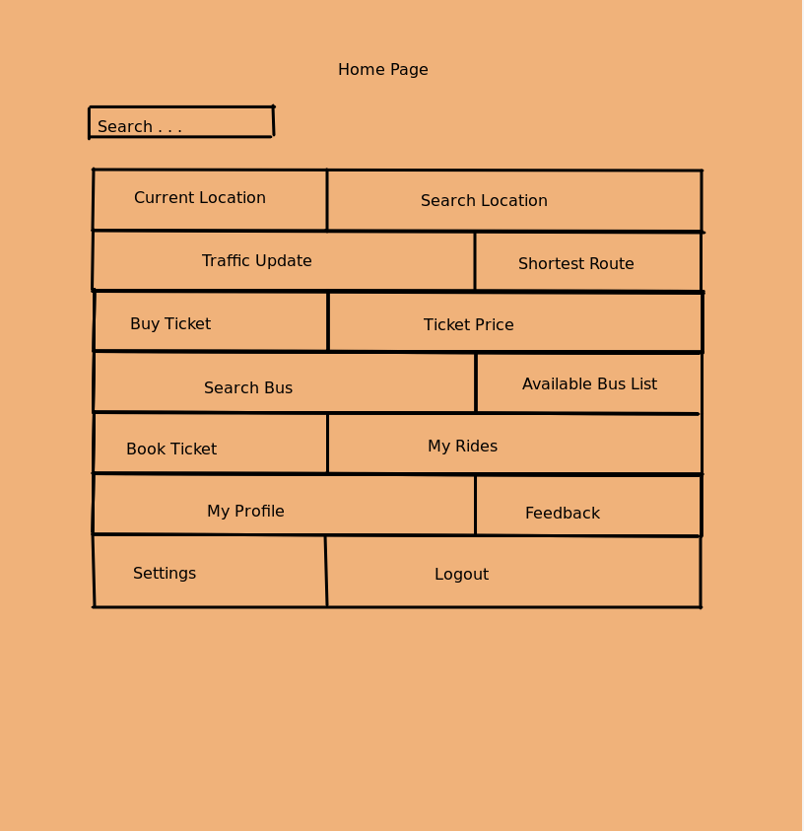

**My Location:**

## 

## 

## 

**Traffic Update:**

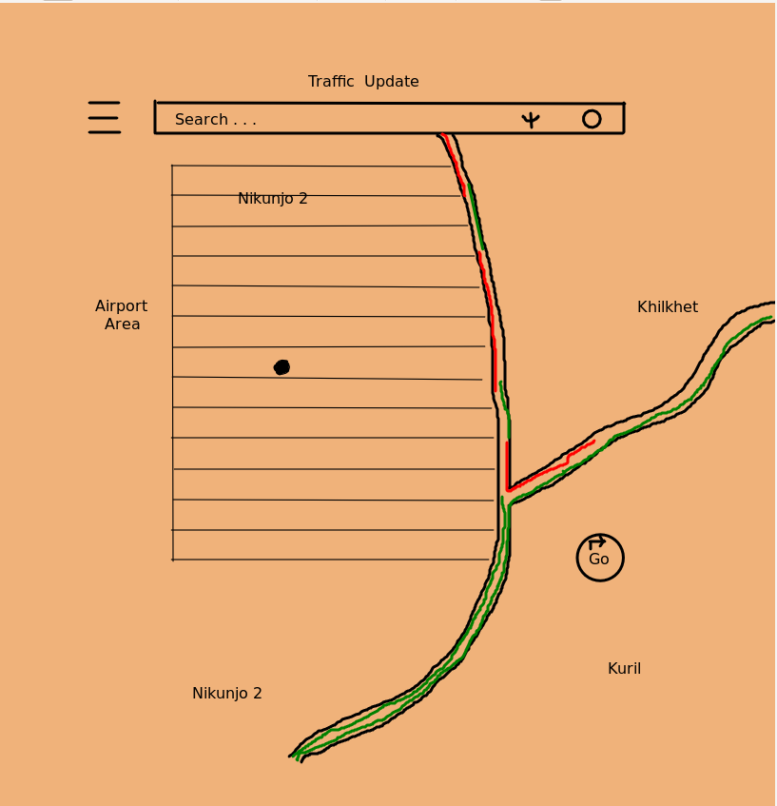

**Shortest Route:**

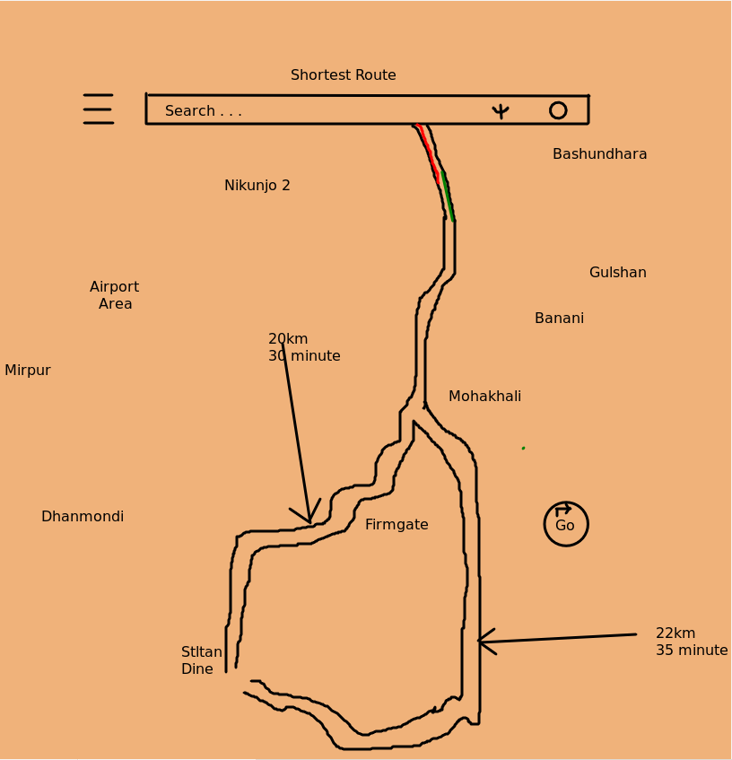

**Buy Ticket:**

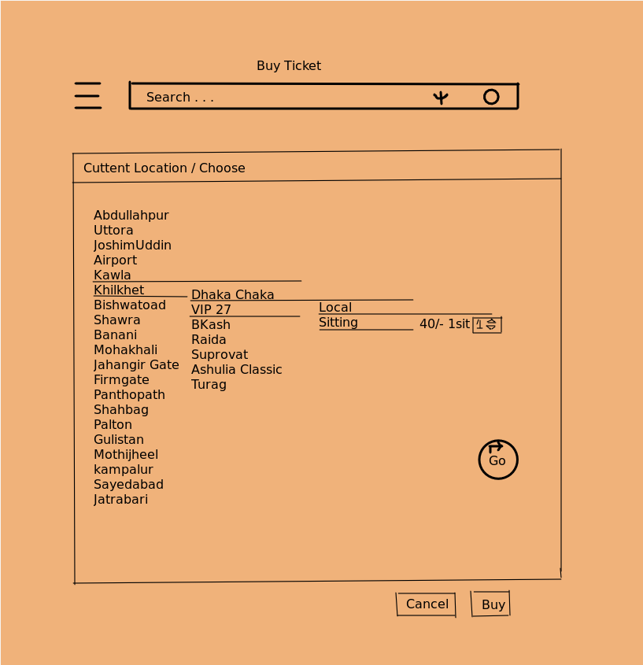

**Available Bus:**

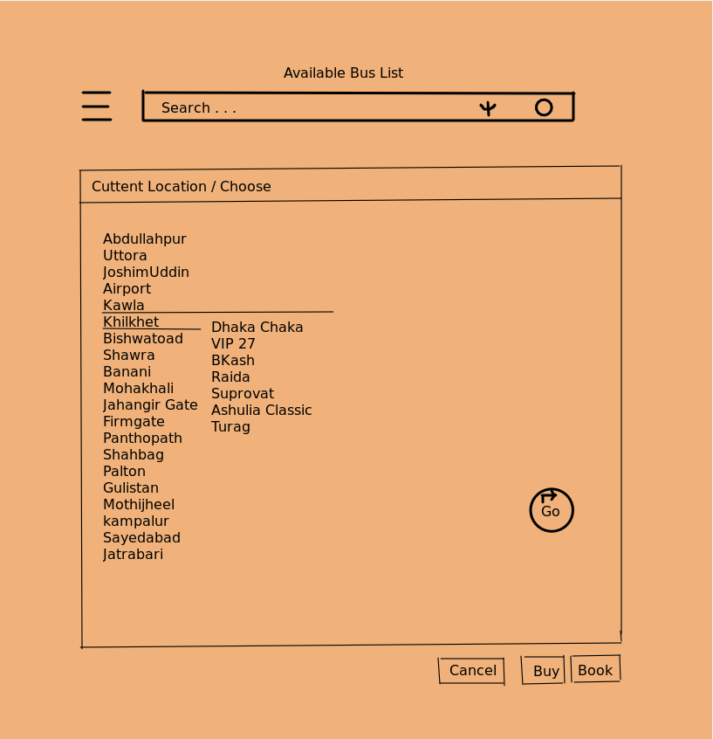

**My Rides:**

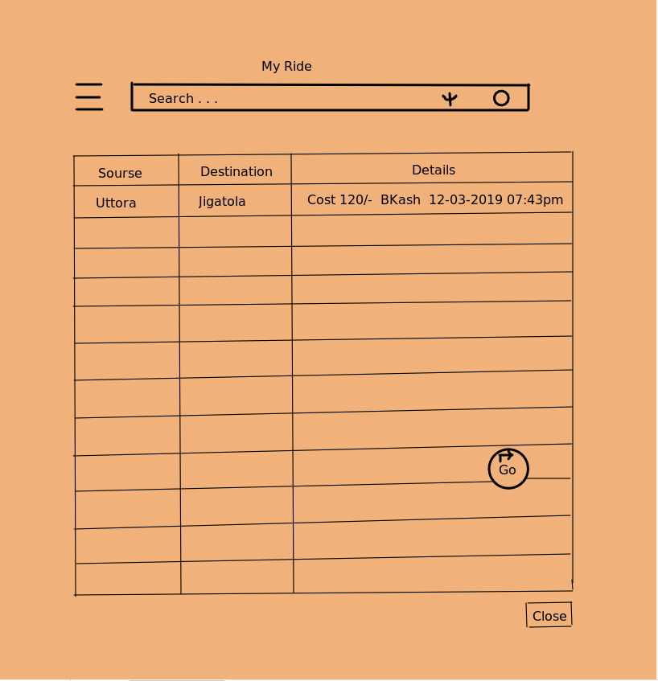

**My Profile:**

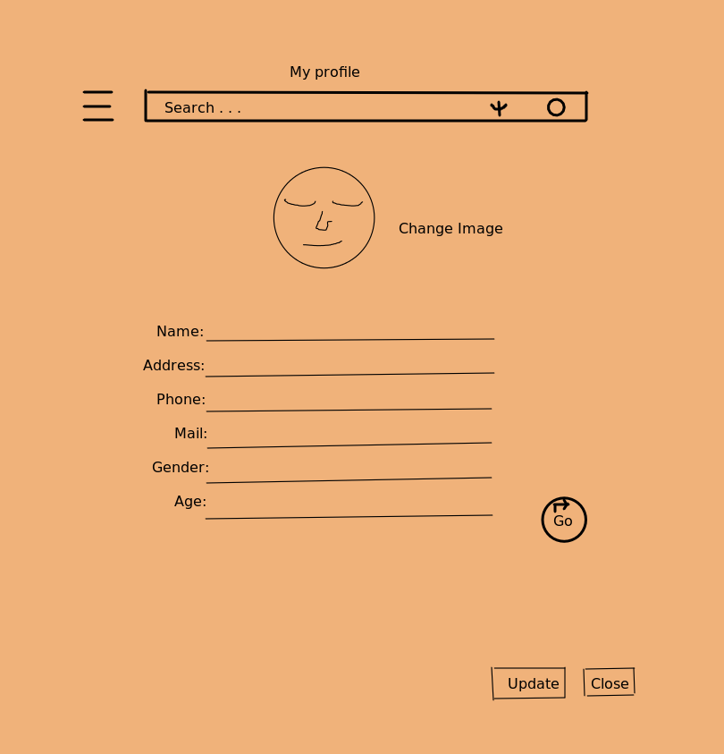

**Feedback:**

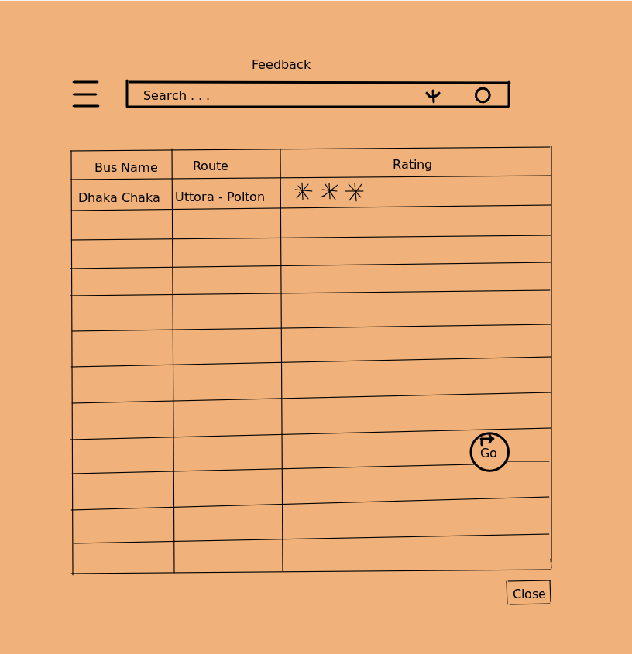

**Settings:**

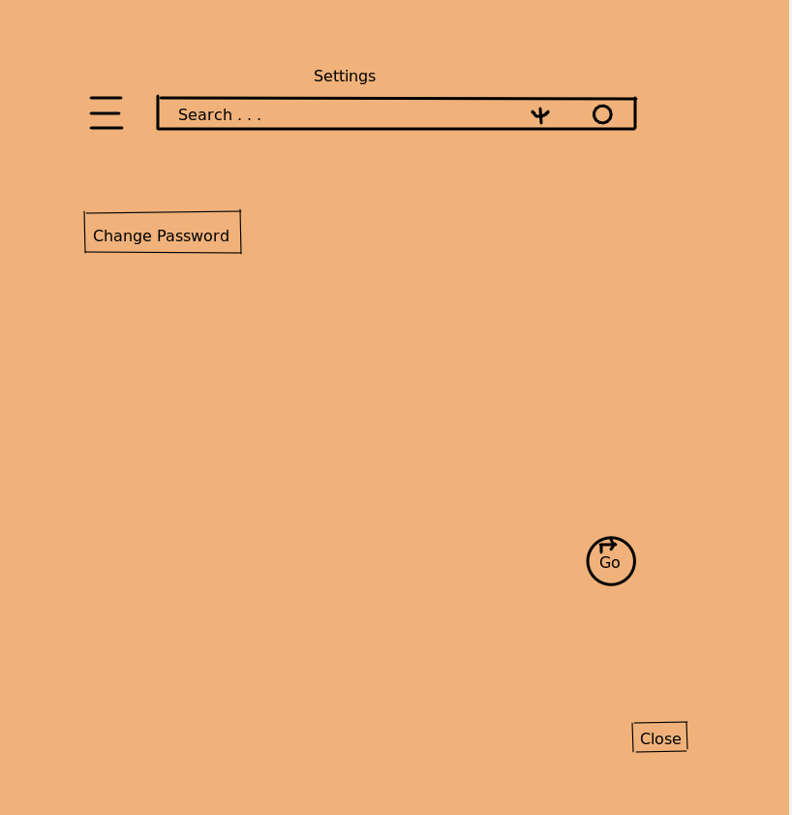

**4.2. Software interface:**

Some other application is also related with the application

1. **Google maps:** google maps is being used to show the routes.
2. **Phone app:** phone is used to contact emergency service.
3. **Facebook app:** This is used to social promotion.

**4.3. Hardware interface:**

The application needs some specific hardware to run.

1. **GPS:** Used to locate position & show routes.
2. **Gyro:** Also used to locate position.
3. **Speaker & Mic:** usedtocall emergency, to voice type, to listen, to route instructions.
4. **GSM:** used to call emergency.
5. **Internet:** used to get access to all the live feed.

**4.4. Communication interface:**

No communication based interface is not used for this application.

## 

## **5. Quality Attributes:**

**5.1. Usability:**

1. Log In
2. Sign Up
3. Current Location
4. Shortest Distance
5. Bus Location
6. Bus Route
7. Bus Fare
8. Bus Stoppage
9. Save History

10. Buy Tickets

11. Traffic Update

12. Settings

13. Feedback

14. Sign Out

**5.2. Performance:**

Performance shows the response of the system to perform certain actions for a certain period of time.

Performance, the degree to which a System or component accomplishes its designated functions within given constraints, such as speed, accuracy, or memory usage.

A misnomer is that performance equates to speed; that is to think that poor performance can be salvaged simply by using more powerful processors or communication links with higher bandwidth. Faster might be better, but for many systems faster is not sufficient to achieve Time lines. Performance issues very often grow into problems that can affect everything, from the server’s capacity or the ways in which you develop your front-end to the efficiency of database queries or the capacity of communication channels.

1. Percent of satisfied customers
2. Number of customers complain received
3. Number of customer calls for information or help
4. Average time to resolve a customer concern
5. Average time that customers waited for a response after calling
6. Cost of servicing a customer problem
7. Backlog of unresolved customer problem
8. Average time to process e-tickets.

## **6. Data Requirements:**

**6.1. Logical data model:**

**Use Case diagram:**

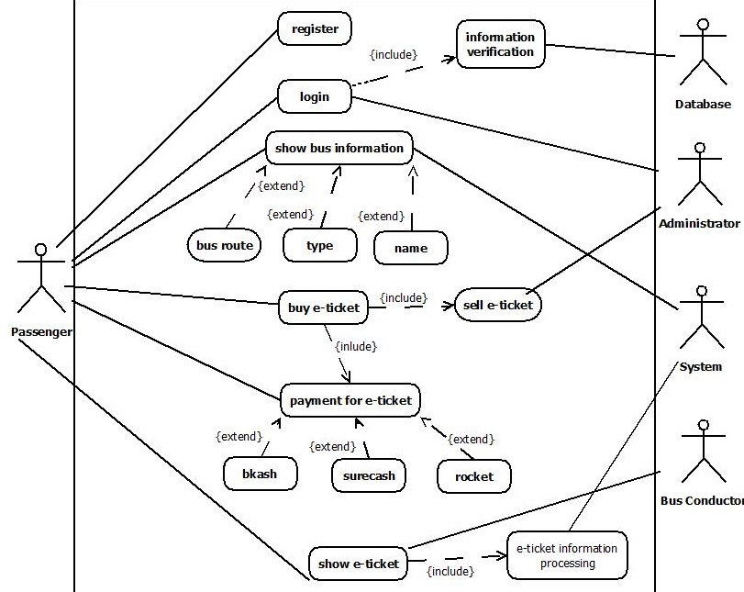

**As-is work flow diagram:**

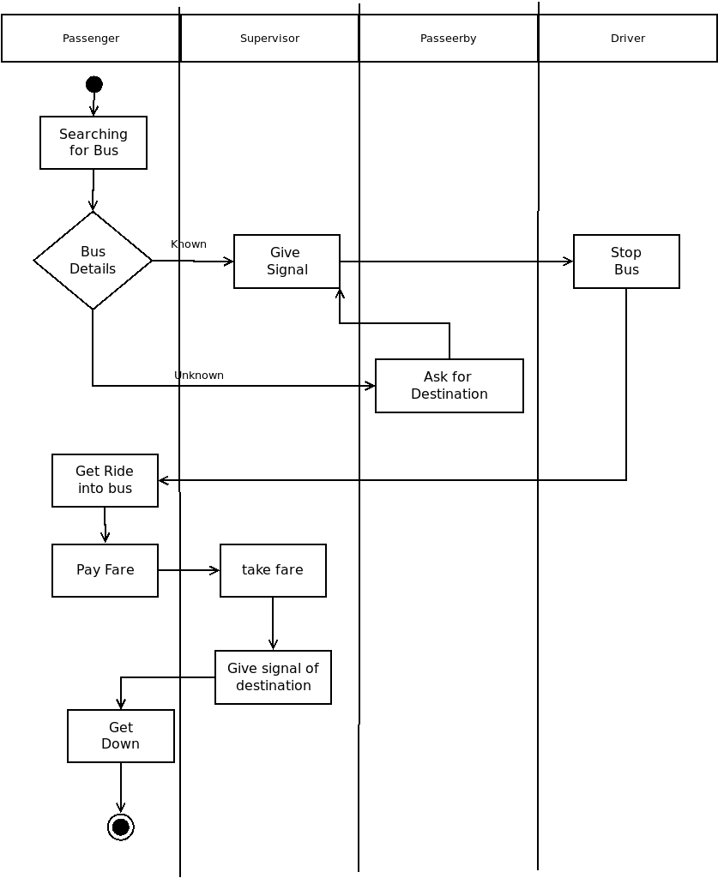

**To-be work flow diagram:**

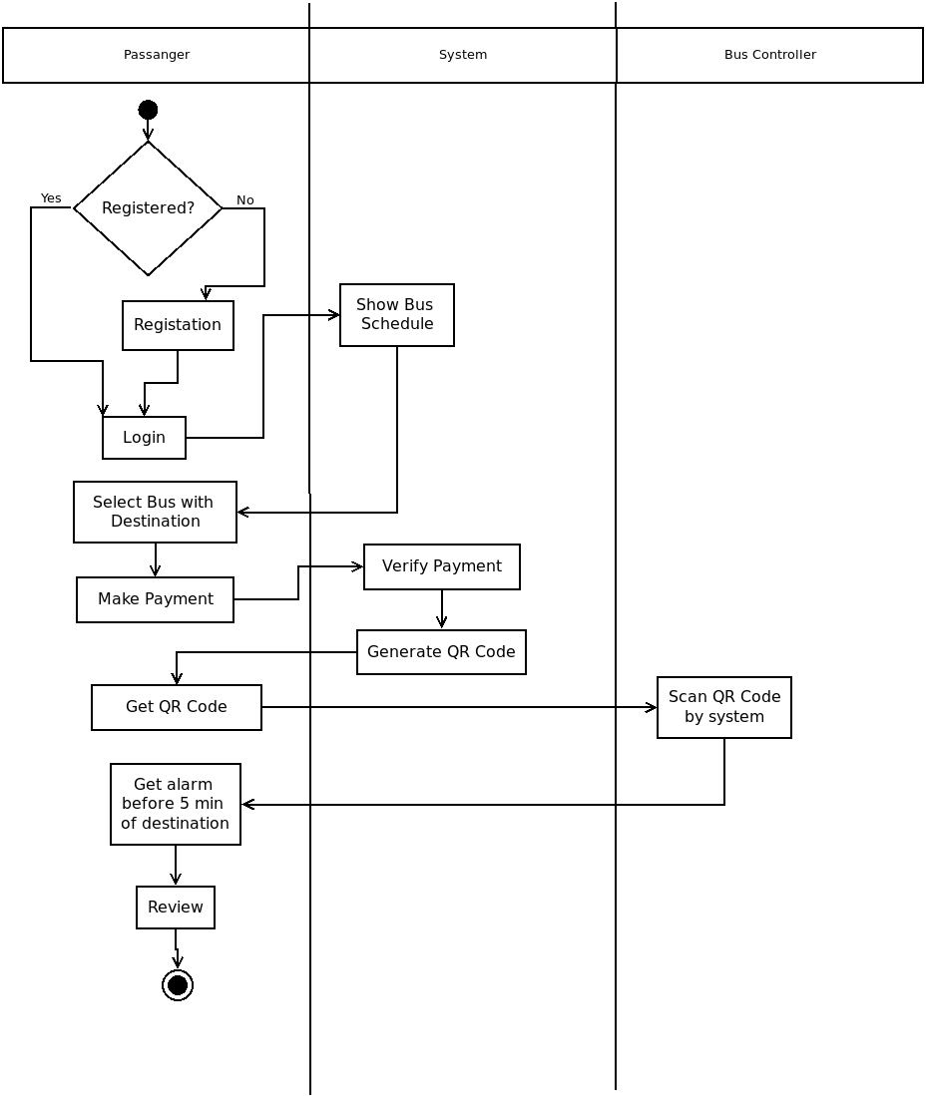

**6.2. Data dictionary:**

|  |  |  |  |  |
| --- | --- | --- | --- | --- |
| **Entity** | **Attribute** | **Size** | **Validation** | **Key** |
| User | User Id | Text(15) | Required | Primary |
| User | Full Name | Text(30) | Required | - |
| User | Password | Text(32) | Required | - |
| User | Phone No. | Number(10) | (+880)9999999999 | - |
| User | Email | Text(30) | Optional | - |
| Admin | User Id | Text(15) | Required | Primary |
| Admin | Full Name | Text(30) | Required | - |
| Admin | Password | Text(32) | Required | - |
| Admin | Email | Text(30) | Required | - |
| Admin | Address | Text(80) | Required | - |