决策树算法

1 第一个数据集: Bank Marketing Data Set
Data Set Information:
The data is related with direct marketing campaigns of a Portuguese banking institution. The marketing campaigns were based on phone calls. Often, more than one contact to the same client was required, in order to access if the product (bank term deposit) would be (or not) subscribed.
There are two datasets:
1) bank-full.csv with all examples, ordered by date (from May 2008 to November 2010).
2) bank.csv with 10% of the examples (4521), randomly selected from bank-full.csv.
The smallest dataset is provided to test more computationally demanding machine learning algorithms (e.g. SVM).
The classification goal is to predict if the client will subscribe a term deposit (variable y).
Attribute Information:
For more information, read [Moro et al., 2011].
Input variables:
# bank client data:
1 - age (numeric)
2 - job : type of job (categorical: 'admin.','unknown','unemployed','management','housemaid','entrepreneur','student',
'blue-collar','self-employed','retired','technician','services')
3 - marital : marital status (categorical: 'married','divorced','single'; note: 'divorced' means divorced or widowed)
4 - education (categorical: 'unknown','secondary','primary','tertiary')
5 - default: has credit in default? (binary: 'yes','no')
6 - balance: average yearly balance, in euros (numeric)
7 - housing: has housing loan? (binary: 'yes','no')
8 - loan: has personal loan? (binary: 'yes','no')
# related with the last contact of the current campaign:
9 - contact: contact communication type (categorical: 'unknown','telephone','cellular')
10 - day: last contact day of the month (numeric)
11 - month: last contact month of year (categorical: 'jan', 'feb', 'mar', ..., 'nov', 'dec')
12 - duration: last contact duration, in seconds (numeric)
# other attributes:
13 - campaign: number of contacts performed during this campaign and for this client (numeric, includes last contact)
14 - pdays: number of days that passed by after the client was last contacted from a previous campaign (numeric, -1 means client was not previously contacted)
15 - previous: number of contacts performed before this campaign and for this client (numeric)
16 - poutcome: outcome of the previous marketing campaign (categorical: 'unknown','other','failure','success')
Output variable (desired target):
17 - y - has the client subscribed a term deposit? (binary: 'yes','no')
对第17个属性即“是否会认购定期存款”进行判别分析（C5.0建模），可以使用本数据集同时作为训练集和测试集。进一步还可以考虑使用本周涉及的图形展示功能、特征选择功能等进行分析。
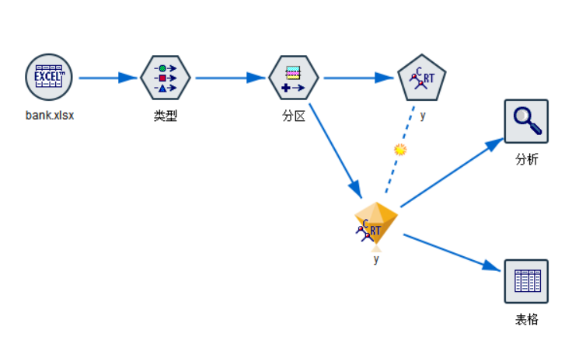
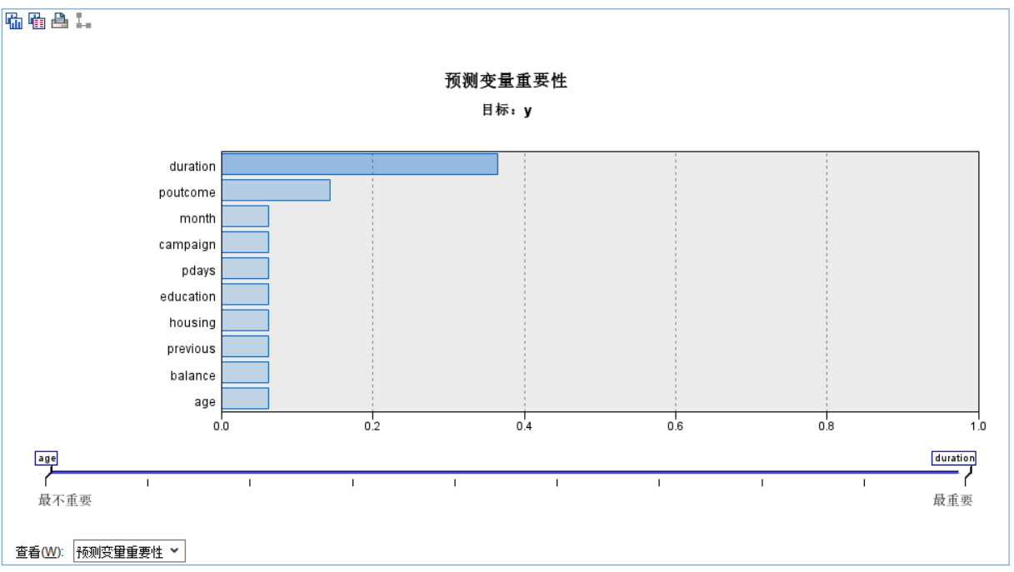
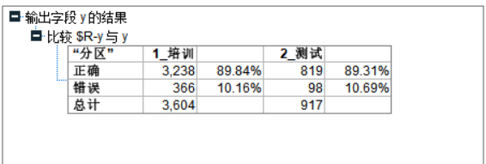
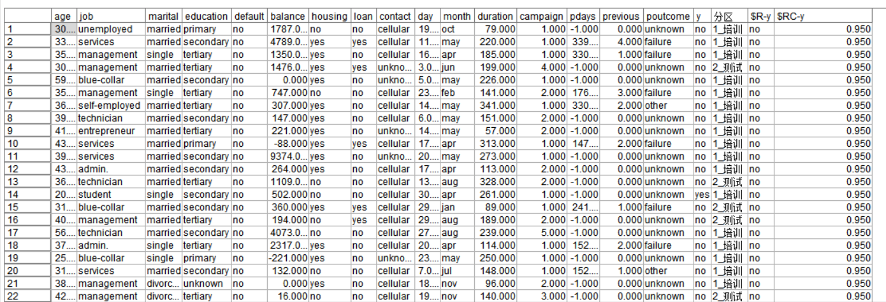
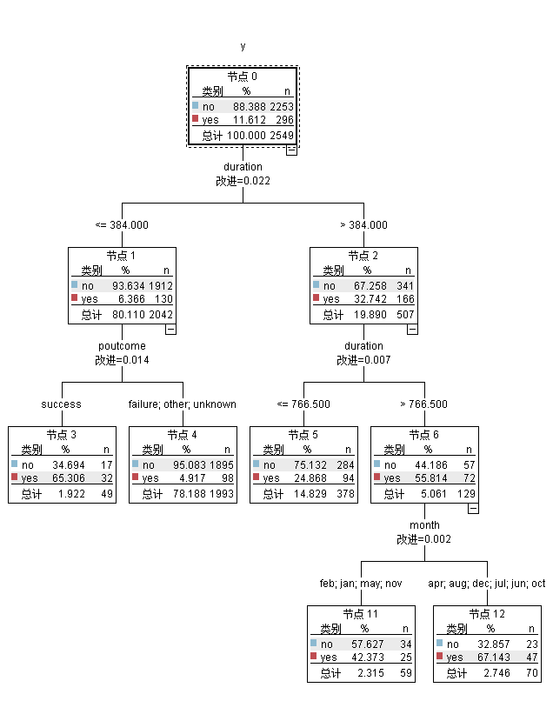

2 第二个数据集: Adult Data Set
Data Set Information:
Extraction was done by Barry Becker from the 1994 Census database. A set of reasonably clean records was extracted using the following conditions: ((AAGE>16) && (AGI>100) && (AFNLWGT>1)&& (HRSWK>0))
Prediction task is to determine whether a person makes over 50K a year.
Attribute Information:
Listing of attributes:
>50K, <=50K.
age: continuous.
workclass: Private, Self-emp-not-inc, Self-emp-inc, Federal-gov, Local-gov, State-gov, Without-pay, Never-worked.
fnlwgt: continuous.
education: Bachelors, Some-college, 11th, HS-grad, Prof-school, Assoc-acdm, Assoc-voc, 9th, 7th-8th, 12th, Masters, 1st-4th, 10th, Doctorate, 5th-6th, Preschool.
education-num: continuous.
marital-status: Married-civ-spouse, Divorced, Never-married, Separated, Widowed, Married-spouse-absent, Married-AF-spouse.
occupation: Tech-support, Craft-repair, Other-service, Sales, Exec-managerial, Prof-specialty, Handlers-cleaners, Machine-op-inspct, Adm-clerical, Farming-fishing, Transport-moving, Priv-house-serv, Protective-serv, Armed-Forces.
relationship: Wife, Own-child, Husband, Not-in-family, Other-relative, Unmarried.
race: White, Asian-Pac-Islander, Amer-Indian-Eskimo, Other, Black.
sex: Female, Male.
capital-gain: continuous.
capital-loss: continuous.
hours-per-week: continuous.
native-country: United-States, Cambodia, England, Puerto-Rico, Canada, Germany, Outlying-US(Guam-USVI-etc), India, Japan, Greece, South, China, Cuba, Iran, Honduras, Philippines, Italy, Poland, Jamaica, Vietnam, Mexico, Portugal, Ireland, France, Dominican-Republic, Laos, Ecuador, Taiwan, Haiti, Columbia, Hungary, Guatemala, Nicaragua, Scotland, Thailand, Yugoslavia, El-Salvador, Trinadad&Tobago, Peru, Hong, Holand-Netherlands.
对第14个属性“一年是否大于50K”进行判别分析（C5.0建模）
- 使用data数据集（3万多条数据）同时作为训练集和测试集测试模型精度；
- 使用data数据集作为训练集，test数据集作为测试集测试模型精度；
- 进一步还可以考虑使用本周涉及的图形展示功能、特征选择功能等进行分析。
