以下四个数据集都是分类数据集，可以使用神经网络（ANN）、判别分析、SVM（Support Vector Machine，支持向量机等算法）进行分类分析，并可对这些算法的分类精度进行对比，还可以跟决策树算法、Logistics回归算法等进行比较。

- Abalone Data Set
Data Set Information:
Predicting the age of abalone from physical measurements. The age of abalone is determined by cutting the shell through the cone, staining it, and counting the number of rings through a microscope -- a boring and time-consuming task. Other measurements, which are easier to obtain, are used to predict the age. Further information, such as weather patterns and location (hence food availability) may be required to solve the problem.
From the original data examples with missing values were removed (the majority having the predicted value missing), and the ranges of the continuous values have been scaled for use with an ANN (by dividing by 200).
Attribute Information:
Given is the attribute name, attribute type, the measurement unit and a brief description. The number of rings is the value to predict: either as a continuous value or as a classification problem.
Name / Data Type / Measurement Unit / Description
-----------------------------
Sex / nominal / -- / M, F, and I (infant)
Length / continuous / mm / Longest shell measurement
Diameter / continuous / mm / perpendicular to length
Height / continuous / mm / with meat in shell
Whole weight / continuous / grams / whole abalone
Shucked weight / continuous / grams / weight of meat
Viscera weight / continuous / grams / gut weight (after bleeding)
Shell weight / continuous / grams / after being dried
Rings / integer / -- / +1.5 gives the age in years
Ring属性作为分类的目标属性，这是一个具有29类问题的多类分类问题，由于类别太多，很多算法结果精度都不高，可以考虑如何提高分类精度。
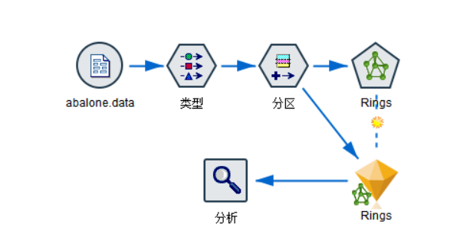
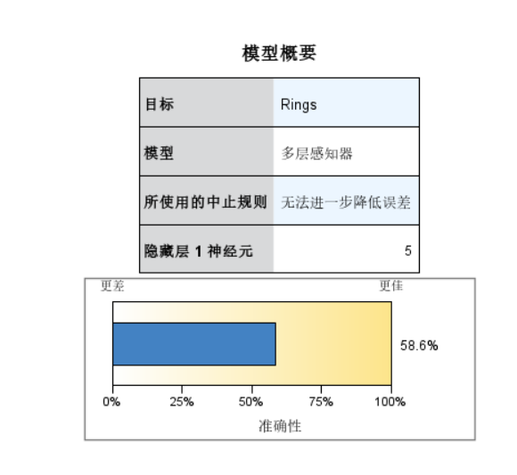
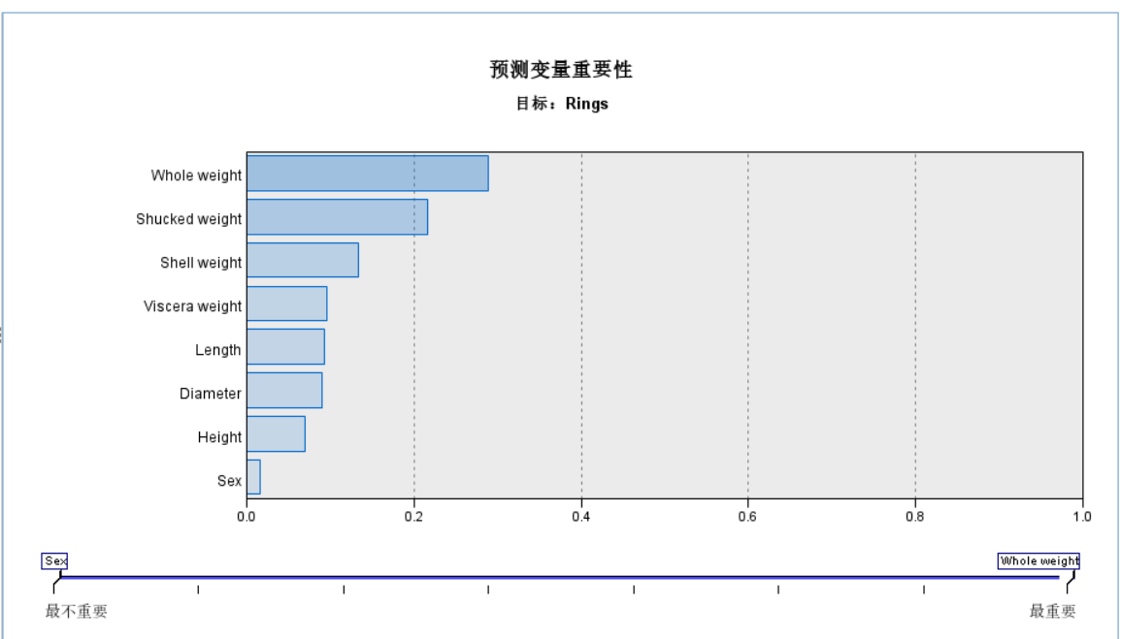
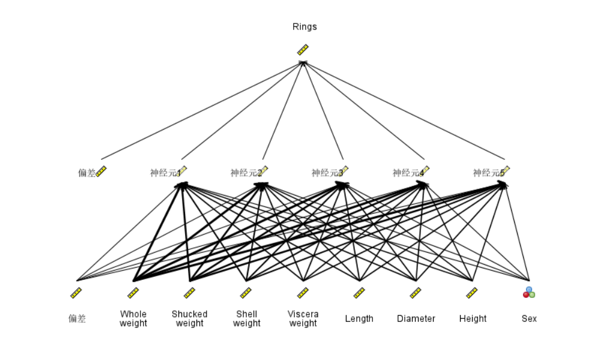
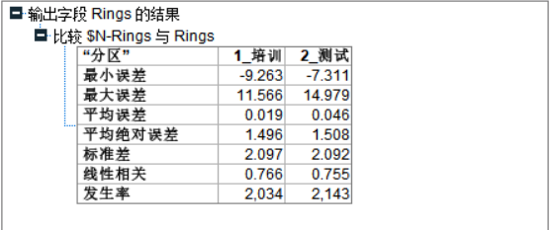

- Breast Cancer Wisconsin (Original) Data Set
Data Set Information:
Samples arrive periodically as Dr. Wolberg reports his clinical cases. The database therefore reflects this chronological grouping of the data. This grouping information appears immediately below, having been removed from the data itself:
Group 1: 367 instances (January 1989)
Group 2: 70 instances (October 1989)
Group 3: 31 instances (February 1990)
Group 4: 17 instances (April 1990)
Group 5: 48 instances (August 1990)
Group 6: 49 instances (Updated January 1991)
Group 7: 31 instances (June 1991)
Group 8: 86 instances (November 1991)
-----------------------------------------
Total: 699 points (as of the donated datbase on 15 July 1992)
Note that the results summarized above in Past Usage refer to a dataset of size 369, while Group 1 has only 367 instances. This is because it originally contained 369 instances; 2 were removed. The following statements summarizes changes to the original Group 1's set of data:
##### Group 1 : 367 points: 200B 167M (January 1989)
##### Revised Jan 10, 1991: Replaced zero bare nuclei in 1080185 & 1187805
##### Revised Nov 22,1991: Removed 765878,4,5,9,7,10,10,10,3,8,1 no record
##### : Removed 484201,2,7,8,8,4,3,10,3,4,1 zero epithelial
##### : Changed 0 to 1 in field 6 of sample 1219406
##### : Changed 0 to 1 in field 8 of following sample:
##### : 1182404,2,3,1,1,1,2,0,1,1,1
Attribute Information:
1. Sample code number: id number
2. Clump Thickness: 1 - 10
3. Uniformity of Cell Size: 1 - 10
4. Uniformity of Cell Shape: 1 - 10
5. Marginal Adhesion: 1 - 10
6. Single Epithelial Cell Size: 1 - 10
7. Bare Nuclei: 1 - 10
8. Bland Chromatin: 1 - 10
9. Normal Nucleoli: 1 - 10
10. Mitoses: 1 - 10
11. Class: (2 for benign, 4 for malignant)
第11个属性Class作为分类属性，这是一个二类问题。
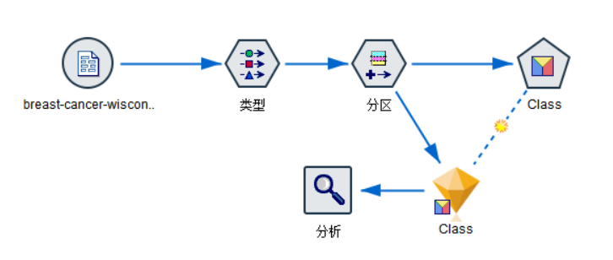
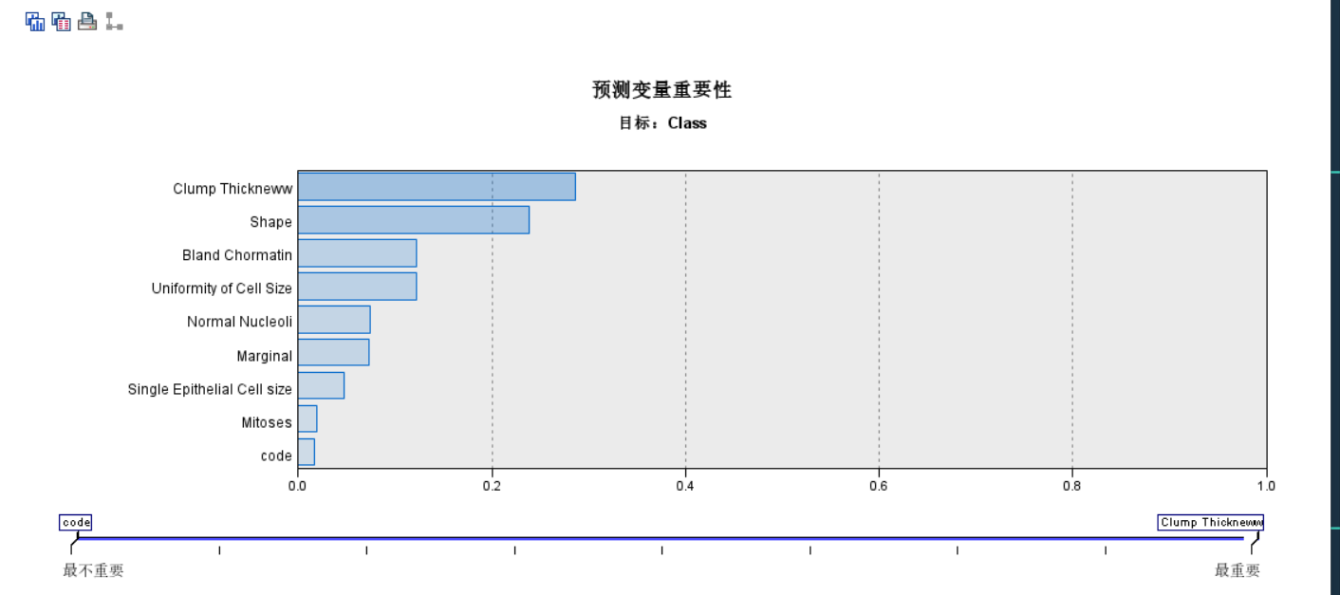
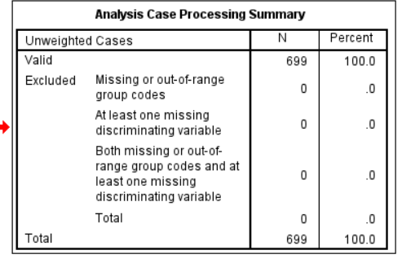
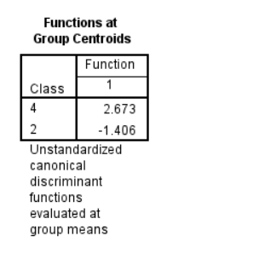

3 Bank Marketing Data Set（数据集同时作为训练集和测试集）
Data Set Information:
The data is related with direct marketing campaigns of a Portuguese banking institution. The marketing campaigns were based on phone calls. Often, more than one contact to the same client was required, in order to access if the product (bank term deposit) would be (or not) subscribed.
There are two datasets:
1) bank-full.csv with all examples, ordered by date (from May 2008 to November 2010).
2) bank.csv with 10% of the examples (4521), randomly selected from bank-full.csv.
The smallest dataset is provided to test more computationally demanding machine learning algorithms (e.g. SVM).
The classification goal is to predict if the client will subscribe a term deposit (variable y).
Attribute Information:
For more information, read [Moro et al., 2011].
Input variables:
# bank client data:
1 - age (numeric)
2 - job : type of job (categorical: 'admin.','unknown','unemployed','management','housemaid','entrepreneur','student',
'blue-collar','self-employed','retired','technician','services')
3 - marital : marital status (categorical: 'married','divorced','single'; note: 'divorced' means divorced or widowed)
4 - education (categorical: 'unknown','secondary','primary','tertiary')
5 - default: has credit in default? (binary: 'yes','no')
6 - balance: average yearly balance, in euros (numeric)
7 - housing: has housing loan? (binary: 'yes','no')
8 - loan: has personal loan? (binary: 'yes','no')
# related with the last contact of the current campaign:
9 - contact: contact communication type (categorical: 'unknown','telephone','cellular')
10 - day: last contact day of the month (numeric)
11 - month: last contact month of year (categorical: 'jan', 'feb', 'mar', ..., 'nov', 'dec')
12 - duration: last contact duration, in seconds (numeric)
# other attributes:
13 - campaign: number of contacts performed during this campaign and for this client (numeric, includes last contact)
14 - pdays: number of days that passed by after the client was last contacted from a previous campaign (numeric, -1 means client was not previously contacted)
15 - previous: number of contacts performed before this campaign and for this client (numeric)
16 - poutcome: outcome of the previous marketing campaign (categorical: 'unknown','other','failure','success')
Output variable (desired target):
17 - y - has the client subscribed a term deposit? (binary: 'yes','no')
第17个属性即“是否会认购定期存款”作为分类属性，这是一个两类问题。

4 Adult Data Set
Data Set Information:
Extraction was done by Barry Becker from the 1994 Census database. A set of reasonably clean records was extracted using the following conditions: ((AAGE>16) && (AGI>100) && (AFNLWGT>1)&& (HRSWK>0))
Prediction task is to determine whether a person makes over 50K a year.
Attribute Information:
Listing of attributes:
>50K, <=50K.
age: continuous.
workclass: Private, Self-emp-not-inc, Self-emp-inc, Federal-gov, Local-gov, State-gov, Without-pay, Never-worked.
fnlwgt: continuous.
education: Bachelors, Some-college, 11th, HS-grad, Prof-school, Assoc-acdm, Assoc-voc, 9th, 7th-8th, 12th, Masters, 1st-4th, 10th, Doctorate, 5th-6th, Preschool.
education-num: continuous.
marital-status: Married-civ-spouse, Divorced, Never-married, Separated, Widowed, Married-spouse-absent, Married-AF-spouse.
occupation: Tech-support, Craft-repair, Other-service, Sales, Exec-managerial, Prof-specialty, Handlers-cleaners, Machine-op-inspct, Adm-clerical, Farming-fishing, Transport-moving, Priv-house-serv, Protective-serv, Armed-Forces.
relationship: Wife, Own-child, Husband, Not-in-family, Other-relative, Unmarried.
race: White, Asian-Pac-Islander, Amer-Indian-Eskimo, Other, Black.
sex: Female, Male.
capital-gain: continuous.
capital-loss: continuous.
hours-per-week: continuous.
native-country: United-States, Cambodia, England, Puerto-Rico, Canada, Germany, Outlying-US(Guam-USVI-etc), India, Japan, Greece, South, China, Cuba, Iran, Honduras, Philippines, Italy, Poland, Jamaica, Vietnam, Mexico, Portugal, Ireland, France, Dominican-Republic, Laos, Ecuador, Taiwan, Haiti, Columbia, Hungary, Guatemala, Nicaragua, Scotland, Thailand, Yugoslavia, El-Salvador, Trinadad&Tobago, Peru, Hong, Holand-Netherlands.
第15个属性“一年是否大于50K” 作为分类属性，这是一个两类问题。
- 使用data数据集（3万多条数据）同时作为训练集和测试集测试模型精度；
- 使用data数据集作为训练集，test数据集作为测试集测试模型精度。

