**1、**

|  |  |  |  |
| --- | --- | --- | --- |
| **模型描述** | | | |
|  | | | 模型類型 |
| 模型 ID | VAR00003 | 模型_1 | ARIMA(0,1,0) |

|  |  |  |  |  |  |  |  |  |  |  |  |
| --- | --- | --- | --- | --- | --- | --- | --- | --- | --- | --- | --- |
| **模型適合度** | | | | | | | | | | | |
| 適合度統計量 | 平均值 | 標準誤 | 最小值 | 最大值 | 百分位數 | | | | | | |
| 5 | 10 | 25 | 50 | 75 | 90 | 95 |
| 平穩 R 平方 | -1.554E-15 | . | -1.554E-15 | -1.554E-15 | -1.554E-15 | -1.554E-15 | -1.554E-15 | -1.554E-15 | -1.554E-15 | -1.554E-15 | -1.554E-15 |
| R 平方 | .995 | . | .995 | .995 | .995 | .995 | .995 | .995 | .995 | .995 | .995 |
| RMSE | 1545.566 | . | 1545.566 | 1545.566 | 1545.566 | 1545.566 | 1545.566 | 1545.566 | 1545.566 | 1545.566 | 1545.566 |
| MAPE | 4.998 | . | 4.998 | 4.998 | 4.998 | 4.998 | 4.998 | 4.998 | 4.998 | 4.998 | 4.998 |
| MaxAPE | 12.384 | . | 12.384 | 12.384 | 12.384 | 12.384 | 12.384 | 12.384 | 12.384 | 12.384 | 12.384 |
| MAE | 1035.401 | . | 1035.401 | 1035.401 | 1035.401 | 1035.401 | 1035.401 | 1035.401 | 1035.401 | 1035.401 | 1035.401 |
| MaxAE | 4848.446 | . | 4848.446 | 4848.446 | 4848.446 | 4848.446 | 4848.446 | 4848.446 | 4848.446 | 4848.446 | 4848.446 |
| 正規化 BIC | 14.805 | . | 14.805 | 14.805 | 14.805 | 14.805 | 14.805 | 14.805 | 14.805 | 14.805 | 14.805 |

|  |  |  |  |  |  |  |  |
| --- | --- | --- | --- | --- | --- | --- | --- |
| **模型統計量** | | | | | | | |
| 模型 | 解釋變數數目 | 模型適合度統計量 | | Ljung-Box Q(18) | | | 離群值數目 |
| 平穩 R 平方 | R 平方 | 統計量 | 自由度 | 顯著性 |
| VAR00003-模型_1 | 0 | -1.554E-15 | .995 | 34.828 | 18 | .010 | 0 |

|  |  |  |  |  |  |  |  |
| --- | --- | --- | --- | --- | --- | --- | --- |
| **ARIMA 模型參數** | | | | | | | |
|  | | | | 估計 | 標準誤 | T | 顯著性 |
| VAR00003-模型_1 | VAR00003 | 自然對數 | 常數 | .139 | .012 | 11.704 | .000 |
| 差異 | 1 |  |  |  |

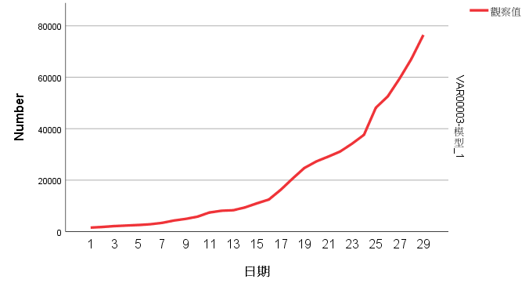

**2、**

