DA 26-786
Released: July 28, 2026

FCC’s public safety and homeland security bureau announces addition of FOREIGN-PRODUCED Power inverters and advanced robotic devices to fcc covered list
WC Docket No. 18-89, ET Docket No. 21-232, EA Docket No. 21-233

The Federal Communications Commission’s (FCC or Commission) Public Safety and Homeland Security Bureau (PSHSB) maintains a list of equipment and services (Covered List) that have been determined to “pose an unacceptable risk to the national security of the United States or the security and safety of United States persons.” Pursuant to section 2 of the Secure and Trusted Communications Networks Act of 2019 (Secure Networks Act) and sections 1.50002(a) and 1.50003 of the Commission’s rules, PSHSB announces the addition of foreign-produced power inverters and advanced robotic devices to the Covered List.

National Security Determinations. The White House convened an Executive Branch interagency body with appropriate national security expertise, including appropriate national security agencies identified in the Secure Networks Act. On July 27, 2026, the Executive Branch interagency body sent the FCC two National Security Determinations.

Power inverters. The first National Security Determination addresses the unacceptable risks posed by power inverters produced in foreign countries. Among other points, the National Security Determination states:

“The lack of a secure U.S. supply chain for inverters and the continuous inflow of foreign-produced or controlled inverters and inverter components poses threats to U.S. economic and national security . . . Inverters’ remote connectivity introduces additional vulnerabilities which compound as inverter-based resources proliferate on the U.S. grid. These vulnerabilities could enable foreign firms to turn off the inverters or use them to collect and exfiltrate data, facilitate remote access and surveillance by foreign government actors, or be otherwise exploited through a cyberattack.”

As a result of the threats described in the National Security Determination, the Executive Branch interagency body determined that power inverters produced in a foreign country pose the following unacceptable risks to the United States: (1) “facilitating a supply chain vulnerability that could disrupt U.S. economic security, including sectors critical to national security”; and (2) “creat[ing] a cybersecurity risk that threatens the security of critical infrastructure and the safety of U.S. persons.”

Based on these findings, the Executive Branch interagency body, including appropriate national security agencies, determined that the following equipment and services should be added to the FCC’s Covered List because they pose an unacceptable risk to the national security of the United States and to the safety and security of U.S. persons: “Power inverters produced in a foreign country, regardless of the nationality of the producer, unless the Department of War or Department of Homeland Security makes a specific determination to the FCC that a given power inverter or class of power inverters do not pose such risks.”

Advanced robotic devices. The second National Security Determination addresses the unacceptable risks posed by advanced robotic devices produced in foreign countries. Among other points, the National Security Determination states:

“The networked capabilities of advanced robotic systems create extensive vulnerabilities and vectors for attacks that can manipulate the data and physical operation of the advanced robotic system. Relying on foreign-produced advanced robotic devices presents unacceptable supply chain and cybersecurity vulnerabilities . . . Advanced robotic devices collect data that could be leveraged by malign actors to surveil Americans, enhance the capabilities of foreign intelligence services, or to remotely commandeer the robots.”

As a result of the threats described in the National Security Determination, the Executive Branch interagency body determined that advanced robotic devices produced in foreign countries presented the following unacceptable risks: (1) “posing a supply chain vulnerability that could disrupt U.S. economic and national security”; and (2) “creating a cybersecurity risk that threatens the security of critical infrastructure and thus the safety and security of U.S. persons.”

Based on these findings, the Executive Branch interagency body, including several appropriate national security agencies, determined that the following equipment should be added to the FCC’s Covered List because they pose an unacceptable risk to the national security of the United States and to the safety and security of U.S. persons: “All foreign-produced advanced robotic devices, unless the Department of War (DOW) transmits to the FCC a specific determination that a given foreign-produced advanced robotic device, or a class of such devices, does not pose such risks.”

The Covered List. We find that each National Security Determination constitutes a specific determination of an unacceptable risk to the national security of the United States or the security or safety of United States persons pursuant to section 2 of the Secure Networks Act. Therefore, we conclude that the Commission is required to place the identified equipment on the Covered List. We update the Covered List to include:

“Foreign-produced power inverters, except power inverters which have been granted a Conditional Approval by DoW or DHS”; and

“Foreign-produced advanced robotic devices, except advanced robotic devices which have been granted a Conditional Approval by DoW.”

We accept the National Security Determinations’ definitions of “foreign-produced,” “power inverters,” and “advanced robotic devices,” as provided in the Appendices below.

Conditional Approvals. The Executive Branch interagency body has established a process in which entities producing power inverters or advanced robotic devices in a foreign country can request an evaluation as to whether their devices do not pose unacceptable risks to national security and receive Conditional Approvals that would exempt the devices from the Covered List. DoW or DHS may evaluate such submissions for power inverters. DoW may evaluate such submissions for advanced robotic devices. Entities seeking Conditional Approvals for power inverters must provide the information requested in the Power Inverters Guidance Document. Likewise, entities seeking Conditional Approvals for advanced robotic devices must provide the information requested in the Advanced Robotic Devices Guidance Document.

If we receive a further specific determination from DoW or DHS that a given power inverter or advanced robotic device, or class of such devices, does not pose unacceptable risks, we will further update the Covered List.

PSHSB takes this action under its authority and obligation to publish and maintain the Covered List. Sections 1.50002(a) and 1.50003 of the Commission’s rules require PSHSB to publish the Covered List on the Commission's website, to maintain and update the Covered List, and to monitor the status of determinations.
Equipment Authorization Impacts of the Covered List. Under the Commission’s existing rules in section 2.903(a), once added to the Covered List, “covered” equipment is prohibited from receiving equipment authorizations. Moreover, pursuant to section 2.911 of the Commission’s rules, all applications seeking equipment authorization from the Commission must certify that the equipment is not prohibited from receiving an equipment authorization by virtue of being “covered equipment.” By so certifying, the applicant would be certifying that the equipment does not qualify as equipment listed in this Public Notice as “covered.” We clarify that these updates will not implicate various rules and programs applicable to entities “identified” on the Covered List, because this newly-covered equipment is identified by place of production, not by entity.

The updated Covered List is attached as Appendix A to this Public Notice and is published on the Bureau’s website at https://www.fcc.gov/supplychain/coveredlist. The Power Inverters National Security Determination is attached as Appendix B. The Advanced Robotic Devices National Security Determination is attached as Appendix C.

We note the continued availability of FCC staff guidance pursuant to sections 0.191 and 0.31(i) of the Commission’s rules. Commission staff will provide guidance to TCBs, test labs, and equipment authorization applicants on the impact of these updates.

For further information, please contact Chris Smeenk, Attorney Advisor, Operations and Emergency Management Division, Public Safety and Homeland Security Bureau at 202-418-1630 or Chris.Smeenk@fcc.gov.
APPENDIX A
COVERED LIST (Updated July 28, 2026)*†±

Covered Equipment or Services* | Date of Inclusion on Covered List
Telecommunications equipment produced or provided by Huawei Technologies Company, including telecommunications or video surveillance services produced or provided by such entity or using such equipment. | March 12, 2021
Telecommunications equipment produced or provided by ZTE Corporation, including telecommunications or video surveillance services provided or provided by such entity or using such equipment. | March 12, 2021
Video surveillance and telecommunications equipment produced or provided by Hytera Communications Corporation, to the extent it is used for the purpose of public safety, security of government facilities, physical security surveillance of critical infrastructure, and other national security purposes, including telecommunications or video surveillance services produced or provided by such entity or using such equipment. | March 12, 2021
Video surveillance and telecommunications equipment produced or provided by Hangzhou Hikvision Digital Technology Company, to the extent it is used for the purpose of public safety, security of government facilities, physical security surveillance of critical infrastructure, and other national security purposes, including telecommunications or video surveillance services produced or provided by such entity or using such equipment. | March 12, 2021
Video surveillance and telecommunications equipment produced or provided by Dahua Technology Company, to the extent it is used for the purpose of public safety, security of government facilities, physical security surveillance of critical infrastructure, and other national security purposes, including telecommunications or video surveillance services produced or provided by such entity or using such equipment. | March 12, 2021
Information security products, solutions, and services supplied, directly or indirectly, by AO Kaspersky Lab or any of its predecessors, successors, parents, subsidiaries, or affiliates. | March 25, 2022
International telecommunications services provided by China Mobile International USA Inc. subject to section 214 of the Communications Act of 1934. | March 25, 2022
Telecommunications services provided by China Telecom (Americas) Corp. subject to section 214 of the Communications Act of 1934. | March 25, 2022
International telecommunications services provided by Pacific Networks Corp. and its wholly-owned subsidiary ComNet (USA) LLC subject to section 214 of the Communications Act of 1934. | September 20, 2022
International telecommunications services provided by China Unicom (Americas) Operations Limited subject to section 214 of the Communications Act of 1934. | September 20, 2022
Cybersecurity and anti-virus software produced or provided by Kaspersky Lab, Inc. or any of its successors and assignees. | July 23, 2024
Uncrewed aircraft systems (UAS) and UAS critical components produced in a foreign country††—except:  (a) UAS and UAS critical components included on the Defense Contract Management Agency’s (DCMA’s) Blue UAS Cleared List, until January 1, 2028,#  (b) UAS and UAS critical components that qualify as “domestic end products” under the Buy American Standard, 48 CFR 25.101(a), until January 1, 2028;  (c) devices which have been granted a Conditional Approval by DoW or DHS; and  (d) foreign-produced “Toy Drones,” as defined in the National Security Determination, and “Toy Drones that contain foreign-produced components.”  All communications and video surveillance equipment and services listed in Section 1709(a)(1) of the FY25 National Defense Authorization Act (Pub. L. 118-159). | December 22, 2025  Updated: January 7, 2026  Updated: March 18, 2026  Updated: June 15, 2026  Updated: July 21, 2026
Routers^ produced in a foreign country, except routers which have been granted a Conditional Approval by DoW or DHS. | March 23, 2026
International telecommunications services provided by Digitalsystem Technology Inc., subject to section 214 of the Communications Act of 1934. | July 7, 2026
Foreign-produced power inverters,£ except power inverters which have been granted a Conditional Approval by DoW or DHS. | July 28, 2026
Foreign-produced advanced robotic devices,³ except advanced robotic devices which have been granted a Conditional Approval by DoW. | July 28, 2026

*The inclusion of producers or providers of equipment or services named on this list should be read to include the subsidiaries and affiliates of such entities.

†Where equipment or services on the list are identified by category, such category should be construed to include only equipment or services capable of the functions outlined in sections 2(b)(2)(A), (B), or (C) of the Secure and Trusted Communications Networks Act of 2019, 47 U.S.C. § 1601(b)(2)(A)-(C).

±The scope of the Covered List is affected by the Conditional Approvals that we have received.

††For purposes of inclusion of UAS and UAS critical components, we incorporate the definitions included in the associated National Security Determination.

#The “Blue UAS list” referred to in the National Security Determination is the combination of the “Blue UAS Cleared List” at https://bluelist.appsplatformportals.us/Cleared-List/ and the list of compliant UAS components and software at https://bluelist.appsplatformportals.us/Framework/. We use the term “Blue UAS Cleared List” to refer to both lists.

^For purposes of inclusion of routers, we incorporate the definitions included in the associated National Security Determination.

£For purposes of inclusion of power inverters, we incorporate the definitions included in the associated National Security Determination.

³For purposes of inclusion of advanced robotic devices, we incorporate the definitions included in the associated National Security Determination.

APPENDIX B

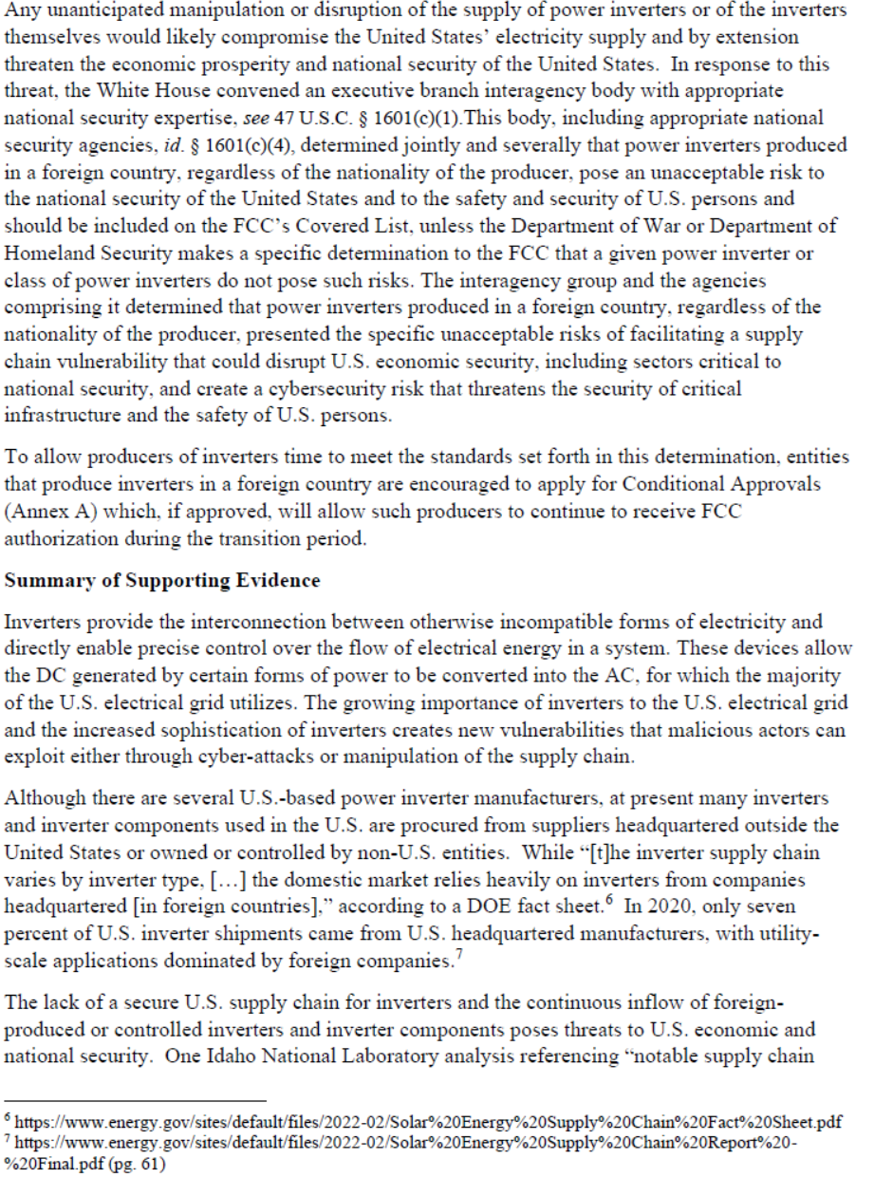
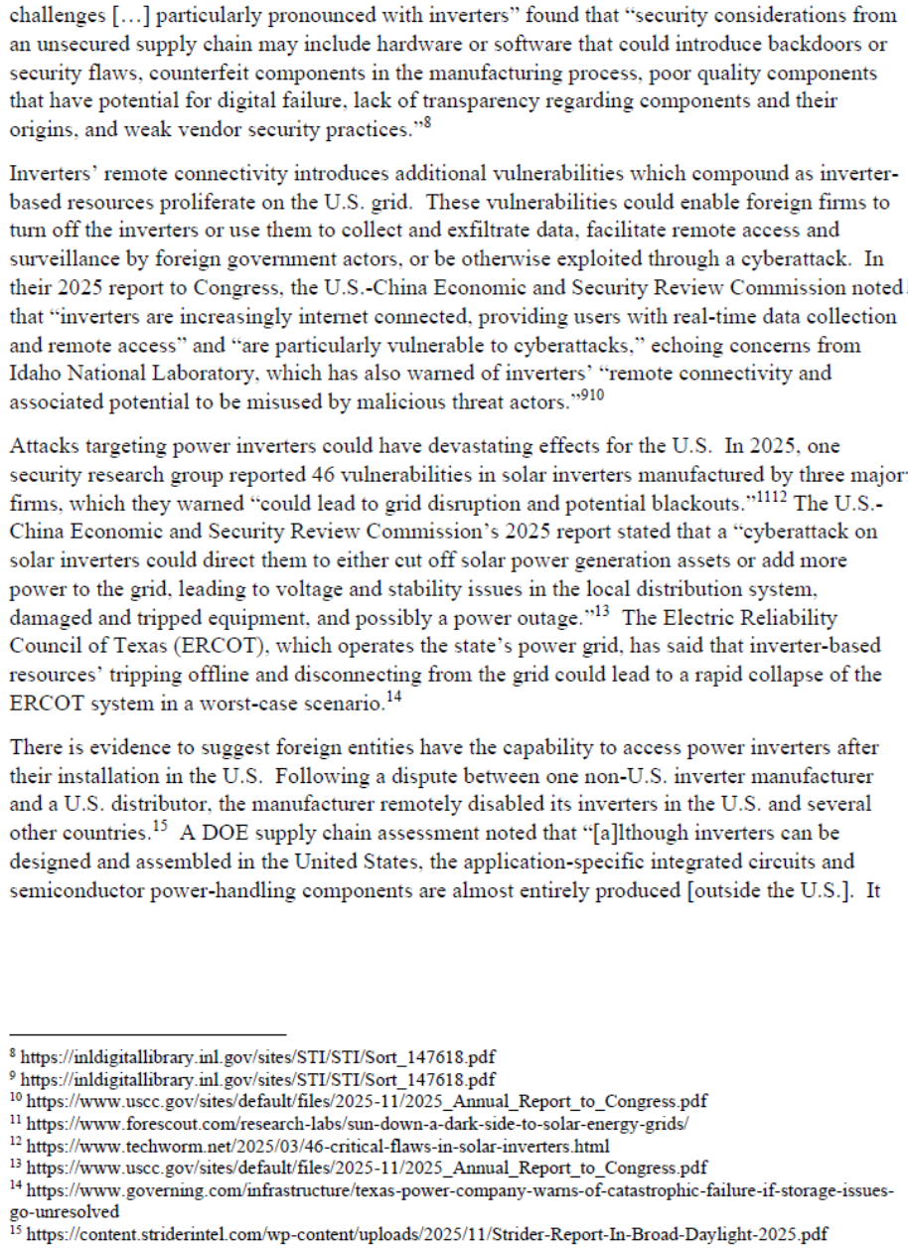
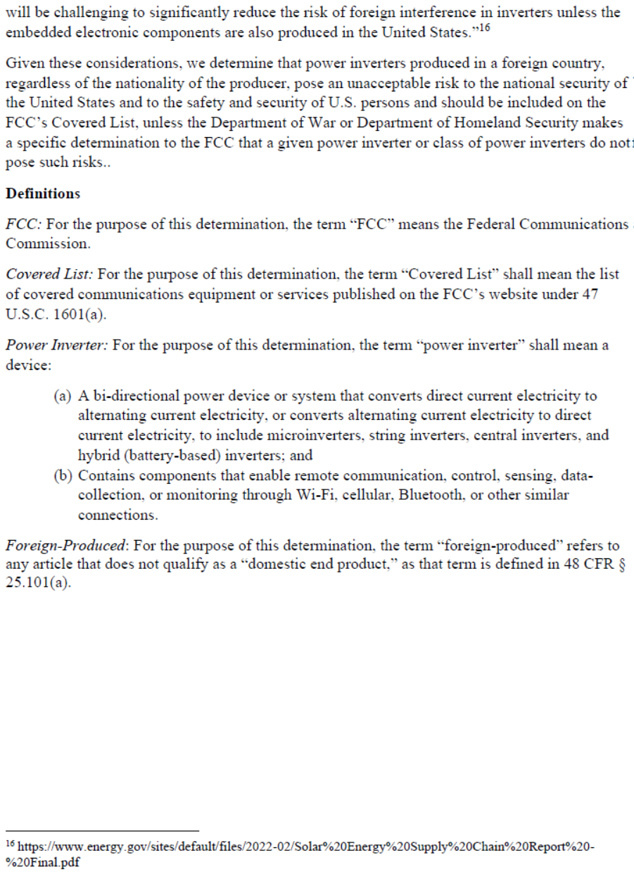
APPENDIX C

Secure and Trusted Communications Networks Act of 2019, Pub. L. No. 116-124, 133 Stat. 158 (2020) (codified as amended at 47 U.S.C. §§ 1601-1609) (Secure Networks Act); 47 CFR §§ 1.50002, 1.50003. For the current version of the Covered List, see Federal Communications Commission, List of Equipment and Services Covered By Section 2 of The Secure Networks Act, https://www.fcc.gov/supplychain/coveredlist (last updated Mar. 18, 2026).
47 U.S.C. § 1601.
47 CFR §§ 1.50002(a), 1.50003; see also Protecting Against National Security Threats to the Communications Supply Chain Through FCC Programs, WC Docket No. 18-89, Second Report and Order, 35 FCC Rcd 14284 (2020) (Supply Chain Second Report and Order).
See 47 U.S.C. § 1601(c)(1).
The Power Inverters National Security Determination is attached as Appendix B to this Public Notice.
Power Inverters National Security Determination at 2-3.
Id. at 2.
Id. at 2.
The Advanced Robotic Devices National Security Determination is attached as Appendix C to this Public Notice.
Advanced Robotic Devices National Security Determination at 2-3.
Id. at 2.
Advanced Robotic Devices National Security Determination at 4.
47 U.S.C. § 1601(c).
47 U.S.C. § 1601(b)-(d).
47 CFR §§ 1.50002(a), 1.50003. See Supply Chain Second Report and Order, 35 FCC Rcd at 14317, 14319, 14325, paras. 72, 77, 92.
47 CFR § 2.903(a).
47 CFR § 2.911(d)(5)(i).
See 47 CFR §§ 2.903, 2.906, 2.907, 2.911, 2.929, 2.932, 2.938, 2.1033, 2.1043.
The FCC website also contains a list of certain affiliates and subsidiaries of entities identified on the Covered List. The list of affiliates and subsidiaries does not constitute a comprehensive list of all entities that the Commission may find, upon further examination, to qualify as relevant subsidiaries or affiliates of entities on the Covered List. Those entities, whether or not they currently provide covered communications equipment or services, are subject to the Commission’s prohibitions, such as the prohibition against obtaining authorizations for covered equipment. See Reminder: Communications Equipment And Services On The Covered List Pose An Unacceptable Risk To National Security, National Security Advisory No. 2025-01, DA 25-927, note 3 (PSHSB Oct. 14, 2025).

