Confidence Aware OCR Document Reader
Author: Shapna
Project Type: Applied Machine Learning / Document AI
Dataset: SROIE 2019 (Real World Scanned Receipts)
Date: January 2026
1. Problem Overview
Organizations continue to process massive volumes of scanned receipts, invoices, and forms. OCR systems are widely used to automate this process but in real world deployments, OCR output is often silently unreliable.
The core problem is not that OCR makes errors.
The problem is that traditional OCR systems do not communicate uncertainty.
This creates two equally flawed workflows:
- Blind automation: Fast, but errors propagate unnoticed
- Full manual review: Accurate, but slow, expensive, and unscalable
In business critical domains (finance, compliance, healthcare), neither approach is acceptable.
Key Insight:
Accuracy without uncertainty is risky. A practical OCR system must explicitly indicate what can be trusted and what requires human review.
2. Why Receipts Are a Hard OCR Problem
Receipts represent one of the most challenging document types for OCR due to:
- Crumpling, folding, and physical distortion
- Mobile image capture (glare, blur, skew)
- Dense numeric content (totals, taxes,
Example Input & Output
Sample receipt from the SROIE 2019 dataset and the corresponding confidence-aware OCR output highlighting uncertain regions.*
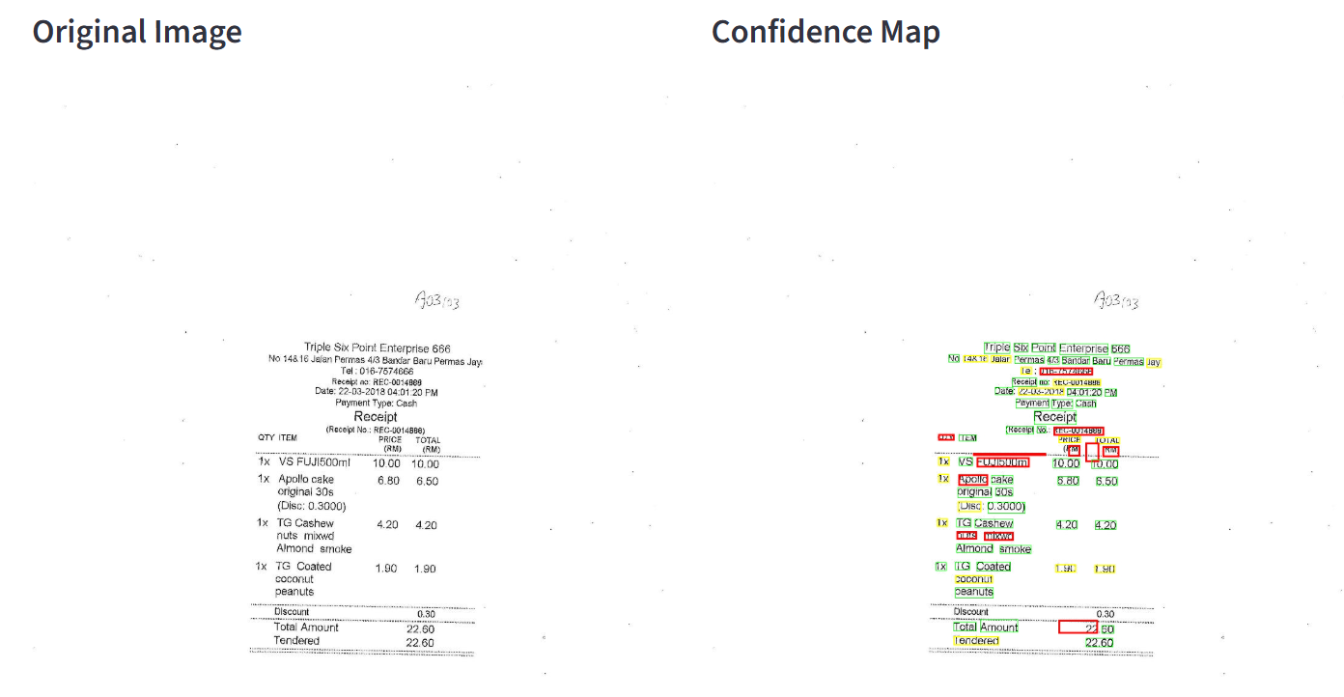

3. Proposed Solution: Confidence Aware OCR
This project introduces a confidence aware OCR system that transforms OCR output from fragile automation into reliable, human guided decision support.
Instead of asking humans to review everything or trust everything the system:
- Extracts word level OCR confidence scores
- Categorizes text into high, medium, and low confidence
- Visually highlights only uncertain regions
- Directs human attention precisely where it adds value
Core Principle:
Perfect automation is unrealistic. Intelligent collaboration is achievable.
4. System Architecture (High Level)
The system is built as a modular pipeline with clear separation of concerns:
- OCR Engine (Tesseract 5.x)
- Confidence Analysis Module
- Visualization Layer
- Evaluation Module
- User Interface (Streamlit + CLI)
Image Architecture of the system
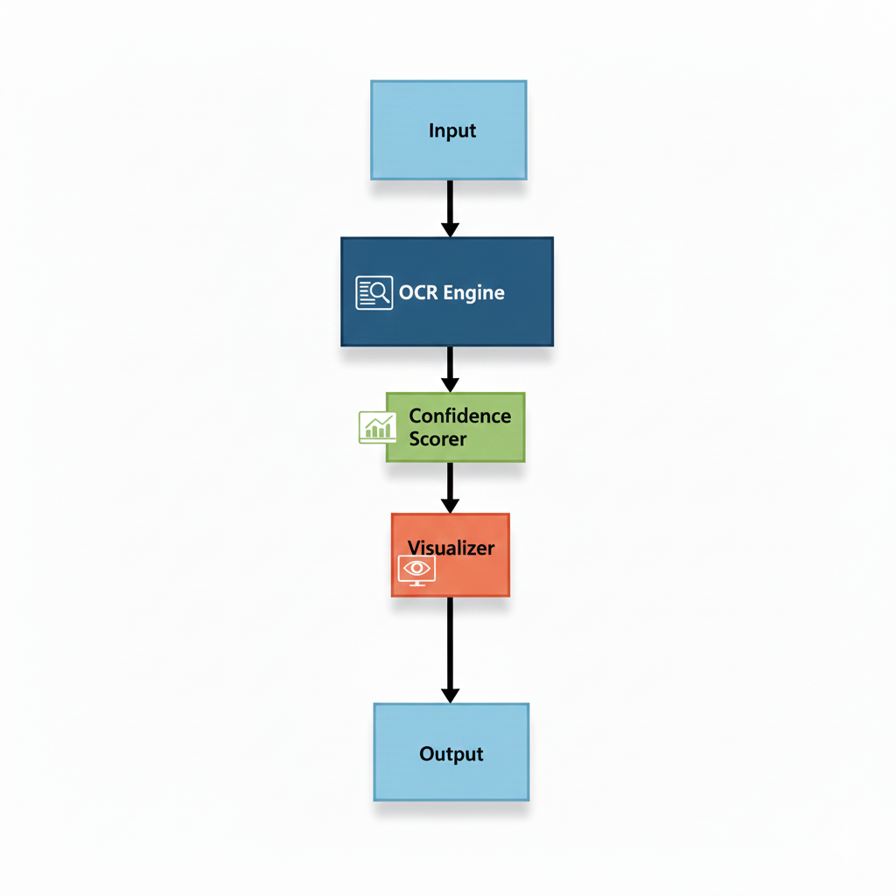
5. Dataset & Evaluation Setup
Dataset: SROIE 2019 (ICDAR Competition)
- 987 real world scanned receipts
- Ground truth text boxes and structured entities
- Highly variable quality and layouts
This dataset reflects actual production conditions, not clean or synthetic data.
The system was evaluated using:
- Word level accuracy
- Confidence–error correlation
- Field level reliability for critical values
6.Reproduction and Setup
1️⃣ Python Environment
Create a python environment
2️⃣ Install Dependencies
pip install -r requirements.txt
3️⃣ Tesseract OCR Installation
- Must install separately, because it’s an external dependency.
- Windows: download installer from UB Mannheim Tesseract and add to PATH
- macOS: brew install tesseract
- Linux: sudo apt-get install tesseract-ocr
4️⃣ Dataset
Download the SROIE 2019 dataset from the following link:
Dataset: https://www.kaggle.com/datasets/urbikn/sroie-datasetv2?resource=download
After downloading:
- Delete the folder named layoutlm-base-uncased (if present).
- Copy and paste the SROIE2019 folder into the data directory.
Folder structure requirement:
- The SROIE2019 folder should contain only the train and test folders.
- Place the SROIE2019 folder inside the raw directory as shown below:
5️⃣ Running the Project
- Streamlit UI:
streamlit run app.py
- CLI (batch processing):
python main.py
- Outputs:
  - Annotated images
  - CSV / JSON summaries
  - Word exports
7. Project structure
confidence-aware-ocr/
├── data/
│ ├── raw/
│ │ └── SROIE2019/ # Dataset (not included in repo)
│ │ ├── train/
│ │ │ ├── img/ # Receipt images
│ │ │ ├── box/ # Ground truth text boxes
│ │ │ └── entities/ # Ground truth structured data
│ │ └── test/
│ ├── processed/ # Processed data
│ └── results/ # Output files
│ ├── visualizations/ # Annotated images
├── src/
│ ├── data_loader.py # Dataset loading utilities
│ ├── ocr_engine.py # Tesseract OCR wrapper
│ ├── confidence_scorer.py # Confidence analysis
│ ├── visualizer.py # Image annotation
│ └── evaluator.py # Accuracy evaluation
├── app.py # Streamlit web interface
├── main.py # CLI pipeline
├── requirements.txt # Python dependencies
├── .gitignore # Git ignore rules
└── README.md # This file
7. Key Results
Confidence Predicts Reliability
Confidence Level | Accuracy | Interpretation
High (≥80%) | 94% | Safe to trust
Medium (60–79%) | 72% | Context dependent
Low (<60%) | 40% | Requires review
Low confidence words are ~2.4× more likely to be incorrect than high confidence words.
This validates the core hypothesis:
OCR confidence scores provide a strong, actionable signal for selective human review.

8. Limitations
- Confidence scores are not calibrated probabilities
- English language focus (multilingual extension possible)
- Streamlit not intended for enterprise scale throughput
9. Conclusion
The Confidence Aware OCR Document Reader demonstrates that the real challenge in document AI is not extraction, but trust.
By making uncertainty explicit and actionable, this system:
- Reduces silent OCR failures
- Focuses human effort where it matters
- Bridges the gap between automation and reliability
Rather than chasing perfect accuracy, the project embraces uncertainty as a first class signal a requirement for responsible, production ready AI systems.

