FMTH0306/Rev.1.0
Course Plan
Semester: V | Year: 2026-27
Course Title: Computer Networks | Course Code: 25ECAC220
Total Contact Hours: 50+30 | Duration of ESA: 3 Hours
ISA Marks: 50 | ESA Marks: 50
Lesson Plan Author: Mrs Pooja S | Date:
Checked By: Dr. Narayan D G | Date:

Prerequisites:
- Programming in C
- Data Structures

Course Outcomes (COs):
At the end of the course the student should be able to:
- Design principles of Internet architecture, and application-layer protocols.
- Apply transport-layer services and protocols to achieve reliable data transfer and congestion control.
- Analyze network-layer functions such as IP addressing, routing algorithms, and routing protocols.
- Demonstrate data link layer operations using error control, access protocols, and switched LANs.
- Apply networking principles to understand network operating systems and troubleshoot network connectivity issues using modern networking tools.
Course Articulation Matrix: Mapping of Course Outcomes (COs) with Program Outcomes (POs)
Course Title: Computer Networks | Semester: 4 - Semester
Course Code: 25ECAC220 | Year: 2026-27

Course Outcomes (COs) / Program Outcomes (POs) | 1 | 2 | 3 | 4 | 5 | 6 | 7 | 8 | 9 | 10 | 11 | 12 | 13 | 14
- Design principles of Internet architecture, and application-layer protocols. | H
- Apply transport-layer services and protocols to achieve reliable data transfer and congestion control. | H | M
- Analyze network-layer functions such as IP addressing, routing algorithms, and routing protocols. | H | M
- Demonstrate data link layer operations using error control, access protocols, and switched LANs. | H | M
v. Apply networking principles to understand network operating systems and troubleshoot network connectivity issues using modern networking tools. | H |  |  |  | M
Degree of compliance L: Low M: Medium H: High

Competency addressed in the Course and corresponding Performance Indicators
Competency | Performance Indicators | Course Specific Performance Indicator (CSPI)
1.4 - Demonstrate the competency in Computer Science and Engineering. | 1.4.3 - Apply network engineering, security, and cloud computing principles to build secure infrastructures, implement secure code, assess vulnerabilities, and design risk-based frameworks | Apply principles of computer networks, to design and evaluate network communication systems
2.2: Demonstrate an ability to apply principles of mathematics, natural sciences, and engineering to formulate and analyze complex problems, incorporating literature review to support sustainable development. | 2.2.2- Apply mathematical and scientific principles to formulate the engineering problem | Use mathematical principles to analyze, and solve problems related to reliable data transfer, congestion control, and network-layer operations
5.5- Demonstrate an ability to  identify appropriate mathematical, statistical and  analytical engineering tools and resources. | 5.5.1- Select suitable mathematical, statistical, or analytical tools based on the complexity of the  engineering problem, data, or modelling requirements. | Designing an enterprise network for high availability and low latency and Evaluating QoS performance in networks.

Eg: 1.2.3: Represents Program Outcome ‘1’, Competency ‘2’ and Performance Indicators ‘3’.

Course Content
Course Code: 25ECAC220 | Course Title: Computer Networks
L-T-P: 4-0-1 | Credits: 5 | Contact Hrs: 50+30
ISA Marks: 50 | ESA Marks: 50 | Total Marks: 100
Teaching Hrs: 50 |  | Exam Duration: 3 hrs

Content | Hrs
Unit - 1
Introduction and Application layer: Introduction to Internet; The Network Edge and Core; Delay, Loss, and Throughput; Protocol Layer and Service Models: OSI and TCP/IP;  Principles of Network Applications; The Web and HTTP; Electronic Mail in the Internet – SMTP, POP3, and IMAP; The Internet’s Directory Service – DNS; Dynamically configuring a host – DHCP. | 10 Hrs
Transport-Layer Services: Introduction and Transport Layer Services; Multiplexing and Demultiplexing; Connectionless Transport: UDP; Pipelined protocols, stop and wait, go-back-N and selective repeat protocols; Connection-Oriented Transport: TCP; Principles of Congestion Control; TCP Congestion Control. | 10 Hrs
Unit - 2
Network Layer: Data plane: Introduction to Data and Control Plane of Network Layer; Virtual Circuit and Datagram Networks; The Internet Protocol: Datagram format, Fragmentation, IPv4 addressing, NAT, Introduction IPv6.  Network Layer: Control plane: The Link-State (LS) Routing Algorithm, The Distance-Vector (DV) Routing Algorithm, Hierarchical Routing, Routing in the Internet, intra-AS Routing in the Internet and introduction to BGP. | 12 hrs
Data Link Layer: Introduction to the Link Layer, Error-Detection and -Correction Techniques: TW0-D-Parity Checks, check summing Methods, Cyclic Redundancy Check (CRC) binary and polynomial, Hamming Code. | 8 hrs
Unit - 3
Data Link Layer: Channel access protocols: Multiple Access Links and Protocols: Channel Partitioning Protocols, Random Access Protocols: Aloha, Slotted Aloha, CSMA, CSMA/CD, CSMA/CA, Introduction to Taking-Turns Protocols, and Channelization protocols | 5 hrs
Switched Local Area Networks: Link-Layer Addressing and ARP, Ethernet 802.3, and LAN standards, Link-Layer Switches, Virtual Local Area Networks (VLANs), Multiprotocol Label Switching (MPLS).Introduction to SDN. | 5 hrs
Text Books:
- J. F. Kurose, K. W. Ross, Computer Networking, A Top-Down Approach, 8th Edition, Pearson Education, 2022
References:
- Peterson, Larry L, Computer networks: a systems approach, 5th Edition, The Morgan Kaufmann series in networking, 2012
- Behrouz A. Forouzan, TCP/IP protocol suite, 4th, McGraw Hill, 2010
Evaluation Scheme
ISA Scheme
Assessment | QP Max Marks | Weightage in Marks
ISA 1 | 60 | 15
ISA 2 | 60 | 15
lab | 40 | 20
Total |  | 50

Course Unitization for ISA and ESA
Topics / Chapters | Teaching Credits | No. of Questions in ISA-1 | No. of Questions in ISA-2 | No. of Questions in Activity | No. of Questions in ESA
Unit I
1.Introduction & Application layer | 10 | 1.50 | -- | 0 | 1.50
2. Transport-Layer Services | 10 | 1.50 | -- | 0 | 1.50
Unit II
3. Network Layer: Data plane, Control plane | 12 | -- | 2.00 | 0 | 2.00
4.Data Link Layer | 8 | -- | 1.00 | 0 | 1.00
Unit III
5.Data link layer: Channel access protocols | 5 | -- | -- | 0 | 1.00
6.Switched Local area Networks | 5 | -- | -- | 0 | 1.00

Note
1. Each Question carries 20 marks and may consists of sub-questions.
2. Mixing of sub-questions from different chapters within a unit (only for Unit I and Unit II) is allowed in ISA I, II and ESA
3. Answer 5 full questions of 20 marks each (two full questions from Unit I, II and one full question from Unit III) out of 8 questions in ESA.

Date: Head of Department CSE-AI

Course Assessment Plan
Course Title: Computer Networks Code: 25ECAC220
Course outcomes (COs) | Weightage in assessment | Assessment Methods
 |  | ISA-I | ISA-II | Lab Activity | ESA
- Design principles of Internet architecture, and application-layer protocols. | 20%
- Apply transport-layer services and protocols to achieve reliable data transfer and congestion control. | 20%
- Analyze network-layer functions such as IP addressing, routing algorithms, and routing protocols. | 20%
- Demonstrate data link layer operations using error control, access protocols, and switched LANs. | 20%
- Apply networking principles to understand network operating systems and troubleshoot network connectivity issues using modern networking tools. | 20%
Weightage |  | 15% | 15% | 20% | 50%

Tutorial Plan

Experiment wise plan

Expt./Job No. | Experiment/job Details | No. of Lab. Session/s per batch (estimate) | Marks/  Experiment | Correlation of Experiment with the theory
1 | Ethernet LAN Setup | 2 | - | Physical layer components for setting up of a LAN configuration.  D-link switch.  Cables.  Addressing formats  Subnetting
2 | Wireshark tool | 2 | - | Network protocols
3. | Cisco Packet Tracer | 2 | - | Demonstration of tool and network protocols
4 | JUNOS | 2 | - | Demonstration of tool and routing protocols
5 | Socket Programming | 2 | - | Client/Server application

List of experiments / jobs planned to meet the requirements of the course

Experiments |  | Total Weightage: NA | No. of lab sessions:14
Expt./Job No. | Experiment | No. of Lab. Session/s per batch | Marks/ | BL, PI Code, CO | Correlation of Experiment with the course content
1 | Demonstration of n/w commands and tools in command prompt. | 1 | - | L3  1.4.3  CO-1 | Chapter 1
2 | Introduction to components and design a small LAN with switches, routers, and PCs.  Configure static IPs and test connectivity with ping. | 1 | - | L3  1.4.3  CO-1 | Chapter 1
3 | Introduction to Wireshark tool overview: |  |  | 3 | Introduction to Wireshark tool overview:
4 | Capture the HTTP protocol and understand the basic GET/response interaction, HTTP message formats, retrieving large HTML files, retrieving HTML files with embedded objects, and HTTP authentication and security. | 1 | - | L3  5.1.1  CO-5 | 4
5 | Capture and analyse DNS packets that are generated by ordinary Web surfing. |  |  | L3  5.1.1  CO-5 | Capture and analyse DNS packets that are generated by ordinary Web surfing.
Evaluation 1 (wireshark) |  |  | 5
6 | Demonstration of Cisco Packet Tracer network tool: usage of hub, switch, and a router using a simple topology |  |  | L3  5.1.1  CO-5 | Chapter 2/4
7 | Application layer protocol implementation – Manual configuration and DHCP. DNS, SMTP and HTTP |  |  | L3  5.1.1  CO-5 | Chap 2/4
Evaluation 2 (cisco packet tracer) |  |  | 5
8 | Introduction to Junos |  |  | L3  5.1.1  CO-5 | Chapter 4
9 | Configuration and analysis of VLAN and BGP and OSPF |  |  | L3  5.1.1  CO-5 | Chapter 4
Evaluation -3 (JUNOS) |  |  | 5
10 | Introduction to Socket Programming and demonstration of Chat Application |  |  | L3  1.4.3  CO-1,2 | Chapter 1/2
Evaluation-4 (Socket Programming) |  |  | 5

Assessment and Rubrics
Evaluation 1 (Note: Evaluated for 10 reduced to 5)
Marks=10M | BL=L3 | CO=5 | PI= 5.1.1
Criteria | Good (8-10) | Satisfactory (5-7) | Needs Improvement (0-4)
Packet Capture and Setup | Accurately configures, and initiates packet capture on the desired interface. | May not be able to configure correctly, and does not initiate packet capture correctly on the desired interface. | Fails to capture packets or unable to do the setup
Use of Filters, Protocol Identification and Analysis | Effectively uses filters to isolate specific protocol traffic and interprets the headers of the protocols correctly | Uses filters appropriately with minor inaccuracies in header identification and explanation | Incorrect or no filters, and unable to identify and interpret the headers.
Evaluation 2 (Note: Evaluated for 10 reduced to 5)
Marks=5 M | BL=L3 | CO=2 | PI= 5.1.1
Criteria | Good (8-10) | Satisfactory (5-7) | Needs Improvement (0-4)
Network Design & Topology Planning device configuration Device Configuration | Accurately designs the topology and Logical device interconnections with proper IP addressing/subnetting plan and  correct interface configurations and accurate use of commands | Minor inaccuracy in designing the topology and Logical device interconnections with no proper IP addressing/subnetting plan not very correct interface configurations and no accurate use of commands | Fails in designing the topology and Logical device interconnections. If done may not be able to configure the device and use the commands
Implementation of Network Services/Protocols Simulation, Verification & Performance Analysis | Correct implementation of assigned protocol(s) along with perfect  working simulation mode for packet flow visualization, with proper logical justification of protocol selection. | Incorrect implementation of assigned protocol(s) along with no proper  working simulation mode for packet flow visualization, no justification of protocol selection. | Fails to implement the assigned protocol(s) no working simulation mode for visualization, no justification of protocol selection.
Evaluation 3 (Note: Evaluated for 10 reduced to 5)
Marks=5 M | BL=L3 | CO=3 | PI= 1.4.3
Criteria | Good (8 M-10 M) | Satisfactory(4 M-7 M) | Needs Improvement (0M- 4 M)
Routing Setup | Static/dynamic routing correct | Partially correct | Incorrect setup
Verification | Routes verified successfully | Partial verification | No verification
Troubleshooting | Errors identified & fixed | Needs hints | No troubleshooting
Evaluation 4 (Note: Evaluated for 10 reduced to 5)
Marks=5 M | BL=L3 | CO=3 | PI= 1.4.3
Criteria (2 Experiment each 5 Marks) | Good (8-10) | Satisfactory (5-7) | Needs Improvement (0-4)
Program Functionality | Implements full socket communication with accurate data handling. | Functional program with minor issues or limited features. | Fails to execute or meet basic requirements.
Testing and Debugging | Thoroughly tested with clear validation of inputs, outputs, and edge cases | Limited testing; some errors unaddressed | Not tested or fails under basic conditions.

Chapter wise Plan
Course Code and Title: 25ECAC220 / Computer Networks
Chapter Number and Title: 1. Introduction | Planned Hours: 10 hrs
Learning Outcomes: -
At the end of the topic the student should be able to:
Topic Learning Outcomes | COs | BL | CA Code
- Discuss the basic hardware and software components that are used to create a network. | 1 | L2 | 1.4
- Explain use of internet in terms of a networking infrastructure that provides services to distributed applications. | 1 | L2 | 1.4
- Differentiate between network architecture and application architecture. | 1 | L3 | 1.4
- Discuss the different type of protocols and its specific application. | 1 | L3 | 1.4
- Distinguish the role of web in the distributed applications. | 1 | L3 | 1.4

Lesson Schedule
Class No. - Portion covered per hour / per Class
- Introduction to Internet
- The Network Edge
- The Network Core
- Protocol layer and service models: OSI Model
- Protocol layer and service models: TCP/IP
- Principles of Network Applications; The Web
- HTTP
- Electronic Mail in the Internet – SMTP
- POP, and IMAP
10.The Internet’s Directory Service
Review Questions
Sl.No. - Questions | TLOs | BL | PI Code
- What is the difference between a host and an end system? List the different types of end systems. Is a Web server an end system? Justify. | TLO1 | L2 | 1.4.3
- What are the four layers in the Internet protocol stack? What are the principal responsibilities of each of these layers? | TLO2 | L2 | 1.4.3
- What advantage does a circuit-switched network has over a packet-switched network? List the advantages of TDM over FDM in a circuit-switched network. | TLO2 | L2 | 1.4.3
- Give the Taxonomy of Real-Time application and briefly explain with suitable examples. | TLO3 | L3 | 1.4.3
- Describe how Web caching can reduce the delay in receiving a requested object. Will Web caching reduce the delay for all objects requested by a user or for only some of the objects? Justify | TLO4 | L3 | 1.4.3
- Suppose Alice, with a Web-based e-mail account (such as Hotmail or gmail), sends a message to Bob, who accesses his mail from his mail server using POP3. Discuss how the message gets from Alice’s host to Bob’s host. Be sure to list the series of application-layer protocols that are used to move the message between the two hosts. | TLO5 | L3 | 1.4.3

Course Code and Title: 25ECAC220 / Computer Networks
Chapter Number and Title: 2. Transport-Layer Services | Planned Hours: 10 hrs
Learning Outcomes: -
At the end of the topic the student should be able to:
Topic Learning Outcomes | COs | BL | CA Code
- Explain the functionalities of transport layer. | 2 | L2 | 1.4
- Describe the principles transport layer services. | 2 | L3 | 1.4
- Explain the addressing mechanism at the transport layer. | 2 | L2 | 1.4
- Describe the principles of reliable data transfer using connection less UDP. | 2 | L3 | 2.2
- Describe the Internet’s transport-layer, connection-oriented, reliable transport protocol | 2 | L3 | 2.2
- Compare the connection-oriented and connection less protocol. | 2 | L3 | 1.4
- Select the suitable transport layer protocol for a given problem. | 2 | L3 | 2.2
- Illustrate congestion control algorithms to provide TCP reliable service. | 2 | L3 | 2.2

Lesson Schedule
Class No. - Portion covered per hour / per Class
- Introduction and Transport Layer Services.
- Multiplexing and Demultiplexing
- Connectionless Transport: UDP
- Stop and wait
- Go-back-N
- Selective repeat protocols
- Connection-Oriented Transport: TCP
- Header Structures
- Principles of Congestion Control
- TCP Congestion Control

Review Questions
Sl.No. - Questions | TLOs | BL | PI Code
- A student in KLETECH is developing the game application, suggest the suitable transport layer protocol service for him. Give the justification for your suggestion. | TLO7 | L3 | 1.4.3
- Compare the TCP header and the UDP header. List the fields in the TCP header that are not part of the UDP header. Give the reason for each missing field. | TLO6 | L3 | 1.4.3
- The following is a dump of a UDP header in hexadecimal format.  0045DF000058FE20  - What is the source port number?  - What is the destination port number?  iii What is the total length of the user datagram?  iv What is the length of the data?  v Is the packet directed from a client to a server or vice versa?  vi What is the client process? | TLO7 | L3 | 2.2.2
- UDP is a message-oriented protocol. TCP is a byte-oriented protocol. If an application needs to protect the boundaries of its message, which protocol should be used? | TLO6 | L3 | 1.4.3
- Why the checksum in TCP is calculated only for header? Justify. | TLO7 | L3 | 2.2.2
- Give your opinion about the TCP segment in which the value of the control field is one of the following: a. 000000 b. 000001 c. 010001 d. 000100 e. 000010 f. 010010 | TLO5 | L3 | 2.2.2
- What are the principles of congestion control? How the TCP will handle the congestion in the network. | TLO8 | L2 | 2.2.2

Course Code and Title: 25ECAC220 / Computer Networks
Chapter Number and Title: 3. Network Layer: Data plane, Control plane | Planned Hours: 12 hrs
Learning Outcomes: -
At the end of the topic the student should be able to:
Topic Learning Outcomes | COs | BL | CA Code
- Explain the data and control plan in the network | 3 | L2 | 1.4
- Compare virtual circuit and datagram network. | 3 | L3 | 1.4
- Describe IPv4, datagram format, fragmentation, and IPv4 addressing. | 3 | L3 | 2.2
- Convert addresses from binary notation to dotted decimal notation. | 3 | L3 | 1.4
- Identify the need of fragmentation in network layer. | 3 | L3 | 2.2
- Describe the need for NAT. | 3 | L3 | 2.2
- Differentiate between IPv4 and IPv6 | 3 | L3 | 2.2
- Understand the design of topological and routing strategies for an IP based networking infrastructure. | 3 | L3 | 2.2

Lesson Schedule
Class No. - Portion covered per hour / per Class
- Introduction to data and control plane
- Virtual circuit and datagram networks
- Internet protocol: datagram format
- Fragmentation
- IP addressing,
- NAT
- Link state routing algorithm
- Distance vector routing algorithm
- Hierarchical routing
10.Routing in the internet OSPF
11.BGP broadcast
12.Multicast routing, Broadcast routing algorithm

Review Questions
Sl.No. - Questions | TLOs | BL | PI Code
- Explain the need of data plane and control plane in the network layer. | TLO1 | L2 | 1.4.3
- IPv4 protocol is an unreliable protocol, is it possible to make it as reliable for the application layer? Justify your answer. | TLO3 | L3 | 2.2.2
- An IP datagram has arrived with the following information in the header (in hexadecimal): 45 00 00 54 00 03 00 00 20 06 00 00 7C 4E 03 02 B4 0E 0F 02  a. Are there any options?  b. Is the packet fragmented?  c. What is the size of the data?  d. Is a checksum used?  e. How many more routers can the packet travel to?  f. What is the identification number of the packet?  g. What is the type of service? | TLO3 | L3 | 2.2.2
- Consider a router that interconnects three subnets: Subnet 1, Subnet 2, and Subnet 3. Suppose all of the interfaces in each of these three subnets are required to have the prefix 223.1.17/24. Also suppose that Subnet 1 is required to support at least 60 interfaces, Subnet 2 is to support at least 90 interfaces, and Subnet 3 is to support at least 12 interfaces. Provide three net- work addresses (of the form a.b.c.d/x) that satisfy these constraints. | TLO8 | L3 | 2.2.2
- Consider sending a 2400-byte datagram into a link that has an MTU of 700 bytes. Suppose the original datagram is stamped with the identification number 422. How many fragments are generated? What are the values in the various fields in the IP datagram(s) generated related to fragmentation? | TLO5 | L3 | 2.2.2
- If a class B network on the Internet has a subnet mask of 255.255.248.0, what is the maximum number of hosts per subnet? | TLO8 | L3 | 2.2.2
- In a block address, we know the IP address of one host is 182.44.82.16/26. What are the first address (network address) and the last address (limited broadcast address) in this block? | TLO6 | L3 | 2.2.2

Course Code and Title: 25ECAC220 / Computer Networks
Chapter Number and Title: 4. Data Link Layer | Planned Hours: 8 hrs

Learning Outcomes: -
At the end of the topic the student should be able to:
Topic Learning Outcomes | COs | BL | CA Code
- Explain importance of error detection and correction. | 4 | L3 | 1.4
- Illustrate error detection and correction mechanism using different techniques. | 4 | L3 | 2.2

Lesson Schedule
Class No. - Portion covered per hour / per Class
- Introduction to link layer
- Error detection techniques
- Correction techniques: Parity Checks
- Checking summing methods
- Checking summing methods contd…
- Cyclic Redundancy Check (CRC) binary
- Cyclic Redundancy Check (CRC) polynomial
- Hamming code
Review Questions
Sl.No. - Questions | TLOs | BL | PI Code
- What is CRC? Explain with an example. Generate check bits for the following information 1100 and generator polynomial 1011. | 2 | L2 | 2.2.2
- A bit stream 10011101 is transmitted using the standard CRC method. The generator polynomial is x³ + 1. Show the actual bit string transmitted. Suppose the third bit from the left is inverted during transmission. Show that this error is detected at the receiver’s end. | 2 | L3 | 2.2.2
3. Distinguish between forward errors corrections versus error correction by retransmission. | 2 | L3 | 2.2.2
4.Suppose the information portion of a packet contains 7 bytes consisting of the 8-bit unsigned binary ASCII representation of string “network” Compute the Internet checksum for this data. (Note: ASCII for ‘a’ is 0x61) | 2 | L2 | 2.2.2

Course Code and Title: 25ECAC220 / Computer Networks
Chapter Number and Title: 5. Data Link layer channel protocols | Planned Hours: 5 hrs
Learning Outcomes: -
At the end of the topic the student should be able to:
Topic Learning Outcomes | COs | BL | CA Code
1.Describe the different Multiple Access Links and protocols. | 4 | L3 | 1.4
2. Understand the Link-Layer Protocol for Cable Internet Access. | 4 | L3 | 2.2

Lesson Schedule
Class No. - Portion covered per hour / per Class
- Multiple access links and protocols
- Channel partitioning protocols
- Random access protocols ALOHA, Slotted Aloha, CSMA
- CSMA/CD
- CSMA/CA, the link layer protocols for cable internet access
Review Questions
Sl.No. - Questions | TLOs | BL | PI Code
1.Differentiate between pure ALOHA and slotted ALOHA. Justify how slotted ALOHA is better than pure ALOHA. | 1 | L3 | 1.4.3
2.The frames generated by active users of a wireless channel follow Poisson’s distribution. If T represents the frame time and G represents the mean number of transmissions per frame time, what is the Probability of k transmission attempts per frame time? When is the probability that 0 frames are generated in the collision duration in pure ALOHA? What is the throughput of the pure ALOHA? Determine the throughput if the channel is accessed using slotted ALOHA. | 2 | L3 | 2.2.2
3.Suppose four active nodes—nodes A, B, C and D—are competing for access to a channel using slotted ALOHA. Assume each node has an infinite number of packets to send. Each node attempts to transmit in each slot with probability p. The first slot is numbered slot 1, the second slot is numbered slot 2, and so on.  - What is the probability that node A succeeds for the first time in slot 5?  - What is the probability that some node (either A, B, C or D) succeeds in slot 4?  - What is the probability that the first success occurs in slot 3?  - What is the efficiency of this four-node system? | 2 | L3 | 2.2.2

Course Code and Title: 25ECAC220 / Computer Networks
Chapter Number and Title: 6. Switched Local area networks | Planned Hours: 5 hrs
Learning Outcomes: -
At the end of the topic the student should be able to:
Topic Learning Outcomes | COs | BL | CA Code
- Explain the link layer addressing and Address Resolution Protocol (ARP). | 4 | L2 | 1.4
- Illustrate the working of VLAN in the network layer. | 4 | L3 | 1.4
- Discuss the importance of MPLS in forwarding the packets. | 4 | L2 | 1.4
- Interpretae the mechanism of data center networking for various applications. | 4 | L3 | 1.4

Lesson Schedule
Class No. - Portion covered per hour / per Class
- Link layer addressing and ARP
- Ethernet 802.3, Token ring 802.5
- FDDI and LAN standards, Link layer Switches
- VLANS
- MPLS

Review Questions
Sl.No. - Questions | TLOs | BL | PI Code
1. What are some of the possible services that a link-layer protocol can offer to the network layer? Which of these link-layer services have corresponding services in IP? In TCP? | 1 | L2 | 1.4.3
2.Suppose that N switches supporting K VLAN groups are to be connected via a trunk protocol. How many ports are needed to connect the switches? Justify your answer. | 2 | L3 | 1.4.3
3.Discuss the MPLS header located between link- and network-layer | 3 | L2 | 1.4.3
4.Describe the working of data center network with a hierarchical topology | 4 | L3 | 1.4.3

Model Question Paper for Minor Examination (ISA-1)
Course Code: |  | 25ECAC220 | Course Title: Computer Network
Duration |  | 75 Mins
Max. Marks |  | 40
Note: Answer any two full questions
Q.No. | Questions |  |  | Marks | CO | BL | PO | PI code
1a | Explain the applications of application layer and data link layer |  |  | 6 | 1 | L2 | 1 | 1.4.3
1b | “Two or more DHCP servers in a same LAN will lead to a network breakdown “. Justify your answer |  |  | 6 | 1 | L3 | 1 | 1.4.3
1c | The following is a dump of a UDP header in hexadecimal format.  0045DF000058FE20  a. What is the source port number?  b. What is the destination port number?  c. What is the total length of the user datagram?  d. What is the length of the data?  e. Is the packet directed from a client to a server or vice versa?  f. What is the client process? |  |  | 8 | 2 | L3 | 2 | 2.2.2
2a | Explain with timing diagram the three-way handshake mechanism in TCP for connection setup and termination. |  |  | 6 | 2 | L2 | 1 | 1.4.3
2b | How does SMTP mark the end of a message body? How about HTTP? Can HTTP use the same method as SMTP to mark the end of a message body? Explain. |  |  | 6 | 1 | L3 | 1 | 1.4.3
2c | Host A wants to send a large file to Host B. The path from Host B has three links, of rates R1 = 500 Kbps, R2 = 2Mbps and R3=1Mbps  - Assuming no other traffic in the network, what is the throughput for the file transfer.  - Suppose the file is 4 million bytes. Dividing the file size by throughput, roughly how long will it take to transfer the file to Host B?  Repeat (a) and (b), but now with R2 reduced to 100kbps. |  |  | 8 | 1 | L3 | 2 | 2.2.2
3a | Differentiate between POP3 and IMAP |  |  | 6 | 1 | L2 | 1 | 1.4.3
3b | Compare the TCP header and the UDP header. List the fields in the TCP header that are not part of the UDP header. Give the reason for each missing field. |  |  | 6 | 2 | L3 | 2 | 1.4.3
3c | Users share a 2Mbps link. Each user transmits continuously at 1Mbps when transmitting, but each user transmits only 20 percent of the time.  - When circuit switching is used, how many users can be supported?  - For the remainder of this problem, suppose packet switching is used. Why will there be essentially no queuing delay before the link if two or fewer users transmit at the same time? Why will there be a queuing delay if three users transmit at the same time?  - Find the probability that a given user is transmitting.  Suppose now there are three users. Find the probability that at any given time, all three users are transmitting simultaneously. Find the fraction of time during which the queue grows. |  |  | 8 | 1 | L3 | 2 | 2.2.2

Model Question Paper for Minor Examination (ISA-2)
Course Code: |  | 25ECAC220 | Course Title: Computer Network
Duration |  | 75 Mins
Max. Marks |  | 40
Note: Answer any two full questions
Q.No. | Questions |  |  | Marks | CO | BL | PO | PI code
1a | Explain the Bellman-Ford algorithm with an example. |  |  | 6 | 3 | L2 | 1 | 1.4.3
1b | Given the data word 1010011110 and the Generator is x⁴ + x² +x +1.  a) Show the generation of the code word at the sender site using binary division.  b) Show the checking of the code word at the receiver site assuming no error has occurred. |  |  | 6 | 4 | L3 | 2 | 2.2.2
1c | Suppose computers A and B have IP address 10.105.1.113 and 10.105.1.91 respectively and they both use same net mask N. which of the values of N given below should not be used in A and B should belong to the same network?  - 255.255.255.0,  - 255.255.255.128,  iii. 255.255.255.192,  iv. 255.255.255.224 |  |  | 8 | 3 | L3 | 1 | 2.2.2
2a | What is classful addressing? Explain the need of classless addressing? |  |  | 6 | 3 | L2 | 1 | 1.4.3
2b | An organization is granted the block 130.56.0.0/16. The administrator wants to create 1024 subnets.  a. Find the subnet mask.  b. Find the number of addresses in each subnet.  c. Find the first and last addresses in subnet 1.  d. Find the first and last addresses in subnet 1024. |  |  | 6 | 3 | L3 | 1 | 2.2.2
2c | Explain the relationship between Data word, code word, check bits and minimum Hamming distance in block coding error detection algorithm. Suppose a binary data 1001101 is to be transmitted. Find the Hamming code that is transmitted. If the sixth bit is flipped during the transmission, explain how receiver can do error correction. |  |  | 8 | 4 | L3 | 2 | 2.2.2
3a | Give the comparison of Virtual Circuit network and Datagram network with relevant diagrams. |  |  | 6 | 4 | L2 | 1 | 1.4.3
3b | Suppose the information portion of a packet contains 7 bytes consisting of the 8-bit unsigned binary ASCII representation of string “network” Compute the Internet checksum for this data.( Note: ASCII for ‘a’ is 0x61) |  |  | 6 | 5 | L3 | 2 | 2.2.2
3c | Write a link-state routing algorithm to calculate shortest path. Apply the same algorithm for the network topology illustrated in figure 2 and compute the shortest path from w to all network nodes.  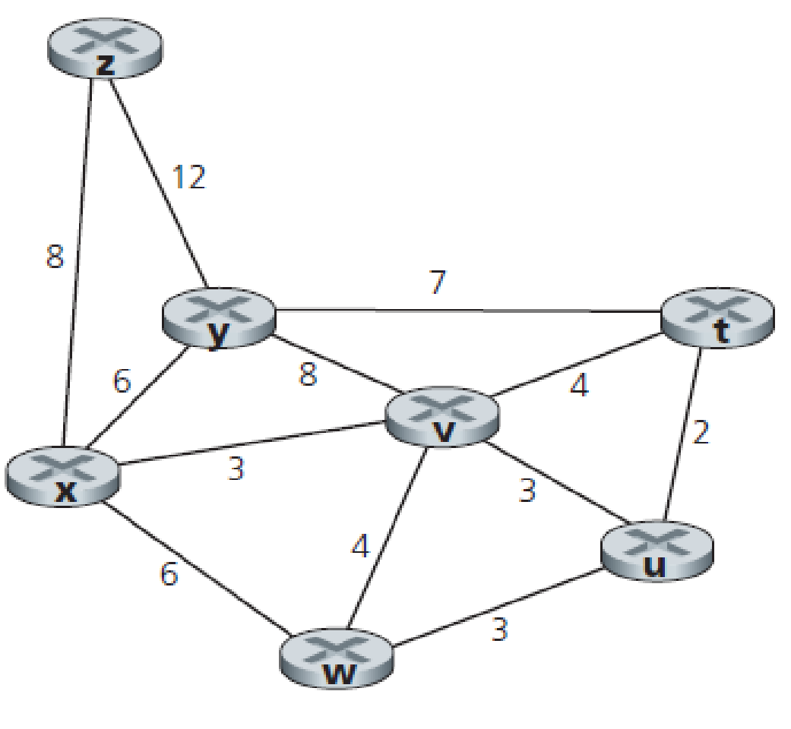  Figure 2: Network Topology |  |  | 8 | 4 | L3 | 3 | 2.2.2

Model Question Paper for End Semester Assessment (ESA)
Course Code: | 25ECAC220 | Course Title: Computer Network
Duration: | 3 Hours
Max. Marks | 100
Note: 1. Answer any five questions selecting 2 questions from UNIT-1 and UNIT-2 and 1
question from UNIT-3.
2. Each question carries equal marks.

UNIT – I
Q.No. | Questions | M | CO | BL | PO | PI Code
1a | How long does it take a packet of length 1,000 bytes to propagate over a link of distance 2,500 km, propagation speed 2.5 · 108 m/s, and transmission rate 2 Mbps?  Does this delay depend on packet length? Does this delay depend on transmission rate? | 6 | 1 | L3 | 2 | 2.2.2
1b | Differentiate between HTTP, HTTPS, SSL and SSH using a Clint server application as example. | 6 | 1 | L3 | 1 | 1.4.3
1c | Differentiate between TCP/IP and OSI architecture. Explain why layering is essential in computer networks? | 8 | 1 | L3 | 1 | 1.4.3
2a | Your organization is experiencing a sudden increase in DNS traffic, and the DNS server is struggling to handle the load. How would you address this issue. Justify | 6 | 1 | L3 | 2 | 2.2.2
2b | State weather following statements are true or false with proper justification  i. A user requests a Web page that consists of some text and three images. For this page, the client will send one request message and receive four response messages.  ii. HTTP response messages never have an empty message body. | 6 | 1 | L3 | 1 | 1.4.3
2c | The following is a dump of a UDP header in hexadecimal format.  0045DF000058FE20  - What is the source port number?  - What is the destination port number?  - What is the total length of the user datagram?  - What is the length of the data? | 8 | 2 | L3 | 2 | 2.2.2
3a | UDP is a message-oriented protocol. TCP is a byte-oriented protocol. If an application needs to protect the boundaries of its message, which protocol should be used, UDP or TCP? Why? Calculate the total time required to transfer a 1000Kb file in the following cases assuming an RTT of 50ms, a packet size of 1KB data and initial 2xRTT of handshaking before data is sent | 6 | 2 | L3 | 2 | 2.2.2
3b | Why do HTTP, FTP, SMTP, and POP3 run on top of TCP rather than on UDP? Justify your answer | 6 | 1 | L3 | 1 | 1.4.3
3c | Consider the TCP header. Every time a TCP segment is sent, it includes 4 unused bits. How does removing these bits, and shifting all subsequent fields four bits to the left, affect performance? | 8 | 2 | L3 | 2 | 2.2.2
UNIT – II
4a | Explain Multiplexing and Demultiplexing with relevant diagrams. | 6 | 3 | L2 | 1 | 1.4.3
4b | Consider the count-to-infinity problem in the distance vector routing. Will the count-to-infinity problem occur if we decrease the cost of a link? Why? How about if we connect two nodes which do not have a link?  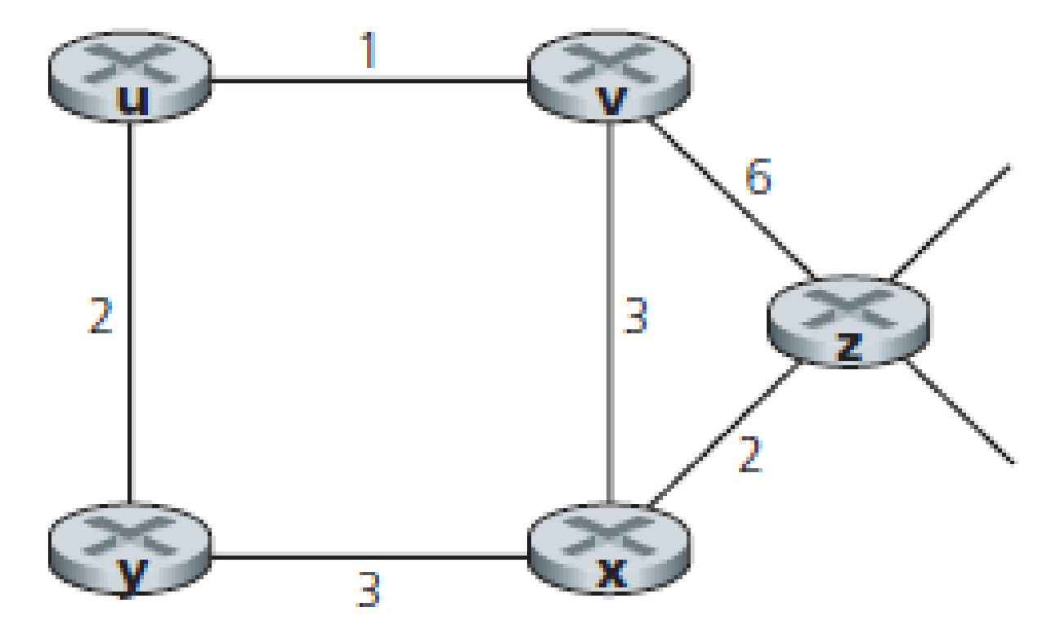 | 6 | 3 | L3 | 2 | 2.2.2
4c | What is IP addressing? Give the classification of classful addressing.  An Internet Service Provider(ISP) has the following chunk of CIDR-based IP addresses available with it:245.248.128.0/20. The ISP wants to give half of this chunk of addresses to organization X, and a quarter to Organization Y, while retaining the remaining with itself. Determine the valid allocation of addresses to X and Y? | 8 | 3 | L3 | 2 | 2.2.2
5a | What is the drawback of classful addressing? How it can be resolved.  An organization is granted the block 130.56.0.0/16. The administrator wants to create 1024 subnets.  - Find the subnet mask.  - Find the number of addresses in each subnet.  - Find the first and the last address in the first subnet.  - Find the first and the last address in the last subnet (subnet number: 1024). | 6 | 3 | L3 | 2 | 2.2.2
5b | Consider the network shown below, and assume that each node initially knows the costs to each of its neighbours. Consider the distance-vector algorithm and show the distance table entries at node z. | 6 | 3 | L3 | 2 | 2.2.2
5c | If ‘n’ is the number of sequence bits, explain with an example what happens if the window size is greater than 2^{(n-1)} . | 8 | 3 | L3 | 1 | 1.4.3
6a | What are the principles of congestion control? How the TCP will handle the congestion in the network. | 6 | 3 | L2 | 1 | 1.4.3
6b | A bit stream 10011101 is transmitted using the standard CRC method. The generator polynomial is x³ + 1. Show the actual bit string transmitted. Suppose the third bit from the left is inverted during transmission. Show that this error is detected at the receivers end. | 6 | 4 | L3 | 2 | 2.2.2
6c | Classless Inter-domain Routing (CIDR) receives a packet with address 131.23.151.76. The router’s routing table has the following entries:  Prefix Output Interface Identifier  131.16.0.0/12 3  131.28.0.0/14 5  131.19.0.0/16 2  131.22.0.0/15 1  Identify the output interface on which this packet will be forwarded. | 8 | 3 | L3 | 2 | 2.2.2
UNIT - III
7a | Suppose four active nodes—nodes A, B, C and D—are competing for access to a channel using slotted ALOHA. Assume each node has an infinite number of packets to send. Each node attempts to transmit in each slot with probability p. The first slot is numbered slot 1, the second slot is numbered slot 2, and so on.  i. What is the probability that node A succeeds for the first time in slot 5?  ii. What is the probability that some node (either A, B, C or D) succeeds in slot 4?  iii. What is the probability that the first success occurs in slot 3?  iv. What is the efficiency of this four-node system? | 6 | 4 | L3 | 2 | 2.2.2
7b | Imagine a scenario where two computers, A and B, attempt to transmit data simultaneously on an Ethernet network using CSMA/CD. Describe how CSMA/CD handles the collision and how the devices retransmit the data. | 6 | 4 | L3 | 2 | 2.2.2
7c | The frames generated by active users of a wireless channel follow Poisson’s distribution. If T represents the frame time and G represents the mean number of transmissions per frame time, what is the  I. Probability of k transmission attempts per frame time?  ii. When is the probability that 0 frames are generated in the collision duration in pure ALOHA?  iii. What is the throughput of the pure ALOHA?  iv. Determine the throughput if the channel is accessed using slotted ALOHA. | 8 | 4 | L3 | 2 | 2.2.2
8a | Describe the working of data center network with a hierarchical topology | 6 | 4 | L3 | 1 | 1.4.3
8b | Suppose that N switches supporting K VLAN groups are to be connected via a trunk protocol. How many ports are needed to connect the switches? Justify your answer | 6 | 4 | L3 | 1 | 1.4.3
8c | Discuss the structure of Ethernet frame with an example. | 8 | 4 | L3 | 1 | 1.4.3

