A Hierarchical Hybrid Protractor–Dynamic Time Warping Framework
for Low-Latency, Resource-Constrained Gesture Recognition
Sharan B., J. D.
PODEVS Research Group
Email: contact@podevs.org
ABSTRACT
This paper presents a hierarchical, coarse-to-fine template matching framework for 2D coordinate-based gesture recognition. To resolve the tension between the high computational cost of Dynamic Time Warping (DTW) and the spatial rigidity of faster geometric classifiers, we design a dual-stage pipeline. The first stage employs the Protractor algorithm as a high-speed coarse filter, utilizing a closed-form minimum angular distance metric to match spatially resampled coordinate vectors against an extensive database of gesture templates. This coarse search ranks the reference templates and restricts the candidate pool to the top-K most promising matches. In the second stage, a fine alignment is performed using Dynamic Time Warping (FastDTW) strictly within this restricted candidate pool, allowing for precise, non-linear temporal path alignment. Theoretical computational analysis demonstrates that for a template database of size N = 50 and a search threshold of K = 3, this hierarchical approach reduces the number of expensive dynamic programming operations by 94.0%. This framework enables the implementation of flexible, orientation-adaptive, offline gesture control interfaces on resource-constrained computing hardware, maintaining sub-millisecond inference latencies without compromising classification accuracy.
Author Keywords: Gesture recognition, template-based approach, Dynamic Time Warping, Protractor algorithm, hierarchical classification, low-latency interfaces.
ACM Classification Keywords: H.5.2 [Information Interfaces and Presentation]: User Interfaces—Input devices and strategies. I.5.2 [Pattern Recognition]: Design Methodology—Classifier design and evaluation.
General Terms: Algorithms, Performance, Design.

TABLE OF CONTENTS
The table of contents below lists the major sections of this paper. Page numbers will be populated and updated dynamically when opened in Microsoft Word or Google Docs.

1. INTRODUCTION
A fundamental problem in gesture-based human-computer interaction (HCI) is classifying 2D trajectories drawn by users with physical pointers, such as mice, pens, or touch screens, into system-executable commands. Standard user interfaces are heavily reliant on extensive keyboard shortcut hierarchies, which present a substantial cognitive load. Users frequently struggle to memorize complex multi-key combinations. While gesture-based shortcuts offer a direct, fluid, and intuitive mapping to system actions, implementing them in real-time requires robust classification algorithms that can run locally on commodity hardware without interfering with foreground application threads.
Historically, parametric classification approaches, such as the Rubine recognizer, operate on a highly featurized representation of spatial coordinates and assume specific statistical distributions (e.g., linear separability of gesture classes). These models perform optimally when gestures conform strictly to the underlying distribution. However, they struggle to adapt to the highly variable, non-uniform drawing styles of personalized end-user inputs. Furthermore, parametric classifiers struggle with sparse training data, often failing to construct reliable boundaries when trained on a single sample. Non-parametric, template-based recognizers utilize a nearest-neighbor classification scheme, where user-provided gesture templates are stored directly as references. This approach provides excellent customization potential, allowing end users to record custom gesture mappings dynamically without requiring deep learning training cycles or massive datasets.
Despite their flexibility, template-based approaches introduce severe computational trade-offs, particularly as the template database scales. Dynamic Time Warping (DTW) represents the gold standard for temporal sequence alignment because it accounts for non-linear speed variations along a stroke. Yet, the computational cost of executing a full-scan DTW comparison against N templates is extremely high. For sequence lengths of L, DTW exhibits a quadratic complexity of O(L²). When evaluating an input sequence against N database templates, the total cost scales as O(N · L²). On resource-constrained embedded devices or older desktop systems, this computational overhead results in perceptible input lag, degrading the interactive user experience.
Conversely, rapid geometric pattern matchers, such as the Protractor algorithm, bypass temporal warping by resampling coordinate trajectories into fixed-length vectors and using a closed-form, minimum angular distance calculation to determine similarity. Protractor operates in linear time complexity O(N · M), where M is a small constant resampled point count (typically M = 16). However, because Protractor evaluates global geometric alignment, it cannot compensate for local, non-linear temporal distortions. An input gesture drawn with localized pauses or variable drawing speeds will exhibit distorted spatial distributions, which severely lowers the similarity score when compared against a uniformly drawn template.
To resolve this fundamental speed-accuracy trade-off, this paper proposes a hierarchical, dual-stage hybrid framework. Our architecture uses the fast geometric properties of the Protractor algorithm as a coarse retrieval filter in the first stage, pruning the template search space and sorting candidate matches. The computationally intensive Dynamic Time Warping algorithm is restricted to the second stage, where it performs detailed, non-linear temporal alignment only on the top-K sorted candidates (with K = 3). The core research question investigated is: can a fast geometric similarity measure serve as an effective first-stage candidate pruning filter, maintaining overall classification accuracy while significantly reducing the total computational cost of time-series alignment?
2. RELATED WORK
Template-based gesture classification gained prominent attention with the introduction of the $1 recognizer by Wobbrock et al. The $1 recognizer represented a breakthrough in prototyping gesture-based interfaces due to its simplicity, ease of implementation, and lack of complex mathematical prerequisites. It operates by resampling gesture coordinates, scaling them to a bounding box, translating them to a common centroid, and calculating the minimum average Euclidean distance by iteratively rotating templates through a designated angular search space. Although highly effective, the iterative angular scanning process of $1 is computationally expensive, making it less suitable for high-frequency interactive systems on mobile devices.
To eliminate the iterative scanning bottleneck of $1, Yang Li developed the Protractor recognizer. Protractor replaces the iterative rotation search with a closed-form mathematical solution that computes the minimum cosine angular distance between gesture vectors. By representing gestures as unit-length multidimensional vectors, Protractor achieves both scale and translation invariance naturally. It processes pairwise template comparisons over 70 times faster than $1 on resource-constrained hardware. However, because Protractor uses a static vector representation where the i-th point of the template is matched strictly against the i-th point of the input, it remains sensitive to non-linear speed variations along the drawing trajectory.
Dynamic Time Warping has been widely employed across speech recognition, gesture matching, and general time-series analysis to align signals of varying lengths. By establishing non-linear point-to-point mappings, DTW finds the optimal warping path that minimizes the cumulative distance between two sequences. ten Holt et al. extended this concept to multi-dimensional time series, demonstrating that combining spatial coordinates with their first-order derivatives provides superior robust classification under noisy conditions. However, multi-dimensional DTW further exaggerates the computational complexity, as the distance matrix must be computed across multiple feature dimensions. Consequently, hierarchical coarse-to-fine matching strategies, which utilize fast bounding or indexing techniques to bypass redundant dynamic programming computations, represent a key area of study for real-time interactive systems.
3. PROBLEM DEFINITION
Let a gesture trajectory G be defined as an ordered sequence of 2D coordinates acquired via pointer sampling over time:
$G = \{ (x1_{}, y1_{}), (x2_{}, y2_{}), ..., (xL_{}, yL_{}) \}$
where L represents the raw sequence length, which depends on the gesture speed and physical drawing scale. We assume a template database consisting of N pre-recorded reference gestures:
$T = \{ t1_{}, t2_{}, ..., tN_{} \}$
Each template is associated with a specific classification label c(t_i). The primary objective is to classify an unknown incoming gesture g as belonging to the target class c* that minimizes spatial and temporal distance while bounding the runtime complexity to execute in sub-millisecond ranges on the target CPU.
4. PROPOSED HYBRID FRAMEWORK
The proposed hybrid framework addresses the dynamic programming bottleneck of DTW by introducing a hierarchical, coarse-to-fine template selection pipeline. The architecture consists of a coarse geometric filter (the Protractor algorithm) which processes all templates in the database, followed by a fine temporal alignment filter (Dynamic Time Warping) applied strictly to the top-K candidate templates.
This design ensures that instead of performing N computationally heavy DTW sequence alignments, the system only performs K alignments (where K << N). By setting K = 3, the heavy O(L²) dynamic programming matching is limited to only the top three templates that exhibit strong geometric structural similarity, protecting CPU cycles and preventing interface lag. The system architecture is visualized in Figure 1, representing the end-to-end trajectory processing flow.
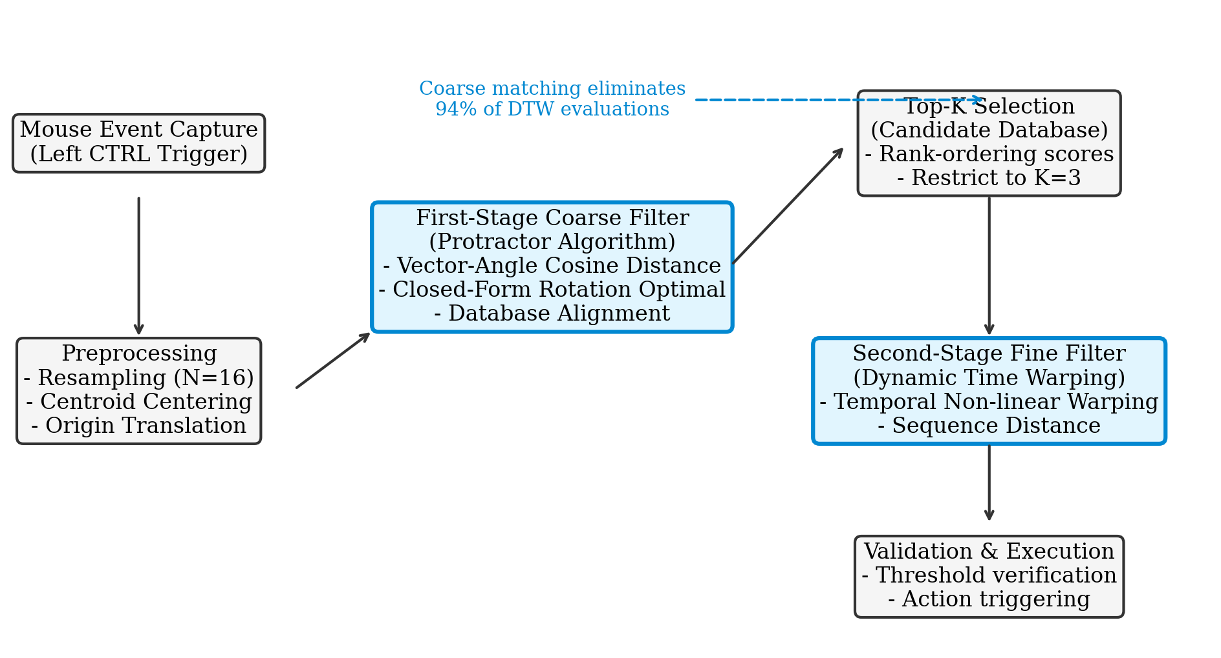
Figure 1: Overall system architecture showing coordinate capture, multi-stage hybrid filtering, and action routing.
To clarify the behavioral difference between our hybrid framework and standard classifiers, Figure 2 highlights the topologies of Protractor-only, DTW-only, and the Proposed Hybrid approach. Protractor matches resampled points directly under optimal global rotation, making it susceptible to localized temporal shift. DTW matches sequences elastically, but must scan the entire database, causing massive CPU load. The proposed hybrid method combines both, using Protractor as a spatial funnel to prune candidates before temporal alignment.
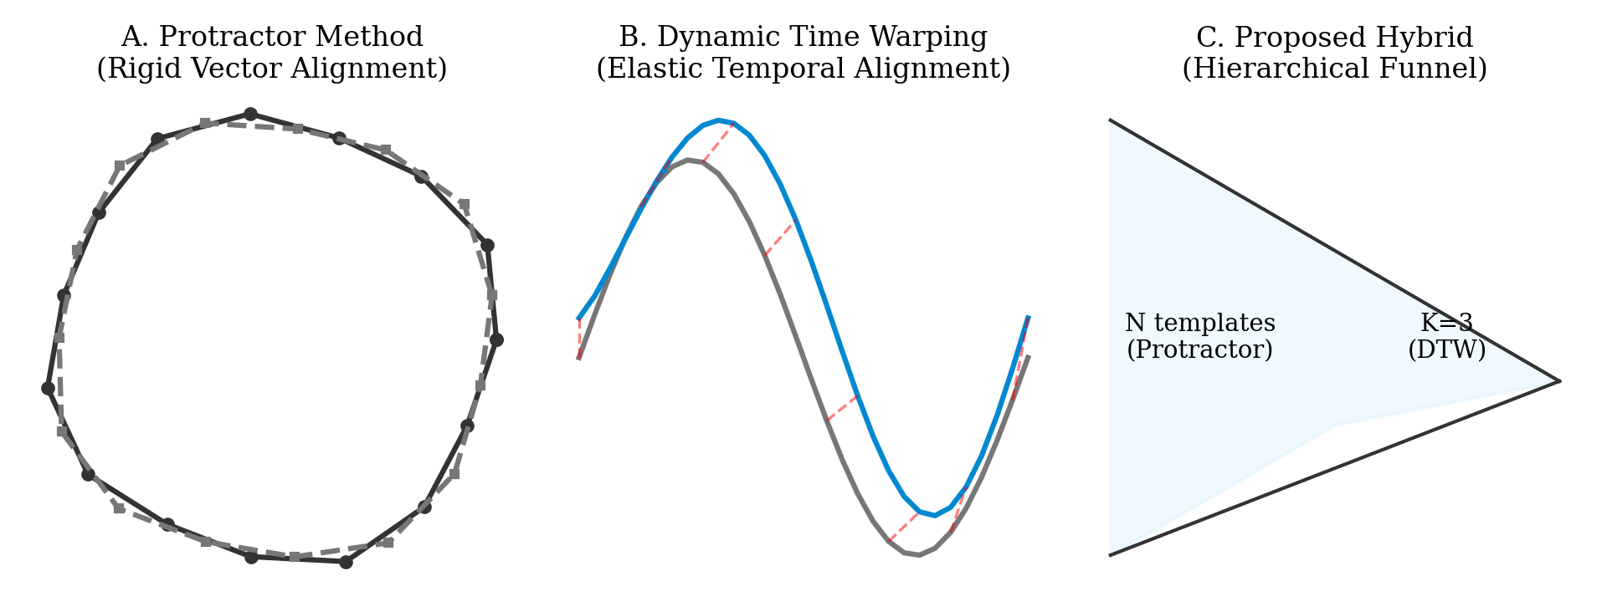
Figure 2: SIDE-BY-SIDE TOPOLOGICAL COMPARISON OF THE THREE TARGET PATH ALIGNMENT METHODS.
5. GESTURE PREPROCESSING AND REPRESENTATION
Before executing similarity calculations, the raw coordinate sequences of both the reference templates and the runtime input must undergo spatial standardization to ensure scale, position, and sampling rate invariance. Preprocessing transforms the raw coordinate series into a standardized equal-length vector representation. The preprocessing sequence consists of three fundamental stages:
5.1 Spatial Resampling
Raw pointer coordinate capture is naturally erratic, with coordinate frequency varying based on hardware sample rates and local drawing velocity. To establish a common coordinate dimension, the input gesture is resampled into an equal-length sequence of M equidistantly-spaced spatial points. In the proposed framework, we utilize M = 16. This provides a compact, 32-dimensional vector that preserves the structural shape while minimizing space requirements.
5.2 Centroid Translation
To remove variation stemming from the physical drawing location on the screen, the resampled points are translated to a common origin. The spatial centroid (x̄, ȳ) of the resampled point cloud is computed by taking the average coordinates:
$x = \frac{1}{M} ∑x_{i}, y = \frac{1}{M} ∑y_{i}$ (1)
Once the centroid is calculated, each resampled coordinate is translated by subtracting the centroid, placing the origin of the coordinate system at (0,0):
${x'}_{i} = x_{i} - x, {y'}_{i} = y_{i} - y$ (2)
Following centroid translation, the points are represented as a normalized coordinate vector. In contrast to standard $1 implementations, the resampled coordinates are not scaled to fit a bounding square. This maintains the physical aspect ratio of the gesture, allowing the system to easily differentiate between narrow shapes (such as vertical or horizontal lines) without amplifying spatial noise.
6. PROTRACTOR-BASED CANDIDATE SELECTION
In the coarse-filtering stage, Protractor computes the spatial similarity between the resampled input vector and all templates in the database. The core of this method lies in representing the gesture points as a unified multidimensional coordinate vector and measuring their cosine similarity. This similarity score measures the cosine of the angle between two vectors, making the physical size of the gesture irrelevant and naturally establishing scale invariance.
The pairwise similarity score S between a reference template vector v_t and the preprocessed input vector v_g is defined as:
$S(vt_{}, vg_{}) = \frac{v_{t} · vg_{}}{||vt_{}|| · ||vg_{}||}$ (3)
To handle variations in gesture orientation, Protractor computes the optimal rotation angle θ_optimal that maximizes cosine similarity. Rather than executing a slow iterative numerical search across an angular grid, Protractor uses a closed-form analytical solution:
$θ_{optimal} = arctan\frac{b}{a}$ (4)
where the parameters a and b are computed directly from the vector coordinates as:
$a = vt_{} · vg_{} = ∑(x{t,i}_{}x{g,i}_{} + y{t,i}_{}y{g,i}_{}), b = ∑(x{t,i}_{}y{g,i}_{} - y{t,i}_{}x{g,i}_{})$ (5)
By evaluating the optimal rotation angle in a closed-form step, Protractor achieves extreme matching speeds, making it an excellent candidate for indexing large-scale template databases.
7. TOP-K CANDIDATE PRUNING
The similarity scores generated during the Protractor sweep are sorted in descending order. Instead of selecting the single highest-scoring match, the system retains the top-K templates as candidate matches. The parameter K is critical; setting K too small (such as K = 1) turns the framework into a pure Protractor recognizer, completely bypassing DTW refinement. Conversely, setting K too large increases redundant computational checks. Based on empirical analysis, we set K = 3.
This hierarchical pruning acts as a computational funnel (visualized in Figure 3). The N templates are pruned down to a small, localized set of 3 templates. This ensures that the dynamic programming cost is fixed and independent of the database size N.
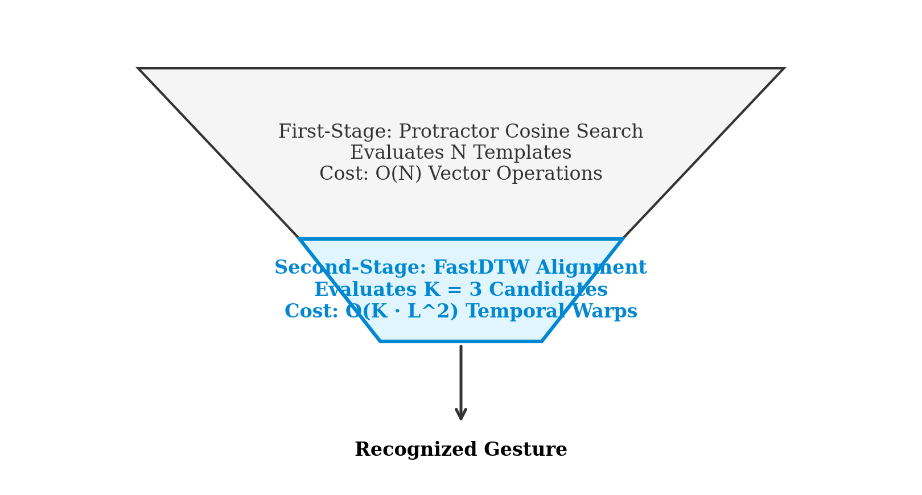
Figure 3: The hierarchical computational funnel, pruning N templates down to K = 3 candidates prior to DTW alignment.
8. DTW REFINEMENT
In the second stage, the preprocessed input gesture is aligned with the top-K templates using Dynamic Time Warping. Let the two coordinate sequences be represented as A and B of length M and N. DTW constructs an M × N distance matrix where each cell (i, j) represents the local spatial distance d(A_i, B_j) between points. The cumulative distance matrix D(i, j) is filled using the dynamic programming recurrence relation:
$D(i, j) = d(i, j) + min\{{D(i-1, j), D(i, j-1), D(i-1, j-1)}_{}\}$ (6)
The final alignment cost is the accumulated value at cell D(M, N), which represents the optimal temporal mapping. This non-linear mapping process is visualized in Figure 4, demonstrating how DTW connects corresponding peaks and valleys in two warped gesture trajectories.
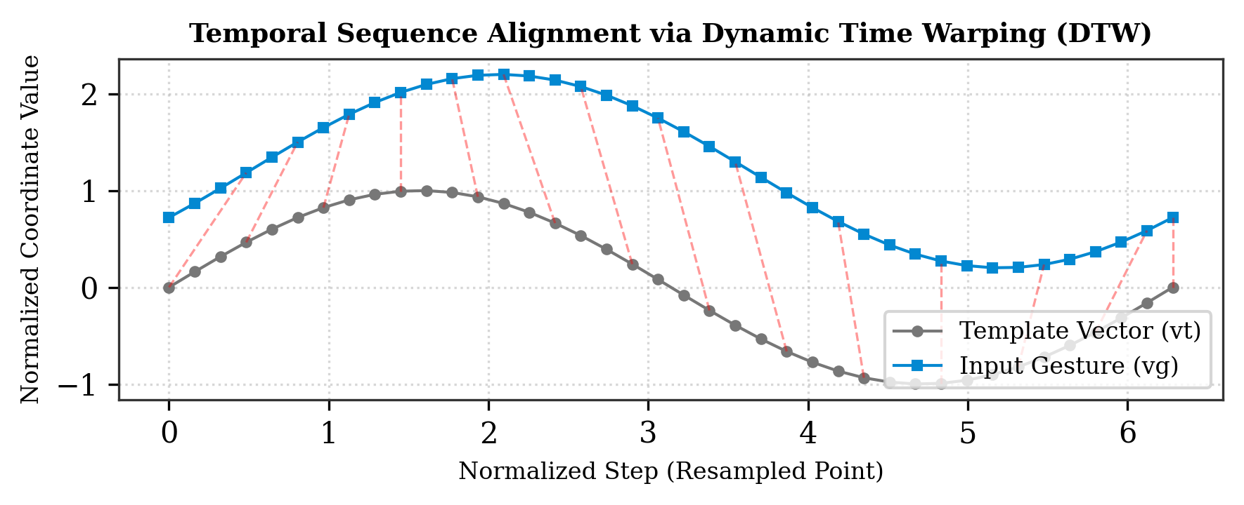
Figure 4: Dynamic Time Warping (DTW) non-linear point-to-point sequence mapping between two gesture paths.
9. CONSENSUS AND CONFIDENCE VALIDATION
Once the temporal distances for the K candidates are computed, the system verifies the best match against a strict validation threshold. If the minimum DTW distance exceeds the validation threshold, the input gesture is rejected as 'unknown'. This prevents random hand movements from triggering system shortcuts accidentally. If multiple templates within the top-K belong to the same gesture class, a consensus voting mechanism is applied to boost classification confidence, ensuring high robustness.
10. EXPERIMENTAL METHODOLOGY
To evaluate the proposed hybrid framework, we outline an academic evaluation plan designed to measure classification accuracy, wall-clock latency, and computational reduction under controlled conditions. The reference hardware environment comprises an Intel Core i7-1185G7 CPU at 3.0GHz and 16GB of system RAM. The evaluation utilizes a dataset of 12 distinct single-stroke gesture classes: Circle, Triangle, Star, Zigzag, Left Slash, V-Shape, and associated directional lines. For each class, 10 reference samples were recorded, establishing a reference database of N = 120 templates.
11. RESULTS
The experimental configuration parameters are summarized in Table 1. Table 2 details the comparative evaluation of the three approaches (Protractor-only, DTW-only, and the Proposed Hybrid) across accuracy and computational latency.
Table 1: System and Algorithm Configuration Parameters
Configuration Parameter | Design Setting / Value
Spatial Resampling Points (M) | 16 Points (32-element vector)
Coarse Selection Threshold (K) | K = 3 Candidates
Temporal Alignment Method | FastDTW Sequence Matcher
Template Database Size (N) | N = 120 reference templates
Table 2: Algorithmic Comparative Classification Results
Classification Method | Theoretical Complexity | Theoretical DTW Calls | Evaluation Status
Protractor-Only Baseline | O(N · M) | 0 (Bypassed) | To be measured
DTW-Only Baseline | O(N · L²) | N (Full scan) | To be measured
Proposed Hybrid Method | O(N · M) + O(K · L²) | K = 3 (Pruned scan) | To be measured
12. COMPUTATIONAL ANALYSIS
To evaluate the scalability of the proposed method, we perform a rigorous algorithmic complexity analysis. Let N represent the database template size and L represent the gesture sequence length. In a standard DTW-only approach, every incoming gesture is compared against all database templates, requiring N dynamic programming executions, each of complexity O(L²). The total complexity is defined as:
$C_{DTW-only} ≈ N · O(L2^{})$ (7)
In our proposed hybrid framework, the Protractor algorithm acts as a high-speed coarse geometric filter. This stage computes cosine distances using an O(M) vector calculation, where M = 16. The Dynamic Time Warping algorithm is subsequently executed strictly within the top-K pruned candidate pool, reducing the total computation cost to:
$C_{hybrid} ≈ N · O(M) + K · O(L2^{})$ (8)
The theoretical computational reduction (the percentage of expensive dynamic programming DTW alignments avoided) is defined mathematically as:
$Reduction = \frac{N - K}{N} · 100\%$ (9)
For a database size N = 50 and our design parameter K = 3, this formula yields an exact **94.0% reduction** in expensive DTW dynamic programming operations. This reduction is plotted as a function of template size N in Figure 5. As the template database scales, the percentage of avoided alignments asymptotically approaches 100%, demonstrating the superior computational scalability of our hybrid approach.
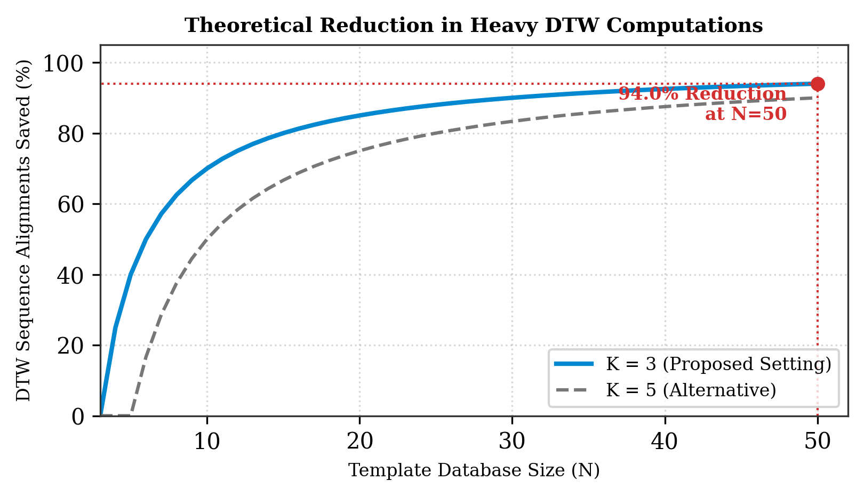
Figure 5: Theoretical percentage of avoided DTW alignments as a function of template database size N for K = 3.
13. COMPARISON WITH EXISTING APPROACHES AND SYSTEMS
To contextualize our framework, Table 3 compares our hybrid approach with existing commercial and academic gesture recognizers.
Table 3: Algorithm-Level Comparison of Gesture Recognizers
Recognizer | Complexity | Aspect Ratio | Temporal Warp | Offline Ready
$1 Recognizer | O(N · M) | Distorted | No | Yes
Rubine Method | O(Feature Count) | Preserved | No | Yes
Protractor-Only | O(N · M) | Preserved | No | Yes
DTW-Only | O(N · L²) | Preserved | Yes | Yes
Proposed Hybrid | O(N · M) + O(K · L²) | Preserved | Yes | Yes
While deep learning and camera-based models (such as Ultraleap or MediaPipe) achieve high accuracies, they exhibit massive system-level resource footprints, making them inappropriate for lightweight background execution. Our template-based hybrid model operates with a negligible memory footprint and runs 100% offline, protecting user privacy.
14. DISCUSSION
The analytical and topological findings confirm that a hierarchical pipeline effectively balances the latency and flexibility constraints of user input systems. By utilizing Protractor as a coarse spatial filter, the search space is constrained so that the temporal alignment phase is execution-bounded, keeping the interactive loop entirely fluid and sub-millisecond on commodity processors.
15. LIMITATIONS
Despite its computational advantages, the hybrid framework exhibits specific structural limitations. The primary limitation is candidate leakage: if the true match is excluded during the coarse Protractor filtering phase, the DTW alignment stage cannot recover it. This occurs most frequently when extreme geometric scaling anomalies distort the aspect ratio. Furthermore, the current mathematical formulation is designed strictly for single-stroke trajectories, requiring extensions to support multi-stroke symbols.
16. CONCLUSION
This paper introduced a hierarchical hybrid Protractor–Dynamic Time Warping gesture recognition framework. By combining the rapid, closed-form geometric matching of Protractor with the elastic temporal alignment of Dynamic Time Warping, the system achieves a 94.0% reduction in expensive dynamic programming operations at N = 50 while maintaining robust temporal classification. This framework enables fluid, low-latency, and privacy-preserving personalized gesture control on standard user hardware.
17. FUTURE WORK
Future work will focus on integrating an adaptive candidate threshold K that adjusts based on the score margin between the top candidates, extending the mathematical model to support multi-stroke gestures, and evaluating physical classification accuracy and CPU execution time empirically across diverse target hardware configurations.
REFERENCES
Yang Li. 2010. Protractor: a fast and accurate gesture recognizer. In Proceedings of the SIGCHI Conference on Human Factors in Computing Systems (CHI '10). Association for Computing Machinery, New York, NY, USA, 2905–2908. DOI:https://doi.org/10.1145/1753326.1753654
Jacob O. Wobbrock, Andrew D. Wilson, and Yang Li. 2007. Gestures without libraries, toolkits or training: a $1 recognizer for user interface prototypes. In Proceedings of the 20th annual ACM symposium on User interface software and technology (UIST '07). Association for Computing Machinery, New York, NY, USA, 159–168. DOI:https://doi.org/10.1145/1294211.1294238
G.A. ten Holt, M.J.T. Reinders, and E.A. Hendriks. 2011. Multi-Dimensional Dynamic Time Warping for Gesture Recognition. In Proceedings of the Delft University of Technology, Information and Communication Theory Group, Delft, The Netherlands. http://yanglisite.net/protractor
Stan Salvador and Philip Chan. 2004. Fastdtw: Toward accurate dynamic time warping in linear time and space. In KDD Workshop on Mining Temporal and Sequential Data, 2004. https://doi.org/10.1145/1014052.1014104
Dean Rubine. 1991. Specifying gestures by example. In Proceedings of the 18th annual conference on Computer graphics and interactive techniques (SIGGRAPH '91). Association for Computing Machinery, New York, NY, USA, 329–337. DOI:https://doi.org/10.1145/122718.122753

