Project management system
Software Requirements Specification
Version <1.0>

Revision History
Date | Version | Description | Author
<04/13/07> | <1.0> | SRS 1.0 | Group-2

Table of Contents
1. Introduction 4
1.1 Purpose 4
1.2 Scope 4
1.3 Definitions, Acronyms, and Abbreviations 4
1.4 References Error! Bookmark not defined.
1.5 Overview 4
2. Overall Description 4
3. Specific Requirements 4
3.1 Functionality 5
3.1.1 Admin 5
3.1.1.1 Add admin 5
3.1.1.2 Admin log-in 5
3.1.1.3 Resources allocated to project 5
3.1.1.4 Close project 5
3.1.2 Project 5
3.1.2.1 Add project 5
3.1.2.2 Search project 6
3.1.2.3 Update project 6
3.1.2.4 Edit project 6
3.1.2.5 Remove project 6
3.1.3 Employee 6
3.1.3.1 Add employee 6
3.1.3.2 Search employee 7
3.1.3.3 Update employee 7
3.1.3.4 Edit employee 7
3.1.3.5 Remove employee 7
3.1.3.6 Employee log-in 7
3.2 USER CHARACTERSTICS 8
3.3 FLOW DIAGRAM 9
3.4 USE CASE MODEL DESCRIPTION 10
3.5 USE CASE DIAGRAM 11
3.6 CLASS DIAGRAM 12
3.7 SEQUENTIAL DIAGRAM 13

4. Supporting Information 14

5. Conclusion 14

6. Valgrind-memory 14

7. Gdb compilation 15

8. G profile 16

9. Splint 18

Software Requirements Specification

Introduction

Purpose:

The purpose of the project is to maintain the details of projects, employees and admin. The main purpose of this project is to maintain an easy circulation system between admin and the employees, resources allocated to the project, close the project, also to search the employees for project allocation and to maintain details about the admin, employee and project. (Id, password, name).

Scope:

The Project Management System addresses the management of software projects. It provides the framework for organizing and managing resources in such a way that these resources deliver all the work required to complete a software project within defined scope, time and cost constraints.

The e Integrated Project Management System provides information's like details of the projects, resources allocated to new projects, close projects.

Overview:

The remaining sections of this document provide a general description, including characteristics of the users of this project, the product's hardware, and the functional and data requirements of the product. General description of the project is discussed in section 2 of this document. Section 3 gives the functional requirements, data requirements. It also gives the admin viewpoint of project. Section 3 also gives the specific requirements of the project. Section 3 also discusses the external interface requirements and gives detailed description of functional requirements. Section 4 is for supporting information.

Overall Description:

An Employee project management system is software that is designed to manage Resources allocation to project and deallocation. It helps admin to maintain the database of new project, current running projects and closed projects. This system completely automates all your projects activities.

The SRS will provide a detailed description of the Employee project management system. This document will provide the outline of the requirements, overview of the characteristics and constraints of the system. This section of the SRS will provide the general factors that affect the product and its requirements.

Specific Requirements

The specific requirements are –

Functionality:

Admin:

Add admin:
. Input: Enter the details of the admin such as names ,password ,Id
. Output: confirmation of admin adding
. Processing: All details will be checked and if any error are found then an error
message is displayed else admin name ,password ,Id will be generated

Admin log-in:
. Input: Enter the admin id and password
. Output: Admin will be able to use the features of software.

Resources allocated to project:
. State: Searched the project and employee admin wants to Resources allocation
. Input: Click the project and employee admin wants
. Output: conformation for Resources allocation.
. Processing: if selected project and employee is available Resources allocated then
else error will be displayed.

Close project:
. State: Searched the project admin wants to Resources deallocation
. Input: Click the project admin wants
. Output: conformation for Resources deallocation.
. Processing: if selected project is available Resources deallocated then
else error will be displayed.

Project:

Add project:
. Input: Enter the details of the project such as name, start date, end date, no of
resources required.
. Output: confirmation of adding the project.

Search project:
. Input: Searched the projects admin wants
. Output: List of projects
. Processing: if projects are available display the projects then else error will be
displayed

Update project:
. State: Searched the project admin wants to update.
. Input: click the project admin wants.
. Output: conformation for project update.
. Processing: if selected project is available then project will be update else error will be
displayed.

Edit project:
. State: Searched the project admin wants to edit.
. Input: click the project admin wants.
. Output: conformation for project edit.
. Processing: if selected project is available then project will be edit else error will be
displayed.

Remove project:
. State: Searched the project admin wants to remove.
. Input: click the project admin wants.
. Output: Conformations for project remove.
. Processing: if selected project is available then project will be removing else error will
be displayed.

Employee:

Add employee:
. Input: Enter the details of the employee such as name, password, gander, basic
salary required.
. Output: confirmation of adding the project.

Search employee:
. Input: Searched the employees admin wants
. Output: List of employee.
. Processing: if employees are available display the employees then else error will be
displayed.

Update employee:
. State: Searched the employee admin wants to update.
. Input: click the employee admin wants.
. Output: conformation for employee update.
. Processing: if selected employee is available then employee will be update else error
will be displayed.

Edit employee:
. State: employee log-in
. Input: click the edit employee name or password.
. Output: conformation for employee edit.
. Processing: if selected employee is available then employee will be edit else error will
be displayed.

Remove employee:
. State: Searched the employee admin wants to remove.
. Input: click the employee for remove.
. Output: Conformation for employee removes.
. Processing: if selected employee is available then employee will be removing else error
will be displayed.

Employee log-in:
. Input: Enter the employee id and password
. Output: Employee will be able to use the features of software.

USER CHARACTERSTICS

We have 2 levels of users:
. Admin:
. Add new project
. Update project
. Resource allocated for project
. Close project
. Employee:
. Add new employee
. Remove employee
. Edit employee details
. Read employee details

FLOW DIAGRAM

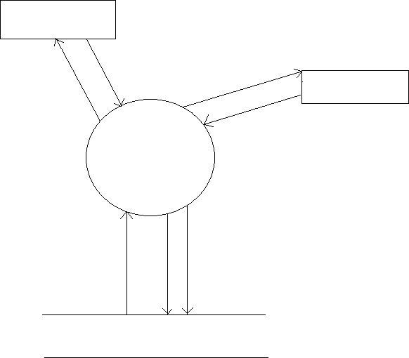
Employees
login
add employee, update, delete
login
Admin
Add project, project allocation, close project
Project Management
System
DATABASE

3.4 USE CASE MODEL DESCRIPTION
Use Case selection | Description
Use Case name | Add admin and employee record
Level | Sub-Functional level
Primary actor | Admin, employee
Stakeholders and interest | Employee: wants to register into the system.  Admin: responsible for the management of the project allocation and deallocation and also login and register details.
condition | Record for a admin/employee has been added.
Main success scenario | - Admin/employee opens the application to access the services of the EPMS  - Admin/employee sign-up to get registered online.  - She/he provides correct information and secret password.  - She/he got registered.
Alternative flow | 1 Admin/employee opens the application  2 She/he tries to sign-up  - She/he fails and receives an error  - She/he will report an error and the error will be rectified as soon as possible.

USE CASE DIAGRAM
Admin
Employee

login

Add Admin

Add Employee

Add Project

Allocated Project

View All Allocated Project

Edit Details

Deallocate Project

Delete Employee

3.6 CLASS DIAGRAM

Project
+project id
+project name
+noofemployess required
+Project start date
+Project end date
+Project noof employess required
+Project Status
+create project()
+Project close()
+Add project()
+Delete project()
+Edit project()
+Readbyid()

Employee
+Employee id

+Employee name

+Employee pwd

+Employee Gender

+Employee Basic salary

+TotalAllocation percentage[100]

+Employee Bonus

+Employee Status

+Employee noofProjects
+create user()
+Add emp()
+Delete emp()
+Edit emp()
+Readbyid()

Project Allocation
+Employee id

+Project id

+Allocation start date

+Employee Gender

+Allocation end date

+Employee Basic salary

+Allocation role

+Allocation Percentage
+create allocation()
+Add allocation()
+Delete allocation()
+Edit allocation()
+Readbyid()

Administrator
+Admin Name

+Admin id

+Admin password
+create admin()
+Add admin()
+Delete admin()
+Edit admin()
+Readbyid()

3.7 SEQUENTIAL DIAGRAM
:Employee
:Allocation
:project
admin login
Admin
Employee Add
Allocation Employee(max of 3projects or it shld be100% allocation)
Add Project
login Employee
view details
view project Details
close project

:login

Supporting Information

Please refer the following document:
- Project management system ppt.
- High level design document.
- Low level design document.
- Test case document.

5. Conclusion

The application created and tested all possible cases successful .The purpose of an employee project management system is to manage & track the daily work of the project such as add project, resources allocated to project resources deallocated to project, etc.

6. valgrind-memory

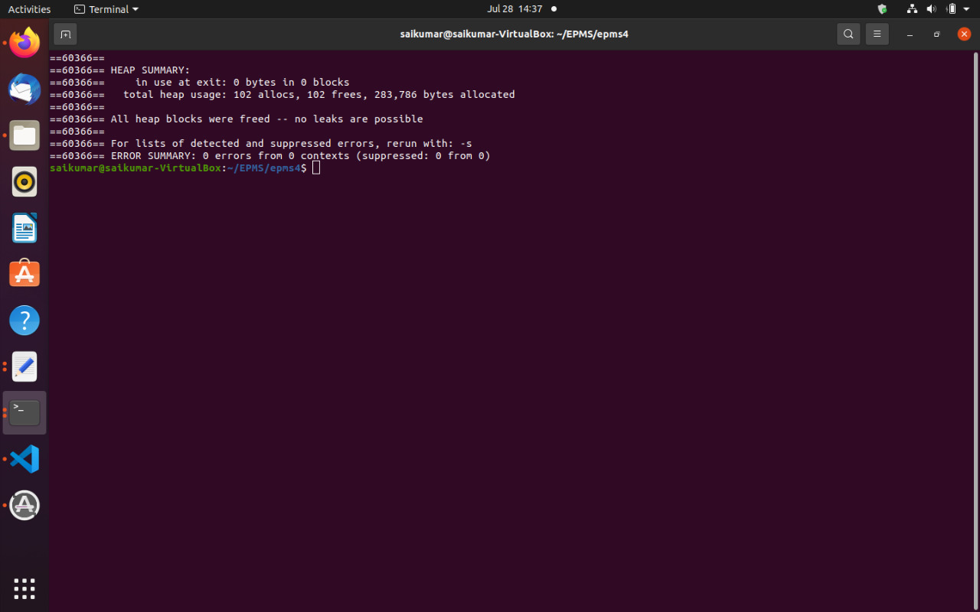

7. Gdb compilation

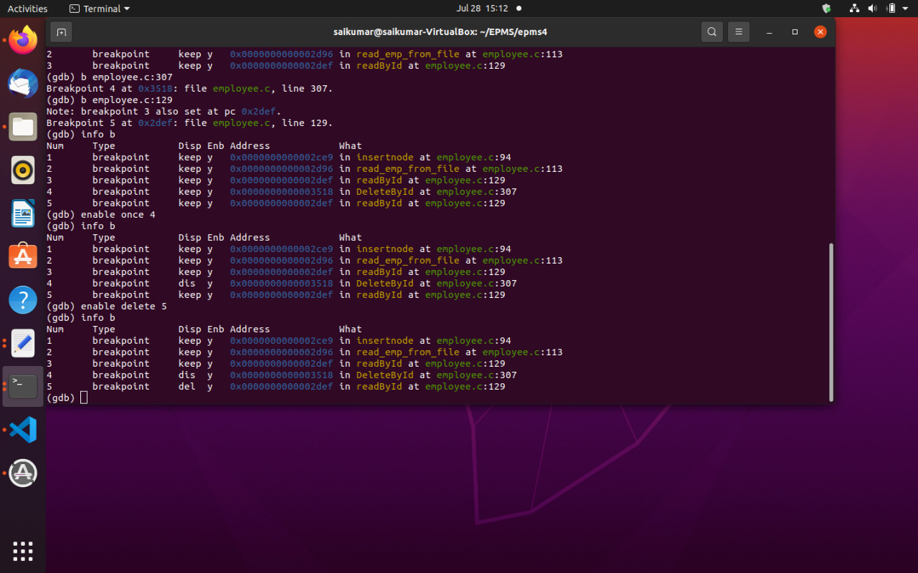

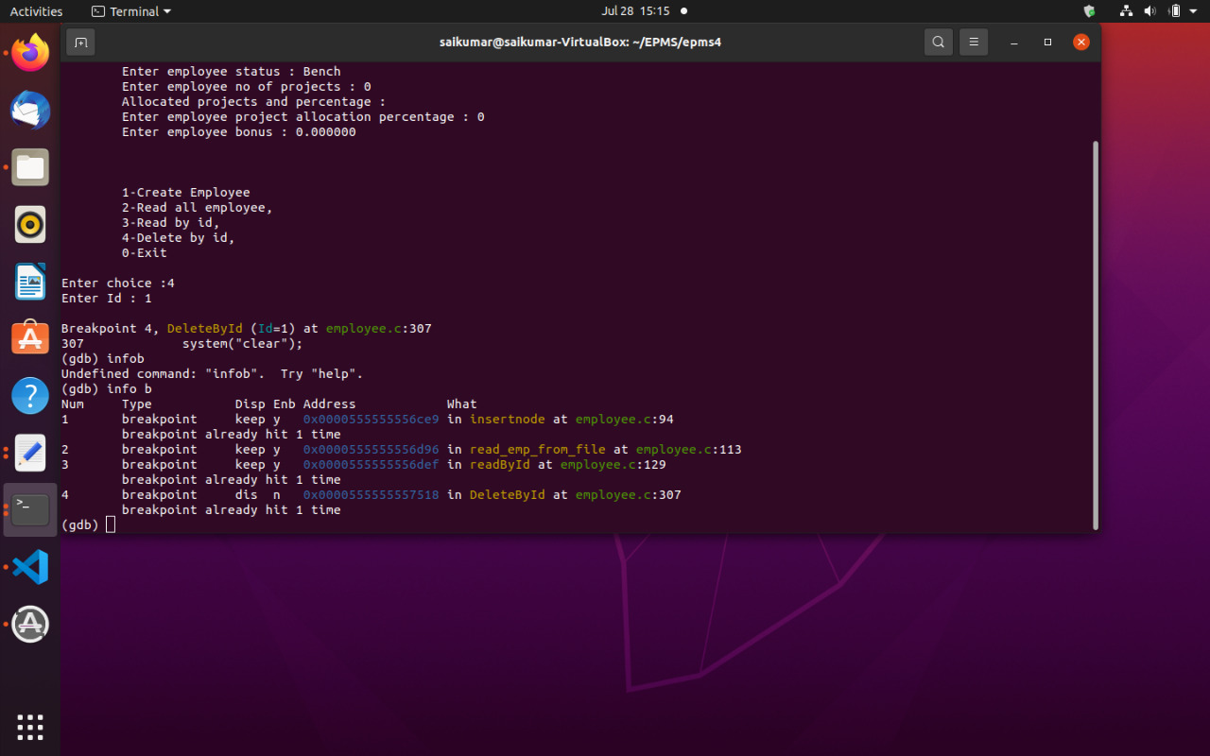
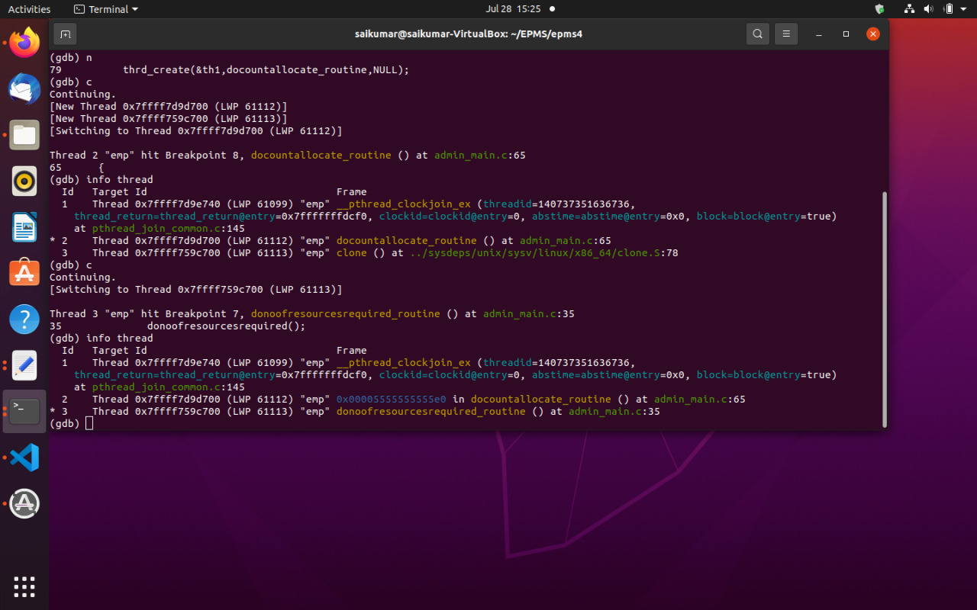

8. G profile

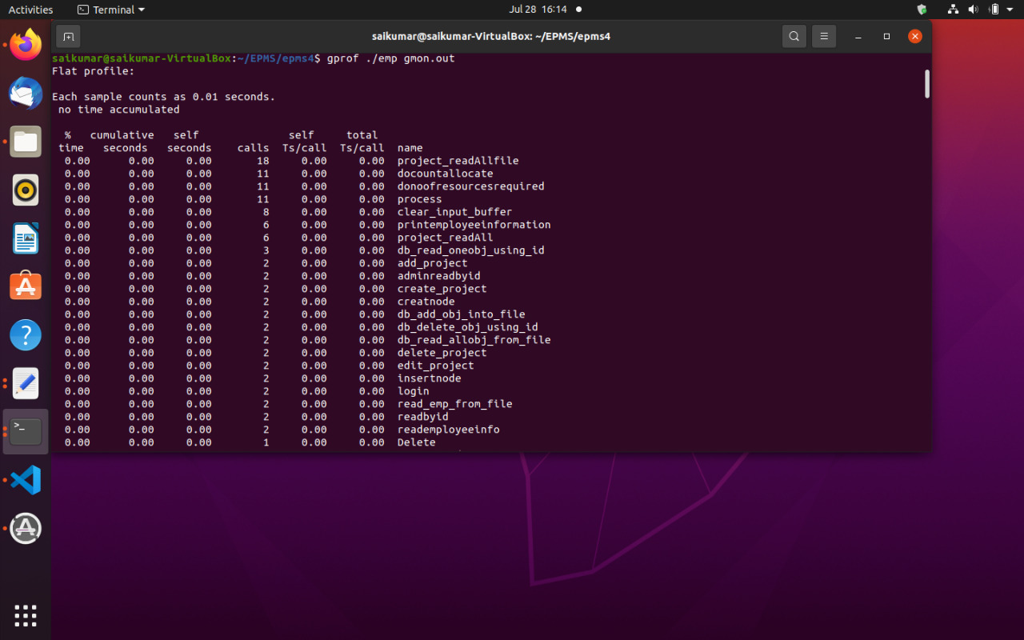
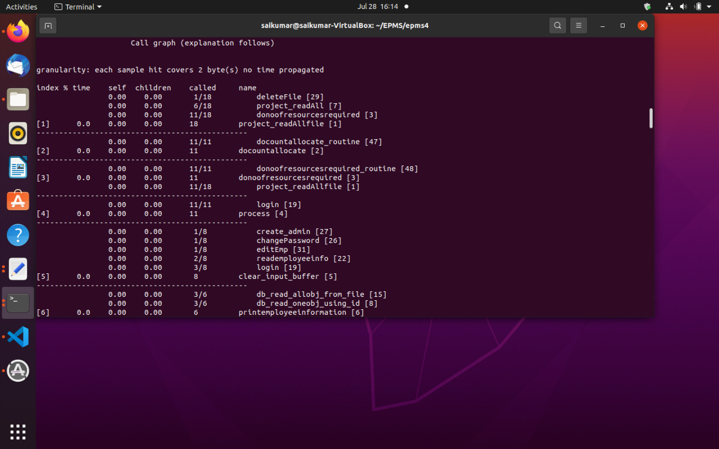

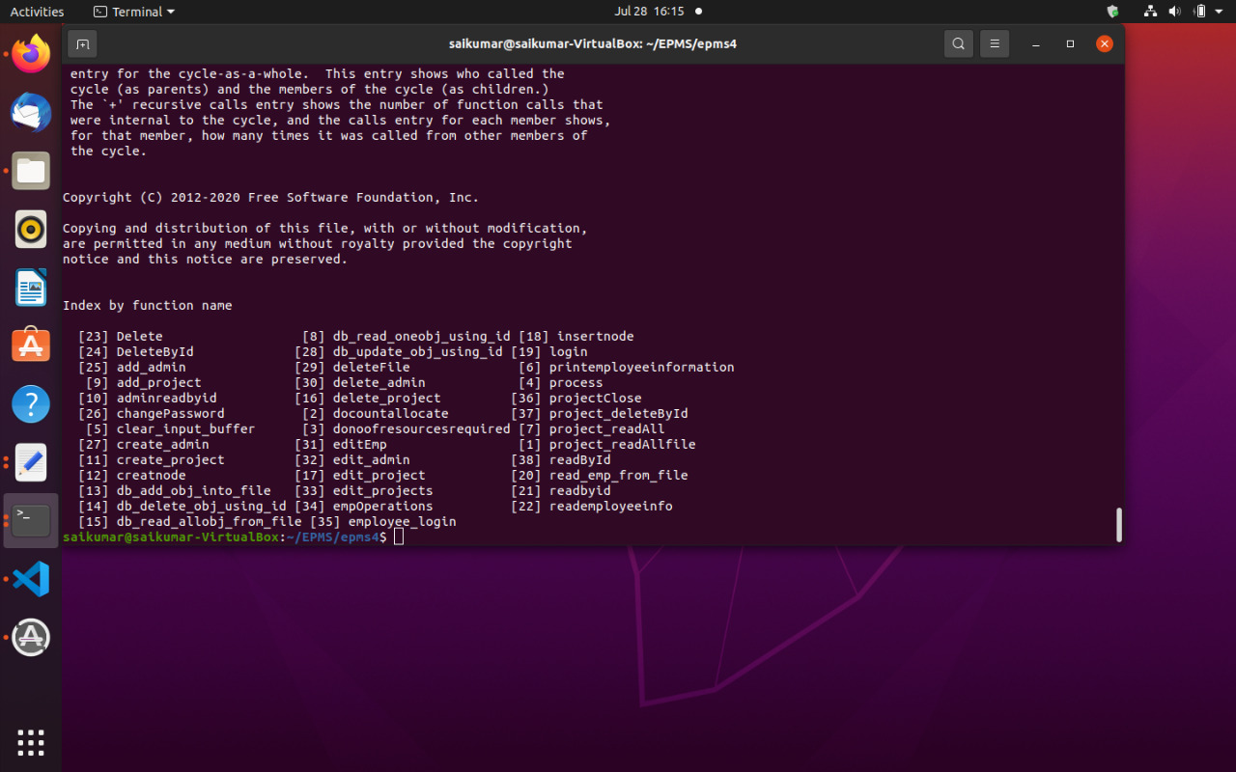
9. Splint

