Low Level Design Document

PROJECT MANAGEMENT SYSTEM

1. Introduction

1.1 Purpose:

The Project Management system helps in maintaining data of employee and projects. This helps admin to spot any particular project and employee details at any given time. The ERP for Project Management systems can be easily customized as per individuals' requirements.

Here are the top use cases of the Project Management System: Add/Remove/Edit projects: To add, remove or modify a project or project item. Add/Remove/Edit employee: To add, remove or modify an employee or employee item. Project allocation and close project: to allocate employees to project and deallocate employees from projects.

## **1.2** **Document Conventions**

TBD

**1.3 Intended Audience and Reading Suggestions**

Document is primarily intended for members of Project Management System team which consists of 4 members of team under the guidance of g maheswaran (trainer).

**1.4 References**

* Project Proposal Document
* System Specification for Library Management System

**2. System Use Cases**

|  |  |  |  |
| --- | --- | --- | --- |
| **Name** | readAllAdmin() | | |
| **Number** | 1.1 | | |
| **Author** | Sharanukumar Gorantli | **Date** | July 25,2022 |
| **Description** | This function is used to print all the admin details from the admin database | | |
| **Actors** | Admin/Employee | | |
| **Pre-conditions** | * If the Admin data is present then only admin details will shown | | |
| **Course** | readAllAdmin()-------  malloc()----- allocate dynamic memory  memset()-----used to initialize the dynamically allocated memory to zero  admin_readAll()----- to get all the admin details from file  insertNodeBack()-----to add admin node to the double link list  doTraversal()----- to print the admin details using double link list, here we are  passing a function pointer to display the details  free()-----used to deallocate the dynamically allocated memory.  destroy()-----used to destroy/free link list | | |
| **Post-conditions** |  | | |
| **Alternatives/**  **Exception** |  | | |
| **Notes** |  | | |

|  |  |  |  |
| --- | --- | --- | --- |
| **Name** | create_project () | | |
| **Number** | 1.1 | | |
| **Author** | Mounika m | **Date** | July 25,2022 |
| **Description** | This function is used to read project details and add to data base | | |
| **Actors** | Admin | | |
| **Pre-conditions** | * If the difference between the start date and end date is less than 30 days, read the dates again. | | |
| **Course** | create_project ()-----  malloc()----- allocate dynamic memory  memset()-----used to initialize the dynamically allocated memory to zero strptime()-----used to convert string to date  mktime()------used to convert date to second  add_project()-----used to add project information to database  free()-------used to free the used to deallocate the dynamically allocated  Memory. | | |
| **Post-conditions** |  | | |
| **Alternatives/**  **Exception** |  | | |
| **Notes** |  | | |

|  |  |  |  |
| --- | --- | --- | --- |
| **Name** | Delete() | | |
| **Number** | 1.1 | | |
| **Author** | Sai Avulakunta | **Date** | July 25,2022 |
| **Description** | This function is used to delete all the employee details from database and DLL | | |
| **Actors** | Admin | | |
| **Pre-conditions** | * Only if employee details is present in database | | |
| **Course** | Delete()  system()-----used to perform terminal operations  db_delete_obj_using_id()------used to delete employee details from  database  free()-----used to free the used to deallocate the dynamically allocated  Memory. | | |
| **Post-conditions** |  | | |
| **Alternatives/**  **Exception** |  | | |
| **Notes** |  | | |

|  |  |  |  |
| --- | --- | --- | --- |
| **Name** | projectAllocation() | | |
| **Number** | 1.1 | | |
| **Author** | Narosh Mathew | **Date** | July 25,2022 |
| **Description** | This function is used to allocate employee to project | | |
| **Actors** | Admin | | |
| **Pre-conditions** | * If there is any active projects * If the percentage to allocation less than 100 * No of employees required is less than allocated employees * If employee have less than 3 projects | | |
| **Course** | projectAllocation()--------  project_readAll(0)-----to show all active projects  readbyid()------to get the project details from file using project id  read_emp_from_file()------to show all the employee details from file  empAlocation()-------to updated the allocated project to the employee  details  edit_project()------update the project details | | |
| **Post-conditions** |  | | |
| **Alternatives/**  **Exception** |  | | |
| **Notes** |  | | |

**3. Detailed System Design**

**3.1 readAllAdmin**

**3.1.1 Design Description:**

In the Project Management System First we will check whether there is admin or not .if admin is present in the database it will show all the admin details.

1st we read the admin details from the file and that data is added to the double link list as node. Then by using the doTraversal() function we will print the admin details. In doTraversal() function we are passing a function pointer, which is used to print the admin details.

**3.2 create_project**

**3.2.1 Design Description:**

In the Project Management System this function is used to create project database.

1st we read the all the project details. While reading the start date and end date we are checking the difference between them. If the difference between then is less than 30 days, it will again ask the admin to enter the date. If the date and other data’s are valid then the data is stored in database.

**3.3 Delete**

**3.3.1 Design Description:**

In the Project Management System this function is used to delete the employee database.

1st we check whether there is any employee information in database and in DLL ,if the data is present in the database and DLL it will delete employee details from data base and also from DLL. After deleting the data from the DLL, the memory is deallocated using free function.

**3.4 projectAllocation**

**3.4.1 Design Description:**

In the Project Management System this function is used to allocate project to employees.

Before we allocate project to an employee we will check some conditions

* + - If there is any active projects
    - If the percentage to allocation less than 100
    - No of employees required is less than allocated employees
    - If employee have less than 3 projects

If these conditions gets true then only the project is allocated to the employee

**4. Class Diagram**

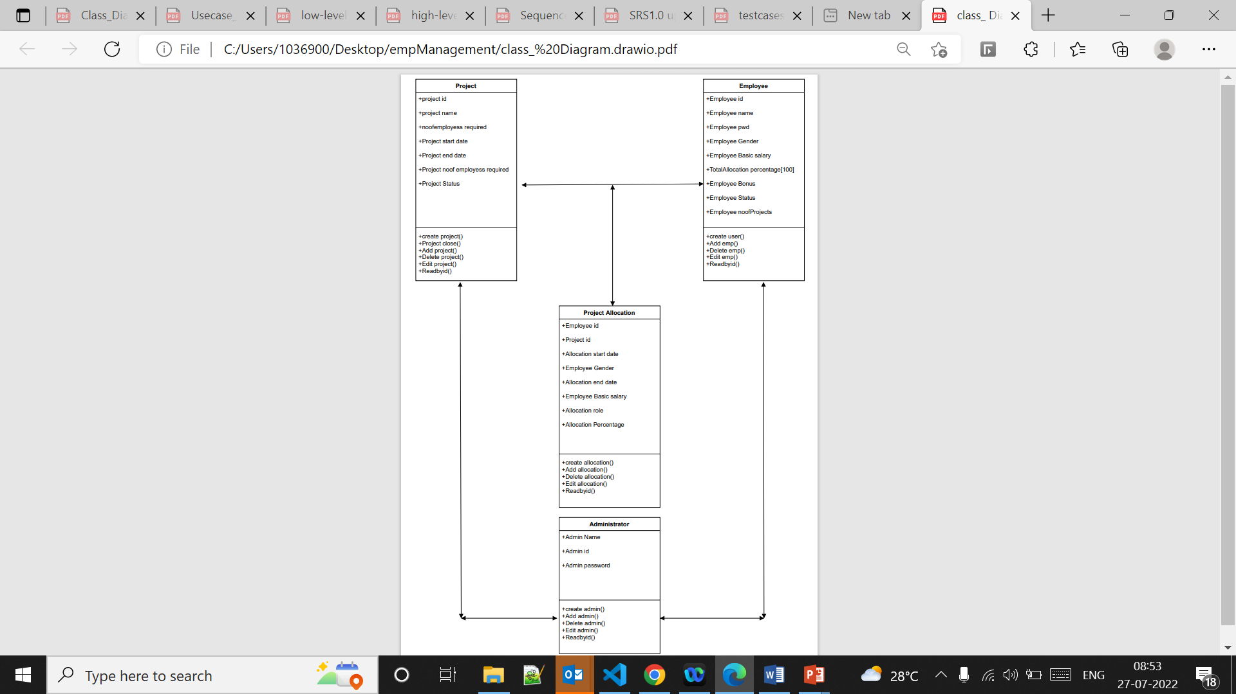

**5. Use case diagram**

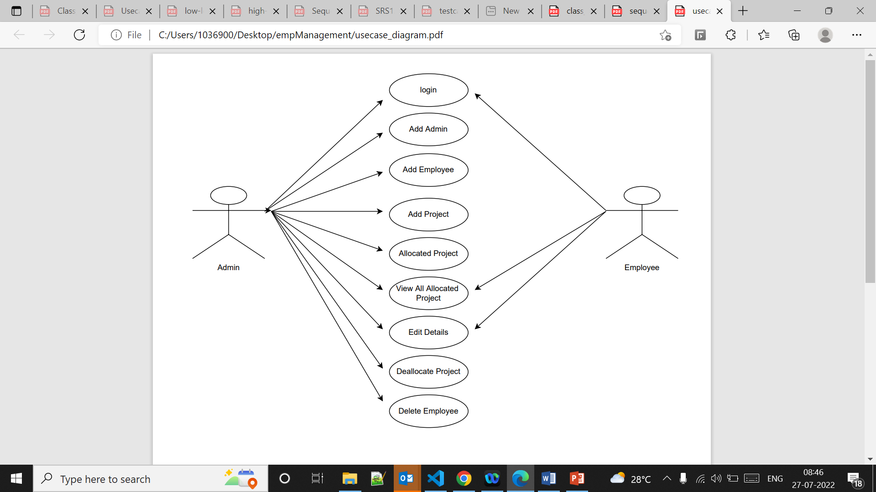

**6. Sequence diagram**

