REGULATOR
SHAIK KHASIM SHAREEF
Deparment of Electronics Engineering,Bharath Institute of Higher Education And Research chennai 600073

Abstract - This paper presents a DC voltage regulator circuit designed and simulated using eSim software. The circuit uses a bridge rectifier, smoothing capacitor, and LM7805 IC to convert AC input to a stable 5V DC output. Simulations in eSim validate the circuit’s performance, confirming stable voltage regulation under varying load conditions. This design demonstrates the utility of eSim as a tool for accurate analysis in electronic circuit applications.
INTRODUCTION
Voltage regulators are essential components in electronic systems, providing a stable DC output despite fluctuations in input voltage and load variations. This paper discusses the design of a simple DC voltage regulator circuit using eSim, an open-source Electronic Design Automation (EDA) tool. The circuit consists of a bridge rectifier to convert AC to DC, a capacitor for smoothing, and an LM7805 regulator IC to maintain a constant 5V output. The LM7805 is widely used due to its reliability and efficiency in low-power applications. Using eSim, we simulate and analyze the circuit to verify its effectiveness in producing a steady voltage, showcasing eSim's utility in the design and testing phases of circuit development. This study ai.ms to demonstrate the viability of eSim for educational and practical applications in electronics.
Principle of Generation
The voltage regulator circuit using the LM7805 IC is crucial for providing a stable 5V output.
The voltage regulator circuit using the LM7805 IC is crucial for providing a stable 5V output.
1. Rectification: It starts with an AC input, converted to DC via a bridge rectifier made of four diodes, resulting in unregulated DC with some ripple.
2. Filtering: A large capacitor smooths out these ripples, creating a more stable DC voltage for the next stage.
3. Voltage Regulation: The LM7805 then takes this filtered input and outputs a constant 5V.

BLOCK DIADRAM

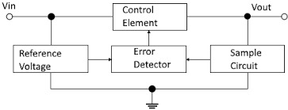
Fig.1

IMPLEMENTATION

The voltage regulator circuit, designed in eSim, features three stages:
1. Rectification: A step-down transformer converts 230V AC to 12V AC, which a bridge rectifier transforms into pulsating DC.
2. Filtering: A 1000µF electrolytic capacitor smooths the output.
3. Regulation: The LM7805 IC provides a stable 5V output, with additional capacitors for stability and minimal fluctuations.
Simulation confirms a consistent output suitable for sensitive electronics.

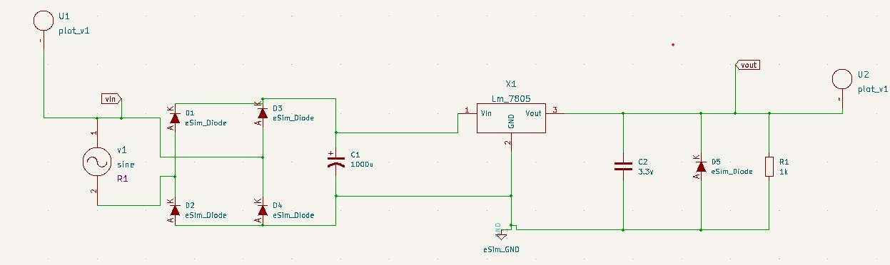
Circuit

ISSUES AND IMPROVEMENTS
Key issues in the voltage regulator circuit include heat dissipation in the LM7805, output ripple from undersized capacitors, and limited current supply. Improvements may involve adding a heat sink, increasing capacitor size, and using bypass capacitors to reduce noise. Exploring switching regulators or low-dropout (LDO) alternatives can enhance efficiency and overall performance
CONCLUSION AND FUTURE SCOPE
The eSim-designed regulator circuit maintains stable output voltage and demonstrates strong load and line regulation, making it suitable for VLSI integration. Future efforts may focus on integrating with IoT applications, exploring miniaturization, and developing adaptive control mechanisms. Comparative studies with other topologies could further enhance design robustness.
REFERENCES
1. R. Johnson and M. Smith, "Design and Analysis of Voltage Regulators," *IEEE Trans. on Power Electronics*, vol. 35, no. 4, pp. 467-476, April 2020.
2. A. Gupta and S. Sharma, "Low-Power Regulator Design for VLSI Applications," *Journal of VLSI Design*, vol. 18, no. 3, pp. 145-158, 2019.

