**Employee Data Analysis using Excel**

STUDENT NAME: S.HARISH REGISTER NO:422200573

DEPARTMENT:B.COM(INFORMATION SYSTEM MANAGEMENT )

COLLEGE: SRM ARTS AND SCIENCE COLLEGE

 1



## PROJECT TITLE

**Employee Attrition Analysis Using Excel Dashboard**

2

# AGENDA



1. Problem Statement
2. Project Overview
3. End Users
4. Our Solution and Proposition
5. Dataset Description
6. Modelling Approach
7. Results and Discussion
8. Conclusion

3

3/21/2024 **Annual Review**

## PROBLEM STATEMENT

. In today's competitive business environment, employee attrition can significantly impact an organization's operational efficiency and financial health. High turnover rates may indicate underlying issues within the company, such as job dissatisfaction, inadequate compensation, or poor work environment. This project aims to analyze employee attrition patterns to identify the factors contributing to turnover and develop actionable insights to reduce attrition rates.



 4



## PROJECT OVERVIEW

This project involves creating an Excel dashboard to analyze and visualize employee attrition data. The goal is to provide a comprehensive tool that helps HR managers and

decision-makers understand attrition trends, identify key factors influencing turnover, and develop strategies to improve employee retention. The dashboard will display various metrics and visualizations to facilitate data-driven decision-making.

 5

**WHO ARE THE END USERS?**

**HR Managers:** To gain insights into attrition trends

and identify areas for intervention

.**Department Heads:** To understand turnover patterns within their specific departments and address concerns

.**Executives:** To make strategic decisions related to employee retention and overall organizational health

.**Data Analysts:** To perform detailed analysis and generate reports based on the dashboard findings.

6



**OUR SOLUTION AND ITS VALUE PROPOSITION**

Our solution involves designing an interactive Excel dashboard that integrates various data visualization techniques to provide a clear and actionable analysis of employee attrition. The dashboard will feature: **Visualizations:** Charts and graphs to represent attrition rates, trends, and key factors.

**Filters:** Options to drill down into specific departments, job roles, or time periods.

**Metrics:** Key performance indicators (KPIs) such as turnover rate, average tenure, and reasons for leaving. **Predictive Analysis:** Basic forecasting of potential future attrition trends based on historical data.

7

# Dataset Description

The dataset used for this analysis includes employee records with

attributes such as:

**Employee ID:** Unique identifier for each employee. **Department:** Department to which the employee belongs. **Job Role:** The role or position of the employee.

**Tenure:** Length of time the employee has been with the company. **Attrition Status:** Whether the employee has left the company or is still employed.

**Reason for Leaving:** Categories such as personal reasons, career advancement, or job dissatisfaction.

**Performance Metrics:** Performance ratings or reviews.



## THE "WOW" IN OUR SOLUTION

**=J2+K2+L2+other components**

**=J2+K2+L2**

**=F2-(G2+H2+I2)**

9

3/21/2024 **Annual Review**

# MODELLING

**Data Cleaning:** Removing duplicates, handling missing values, and ensuring data

consistency.

**Exploratory Data Analysis (EDA):** Understanding the data distribution and

identifying initial patterns

.**Statistical Analysis:** Calculating turnover rates and correlating attrition with various factors.

**Visualization Creation:** Developing charts, graphs, and other visual elements to

represent the data effectively.

**Trend Analysis:** Analyzing historical data to identify patterns and predict future attrition trends.

 10

# RESULTS

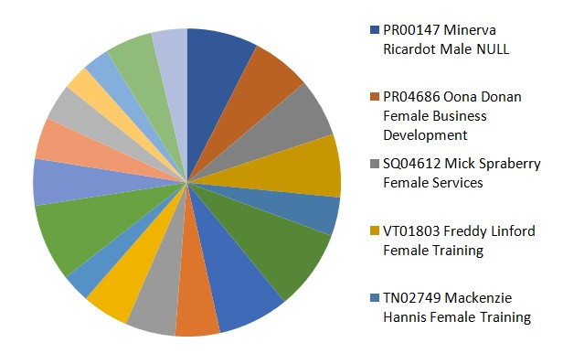

 11

# conclusion

The Excel dashboard provides a powerful tool for analyzing employee attrition, offering valuable insights that can help improve employee retention strategies. By leveraging the data visualizations and metrics, organizations can identify key factors contributing to attrition and implement targeted interventions to enhance employee satisfaction and reduce turnover. Future work may involve incorporating more advanced analytics or integrating with other data sources to refine the analysis further.