# OFFER LETTER

PRIVATE AND CONFIDENTIAL

# Dear Sharmistha,

This is regarding your application and subsequent discussion you had with us. We are pleased to inform you that you have been selected to join our organization as a**Software Engineer Inter.**We look for people who are committed to leadership and our culture of innovation.Your foundation phase starts from **1st September 2020..**

You shall be governed by the following terms and conditions of service during the internship period with Xenonstack, and those may be amended from time to time.

Please refer to:

Annexure A - Benefit Summary

Annexure B - Laptop/Desktop Issue & Usage Agreement Annexure C - Joining Time Document Checklist

# Compensation and Allowances

* 1. You will join at L1 level. After successful completion of L1 , you will move on to the next Level that is L2 level of internship.Depending upon your performance and shift timing, you may be paid a stipend of**INR 7500 PM**during L2 Level and**INR 15000 PM**during

L3 Level of the internship. This payout will totally depend on the feedback received on your performance and behaviour.

* 1. Your annual package after the successful completion of the internship will be**INR. 4,50,000**including 10% Performance Incentives, Benefits & Taxes as per government rules. Therefore, in hand monthly salary will include(Employee PF, Employer PF, Profession Taxes & other charges as per Income Tax Act, as amended and applicable from time to time.)
  2. Your compensation components, all amounts, and allowances are Pre-Tax amounts and will be taxable in accordance with the taxation laws in India and you shall be liable for the same from time to time. For allowances requiring reimbursement as non-taxable components, you will need to submit receipts/bills; otherwise, they will be paid as taxable components.

# Scope and Responsibilities

* 1. Your scope of responsibilities will include those for which you are engaged, as well as any other duties given to you by your Manager from time to time. In accepting this offer of internship, you will be required to perform all responsibilities assigned to you with due care and diligence and in compliance with the direction of management. You are also

required to perform these tasks during business hours and such reasonable additional time as may be necessary. The above internship will neither create any right of employment in the Company until a definitive employment agreement is signed between the Parties.

***You have to Complete Assignment of Foundation Module level 1 remotely. Your performance will be evaluated on the basis of your Presentation. If your feedback is below good in the presentation foundation phase will be extended 2-3 weeks.***

***You have to complete level 2 of your internship remotely.***

1. **Internship Period**
   1. You shall be an Internship for a period of**11 Months(1st September 2020 to July 2021)**.During the period of internship, your performance will be evaluated on a regular basis, and if the same is not as per the expected standards, your internship is liable to be terminated. The notice period during Internship would be **one month** for all interns.

# Probation Period

* 1. You shall be on Probation for**one hundred and eighty (180)**calendar days after the completion of internship and confirmation as an employee and the said period, at the discretion of the management may be extended up to**ninety (90)**calendar days. During the period of Probation, your performance will be evaluated regularly, and if the same is not as per the expected standards, the Company may terminate your employment.

# Posting and Procedures

* 1. At present, you will be posted at**Mohali**. However, based on the job/business requirements of the company, you are liable to be transferred to any of the other offices/companies/associate companies, whether in existence and planned in the future, in India or abroad, at our sole discretion.

# Shift and Leave Policy

* 1. You will be flexible to work in any Shift i.e. Morning, Evening or Night during your association with XenonStack. You will be entitled to leave & holidays as per the leave policy of the company as well as the location of posting.

# Data Protection and Security Policy

* 1. As an intern with XenonStack, you are committed to ensuring that all the PrincipalData (related to you and third party) handled by us will be processed according to legal complaint standards of
  2. This is your personal responsibility to ensure compliance with this policy, to handle all PrincipalData consistently with the principles and to ensure that measures are taken to protect the data security. And, the company (employer) will not be responsible, in any

case Data Protection and Security comes and reserves all the rights to take strict action against.

# Non-Disclosure Agreement

* 1. As XenonStack is dealing with International as well as Indian clients working in Data and IP, you are liable to sign Non-Disclosure Agreement and Data Protection Policy.

# Travel and Expenses

* 1. You may be required to travel, whether in or around India or overseas, in connection with your internship with the Company upon short notice to you. While traveling for work, your expenses and costs in connection with such travel and any other expenses incurred by you during your internship will be reimbursed in accordance with the current travel and expense policy of the Company. You are expected to keep your passport valid always.

# Policies and Procedures

* 1. You are required to comply with all Company policies and procedures written in the internship handbook as they may be amended or added to from time to time.

# Minimum Service Period

* 1. After the completion of the L2 level of internship, interns who decide to join the organization at L3 Level will have to sign a **2 years** service agreement.
  2. Since the Employer will invest money and resources in training and upgrading the Employee’s skills as a professional, the Employee willingly agrees to work at the Company and sign a service agreement for a**minimum period of 2 years**, inclusive of probationary period, from the date of joining and signing of the agreement (hereinafter referred to as “**Minimum ServicePeriod**”). After completion of the Minimum Service Period, the Employee shall be at liberty to resign from the Company after giving an advance written a notice to the effect, at least**90 (ninety) days**prior to the intended last working day (hereinafter referred to as “**Notice Period**”). This provision is inserted in order to help the Employer find an appropriate replacement.
  3. The Parties reserve their right to take appropriate legal action as per the Indian Contract Act, 1872 if a breach of the aforesaid clause occurs. Additionally, the Employee agrees to pay damages to the Employer amounting or equal to**Rs 2,00,000**(Rs Two lac only) if the aforesaid breach occurs by or on part of the Employee.
  4. The Intern shall also be responsible and penalized for the loss incurred by the Company due to project delays as a result of the abrupt absence of the Intern. In such a scenario the Company also forfeits its obligation to issue to the Intern a No Objection Certificate, Experience Certificate, Relieving Letter or/and Reference Letter, as and what shall be applicable.

# Resignation Acceptance Policy

* 1. You may at any time terminate your internship by giving theCompany**thirty (30)** calendar days prior written notice of 30 days pay in lieu of notice. Upon you providing such notice, approval of any request for early release and/or any kind of waiver will be granted at the sole discretion of the Company and will be subject to the terms and conditions of the Company, including and not limited to the recovery in lieu of notice period not served.

# Termination Policy

* 1. Your internship may be terminated by the Employer by giving**7 day's notice or 7 days' pay**in lieu of notice. In case the intern gives notice for termination, the Company, at their sole discretion, may relieve the intern before the expiry of the notice period without any financial liability or commitment to allow them to continue in service till the end of the notice period.
  2. The Company may terminate your internship without notice if you willfully disobey a lawful and reasonable instruction or direction, commit an act of misconduct, including but not limited to, fraud or dishonesty, or are habitually negligent in your duties, you will be liable to dismissal by the Company without notice or pay in lieu of the same.
  3. Upon termination, a reconciliation of reimbursements against monthly accrued allowances will be calculated. You agree for Company to offset any overpayment against any money owing to you on termination of the internship.

# Benefits and Others

* 1. Additional benefits and terms of internship are described in Annexure A.
  2. Your stipend for the first month shall be payable only on the completion of 1 month from the commencement of your services. If you choose to terminate your services at any time during the aforesaid period of 1 month, your stipend for the period served by you shall be forfeited.

# Return of Company Property

* 1. On termination of your internship, for any reason, you must immediately return to Company all Company property in whatever form, relating in any way to Company. Company is entitled to deduct or set off any amount owing to you on termination for the value of any property not returned, or amounts owing to the Company.

# Closing

This offer of employment is conditional upon the following:

* 1. Signing the acceptance clause under the heading “Acceptance of Internship Offer”;
  2. You are under no obligation to anyone which prevents you from entering into this Agreement or restricts the activities or duties which may be assigned to you by the Company;
  3. All information provided by you is accurate, including academic credentials, if required;
  4. Successful completion of any background check or security clearance investigation;
  5. Satisfactory reference having been obtained from your previous and present managers/College staff.

To indicate your acceptance, please acknowledge by replying to this email within 2 days of receiving this letter. If you do not return the required documents by this deadline, we will assume that you do not intend to accept this internship offer and it will be automatically withdrawn without further action on the part of the Company.

We look forward to receiving your acceptance of this offer and joining our team. Sincerely,

On behalf of XenonStack Private Limited

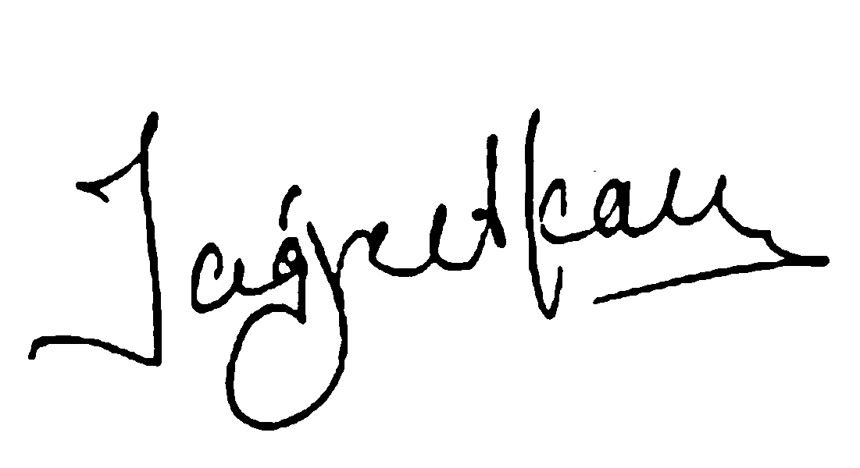

# Director

**(For, Xenonstack Pvt. Ltd.)**

**------------------ Please send the Acceptance on Mail------------------**

**Acceptance of Employment Offer**

I have read, understood, and accepted this offer of Employment Offer, as set forth above, with Company and will report on **01.09.2020** .



# Annexure A

Terms & Benefits Summary

|  |  |  |  |  |  |  |  |
| --- | --- | --- | --- | --- | --- | --- | --- |
| **Terms & Benefit Items (Applicable)** | **Description** | | | | | | |
| Working Hours (Applicable) | The core working hours for interns are 10 hrs per day (Monday to Saturday) unless otherwise specified. You may be required to work for additional hours and days depending on your assigned commitments and deliverables. | | | | | | |
| Break (Applicable) | One hour break for breakfast/lunch/dinner, tea/coffee for interns or any other work according to their working shift. | | | | | | |
| Notice Period (Applicable) | One month notice internship contract. | period | unless | otherwise | specified | by | the |
| Phone & Internet Allowance | Interns are required to avail mobile internet (at least 4G connection) on their Smartphones and Broadband Internet at their Home/ Place of Stay. | | | | | | |
| Annual Leave (Applicable) | Interns are eligible for 1 casual paid leave per month. Interns will have to avail leaves according to the rules of the company. | | | | | | |

# Annexure B Laptop/Desktop Issue & Usage Agreement

XenonStack Private Limited(“Company”) in consideration of improving productivity and meeting business needs of the Company has decided to issue Laptop/Desktop and components like power supply adaptor, mouse & installed softwares (“Laptop/Desktop”) to employees and contractors based on an appropriate recommendation from the Managers.

The issue, usage, and return of Laptop/Desktop are governed by the following terms & conditions:

1. Ownership of Laptop/Desktop shall lie with the Company. Any data created or stored on the Laptop/Desktop shall be the property of the Company.
2. The Laptop/Desktop shall be used for Company related activities. Employees are permitted to use the Laptop/Desktop for a reasonable amount of personal use.
3. The Employees shall ensure that Laptop/Desktop and contents in the same comply with all of the Company's IT policies and practices including data security, network traffic, etc. Employees shall make sure that the Laptop/Desktop does not contain any unauthorized software or programs. The Company is authorized to audit and monitor the Laptop/Desktop at any point of time without notice.
4. The Employees shall take all steps to ensure the security of data and information and shall make sure it is not copied in part or full, backed up or reproduced at any place other than designated media and storage space by the Company.
5. The Employees shall be responsible for the safety and security of Laptop/Desktop including theft, damage or loss of Laptop/Desktop. The Employees shall inform the Company promptly about any such incidence if any. The Employees agree to pay/ compensate the Company equivalent amount in cash as per details below:

* Within 1 Year from the date of purchase – 100% of Laptop/Desktop cost.
* 1-2 Years from the date of purchase – 75% of Laptop/Desktop cost.
* 2-3 Years from the date of purchase – 50% of Laptop/Desktop cost.
* More than 3 years from the date of purchase – 25% of the cost.

The Company, at their sole discretion, may waive off this cost based on their analysis of the incidence.

1. The Employees shall return the Laptop/Desktop to the designated Manager or department before leaving the Company.
2. Any support request related to Laptop/Desktop, software or hardware issues should be notified to the designated department which shall take suitable action as needed.
3. The Company may withdraw the Laptop/Desktop anytime without any notice or reason.

# Annexure C

**Joining Time Document Checklist**

The following is a checklist which indicates the documents that you have to submit at the time of joining **XenonStack Private Limited.**

Duplicate copies of the following documents to be submitted:

|  |  |  |
| --- | --- | --- |
| Sl.No | Description of Document | Submitted  (Yes/ No) |
| 1. | PASSPORT/ PAN Card/ Driving License |  |
| 2. | DEGREE CERTIFICATE   * If you are a fresh candidate you can submit the provisional certificate, if your convocation has not yet taken place * If you are a candidate with experience, you are requested to produce the final degree certificates of your Diploma/ Bachelors degree/ Masters degree/ Any other professional qualification   program |  |
| 3. | MARKS SHEET  Mark-sheets for all semesters must be provided. In the case of multiple attempts, the mark-sheets of all attempts must be provided |  |
| 4. | SALARY PROOF  If you are joining with prior experience, please submit a copy of Appointment Letter/ Last 3 Months Salary Slip |  |
| 5. | UPDATED RESUME |  |
| 6. | RELIEVING LETTER  If you are joining with prior experience, please submit a relieving letter from your former employer |  |
| 7. | PHOTOGRAPH  One passport size color photograph |  |
| 8. | Any two references   * HR of Previous company (If previously employed) * Any other reference (2nd reference) |  |

** Offer letters are**Strictly confidential**. Don’t disclose to anyone in the company.

** You have to sign the offer letter and share on the same mail as acceptance.



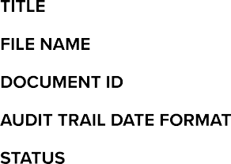Sharmistha Offer Letter Sharmistha offer letter.pdf

e44f27f921042f645c720186b288f5f81cdc9fda MM / DD / YYYY

Completed



**08 / 28 / 2020**

09:53:41 UTC

Sent for signature to Dr.Jagreet (jagreet@xenonstack.com) from [people@xenonstack.com](mailto:people@xenonstack.com)

IP: 203.129.220.226

**08 / 28 / 2020**

10:51:20 UTC

**08 / 28 / 2020**

10:51:37 UTC

**08 / 28 / 2020**

10:51:37 UTC

Viewed by Dr.Jagreet (jagreet@xenonstack.com) IP: 122.173.103.213

Signed by Dr.Jagreet (jagreet@xenonstack.com) IP: 122.173.103.213

The document has been completed.

